Name: ________________________________

**1.2.3 Markets**

1. Match each diagram to one of the statements.
   1. A change in price has led to a change in quantity demanded
   2. A change in consumer preferences has led to an increase in quantity demanded
   3. The market is in equilibrium at price P
   4. A change in price has led to a change in quantity supplied
   5. There is excess supply on the market at price P
   6. Market forces will push prices upwards

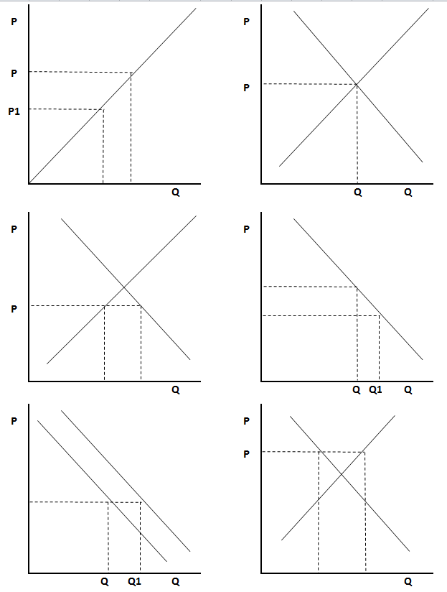

1. Fully label the diagram to show:
   1. Price
   2. Quantity
   3. Supply
   4. Demand
   5. Equilibrium
   6. Excess supply
   7. Excess demand