**Primary and Secondary Market Research Explained**

[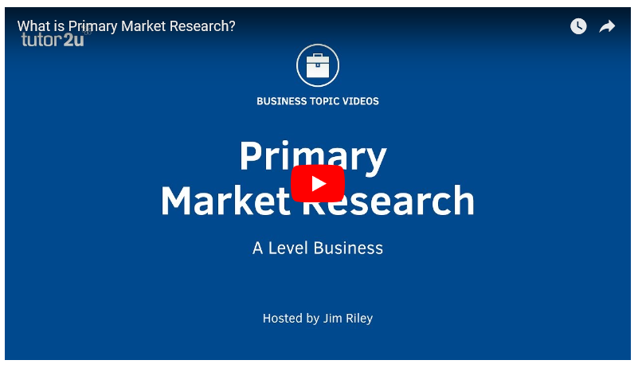](https://www.youtube.com/watch?v=tJi_JsiOs2I)

Link <https://www.youtube.com/watch?v=tJi_JsiOs2I>

[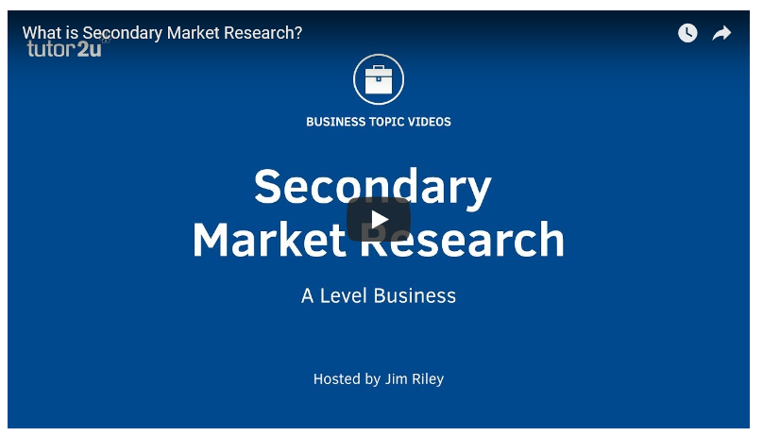](https://www.youtube.com/watch?v=ELX2kIPmyqY)

Link <https://www.youtube.com/watch?v=ELX2kIPmyqY>