Name: ________________________________

**1.4.4 Motivation in theory and practice**

1. Match each term to the correct motivational theorist.

|  |  |  |  |
| --- | --- | --- | --- |
| Hierarchy of needs | Self-actualisation | Scientific management | Time & motion study |
| Economic man | Piecework | Psychological needs | Esteem needs |

|  |  |
| --- | --- |
| Maslow | Taylor |
|  |  |

1. Complete the diagram to show your understanding of Herzberg's Dual Factor Theory.

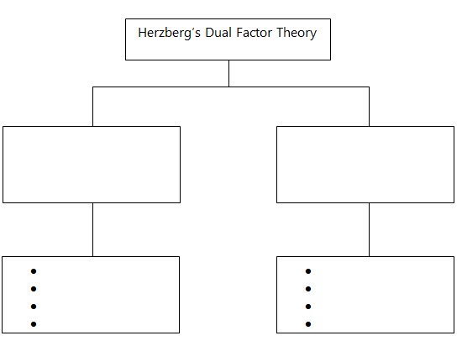

Name of each factor

Examples of each factor

1. Name one other motivational theory ___________________________________________
2. Complete the table below.

|  |  |  |
| --- | --- | --- |
| Method of motivation | Financial or non-financial | Definition |
| Piecework |  |  |
| Teamwork |  |  |
| Performance related pay |  |  |
| Commission |  |  |
| Job enrichment |  |  |