**NAME** ............................................ Chemistry Class ....................

Student Number ……….

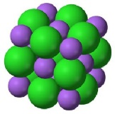

Solubility

***H*solution**

***H*hydration**

***H*lattice**

IONIC LATTICE

GASEOUS IONS

AQUEOUS IONS

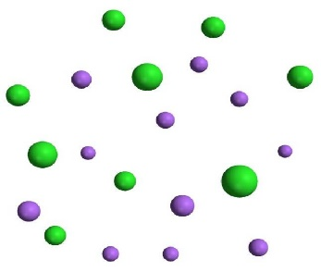

Hess cycle for determining solubility

Topic 13A

9. be able to define the terms ‘enthalpy change of solution, Δ *Hsol* and ‘enthalpy change of hydration, Δ*Hhyd*

10. be able to use energy cycles and energy level diagrams to carry out calculations involving enthalpy change of solution, enthalpy change of hydration and lattice energy

11. understand the effect of ionic charge and ionic radius on the values of:

i lattice energy

ii enthalpy change of hydration

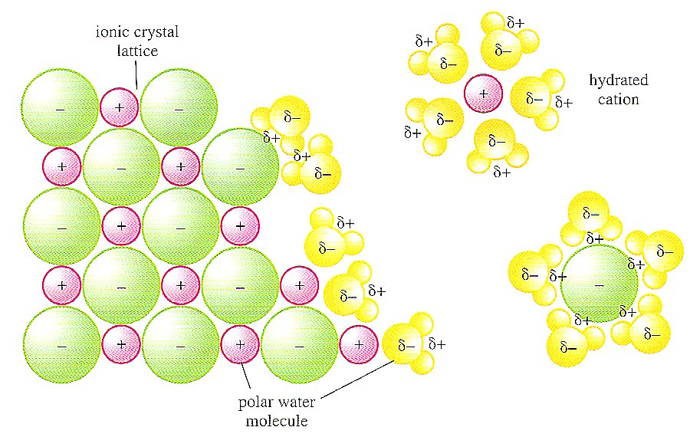

[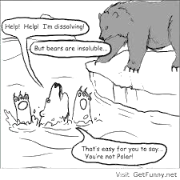](https://www.google.co.uk/url?sa=i&rct=j&q=&esrc=s&source=images&cd=&cad=rja&uact=8&ved=0ahUKEwioi96syuXWAhVDLhoKHRNgDUQQjRwIBw&url=https://lavelle.chem.ucla.edu/forum/viewtopic.php?t%3D4291%26start%3D500&psig=AOvVaw2C2245D-3bN_BD7GoKCCsH&ust=1507708547001310)

Sodium and chloride ions leaving a crystal lattice and becoming hydrated as they dissolve in water. Here the bond between the ions and the polar water molecules is electrostatic attraction.

**SOLUBILITY**

This topic builds on concepts used in AS Energetics and A2 Entropy to understand why some ionic compounds dissolve and others do not.

MCj04247820000[1]See the energetics revision power point:- <http://www.knockhardy.org.uk/ppoints_htm_files/DELTAHPP.PPT>

**Dept website**

Factsheets

|  |  |
| --- | --- |
| 94 | Enthalpies of Solution |
| 29 | Answering Questions on Born-Haber Cycles |
| 102 | Improve your marks: A2 energetics – Born Haber cycles |
| 125 | Why students loose marks: Born-Haber calculations |

Edexcel A-level Chemistry student Book 2 pages 61 - 64

**Solubility Rules.**

a) Solubles

1) All **Nitrates** are **soluble.**

2) All **Chlorides** are **soluble** *except* **silver\*** (soluble in ammonia) and lead (fairly soluble in hot water).

3) All **Sulfates** are **soluble** *except* **barium\*** and **lead** (calcium sulfate is sparingly soluble).

4) All **ammonium** and **Group 1** metal salts **(Na & K)** are **soluble.**

b) Insolubles:

1) All **Carbonates** are **insoluble** *except* **ammonium and Group 1 (Na & K).**

2) All **Metal Hydroxides** are **insoluble** *except* **ammonium and Group 1 (Na & K).**

Group 2 are moderately soluble (increasing down the group).

3) All **Oxides** are **insoluble** but **Groups 1 & 2** dissolve by forming the hydroxide.

4) All **Sulfides** are **insoluble** *except* **Groups 1 & 2.**

**Solubility of salts**New Reference

For a solid to be soluble two processes must occur:-

* the ionic lattice must be broken up
* the ions are hydrated with the water/solvent molecules, (i.e. bonded to them).

We have studied ionic lattices in Born Haber pack. You need to remember what is meant by lattice enthalpy:-

**Lattice enthalpy Hlattice**

Lattice enthalpy is the enthalpy change when 1 mole of the solid ionic lattice is formed from its constituent gaseous ions, under standard conditions of 298K 1atm.

Looking at the definition would you expect the Lattice enthalpy to be:- *(circle correct answer)*

1. always –ve
2. always +ve
3. it depends on the ionic lattice formed

It is important that you understand that the lattice enthalpy is always exothermic, bonds are being formed.

In terms of entropy, would you expect the system to:- *(circle correct answer)*

New exercise

a) gain in entropy (i.e. becoming more disordered)

b) lose entropy (i.e. becoming more ordered)

c) depends on the ionic lattice formed.

Write out the equation for the lattice enthalpy of these ionic solids:-

MgO

CaCl2

LiF

NaCl

However when we are dissolving a substance we are doing the **opposite** process, we are breaking up the lattice, so the process is reversed.

The breaking up of the lattice is **always endothermic** i.e. it takes in energy, but there is an **increase** in the entropy of the system as the ions become mobile.

However breaking the lattice is only half of the process, we also hydrate the ions (i.e. they form bonds with the water); we call this the hydration enthalpy.

Edexcel A-level Chemistry student Book 2 pages 61

**Hydration enthalpy** **Hhyd**

This again is an exothermic process as bonds are being formed. We can combine these two processes, the breaking of the ionic lattice and the formation of bonds with the water, to define the enthalpy of solution:-

**Enthalpy of solution Hsoln**

For a substance to dissolve two processes must occur:-

* Energy is used to break up the lattice – an endothermic process

this will have a +ve value and so will be equal to -Hlatt

* Energy is released on hydration of the resulting ions both cations and anions

Hhyd = -ve value

The resulting difference in enthalpy is referred to as the enthalpy of solution and **largely** determines whether a salt is soluble

**Hsolution = Hhyd - Hlatt**

Consideration of factors which affect these energy changes enable us to understand how the solubilities of salts vary.

**Factors affecting lattice enthalpy and enthalpy of hydration**

Lattice enthalpy

The lattice enthalpy will be more exothermic if:-

* 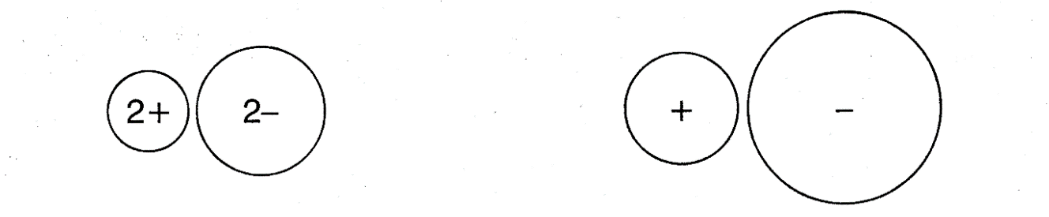The ionic charge increases
* The ionic radius decreases

Compare the attraction between the two pairs of ions and explain any differences in lattice enthalpy to be expected

………………………………………………………………………………………………………………………………………………………………………………………………………………………………………………………………………………………………………………………………………………………………………………………………………………………………

F = k_\mathrm{e} \frac{q_1q_2}{r^2}This is **quantified** by Coulomb’s Law which describes the magnitude of the electrostatic force between two electric charges. The magnitude of the electrostatic force (*F*) on a charge (*q*1) due to the presence of a second charge (*q*2), is given by

where *r* is the distance between the two charges and *k*e a proportionality constant.

Note that this calculation assumes the ions are point charges and leads to the **theoretical values** in data tables.

**New exerciseQuestions**

**1.** Explain the difference in lattice energies between the following pairs of ions

LiF (-1033 kJ mol –1) and NaF (-915 kJ mol –1)

…………………………………………………………………………………………………..

…………………………………………………………………………………………………..

Rb2O (-2161 kJ mol –1) and K2O (-2232 kJ mol –1)

…………………………………………………………………………………………………..

…………………………………………………………………………………………………..

MgO (-3793 kJ mol –1) and Na2O (-2478 kJ mol –1)

…………………………………………………………………………………………………..

…………………………………………………………………………………………………..

Al2O3 (-15916 kJ mol –1) and MgO (-3793 kJ mol –1)

…………………………………………………………………………………………………..

…………………………………………………………………………………………………..

**(8)**

**2.** Which of the following pairs of compounds will have the more exothermic lattice energy?

Give a reason in each case.

RbF and SrF2 …………………………………………………………………………………………………………..

…………………………………………………………………………………………………………..

Cs2O and BaO ………………………………………………………………………………………………………….

………………………………………………………………………………………………………….

CuO and Cu2O …………………………………………………………………………………………………………..

…………………………………………………………………………………………………………...

**(6)**

**3.**a) For the chlorides of group I, how does the magnitude of lattice enthalpy change on descending the group? Explain your answer.

Change ………………………………………………………………………………….……………....

Explanation ………………………………………………………………………………………………...................

………………………………………………………………………...…………………………………

b) From Lattice enthalpy considerations only, would you expect the following physical properties of the group I chlorides to increase, decrease or remain approximately constant on descending the group?

Melting point …………………………………………………………………………………………..

Solubility in water ……………………………………………………………………………………..

**(5)**

**Hydration Enthalpy**

Draw a diagram to show a polar water molecule:-

Water molecules are attracted to ions in the solid lattice and they become hydrated:-

#### *Complete the labels*

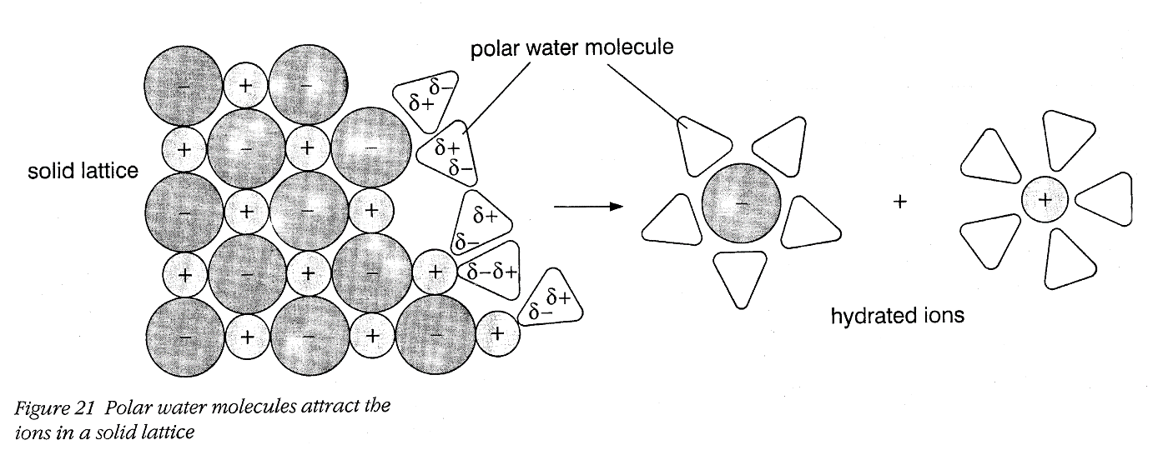

Enthalpies of hydration are always negative as it is an exothermic process

The size of the hydration enthalpy depends on

* …………………………………………..
* …………………………………………..

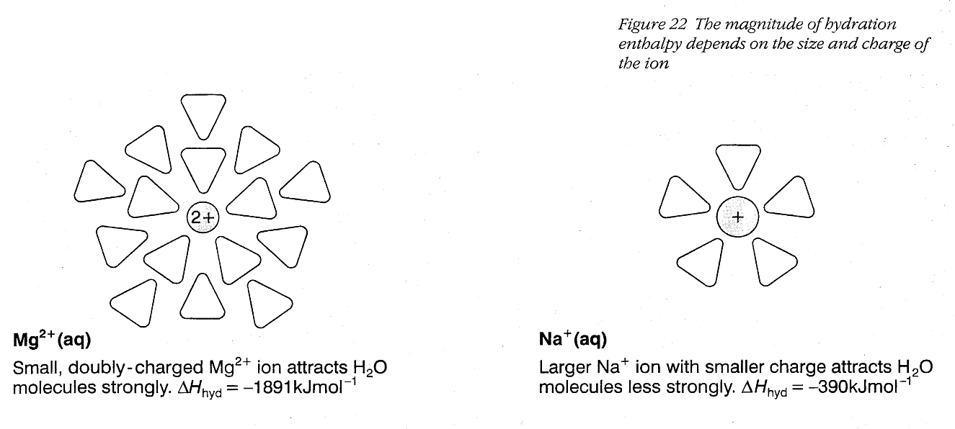

**Question**

**New exercise**

**1 a**) How and why would you expect the magnitude of the hydration enthalpy to change on progressing:-

(i) from Li +  Na +  K + ?

*Change* ……………………………………………………………………..………….*.* **[1]**

*Reason* …………..………………………………………………………….……..…....**[1]**

(ii) from Na +Ca 2+Al 3+ ?

*Change ..*…………………………………………………………………..…………….**[1]**

*Reasons* ..………………………………………………………………………….………..

............................………………………………………………………………………...**[2]**

(iii) from F -Cl - Br - ?

*Change…..*………………………………………….……………………………….......**[1]**

*Reason .*…………………………………………………………………….…………....**[1]**

**b**) How do you account for the fact that the hydration enthalpy of H+ is exceptionally large

(-1200 kJ mol-1)?

…………………………………………………………............................................…………………………………………………………............................................…………………………………………………………............................................…………………………………………………………....................................…………………………………………………………………**[4]**

## Enthalpy of solution

This represents the difference between the energy required to break up the lattice and the energy released on hydration of the resulting ions. In questions relating to solubility it is always necessary to quote the following equation.

**Hsolution = (****Hhydration (anions + cations)) - (****Hlattice)**

(exothermic) (exothermic)

Enthalpies of solution can be calculated using a Hess cycle:-

Ionic lattice + solvent

M+X-(s) + H2O(l)

Solution

M+(aq) + X-(aq)

Gaseous ions + solvent

M+(g) + X-(g) + H2O(l)

*H*lattice

*H*hydration

*H*solution

MCj04247820000[1]Using Hess cycles, we can calculate the enthalpy change when one mole of an ionic solid dissolves to form a solution of 1 mol dm-3.

*H*solution = -*H*lattice + *H*hydration

We can rearrange this equation to give *H*lattice  and *H*hydration

New exercise

*H*hydration =

*H*lattice =

This lead us to the hypothesis that an exothermic enthalpy of solution means that the solid is soluble.

**New exerciseEnthalpy of solution Problems**

1. Calculate the enthalpy change of solution of lithium fluoride from the following data:-

Li+ (g) + F-(g) 🡪LiF (s) Hlattice = -1022 kJ mol-1

Hydration enthalpies, kJ mol-1 Li+ (g) = -519 F-(g) = -506

2) Calculate the enthalpy of hydration of bromide ions given that the hydration enthalpy of barium ions is -1360 kJ mol-1, the lattice enthalpy for BaBr2 is -1937 kJ mol-1 and the Enthalpy of solution of BaBr2 = -38 kJ/mole

3) Use the data below to calculate the enthalpy of solution of

a) magnesium sulphate b) barium sulphate

Lattice enthalpy of formation (kJ mol-1): MgSO4 = -2833; BaSO4 = -2474

Hydration enthalpy (kJ mol-1): Mg2+ = -1891; Ba2+ = -1360; SO42- = -1004

**Comparison of calculated and experimental Hsoln.**

**New exercise**

Using the values given calculate the enthalpy of solution for each of the following, indicate if the solid is soluble or insoluble in water. Data given in kJ mol-1

1) NaCl Hydration enthalpy Na+ = - 405 Cl- = - 381 Lattice enthalpy NaCl = - 789.9

2)CaCO3 Hydration enthalpy Ca2+ = -1650 CO32- = -1176 Lattice enthalpy CaCO3 = -2814

3)NH4Cl Hydration enthalpy NH4+ = -307 Cl- = -381 Lattice enthalpy NH4Cl = -705

4) NaNO3 Hydration enthalpy Na+ = - 405 NO3- =-329 Lattice enthalpy NaNO­3 = -755

5) MgCl2 Hydration enthalpy Mg2+ = -1920 Cl- = -381 Lattice enthalpy MgCl2 = -2526

6) Ba(OH)2 Hydration enthalpy Ba2+ = -1360 OH- = -460 Lattice enthalpy Ba(OH)2 = -2142

Now add a spatula tip of each of these to half a test tube of water and measure any temperature change

Remember we hypothesized that a –ve enthalpy of solution would mean that the solid dissolved.

Do your calculations above support this hypothesis? ……….

The more –ve the enthalpy of solution the more likely the salt will be soluble. However simply having a –ve or +ve value is not enough **on its own** to determine solubility. For a reaction to be feasible the *Δ*Stotal value must be +ve ie *Δ*Gsol must be -ve. So far we have only considered *Δ*H.

**Entropy and solubility**

Sodium chloride and Ammonium chloride dissolve despite the fact that their enthalpies of solution are positive, and yet calcium carbonate and most of the other Group 2 carbonates are very sparingly soluble, but have exothermic enthalpies of solution. You might have expected exactly the opposite to happen.

Clearly, trying to correlate solubility simply with the enthalpy change of solution doesn't work.

We have to introduce a concept we looked at in the previous pack, Entropy and it’s allied concept Gibbs energy.

Look back at the equation for *Δ*Gsol , it is helpful to break down gibbs into the enthalpy and entropy terms

ΔGsol = ΔHsol - TΔSsol

As long as the Gibbs energy is -ve the reaction is feasible. We can use this to explain why NaCl dissolves in water even though the Δ*Hsol* value is +ve

Originally, the sodium and chloride ions were arranged in the crystal lattice - their entropy was low.

When you dissolve the crystal in water, the entropy increases as the ions and water molecules become randomly mixed - they become much more disordered than they were originally. Therefore the -TΔ*Ssol* term becomes negative enough to outweigh the small positive Δ*H*.

We now have to explain why MgCO3 is not soluble in water despite its –ve enthalpy of solution. For MgCO3 to be insoluble the Δ*Ssol* must be negative, i.e. the system is becoming more ordered, entropy decreasing. (thus making the -TΔ*Ssol* positive)

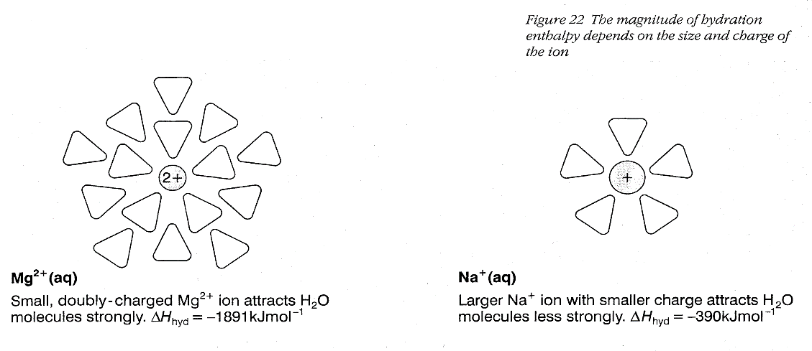In other words the solution must be more ordered than the lattice and the water. To understand this we need to look back at the diagram of the hydrated Mg2+ ion:-

The water molecules are not free to move but are ordered around the small positive ion (called hydration shells), therefore they are becoming more ordered and the entropy of the system is decreasing.

That means that you have two entropy effects to consider. There is the increase in *disorder* as the crystal lattice breaks up, but a corresponding increase in *order* in the water - which varies depending on the sizes and charges of the ions present. The table below gives the number of water molecules associated with various ions.

|  |  |  |  |  |  |  |  |
| --- | --- | --- | --- | --- | --- | --- | --- |
| ion | Cs+ | K+ | Na+ | Li+ | Ca2+ | Mg2+ | Zn2+ |
| Hydration number | 6 | 7 | 13 | 22 | 29 | 36 | 44 |

**To find the enthalpy of solution of ammonium chloride**

****

You are provided with:

* A stoppered sample tube containing ammonium chloride, labelled **D**.

You are required to measure the molar enthalpy change when ammonium chloride

dissolves in water.

(a) **Procedure**

1. Use a measuring cylinder to measure 50 cm3 of distilled water into a dry polystyrene cup held firmly in a 250 cm3 beaker. Place the thermometer in the water.

2. Weigh the stoppered tube containing **D**. Record the mass of the stoppered tube

plus **D** in **Table 2**.

3. Measure the steady temperature of the water in the polystyrene cup to the nearest

0.5 °C. Record the temperature in **Table 3**.

4. Empty the solid **D** from the tube into the water and stir with the thermometer

until all the solid has dissolved. Measure the lowest steady temperature of the

solution to the nearest 0.5 °C. Record this temperature in **Table 3**.

5. Weigh the stoppered tube after the transfer of solid **D**. Record its mass in

**Table 2.**

**Table 2**

|  |  |
| --- | --- |
| Mass of stoppered tube + **D**/g |  |
| Mass of stoppered tube after transfer of **D**/g |  |
| Mass of **D** used/g |  |

**Table 3**

|  |  |
| --- | --- |
| Temperature of water before adding solid **D,** T1 / oC |  |
| Steady lowest temperature of solution, T2 / oC |  |

(a) Calculate the temperature change, T, by subtracting T1 from T2.

T = T2 – T1 = ...................-....................... = .......................°C

(b) (i) Calculate the amount (moles) of ammonium chloride in your weighed sample of **D**.

[Molar mass /g mol-1: ammonium chloride = 53.5]

**(1)**

(ii) Calculate the heat change when your sample of **D** dissolves.

Assume that the total mass of the solution is 50 g and that the specific heat capacity of the solution is 4.18 J g-1 oC-1.

**(1)**

(iii) Using your answers to (i) and (ii), calculate the molar enthalpy change when **D** dissolves in water. Include a sign and units with your answer.

(iv) Explain why it is inappropriate to give the value of the molar enthalpy change found in this experiment to more than two significant figures. .

..................................................................................................................................................

..................................................................................................................................................

..................................................................................................................................................

**(Total 14 marks)**

(v) Write an equation for the process of dissolving and state whether you would expect the Ssystem to be positive or negative? Give reasons.

..................................................................................................................................................

..................................................................................................................................................

(vi) Given that the salt is soluble at 298K what can you say about the relative values of Ssys and H?

.................................................................................................................................................

.................................................................................................................................................

**To measure the lattice enthalpy of calcium chloride**

****

The enthalpy of solution, *H*sol, of calcium chloride is defined according to the equation:

CaCl2(s) + aq → Ca2+(aq) + 2Cl-(aq)

This can be measured by a calorimetry method. A known mass of calcium chloride is added to excess water, and the initial and final temperatures measured. The enthalpy of solution can then be calculated and, by applying Hess’s law and using the relevant enthalpies of hydration, the lattice energy of calcium chloride can be determined.

**Method**

**1** Pour 100 cm3 of distilled water into the polystyrene cup held firmly in a 250cm3 beaker. . Record its temperature.

**2** Weigh accurately 12 g of calcium chloride and add, in one go, into the water stirring continuously.

**3** Record the highest maximum temperature reached.

**4** Repeat twice more.

**Results**

|  |  |  |  |
| --- | --- | --- | --- |
| Experiment | Initial temperature /°C | Final temperature /°C | Temperature change,  T /oC |
| 1. |  |  |  |
| 2. |  |  |  |
| 3. |  |  |  |

**Calculation**

**1** Calculate the temperature change, *T*, in each experiment from your initial and final temperatures. Work out the average temperature change.

**2** Use the equation:

energy change = mass of water x specific heat capacity x T

to calculate the energy change. The specific heat capacity of water is 4.2 J g-1 K-1.

Convert this to kJ.

**3** Work out the number of moles of calcium chloride used.

**4** Use your answers from steps **2** and **3** to calculate a value for *H*sol in kJ mol-1. Remember to insert the correct sign to signify an exothermic or endothermic reaction.

**5** Draw a Hess’s law cycle linking the enthalpy of solution, the hydration enthalpies and the

lattice enthalpy for calcium chloride.

**6** Given that the hydration energies of the ions involved are: *H*hyd[Ca2+(g)] = −1650 kJ mol-1

*H*hyd[Cl-(g)] = −381 kJ mol-1

calculate a value for the lattice energy of calcium chloride.

**Questions**

**1.** State the two assumptions made during the experiment.

.........................................................................................................................................................

.........................................................................................................................................................

**2.** State the main source of error during the experiment.

.........................................................................................................................................................

.........................................................................................................................................................

.........................................................................................................................................................

.........................................................................................................................................................

**3.** Explain why hydration enthalpies are negative values.

.........................................................................................................................................................

.........................................................................................................................................................

**4.** List the two main factors that affect hydration and lattice enthalpies.

.........................................................................................................................................................

**5.** State and explain the relationship between enthalpy of solution values and solubility of a salt.

.........................................................................................................................................................

**6.** Apart from lattice and hydration enthalpies, what other factor is important in determining the solubility of a salt in water?

.........................................................................................................................................................

**7.** The Ssys**tem** is negative. From the equation on the previous page and your knowledge of entropy suggest *two reasons* why this is so.

.........................................................................................................................................................

.........................................................................................................................................................

.........................................................................................................................................................

**Entropy and solubility**

Group 1 and ammonium salts.

* Δ*S*system for dissolving such as

NaCl(s) + (aq) → Na+(aq) + Cl-(aq)

will be positive as the ions are spread out and the water only slightly more organised.

* If Δ*H* is positive and the salt soluble, then the Δ*H* term must be outweighed by the–ve entropy term (-TΔ*S*)

Group 2, group 3 and d block salts

* This is more complex as Δ*S*system is negative. The reasons are:

1. The number of particles decreases as the cations become hydrated. MgSO4(s) + 6H2O(l) → [Mg(H2O)6]2+(aq) + SO42-(aq)
2. The water molecules get more ordered as they become attached to the ions.

* If the solid is soluble, dissolving must be exothermic to such an extent that the Δ*H* term outweighs the positive entropy term (-TΔ*S*)
* If insoluble, the positive -TΔ*S* term outweighs the negative Δ*H* term

The key point to remember is that for ANY reaction to ‘go’ the Δ*G* must be negative (ie the total entropy of the universe must increase)

Relationship of Hsolution  and Ssystem to solubility

|  |  |  |
| --- | --- | --- |
|  | Hsolution | |
|  | +ve endothermic | -ve exothermic |
| Soluble | Ssystem > Hsolution  T | Ssystem > Hsolution  T |
| Insoluble | Ssystem < Hsolution  T | Ssystem < Hsolution  T |

**Revision page**

**New exercise**Use the syllabus statement on the front page to complete this.

**Questions**

**Q1.**

This question is about some Group 2 compounds.

(b)   Magnesium chloride is soluble in water. The enthalpy level diagram for the dissolving of magnesium chloride is

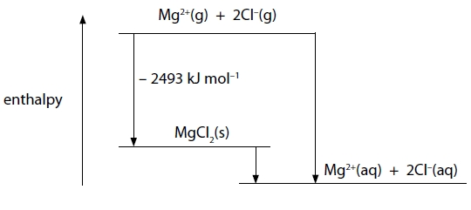

The enthalpy changes of hydration of the ions are:

Mg2+   −1920 kJ mol−1

Cl−1    −364 kJ mol−1

Calculate the enthalpy change of solution, *H*solution, of MgCl2(s) in kJ mol−1.

**(2)**

(c)   The table shows some data relating to the dissolving of magnesium sulfate, MgSO4, in water at 298 K.

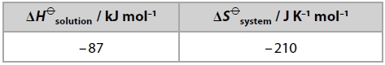

(i)   Explain why the dissolving of magnesium sulfate in water is exothermic by considering the enthalpy changes involved.

**(2)**

.............................................................................................................................................

.............................................................................................................................................

.............................................................................................................................................

.............................................................................................................................................

(ii)   Use the data in the table to calculate *G* when magnesium sulfate dissolves in water at 298 K. State the significance of your answer.

**(2)**

.............................................................................................................................................

.............................................................................................................................................

\*(d)   The table shows some data relating to the dissolving of barium sulfate and calcium sulfate in water at 298 K.

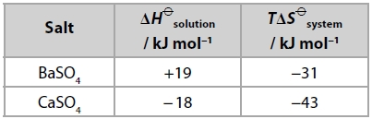

Comment on the relative solubility in water of barium sulfate and calcium sulfate at 298 K, using data from the table.

**(6)**

.............................................................................................................................................

.............................................................................................................................................

.............................................................................................................................................

.............................................................................................................................................

.............................................................................................................................................

.............................................................................................................................................

.............................................................................................................................................

.............................................................................................................................................

.............................................................................................................................................

.............................................................................................................................................

.............................................................................................................................................

.............................................................................................................................................

**Q2.**This question is about calcium chloride, CaCl2.

It can be formed by burning calcium in chlorine.



You must include a sign and units in your answers to the calculations in this question.

(a)  (i)  Calculate the standard entropy change, , for this reaction.

|  |  |  |  |
| --- | --- | --- | --- |
|  | Ca | Cl2 | CaCl2 |
| S (J/mol K) | 41.4 | 165 | 104.6 |

**(2)**

\*(ii)  Explain fully why the sign for the standard entropy change of the system,  is as you would expect.

**(2)**

.............................................................................................................................................

.............................................................................................................................................

.............................................................................................................................................

.............................................................................................................................................

(b)  Calculate the total entropy change, , in J mol−1 K−1, for this reaction, giving your answer to three significant figures.

**(2)**

(c)  Use the standard entropy change of the surroundings, , to calculate the standard enthalpy change, , in kJ mol−1, for the reaction at 298 K.

**(2)**

(d)  0.0500 mol of calcium chloride, prepared by burning calcium in chlorine, is added to 51.8 cm3 of water.

50.0 cm3 of a 1.00 mol dm−3 solution is formed, and the temperature rise, ΔT, is 15.0°C.

(i)  Calculate the energy transferred, in joules, for this process using:

Energy transferred in joules = volume of **solution formed** × 4.2 × ΔT

**(1)**

(ii)  Calculate the enthalpy change of solution, , of calcium chloride in kJ mol−1.

**(2)**

\*(iii)  The enthalpy change of hydration of Ca2+(g) is −1560 kJ mol−1.

Use this, your value from (d)(ii) and the experimental lattice energy of -2258 kJ/mol, to calculate the standard enthalpy change of hydration of Cl−(g).

**(3)**

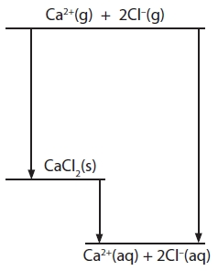

Answer ........................................................... kJ mol−1

(iv)  Draw diagrams to represent hydrated calcium ions and hydrated chloride ions.

**(2)**

(v)  Suggest why the addition of anhydrous calcium chloride to water results in an increase in temperature and a decrease in volume.

**(2)**

Temperature increases

.............................................................................................................................................

.............................................................................................................................................

.............................................................................................................................................

Volume decreases

.............................................................................................................................................

.............................................................................................................................................

.............................................................................................................................................

**(Total for question = 18 marks)**

S08C.4.4C

**NAME ...........................……... HOMEWORK DEADLINE .....................**

**Student Number ………… Chemistry Class ………**

Student targets from **previous pack**

Solubility

|  |  |
| --- | --- |
| **Task** | Mark |
| Notes completed | /10 |
| Revision Notes | /10 |
| Exam questions | /30    % |
| Overall Grade for this work | A B C D E U |

Student comments

Tutor comments

Tutor signature Date

Student targets for **next pack**

Student targets for **next pack**