**NAME** ............................................ Chemistry Class ....................

Student Number ……….

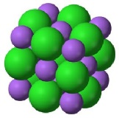

Solubility

***H*solution**

***H*hydration**

***H*lattice**

IONIC LATTICE

GASEOUS IONS

AQUEOUS IONS

answers

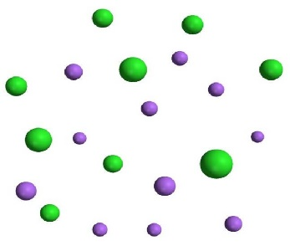

Hess cycle for determining solubility

Topic 13A

9. be able to define the terms ‘enthalpy change of solution, Δ *Hsol* and ‘enthalpy change of hydration, Δ*Hhyd*

10. be able to use energy cycles and energy level diagrams to carry out calculations involving enthalpy change of solution, enthalpy change of hydration and lattice energy

11. understand the effect of ionic charge and ionic radius on the values of:

i lattice energy

ii enthalpy change of hydration

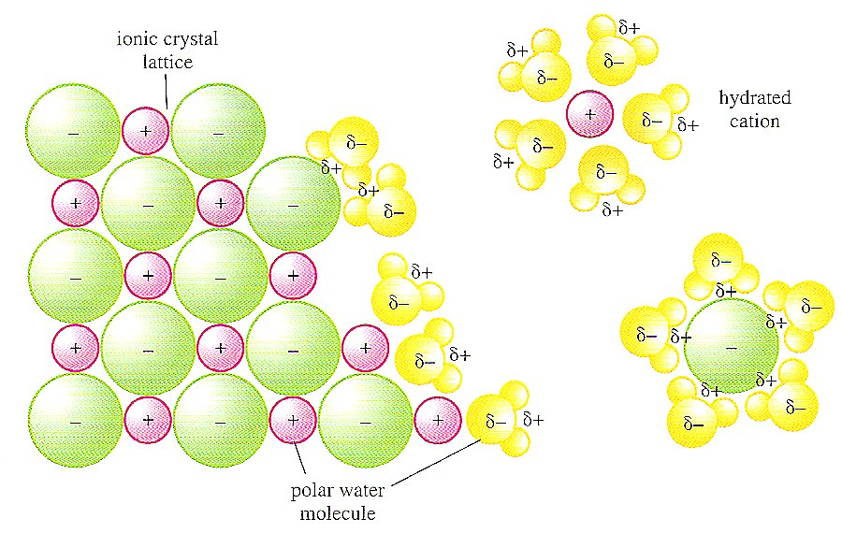

Sodium and chloride ions leaving a crystal lattice and becoming hydrated as they dissolve in water. Here the bond between the ions and the polar water molecules is electrostatic attraction.

**SOLUBILITY**

This topic builds on concepts used in AS Energetics (Unit 2) and A2 Entropy (unit 4) to understand why some ionic compounds dissolve and others do not.

MCj04247820000[1]See the energetics revision power point:- <http://www.knockhardy.org.uk/ppoints_htm_files/DELTAHPP.PPT>

**Resources**

Edexcel A-level Chemistry student Book 2 pages 61 - 64

**Dept website**

Factsheets

|  |  |
| --- | --- |
| 94 | Enthalpies of Solution |
| 29 | Answering Questions on Born-Haber Cycles |
| 102 | Improve your marks: A2 energetics – Born Haber cycles |
| 125 | Why students loose marks: Born-Haber calculations |

**Solubility Rules.**

a) Solubles

1) All **Nitrates** are **soluble.**

2) All **Chlorides** are **soluble** *except* **silver\*** (soluble in ammonia) and lead (fairly soluble in hot water).

3) All **Sulfates** are **soluble** *except* **barium\*** and **lead** (calcium sulfate is sparingly soluble).

4) All **ammonium** and **Group 1** metal salts **(Na & K)** are **soluble.**

b) Insoluble’s:

1) All **Carbonates** are **insoluble** *except* **ammonium and Group 1 (Na & K).**

2) All **Metal Hydroxides** are **insoluble** *except* **ammonium and Group 1 (Na & K).**

Group 2 are moderately soluble (increasing down the group).

3) All **Oxides** are **insoluble** but **Groups 1 & 2** dissolve by forming the hydroxide.

4) All **Sulfides** are **insoluble** *except* **Groups 1 & 2.**

**Solubility of salts**

New ReferenceReference Facer A2 Chemistry p37 - 48

For a solid to be soluble two processes must occur:-

* the ionic lattice must be broken up
* the ions are hydrated with the water/solvent molecules, (i.e. bonded to them).

We have studied ionic lattices in Unit 1. You need to remember what is meant by lattice enthalpy:-

**Lattice enthalpy Hlattice**

Lattice enthalpy is the enthalpy change when 1 mole of the solid ionic lattice is formed from its constituent gaseous ions, under standard conditions of 298K 1atm.

Looking at the definition would you expect the Lattice enthalpy to be:- *(circle correct answer)*

1. always –ve ✓
2. always +ve
3. it depends on the ionic lattice formed

It is important that you understand that the lattice enthalpy is always exothermic, bonds are being formed.

In terms of entropy, would you expect the system to:- *(circle correct answer)*

New exercise

a) gain in entropy (i.e. becoming more disordered)

b) lose entropy (i.e. becoming more ordered) ✓

c) depends on the ionic lattice formed.

Write out the equation for the lattice enthalpy of these ionic solids:-

MgO

Mg2+(g) + O2-(g) 🡪 MgO(s)

CaCl2

Ca2+(g) + 2Cl-(g) 🡪 CaCl2(s)

LiF

Li+(g) + F-(g) 🡪 LiF(s)

NaCl

Na+(g) + Cl-(g) 🡪 NaCl(s)

However when we are dissolving a substance we are doing the **opposite** process, we are breaking up the lattice, so the process is reversed.

The breaking up of the lattice is always endothermic i.e. it takes in energy, and there is an **increase** in the entropy of the system.

However breaking the lattice is only half of the process, we also hydrate the ions (i.e. they form bonds with the water); we call this the hydration enthalpy.

Edexcel A-level Chemistry student Book 2 pages 61

**Hydration enthalpy** **Hhyd** M+(g) + (aq) 🡪 M+(aq)

The enthalpy change when one mole of an ion in its gaseous state is completely hydrated by water.

This again is an exothermic process as bonds are being formed. We can combine these two processes, the breaking of the ionic lattice and the formation of bonds with the water, to define the enthalpy of solution:-

**Enthalpy of solution Hsoln** M+X-(s) + (aq) 🡪 M+(aq) + X+(aq)

The enthalpy change when 1 mol of an ionic solid dissolves in water to form an infinitely dilute solution.

For a substance to dissolve two processes must occur:-

* Energy is used to break up the lattice – an endothermic process

this will have a +ve value and so will be equal to -Hlatt

* Energy is released on hydration of the resulting ions both cations and anions

Hhyd = -ve value

The resulting difference in enthalpy is referred to as the enthalpy of solution and **largely** determines whether a salt is soluble

See front cover Hess cycle

**Hsolution = Hhyd - Hlatt**

Consideration of factors which affect these energy changes enable us to understand how the solubilities of salts vary.

**Factors affecting lattice enthalpy and enthalpy of hydration**

Lattice enthalpy

The lattice enthalpy will be more exothermic if:-

* 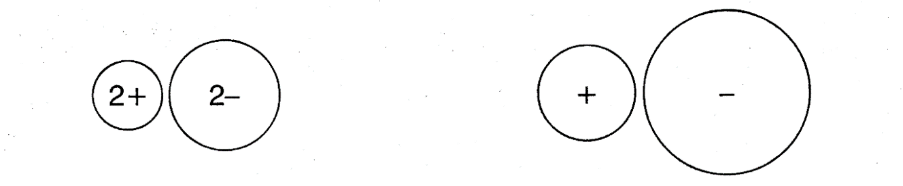The ionic charge increases



* The ionic radius decreases



Compare the attraction between the two pairs of ions and explain any differences in lattice enthalpy to be expected

Small highly charged ions get close together and attract strongly whereas large, singly charged ions attract less strongly:

For the small highly charged ions *latt* is more negative thus more energy is given out when the lattice forms.

F = k_\mathrm{e} \frac{q_1q_2}{r^2}This is **quantified** by Coulomb’s Law which describes the magnitude of the electrostatic force between two electric charges. The magnitude of the electrostatic force (*F*) on a charge (*q*1) due to the presence of a second charge (*q*2), is given by

ke = 4o permativity of free space

where *r* is the distance between the two charges and *k*e a proportionality constant.

Note that this calculation assumes the ions are point charges and leads to the **theoretical values** in data tables.

**New exerciseQuestions**

**1.** Explain the difference in lattice energies between the following pairs of ions

LiF (-1033 kJ mol –1) and NaF (-915 kJ mol –1)

Li+ is a smaller cation, closer approach; stronger attraction, more exothermic H latt;

Rb2O (-2161 kJ mol –1) and K2O (-2232 kJ mol –1)

K+ is a smaller cation, closer approach; stronger attraction, more exothermic H latt;

MgO (-3793 kJ mol –1) and Na2O (-2478 kJ mol –1)

Mg2+ has a higher charge; smaller ionic radius; stronger attraction, more exothermic lattice energy

Al2O3 (-15916 kJ mol –1) and MgO (-3793 kJ mol –1)

Al3+has a higher charge and smaller cation; stronger attraction, more exothermic lattice energy

**(8)**

**2.** Which of the following pairs of compounds will have the more exothermic lattice energy?

Give a reason in each case.

RbF and SrF2

SrF2; cation is smaller with 2+ charge, closer approach, attracts more strongly

Cs2O and BaO

BaO; cation is smaller with 2+ charge, closer approach, attracts more strongly

CuO and Cu2O

CuO; cation is smaller with 2+ charge, closer approach, attracts more strongly

.

**(6)**

**3.**a) For the chlorides of group I, how does the magnitude of lattice enthalpy change on descending the group? Explain your answer.

Change Lattice enthalpy becomes less exothermic on descending the group

Explanation Cation radius increases due to increased number of shells

Larger ions are further apart and attract less strongly

.

b) From Lattice enthalpy considerations only, would you expect the following physical properties of the group I chlorides to increase, decrease or remain approximately constant on descending the group?

Melting point Decrease on descending the group

Solubility in water Increases on descending the group (but no information on Hhyd)

**(5)**

**Hydration Enthalpy**

Draw a diagram to show a polar water molecule:-

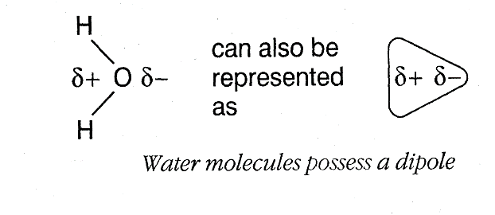

Water molecules are attracted to ions in the solid lattice and they become hydrated:-

#### *Complete the labels*

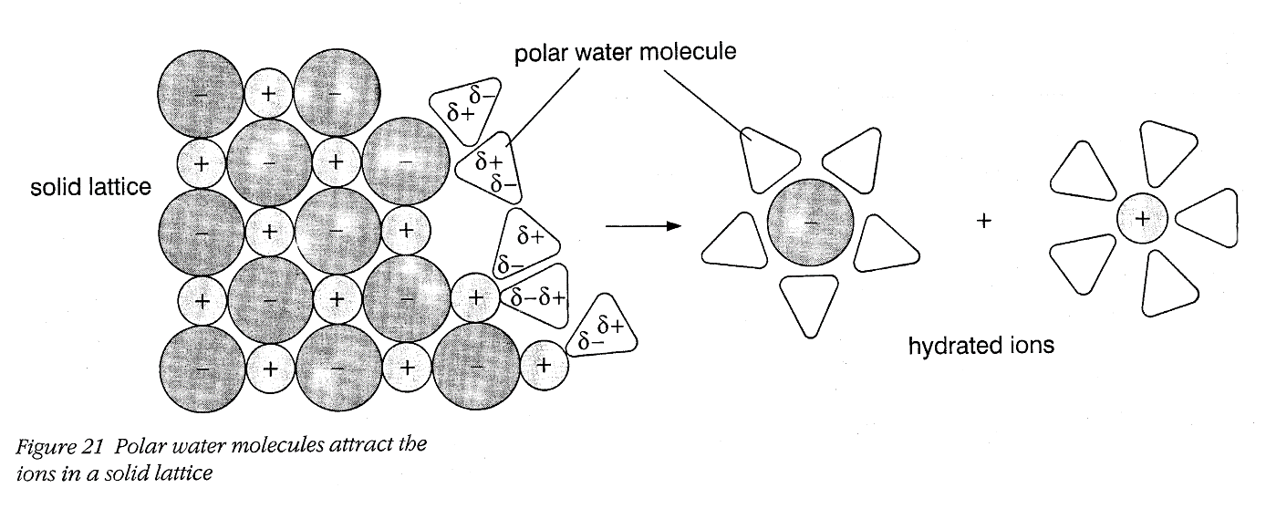

Enthalpies of hydration are always negative as it is an exothermic process

The size of the hydration enthalpy depends on

* The size of the ion
* The charge on the ion

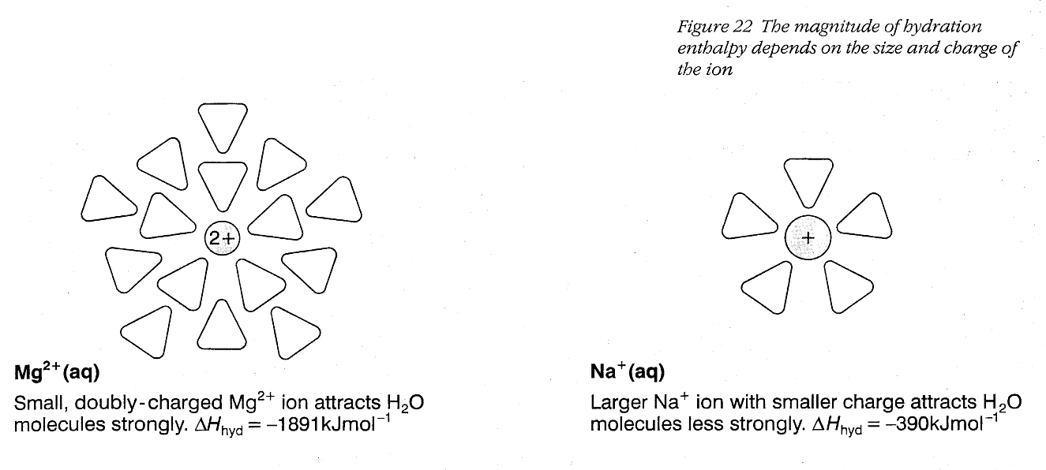

**Question**

**New exercise**

**1 a**) How and why would you expect the magnitude of the hydration enthalpy to change on progressing:-

(i) from Li +  Na +  K + ?

*Change Change* Decreases / becomes less exothermic …………………………..………**[1]**

*Reason* Increasing ionic radius means water molecules are attracted less strongly.**[1]**

(ii) from Na + Ca 2+ Al 3+ ?

*Change*  Increases / becomes more exothermic …………..…………..……**[1]**

*Reasons* ..… increasing charge of cation

Decreasing size / ionic radius result in stronger attraction ……….**[2]**

(iii) from F - Cl - Br - ?

*Change* Decreases / becomes less exothermic ……………..………………….......**[1]**

*Reason*  Increasing size of anion results in reduced attraction to water molecules **[1]**

**b**) How do you account for the fact that the hydration enthalpy of H+ is exceptionally large

(-1200 kJ mol-1)?

H+ is very small

and has the highest charge density

It strongly attracts water molecules

and a dative covalent bond is formed H+ + H2O 🡪 H3O+ hydroxonium ion…**[4]**

## Enthalpy of solution

This represents the difference between the energy required to break up the lattice and the energy released on hydration of the resulting ions.

**Hsolution = (****Hhydration (anions + cations)) - (****Hlattice)**

(exothermic) (exothermic)

Enthalpies of solution can be calculated using a Hess cycle:-

Ionic lattice + solvent

M+X-(s) + H2O(l)

Solution

M+(aq) + X-(aq)

Gaseous ions + solvent

M+(g) + X-(g) + H2O(l)

*H*lattice

*H*hydration

*H*solution

MCj04247820000[1]Using Hess cycle, calculate the enthalpy change when one mole of NaCl dissolves to form a solution of 1 mol dm-3.

You will need to download a copy of the ‘**Data sheet for solubility pack**’ available from Godalmingonline / A2 Chemistry / Solubility / Resources

or use an old red / dark blue data book in the lab.

New exercise

*H*lattice + *H*solution = *H*hydration

*H*lattice (NaOH) = -821 kJ mol-1

*H*hydration = *H*hydration (Na+) + *H*hydration (OH-)

=(-406) + (-460)

= -866 kJ mol-1

Hsolution = (- 866) - (- 821)

= - 45 kJ mol-1

This could lead us to the hypothesis that an exothermic enthalpy of solution means that the solid is soluble.

**New exerciseEnthalpy of solution Problems**

1. Calculate the enthalpy change of solution of lithium fluoride from the following data:-

Li+ (g) + F-(g) 🡪LiF (s) H= -1022 kJ mol-1

Hydration enthalpies, kJ mol-1 Li+ (g) = -519 F-(g) = -506

Hsoln = Hhyd - Hlatt

Hsoln = (Hhyd Li+ + Hhyd F-) - Hlatt

= (-519 + (-506)) – (-1022)

= 1025 + 1022

= - 3.0 kJ mol-1

2) Calculate the enthalpy of hydration of bromide ions given that the hydration enthalpy of barium ions is -1360 kJ mol-1, the lattice enthalpy for BaBr2 is -1937 kJ mol-1 and the Enthalpy of solution of BaBr2 = -38 kJ/mole

Hsoln = Hhyd - Hlatt

Hsoln = (Hhyd Ba2+ + 2 x Hhyd Br-) - Hlatt

(Hhyd Ba2+ + 2 x Hhyd Br-) = Hsoln + Hlatt

2 x Hhyd Br- = Hsoln + Hlatt - Hhyd Ba2+

Hhyd Br- = Hsoln + Hlatt - Hhyd Ba2+

2

= (-38)+ (-1937) - ( -1360)

2

= -615/2 = -307.5 kJ mol-1

3) Use the data below to calculate the enthalpy of solution of

a) magnesium sulphate b) barium sulphate

Lattice enthalpy of formation (kJ mol-1): MgSO4 = -2833; BaSO4 = -2474

Hydration enthalpy (kJ mol-1): Mg2+ = -1891; Ba2+ = -1360; SO42- = -1004

a) Hsoln = Hhyd ) - Hlatt

Hsoln = (Hhyd Mg2+ + Hhyd SO42-) - Hlatt

= ( -1891 + -1004) – (-2833)

= - 2895 + 2833

= - 62 kJ mol-1

b) Hsoln = Hhyd ) - Hlatt

Hsoln = (Hhyd Ba2+ + Hhyd SO42-) - Hlatt

= ( -1360 + -1004) – (-2474)

= - 2364 + 2474

= + 110 kJ mol-1

**Comparison of calculated and experimental Hsoln.**

**New exercise**

Using the values given calculate the enthalpy of solution for each of the following, indicate if the solid is soluble or insoluble in water. Data given in kJ mol-1

1) NaCl Hydration enthalpy Na+ = - 405 Cl- = - 381 Lattice enthalpy NaCl = - 789.9

Hsolution = 789.9 - 405 - 381

Hsolution = +3.9 kjmol-1

2)CaCO3 Hydration enthalpy Ca2+ = -1650 CO32- = -1176 Lattice enthalpy CaCO3 = -2814

Hsolution = 2814 – 1650 - 1176

Hsolution = -12 kjmol-1

3)NH4Cl Hydration enthalpy NH4+ = -307 Cl- = -381 Lattice enthalpy NH4Cl = -705

Hsolution = 705-307-381

Hsolution = +17 kjmol-1

4) NaNO3 Hydration enthalpy Na+ = - 405 NO3- =-329 Lattice enthalpy NaNO­3 = -755

Hsolution = 755 – 405 – 329

Hsolution = +21 kjmol-1

5) MgCl2 Hydration enthalpy Mg2+ = -1920 Cl- = -381 Lattice enthalpy MgCl2 = -2526

Hsolution = 2526 – 1920 -2(381)

Hsolution = -156 kjmol-1

6) Ba(OH)2 Hydration enthalpy Ba2+ = -1360 OH- = -460 Lattice enthalpy Ba(OH)2 = -2142

Hsolution = 2142 – 1360 – 2(460)

Hsolution = -138 kjmol-1

Now add a spatula tip of each of these to half a test tube of water and measure any temperature change

Remember we hypothesized that a –ve enthalpy of solution would mean that the solid dissolved.

Do your calculations above support this hypothesis? ……….

The more –ve the enthalpy of solution the more likely the salt will be soluble. However simply having a –ve or +ve value is not enough **on its own** to determine solubility. For a reaction to be feasible the *Δ*Stotal value must be +ve. So far we have only considered *Δ*H.

.**Entropy and solubility**

Sodium chloride and Ammonium chloride dissolve despite the fact that their enthalpies of solution are positive, and yet calcium carbonate and most of the other Group 2 carbonates are very sparingly soluble, but have exothermic enthalpies of solution. You might have expected exactly the opposite to happen.

Clearly, trying to correlate solubility simply with the enthalpy change of solution doesn't work.

We have to introduce a concept we looked at in the previous pack, Entropy and it’s allied concept Gibbs energy.

Look back at the equation for *Δ*Gsol , it is helpful to break down gibbs into the enthalpy and entropy terms

ΔGsol = ΔHsol - TΔSsol

As long as the Gibbs energy is -ve the reaction is feasible. We can use this to explain why NaCl dissolves in water even though the Δ*Hsol* value is +ve

Originally, the sodium and chloride ions were arranged in the crystal lattice - their entropy was low.

When you dissolve the crystal in water, the entropy increases as the ions and water molecules become randomly mixed - they become much more disordered than they were originally. Therefore the Δ*Ssol* term becomes negative enough to outweigh the small positive Δ*H*.

We now have to explain why MgCO3 is not soluble in water despite its –ve enthalpy of solution. For MgCO3 to be insoluble the Δ*Ssol* term must be positive, i.e. the system is becoming more ordered, entropy decreasing.

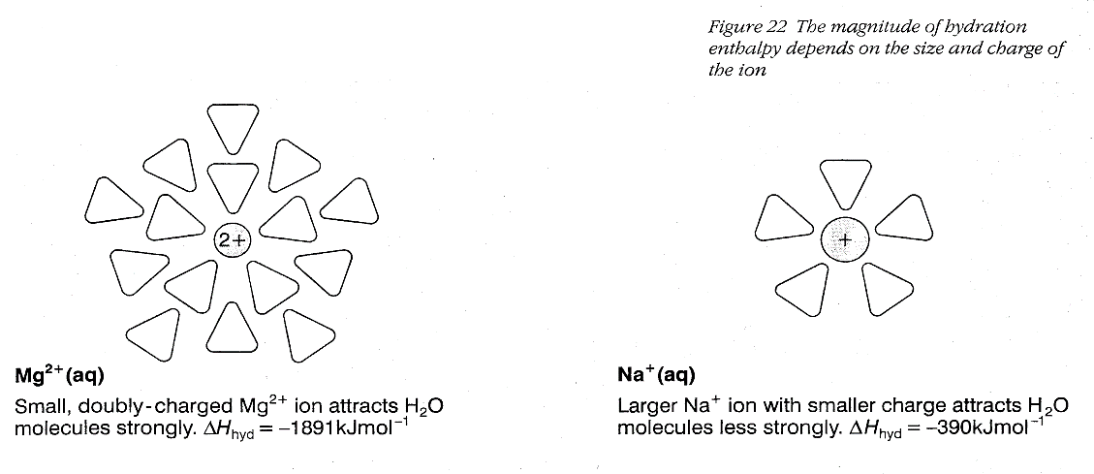In other words the solution must be more ordered than the lattice and the water. To understand this we need to look back at the diagram of the hydrated Mg2+ ion:-

The water molecules are not free to move but are ordered around the small positive ion (called hydration shells), therefore they are becoming more ordered and the entropy of the system is decreasing.

That means that you have two entropy effects to consider. There is the increase in *disorder* as the crystal lattice breaks up, but a corresponding increase in *order* in the water - which varies depending on the sizes and charges of the ions present. The table below gives the number of water molecules associated with various ions.

|  |  |  |  |  |  |  |  |
| --- | --- | --- | --- | --- | --- | --- | --- |
| ion | Cs+ | K+ | Na+ | Li+ | Ca2+ | Mg2+ | Zn2+ |
| Hydration number | 6 | 7 | 13 | 22 | 29 | 36 | 44 |

**To find the enthalpy of solution of ammonium chloride**

**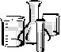**

You are provided with:

* A stoppered sample tube containing ammonium chloride, labelled **D**.

You are required to measure the molar enthalpy change when ammonium chloride

dissolves in water.

(a) **Procedure**

1. Use a measuring cylinder to measure 50 cm3 of distilled water into a dry polystyrene cup held firmly in a 250 cm3 beaker. Place the thermometer in the water.

2. Weigh the stoppered tube containing **D**. Record the mass of the stoppered tube

plus **D** in **Table 2**.

3. Measure the steady temperature of the water in the polystyrene cup to the nearest

0.5 °C. Record the temperature in **Table 3**.

4. Empty the solid **D** from the tube into the water and stir with the thermometer

until all the solid has dissolved. Measure the lowest steady temperature of the

solution to the nearest 0.5 °C. Record this temperature in **Table 3**.

5. Weigh the stoppered tube after the transfer of solid **D**. Record its mass in

**Table 2.**

**Table 2**

|  |  |
| --- | --- |
| Mass of stoppered tube + **D**/g |  |
| Mass of stoppered tube after transfer of **D**/g |  |
| Mass of **D** used/g | 3.95 |

**Table 3**

|  |  |
| --- | --- |
| Temperature of water before adding solid **D,** T1 / oC | 21.5 |
| Steady lowest temperature of solution, T2 / oC | 16.0 |

(a) Calculate the temperature change, T, by subtracting T1 from T2.

T = T2 – T1 = 16.0......-....... 21.5....... = ......-5.5.°C

(b) (i) Calculate the amount (moles) of ammonium chloride in your weighed sample of **D**.

[Molar mass /g mol-1: ammonium chloride = 53.5]

3.95 = 0.07383

53.5

**(1)**

(ii) Calculate the heat change when your sample of **D** dissolves.

Assume that the total mass of the solution is 50 g and that the specific heat capacity of the solution is 4.18 J g-1 oC-1.

H = 50 x 4.18 x 5.5

= 1149.5 J

= 1.1495 kJ

**(1)**

(iii) Using your answers to (i) and (ii), calculate the molar enthalpy change when **D** dissolves in water. Include a sign and units with your answer.

H = 1.1495

0.07383

Temperature fell so endothermic and H must be +ve

= +15.56

= +15.6 kJ mol-1 (3s.f.)

Data Book value = + 15.2 kJ mol-1

(iv) Explain why it is inappropriate to give the value of the molar enthalpy change found in this experiment to more than two significant figures. .

Thermometer only reads to 0.5oC so temp rise = 5.5 ±1oC 18% error,

(volumes only to nearest cm3.so volume = 50±1 cm 2% error

Mass to 2dp 3.95 ± 0.02 0.5% error)

Experimental result is subject to error 15.6 ± 1.6 kJ mol-1

We have not produced an infinitely dilute solution

**(Total 14 marks)**

(v) Write an equation for the process of dissolving and state whether you would expect the Ssystem to be positive or negative? Give reasons.

NH4Cl(s) + (aq) → NH4+(aq) + Cl-(aq)

will be positive as the ions are spread out and the water only slightly more organised.

(vi) Given that the salt is soluble at 298K what can you say about the relative values of Sand H?

If Δ*H* is positive and the salt soluble, then the positive Δ*H*  must be outweighed by the negative -TΔ*S* in order for Δ*G* to be negative.

**To measure the lattice enthalpy of calcium chloride**

****

The enthalpy of solution, *H*sol, of calcium chloride is defined according to the equation:

CaCl2(s) + aq → Ca2+(aq) + 2Cl-(aq)

This can be measured by a calorimetry method. A known mass of calcium chloride is added to excess water, and the initial and final temperatures measured. The enthalpy of solution can then be calculated and, by applying Hess’s law and using the relevant enthalpies of hydration, the lattice energy of calcium chloride can be determined.

**Method**

**1** Pour 100 cm3 of distilled water into the polystyrene cup held firmly in a 250cm3 beaker. . Record its temperature.



**2** Weigh accurately 12 g of calcium chloride and add, in one go, into the water stirring continuously.

**3** Record the highest maximum temperature reached.

**4** Repeat twice more.

**Results**

|  |  |  |  |
| --- | --- | --- | --- |
| Experiment | Initial temperature /°C | Final temperature /°C | Temperature change,  T /oC |
| 1. |  |  |  |
| 2. |  |  |  |
| 3. |  |  |  |

**Calculation**

**1** Calculate the temperature change, *T*, in each experiment from your initial and final temperatures. Work out the average temperature change.

13.8 oC

**2** Use the equation:

energy change = mass of water x specific heat capacity x T

to calculate the energy change. The specific heat capacity of water is 4.2 J g-1 K-1.



H = 100 x 4.2 x 13.8

= 5797 J



Convert this to kJ. 5.79 kJ

**3** Work out the number of moles of calcium chloride used.

Moles CaCl2 = 12.00 = 0.10801

111.1



**4** Use your answers from steps **2** and **3** to calculate a value for *H*sol in kJ mol-1. Remember to insert the correct sign to signify an exothermic or endothermic reaction.

H = 5.79 = 53.60576 = - 53.6 kJ mol-1 exothermic ∴ negative

0.10801 (3sf)

**5** Draw a Hess’s law cycle linking the enthalpy of solution, the hydration enthalpies and the

lattice enthalpy for calcium chloride.



Hsoln

CaCl2 (s)

Ca2+(aq) + 2Cl-(aq)

Ca2+(g) + 2Cl-(g)

Hhyd Ca2+ -1650 kJ mol -1

HlatticeCaCl2 2 x Hhyd Cl- -364 kJ mol -1

**6** Given that the hydration energies of the ions involved are: *H*hyd[Ca2+(g)] = −1650 kJ mol-1

*H*hyd[Cl-(g)] = −364 kJ mol-1



calculate a value for the lattice energy of calcium chloride.

Hlattice  Hsoln = HhydCa2+ + 2 x HhydCl-

Hlattice = HhydCa2+ + 2 x HhydCl- - Hsoln

= (-1650 + 2(-364)) –(– 53.6)

= -2324.4 kJ mol-1 Data book values – 2237 kJ mol-1

= - – 2258 kJ mol-1

**Questions**

**1.** State the two assumptions made during the experiment.

The density of water is 1 g cm-3;

the heat lost to the surrounding is minimal.

**2.** State the main source of error during the experiment.

Inaccurate weighing of the calcium chloride; (approx 0.083%

Inaccuracy in measuring water volume; (approx 1.0%)

Inaccuracy in reading the thermometer; (approx 2.08%)

CaCl2 was originally anydrous however it may have absorbed water during use by….

However the main source of error is the heat energy lost to the surroundings.

**3.** Explain why hydration enthalpies are negative values.

Polar water molecules form electrostatic interactions (i.e. bonds) to the positive and negative ions, releasing energy.

**4.** List the two main factors that affect hydration and lattice enthalpies.

The charges and ionic radii of the cation and anions.

**5.** State and explain the relationship between enthalpy of solution values and solubility of a salt.

The more negative the enthalpy of solution, the more soluble the salt.

**6.** Apart from lattice and hydration enthalpies, what other factor is important in determining the solubility of a salt in water?

Entropy.



**7.** The Ssys**tem** is negative. From the equation on the previous page and your knowledge of entropy suggest *two reasons* why this is so.

1. The number of particles decreases as the cations become hydrated. CaCl2(s) + 6H2O(l) → [Ca(H2O)6]2+(aq) + 2Cl-(aq)
2. The water molecules get more ordered as they become attracted to the ions.

**Entropy and solubility**

Group 1 and ammonium salts.

* Δ*S*system for dissolving such as

NaCl(s) + (aq) → Na+(aq) + Cl-(aq)

will be positive as the ions are spread out and the water only slightly more organised.

* If Δ*H* is positive and the salt soluble, then the Δ*H* term must be outweighed by the–ve entropy term (-TΔ*S*)

Group 2, group 3 and d block salts

* This is more complex as Δ*S*system is negative. The reasons are:

1. The number of particles decreases as the cations become hydrated. MgSO4(s) + 6H2O(l) → [Mg(H2O)6]2+(aq) + SO42-(aq)
2. The water molecules get more ordered as they become attached to the ions.

* If the solid is soluble, dissolving must be exothermic to such an extent that the Δ*H* term outweighs the positive entropy term (-TΔ*S*)
* If insoluble, the positive -TΔ*S* term outweighs the negative Δ*H* term

The key point to remember is that for ANY reaction to ‘go’ the Δ*G* must be negative (ie the total entropy of the universe must increase)

Relationship of Hsolution  and Ssystem to solubility

|  |  |  |
| --- | --- | --- |
|  | Hsolution | |
|  | +ve endothermic | -ve exothermic |
| Soluble | Ssystem > Hsolution  T | Ssystem > Hsolution  T |
| Insoluble | Ssystem < Hsolution  T | Ssystem < Hsolution  T |

**Revision page**

**New exercise**Use the syllabus statement on the front page to complete this.

**Definitions**

**Lattice enthalpy Hlattice**

Lattice enthalpy is the enthalpy change when 1 mole of the solid ionic lattice is formed from its constituent gaseous ions, under standard conditions of 298K 1atm.

**Enthalpy change of Hydration** **hydH** M+(g) + (aq) 🡪 M+(aq)

The enthalpy change when 1 mole of gaseous ions is completely hydrated by water.

**Enthalpy of solution Hsoln** M+X-(s) + (aq) 🡪 M+(aq) + X+(aq)

The enthalpy change when 1 mol of the ionic solid dissolves in water to form an infinitely dilute solution.

**Hess cycle**

Eg for calcium chloride.

Hsoln

CaCl2 (s)

Ca2+(aq) + 2Cl-(aq)

Ca2+(g) + 2Cl-(g)

**Hhyd** affected by charge and radius of ions

Hhyd Ca2+ -1650 kJ mol -1

HlatticeCaCl2 2 x Hhyd Cl- -364 kJ mol -1

**Hlattice  Hsoln = HhydCa2+ + 2 x HhydCl-**

Experiment: **H = mass water x specific heat capacity x T** 🡪 answer in Joules

Convert to kJ

Calculate moles of solute and hence kJ mol-1

**Errors** = ½ smallest division x number of readings x 100 = %

Smaller value of reading

**Mark Scheme**

Q1.

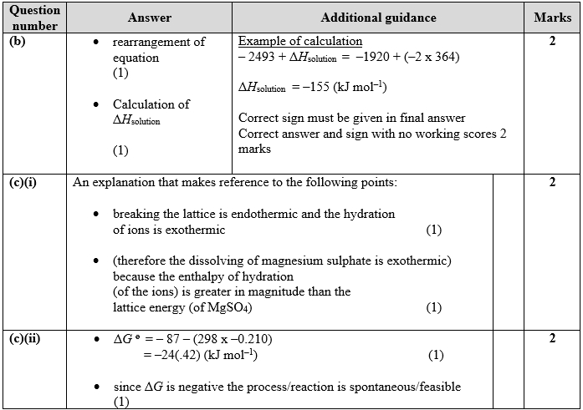

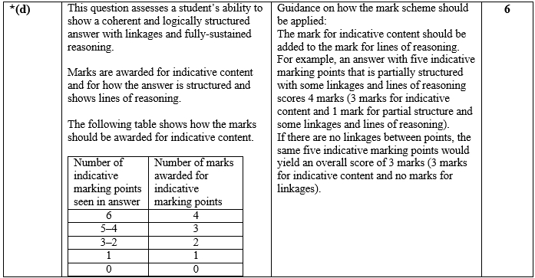

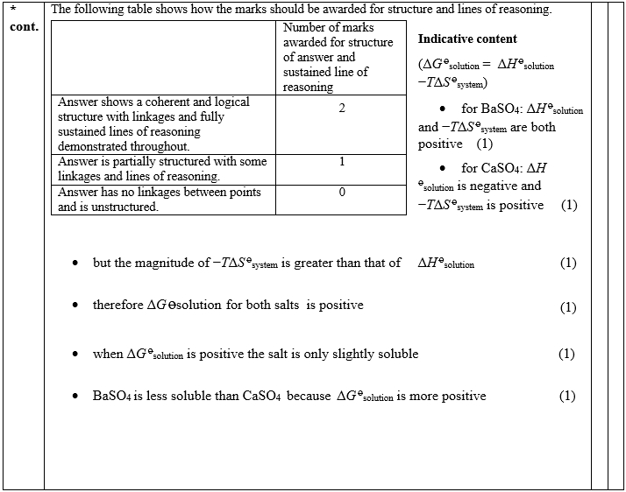

**Q2.**

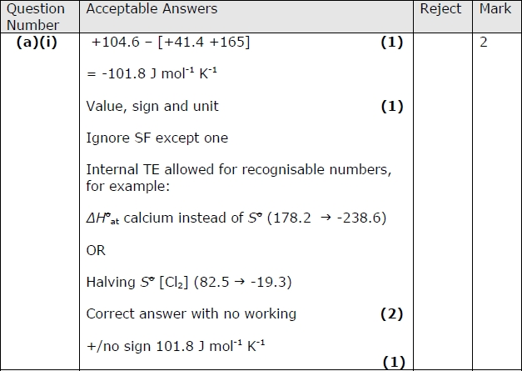

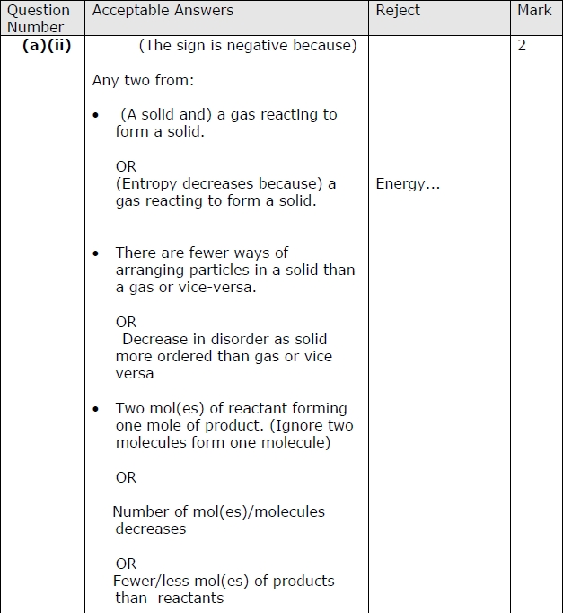

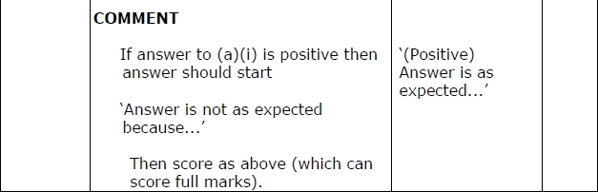

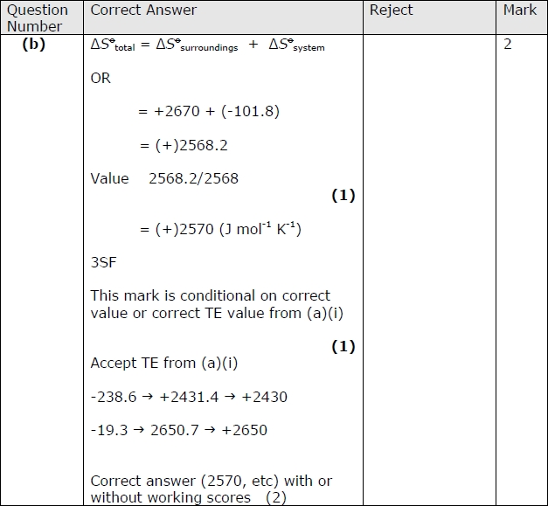

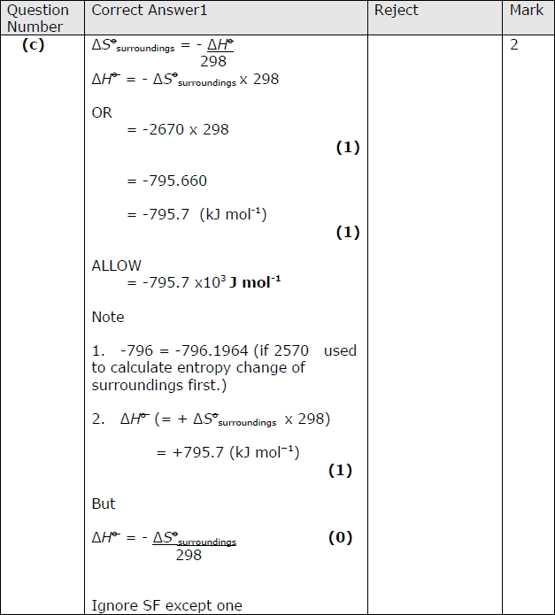

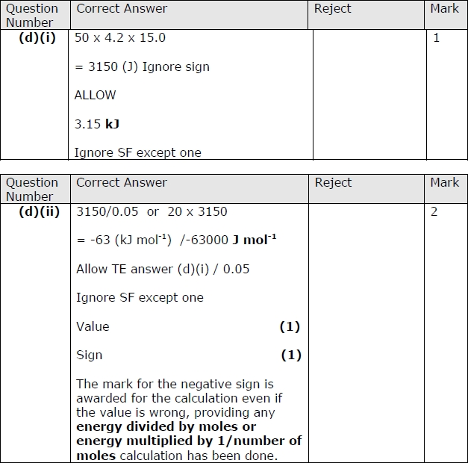

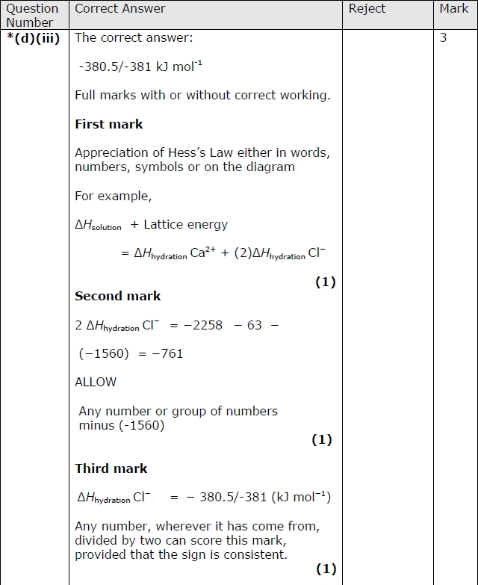

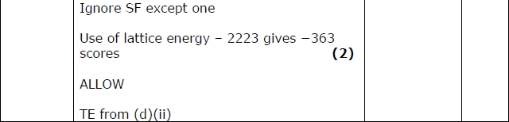

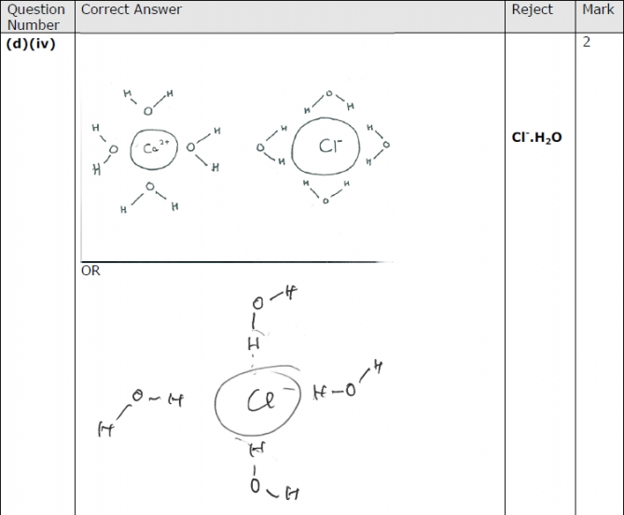

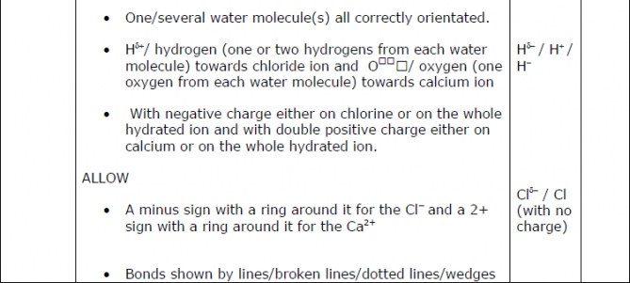

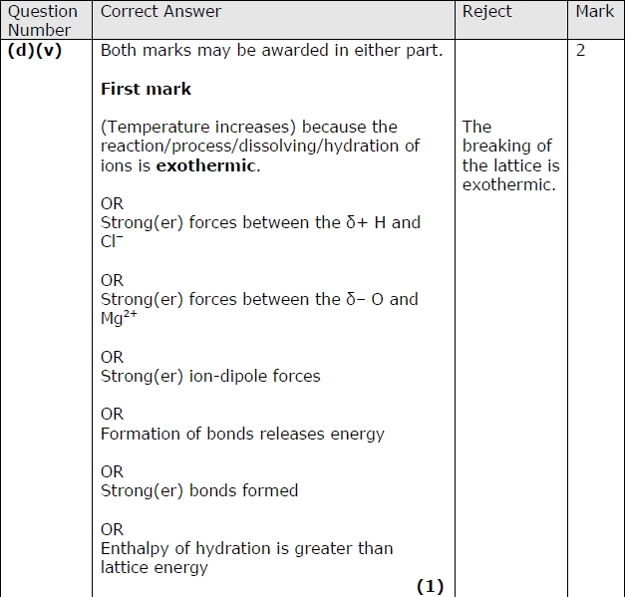

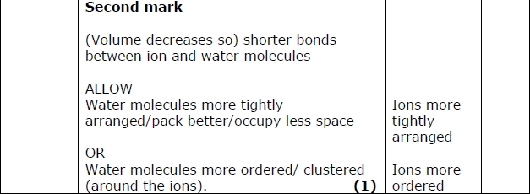

**Questions** Multiple choice and short answer

**NAME ...........................……... HOMEWORK DEADLINE .....................**

**Student Number ………… Chemistry Class ………**

Student targets from **previous pack**

Solubility

|  |  |
| --- | --- |
| **Task** | Mark |
| Notes completed | /10 |
| Revision Notes | /10 |
| Exam questions | /34  % |
| Overall Grade for this work | A B C D E U |

Student comments

Tutor comments

Tutor signature Date

Student targets for **next pack**

Student targets for **next pack**