NAME ............................................ Chemistry Class ..........................
Student Number ……….

Answers
Entropy

Topic 13B: Entropy

12. understand that, since some endothermic reactions can occur at room
temperature, enthalpy changes alone do not control whether reactions occur
13. know that entropy is a measure of the disorder of a system and that the natural
direction of change is increasing total entropy (positive entropy change)
14. understand why entropy changes occur during:
i changes of state
ii dissolving of a solid ionic lattice
iii reactions in which there is a change in the number of moles from reactants to
products
Students should be able to discuss typical reactions in terms of disorder and
enthalpy change, including:
dissolving ammonium nitrate crystals in water
reacting ethanoic acid with ammonium carbonate
burning magnesium ribbon in air
mixing solid barium hydroxide, Ba(OH)2.8H2O, with solid ammonium chloride.
15. understand that the total entropy change in any reaction is the entropy change in
the system added to the entropy change in the surroundings, shown by the
expression:
ΔStotal = ΔSsystem + ΔSsurroundings
16. be able to calculate the entropy change for the system, ΔSsystem , in a reaction,
given the entropies of the reactants and products
17. be able to calculate the entropy change in the surroundings, and hence ΔStotal ,
using the expression:
18. know that the balance between the entropy change and the enthalpy change
determines the feasibility of a reaction and is represented by the equation
ΔG = ΔH − TΔSsystem
19. be able to use the equation ΔG = ΔH − TΔSsystem to:
i predict whether a reaction is feasible
ii determine the temperature at which a reaction is feasible
21. understand why a reaction for which the ΔG value is negative may not occur in
practice
22. know that reactions that are thermodynamically feasible may be inhibited by kinetic factors.


For this pack you will need to have re-read your work on Energetics. The concept of Entropy explains why reactions occur and is a fundamental principle of thermodynamics.

Reference
Data booklet (issue 3)– published by Edexcel Nov 2008 – available by download from the website, also on Godalming online.
DATA
BOOK

Websites
http://hyperphysics.phy-astr.gsu.edu/hbase/hframe.html
A good basic introduction, on the web diagram, you will need thermodynamics, entropy, and the 2nd law.
http://entropysite.oxy.edu/students_approach.html
A swift and clear explanation of entropy and the second law of thermodynamics.
http://thequantumcasino.org/
*An informative site endorsed by RSC with tutorials and simulations to aid understanding of thermodynamics. Note Gibbs free energy is NOT on your syllabus
http://www.chem.ox.ac.uk/vrchemistry/entropy/page1.htm
A more advanced site from the oxford university chemistry dept.
http://www.youtube.com/watch?v=B4SFv_2Skdc
AP thermodynamics 1 A YouTube video explaining the basic concepts of entropy
http://www.youtube.com/watch?v=94p9ZfTjeKc&feature=related
AP thermodynamics 2 A YouTube video introducing the second law

Contents
First law of thermodynamics
Entropy
Standard molar entropy
Entropy of the system
Entropy of the surroundings
Total entropy change
Equilibria and changes of state
Why reactions do not occur.

The First Law of Thermodynamics
This is one of the most basic assumptions in all of science and underpins chemistry, physics and biology.
The First law of thermodynamics states that energy cannot be created or destroyed. It can be transferred from one place to another and in that transfer can be made to do work.

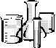
This means that in any reaction where there is a change of energy, that energy must have come from somewhere or be going somewhere.

Complete the experiments:-

1) HCl and Mg ribbon
- Measure out 10cm³ 2M HCl into a boiling tube and note the temperature. ………………ºC
- Add a small piece of Mg ribbon, measure the max. temperature ………………ºC
- Calculate the max. temperature rise. …+6.0…….ºC
- Draw and label an enthalpy level diagram for this reaction.
2HCl(aq) + Mg(s)
MgCl₂(aq) + H₂(g)
ΔH = -ve, exothermic
Enthalpy KJ mol⁻¹

progress of reaction →

2) HCl and Na₂CO₃
- Measure out 10cm³ 2M HCl into a boiling tube and note the temperature. ………………ºC
- Add 10cm³ Na₂CO₃(aq), measure the max temperature ………………ºC
- Calculate the max temperature change. …+2.0………ºC
- Draw and label an enthalpy level diagram for this reaction.
2HCl(aq) + Na₂CO₃(s)
2NaCl(aq) + H₂O(l) + CO₂(g)
ΔH = -ve, exothermic
Enthalpy KJ mol⁻¹
progress of reaction →
Note the chemicals (system) lose energy.
The aqueous solution (surroundings) have gained energy and warmed up.

In thermodynamics we refer to the ‘system’ and the ‘surroundings’. In chemistry the system means the chemicals undergoing the reaction and the surrounding are everything else.
In these exothermic reactions the system loses energy so the surroundings must have gained energy. We can say that the products are at a lower energy level than the reactants. The system has become more stable.
The previous reactions are said to be spontaneous, i.e. they ‘go’ at room temperature. It would be tempting to assume that exothermic reactions are the only type of reactions that will spontaneously go at room temperature. However there are several endothermic reactions which are also spontaneous:-

3) NH₄NO₃ and water
- Measure out 10cm³ water into a boiling tube and note the temperature. ………………ºC
- Add a spatula of NH₄NO₃ and note the min temperature. ….……………ºC
- Calculate the max temperature change. ……-2.5…….ºC
- Draw and label an enthalpy level diagram for this reaction.
Enthalpy KJ mol⁻¹
NH₄NO₃(aq)

ΔH = +ve, endothermic

NH₄NO₃(s) + (aq)

progress of reaction →

4) Ethanoic acid and ammonium carbonate.
- Measure out 10cm³ glacial ethanoic acid into a boiling tube and note the temperature. ………………ºC
- Add 1g of (NH₄)₂CO₃, note the min. temperature. ……………….ºC
- Calculate the max temperature change. ……-4.5…….ºC
- Draw and label an enthalpy level diagram for this reaction.
2CH₃COONH₄(aq) + H₂O(l) + CO₂(g)
2CH₃COOH(aq) + (NH₄)₂CO₃(s)
ΔH = +ve, endothermic
Enthalpy KJ mol⁻¹
progress of reaction →

Here we have two reactions in which the surroundings lose energy to the system. These endothermic reactions ‘go’ spontaneously at room temperature. We can therefore conclude that since endothermic reactions can occur spontaneously at room temperature enthalpy changes alone do not control whether reactions will occur spontaneously or not.
To understand this we need to consider the dispersal, ‘spreading out’ of energy and matter, called Entropy.
Entropy.

An introductory video clip at www.sixtysymbols.com/videos/entropy.htm

Entropy is a property of matter that is associated with the degree of disorder, or degree of randomness of the particles.

We can describe entropy being a measure of the amount of disorder in a system.
A deeper understanding may be gained by a consideration of statistical thermodynamics – this is the probability of a particle having a particular position and energy quanta.

Firstly we need to appreciate how a random distribution or spreading out to give the most ways of arrangement is the ‘expected’ outcome.
Illustration
A pack of cards fresh from the manufacturer is perfectly ordered so the entropy of this system is said to be zero. When the pack is shuffled, the entropy of the system increases as the pack becomes more disordered. There are 8.066 x 10⁶⁷ different ways of organizing a pack of cards. Therefore there is only 1 ordered sequence but 8.066 x 10⁶⁷ disordered sequences. So the probability of obtaining the ordered sequence of cards when the pack is shuffled is 1 part in 8.066 x 10⁶⁷. In theory, it is possible to shuffle a pack of cards until the cards fall into perfect order. The chances of this are 1 in 8.066 x 10⁶⁷!
Thus there is a much higher chance of disorder rather than order.
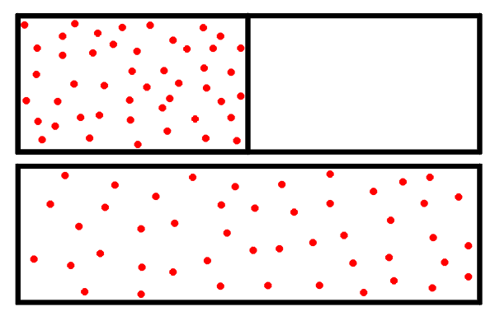
Applying this concept to a gas in a container:-

In the first situation all the gas molecules are in the left hand container. Removing the division allows the gas to occupy the whole container. Again, like the pack of cards it is theoretically possible for all the molecules to be on the left hand side. However 1 mole of gas containing 6.023 x 10²³ molecules rather than the 52 cards in the first example so the probability that all the gas molecules will be in the left hand container is effectively zero.

Activities ‘A simulation of molecular mixing’
‘The number of ways of dissolving’
‘Sharing energy quanta’
Events that happen are the ones that are most likely to. The more ways an event can occur the more likely is to happen, it has a greater probability of occurring.
This concept not only explains diffusion but also solids dissolving and liquids mixing.

http://www.bbc.co.uk/programmes/p00fflcs

Prof. Brian Cox Entropy and time
We have discussed the increase in entropy but what sort of system would have zero entropy?
A highly ordered system with no energy to be arranged or dispersed:-
The third Law of Thermodynamics:
The entropy of a perfect crystalline substance at 0 K is zero. (impossible to achieve!)

The standard molar entropy, Sο is the entropy per mole of a substance under standard conditions, usually 298K and 1 atm.
Units are Joules per mole per Kelvin (J mol⁻¹ K⁻¹). Note Joules not kilojoules


Entropy of solids liquids and gases
View the animation and then complete the table
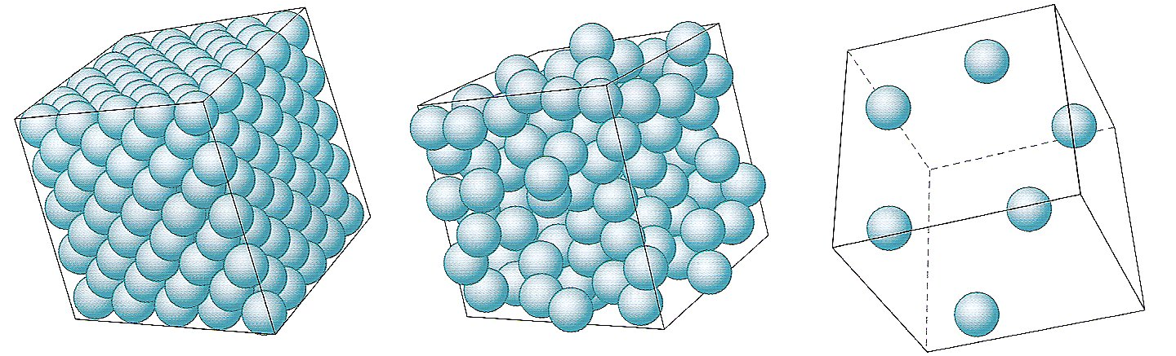

 | SOLID | LIQUID | GAS
Position of particles | Fixed position | close together | widely spaced
Arrangement of particles | Regular lattice | random | totally random  infinite possibilities
Types of energy levels | vibration  electronic | some translation  rotation  vibration  electronic | translation  rotation  vibration  electronic
Entropy | Low | medium | Very high

The entropy of a chemical rises as the temperature rises:-

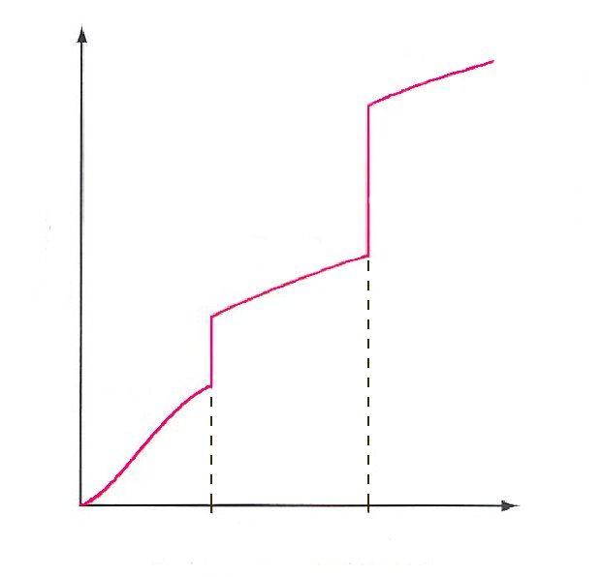
Why are there sudden jumps in entropy levels at the melting and boiling temperatures?
solid
liquid
gas
melting temperature
Entropy
boiling temperature

Energy is added to convert solid to liquid and liquid to gas with a consequent entropy increase – increase in possible microstates(E arrangements).

The jumps in entropy values at the phase transitions are due to increases in positional disorder and an increase in the ways the energy can be arranged.

Standard molar entropy Sο
During your studies of A2 chemistry you will use a Data booklet. You will need to be familiar with using it as it will be used in your Unit 4 and 5 exams and in the practical assessments
DATA
BOOK
Use the Data booklet pages 2-4 and 20 – 29 to find the standard molar entropy for:-
H₂O (s) S^{ο} = 47.99 J mol⁻¹ K⁻¹

H₂O (l) S^{θ} = 69.9….. J mol⁻¹ K⁻¹

H₂O (g) S^{θ} = 188.7. J mol⁻¹ K⁻¹

Why is there an increase in entropy?
There is an increase in the number of microstates (in terms of energy levels and positional states) for the molecules to be arranged in.
Entropy changes during physical or chemical processes.
These are expressed as ΔS, units again are J mol⁻¹ K⁻¹.
Predict whether the entropy, S, is increasing (ΔS > 0) or decreasing (ΔS < 0) for the following changes and give a reason for your answer.
Steam condenses to water ΔS decreases, change of state g → l, molecules less spread out and lower enthalpy so fewer positional and energy microstates possible
Solid CO₂ sublimes ΔS increases, change of state s → g, molecules much more spread out and much higher enthalpy so many more positional and energy microstates possible
N₂O₄ (g) → 2 NO₂ (g) ΔS increases, more moles, molecules more spread out and more positional and energy microstates possible
C₆H₆ (l) + 7.5 O₂ (g) → 6 CO₂ (g) + 3 H₂O (l) Increase in total number of moles but decrease of gas moles; this is the predominant effect so ΔS decreases
To summarise
- Entropy is a measure of disorder
- A collection of molecules has greater entropy if the molecules are spread out as much as possible.
- There are more ways of arranging the energy of a collection of molecules if they spread out among the energy levels available to them.
- The entropy is increased if the energy is shared among more molecules.
- The entropy depends on the number of quanta of energy available.
- In general, gases have higher entropies than liquids, and liquids have higher entropies than solids

Following on from this then it is reasonable to expect reactions where there is an increase in entropy to be spontaneous. The 2nd Law of thermodynamics states that the entropy of an isolated system increases in the course of a spontaneous change.
Heating an elastic band video www.sixtysymbols.com/videos/morework.htm
Standard molar entropy values can be used to calculate entropy changes in a reaction.
The entropy of the system ΔS_{system}
ΔS_{system} is a measurement of the entropy of the chemicals and is defined as:-
Δ Sο_{system} = Σ n Sο (products) – Σ n Sο (reactants)
Where Σ, represents the sum of the standard molar entropies,
and n is the stoichiometric number in the chemical equation.

DATA
BOOK
Using the data booklet work out the standard entropy change of the system, ΔSο_{system} for these reactions.
- P₄(s(white)) + 5O₂(g) → P₄O₁₀ (s)
Δ Sο_{system} = Σ n Sο (products) – Σ n Sο (reactants)
= 228.9 - (4 x 41.1) + 5(2 x 102.5)
= 228.9 – (164.4 +1025)
= -960.5 J mol⁻¹ K⁻¹
Is this answer consistent with your understanding of entropy changes? Explain
Entropy is decreasing, major effect is 5 mole gas → solid ∴ ΔS↓
Although 1 mole solid P₄ → 1 mole of more complex solid ∴ ΔS↑
Loss of gaseous molecules is the major effect in reducing the number of possible microstates and consequent reduction in entropy.
- H₂(g) + Cl₂(g) → 2HCl (g)
ΔSο_{system} = Σ n Sο (products) – Σ n Sο (reactants)

= 2(186.8) – (2(65.3) + 2(82.5))

= 373.6 – 295.6

= + 78 J mol⁻¹ K⁻¹
Is this answer consistent with your understanding of entropy changes? Explain
ΔS of HCl is higher than H₂ and Cl₂, it is a heavier and more complex molecule so has more possible microstates possible with a consequent increase in entropy.
Additional worksheet on ‘ΔS_{system} calculations’
Predict, without doing any calculations, whether the following reactions will have a positive or negative value for ΔSο_{system} and give an explanation in each case
You need to consider:- change of state, number of moles, complexity of structures.

- NH₄NO₃ (s) → N₂O (g) + 2H₂O (g)
ΔS _{sys} increasing, solid → gas, more microstates
Also 1 mole → 3 moles
ΔSο_{system} = Σ n Sο (products) – Σ n Sο (reactants)
= 597.1 – 151.1 = + 446 J mol⁻¹ K⁻¹
2) 2H₂O₂ (aq) → 2H₂O (l) + O₂ (g)
ΔS _{sys} increasing, aqueous → gas, more microstates
Also 2 moles → 3 moles
ΔSο_{system} = Σ n Sο (products) – Σ n Sο (reactants)
= 344.8 – 219.2 = + 125.6 J mol⁻¹ K⁻¹

3) 3O₂(g) → 2O₃ (g)
ΔS _{sys} decreasing, simpler O₂ → more complex O₃, more microstates
but 3 moles → 2 moles
ΔSο_{system} = Σ n Sο (products) – Σ n Sο (reactants)
= 477.6 – 615 = - 137.4 J mol⁻¹ K⁻¹
4) CO₂(g) + C(s) → 2CO (g)
ΔS _{sys} increasing, solid → gas, more microstates
For ΔS _{sys} changes, consider:-
Change of state
Number of moles
Complexity/ structure
Also 1 mole gas → 2 moles gas
ΔSο_{system} = Σ n Sο (products) – Σ n Sο (reactants)
= 395.2 – 219.3 = + 175.9 J mol⁻¹ K⁻¹
Now use the data book to check your predictions.
So, does a positive ΔSο_{system} indicate a reaction that will occur spontaneously? No – only considering the system.

So far, we have ignored the entropy of the surroundings.
If ΔSο_{total} = + ve then a reaction is possibly spontaneous.
Entropy of surroundings ΔS_{surroundings}
You already know that molecules do not all have the same energy; they are spread out among energy levels. You now know that they are distributed amongst energy levels in such a way that gives the greatest entropy.

When an exothermic reaction takes place the surroundings heat up. Are the surroundings gaining entropy (becoming more disordered) or losing entropy (becoming more ordered)? See front cover.
Surroundings gain heat energy so there are more energy quanta to be distributed, thus a gain of entropy
Consider a Maxwell Boltzmann distribution of energies at two temperatures:-
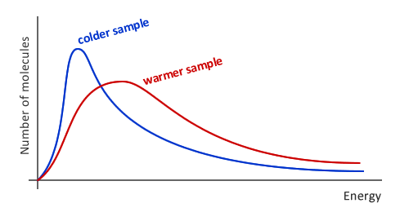

Consider the energy distribution of the molecules. Would the lower or higher temperature provide more energy levels? higher

At a higher temperature the particles have a much greater range of energies. Therefore there are more possible energy levels that the molecules could possess, hence they have a higher entropy. Thus entropy is also a measure of the number of ways that quanta of energy can be arranged.

Refer back to the ‘Sharing energy quanta’ activity.

So entropy is a measurement of two things, firstly the random dispersal of molecules and secondly the energy quanta shared amongst molecules. We have moved on from our basic understanding of entropy and we can now define it as:-
Entropy is a measure of disorder

Or in more detail:-
Entropy measures the spontaneous dispersal of energy: how much energy is spread out in a process, or how widely spread out it becomes — at a specific temperature.

Extension ‘Bridging macro and micro worlds - Boltzmann’
Calculation of ΔS_{surroundings}
If the enthalpy change of the system is ΔH, then the heat that flows into the surroundings is -ΔH; so for an exothermic reaction (ΔH is negative) the surroundings gain heat energy (minus the negative ΔH = + ΔH). We can assume that the disorder stirred up in the surroundings is proportional to the heat transferred to them, so
ΔS_{surroundings} - ΔH

The change in entropy of the surroundings caused by a given transfer of heat also depends on the temperature. When the surroundings are hot, they are already very chaotic and a small inflow of heat from the system has very little impact. On the other hand cool surroundings are relatively ordered and a small influx of heat will result in a much greater increase in disorder. The change in entropy of the surroundings is inversely proportional to the temperature at which the transfer takes place. This results in:-
ΔH = enthalpy change
remember to convert to J mol⁻¹
T = temp in K (= ºC + 273)
ΔS_{surroundings} = - ΔH
T

Using the data booklet, calculate the ΔS_{surroundings} for the following reactions.
Show all your working – this enables you to track down any errors - and gain consequential marks!
- Al(s) + 1½Cl₂(g) → AlCl₃ (s)
- You need to recognise this as the enthalpy of formation of AlCl₃. In the data book look up the ΔH_{f} for this reaction (include units).
DATA
BOOK
ΔH_{f} = -704.2 kJ mol⁻¹ = -704200 J mol⁻¹
- Calculate ΔS_{surr} at 298K. Remember to quote your answer in J mol⁻¹ not kJ mol⁻¹
ΔS_{surr} = -(-704200) = + 2363.08 J mol⁻¹ K⁻¹
298
- H₂(g) + ½O₂(g) → H₂O(l)
Calculate ΔS_{surr} at 298K
ΔH_{f} H₂O(l) = -285.8 kJ mol⁻¹ = -285800 J mol⁻¹
ΔS_{surr} = -(-285800) = + 959.1 J mol⁻¹ K⁻¹
298
- CH₄(g) + 2O₂(g) → CO₂(g) + 2H₂O(l)
Construct a Hess cycle and use ΔH_{f} data to calculate the ΔH_{r} for the reaction.
ΔH_{r}
CH₄(g) + 2O₂(g) → CO₂(g) + 2H₂O(l)
ΔH_{f} CH₄ ΔH_{f} CO₂ + 2 x ΔH_{f} H₂O(l)
C(s) + 2H₂(g) + 2O₂(g)
ΔH_{reaction} = (ΔH_{f} CO₂ + 2 x ΔH_{f} H₂O(l)) - ΔH_{f} CH₄
=(( - 393.5) + 2( -285.8)) - ( -74.8)
= -393.5 – 571.6 + 74.8
= - 890.3 kJ mol⁻¹
Look up ΔH_{c} CH₄(g). Hopefully your values agree as the ΔH_{r} = ΔH_{c} CH₄(g).= -890.3 kJ mol⁻¹
Calculate ΔS_{surr} at 298K
ΔS_{surr} = -(-890.3 x 1000) = + 2987 J mol⁻¹ K⁻¹
298
Did you remember that if using ΔH_{f} data:-
ΔH_{reaction} = Σ n H_{f}ο (products) – Σ n H_{f}ο (reactants)
- C₂H₅OH(l) + 3O₂(g) → 2CO₂(g) + 3H₂O(l)
Calculate ΔS_{surr} at 298K

ΔH_{reaction} = (2 x ΔH_{f} CO₂ + 3 x ΔH_{f} H₂O(l)) - ΔH_{f} C₂H₅OH(l) + 3 x ΔH_{f} O₂(g)
= -1367.3 kJ mol⁻¹
= ΔH_{c} C₂H₅OH(l)
ΔS_{surr} = - ΔH = -(-1367.3 x 10³)
T 298
= +4588.2 J mol⁻¹ K⁻¹

- CH₃I(l) + H₂O(l) → CH₃OH(l) + HI(g)
Calculate ΔS_{surr} at 298K

ΔH_{reaction} = ΣnΔH_{f} products - ΣnΔH_{f} reactants
= (ΔH_{f} CH₃OH(l) + ΔH_{f} HI(g)) - ΔH_{f} CH₃I(l) + ΔH_{f} H₂O(l)
= (-239.1 + +26.5) – (-15.5 + -285.8)
= + 88.7 kJ mol⁻¹

ΔS_{surr} = - ΔH = -(+ 88.7 x 10³)
T 298
= - 297.65 J mol⁻¹ K⁻¹

6) CH₃COOH(l) + CH₃CH₂OH(l) → CH₃COOCH₂CH₃(l) + H₂O(l)

Calculate ΔS_{surr} at 298K
ΔH_{reaction} = ΣnΔH_{f} products - ΣnΔH_{f} reactants
= (ΔH_{f} CH₃COOCH₂CH₃(l) + ΔH_{f} H₂O(l)) - ΔH_{f} CH₃COOH(l) + ΔH_{f} CH₃CH₂OH(l)
= - 3.5 kJ mol⁻¹

ΔS_{surr} = - ΔH = -(- 3.5 x 10³)
T 298
= +11.7 J mol⁻¹ K⁻¹

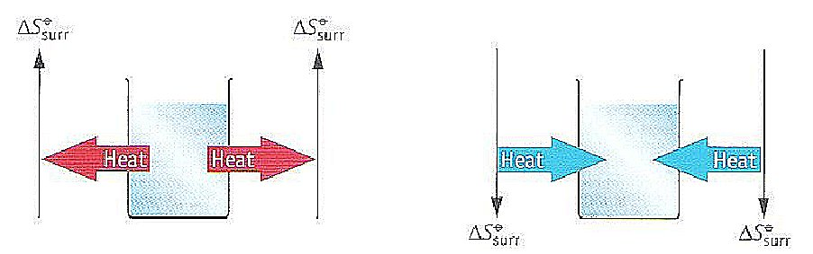
Note:-
ΔS_{surroundings} = +ve for all exothermic reactions.
ΔS_{surroundings} = -ve for all endothermic reaction.

Combining the change in entropy of the surroundings and the system we can calculate the total entropy and therefore whether the reaction is feasible at a given temperature. This is governed by:-
The second law of thermodynamics
The 2nd Law of thermodynamics states that:-
Every natural thermodynamic process proceeds in the direction in which the total entropy is increased, ie If ΔS_{total} is greater than 0 the reaction is spontaneous

A spontaneous process is one that takes place without continuous intervention from us

We now need to consider both the surroundings and system in terms of their entropy change. For a reaction to tend to occur spontaneously the total entropy change must be positive (as defined by the 2nd law). The natural direction of change is in the direction of increasing total entropy (positive entropy change).

So even if the system (i.e. the chemicals) loses entropy i.e. becomes more ordered (an exothermic reaction) as long as the surroundings gain entropy i.e. become more disordered the total entropy can still be positive and therefore the reaction will tend to ‘go’.
ΔSο_{total} = ΔSο_{system} + ΔSο_{surroundings}

You will need to use this equation to see if a reaction is thermodynamically feasible.
Calculating total entropy change.

1) Calculate the total entropy change for the following reaction.
CaO(s) + H₂O(l) → Ca(OH)₂(s) where ΔH_{r} = - 65 kJ mol⁻¹

a) Calculate ΔS_{surr} at 298K.
ΔS_{surr} = - ΔH_{r} = -(-65 x 10³)
T 298
= +218.2 J mol⁻¹ K⁻¹

- Calculate ΔS_{system.}
ΔSο_{system} = Σ n Sο (products) – Σ n Sο (reactants)
= ( + 83.4) – ( + 39.7 + 69.9)
= - 26.2 J mol⁻¹ K⁻¹
- Calculate ΔS_{total}
ΔSο_{total} = ΔSο_{system} + ΔSο_{surroundings}
= - 26.2 + 218.1
= + 191.92 J mol⁻¹ K⁻¹

Is this reaction feasible? As ΔSο_{total} > 0 then the reaction is thermodynamically feasible
2) At high temperatures carbon (graphite) reduces carbon dioxide to carbon monoxide.
C(s) + CO₂(g) → 2CO(g) where ΔH_{r} = +173 kJ mol⁻¹
Calculate if this reaction is feasible at:- (show all working with units and signs)
a) 400K
ΔSο_{system} = Σ n Sο (products) – Σ n Sο (reactants)
= 2 x S(CO(g)) - S(CO₂(g) + S(C(s)
= 2 x 197.6 - 213.6 + 5.7
= + 175.9 J mol⁻¹ K⁻¹
ΔS_{surr} = - ΔH_{r} = -(+ 173 x 10³)
T 400
= - 432.5 J mol⁻¹ K⁻¹
ΔSο_{total} = ΔSο_{system} + ΔSο_{surroundings}
= + 175.9 + (- 432.5)
= - 256.6 J mol⁻¹ K⁻¹ so not thermodynamically feasible.

b) 1000K
ΔSο_{system} = + 175 9 J mol⁻¹ K⁻¹ (from above)

ΔS_{surr} = - ΔH_{r} = -(+ 173 x 10³)
T 1000
= - 173 J mol⁻¹ K⁻¹

ΔSο_{total} = ΔSο_{system} + ΔSο_{surroundings}
= + 175.9 + (- 173)
= + 2.9 J mol⁻¹ K⁻¹ just thermodynamically feasible

Comment on the difference in values.
Reaction becomes feasible at 1000K.
Although the ΔSο_{system} does not change, at higher temperatures the ΔS_{surr} becomes less negative as it is = minus ΔH_{r} / T. When this value becomes greater than – 175.9 J mol⁻¹ K⁻¹ then the total entropy change will be greater than zero and the reaction feasible.
At what temperature does this reaction become feasible?
Hint, if ΔS_{total} = 0 then ΔS_{system.} = - ΔS_{surr} Feasible when ΔSο_{total} = 0 so ΔS_{sys} = -ΔS_{surr}
ΔS_{sys} = - (-ΔH_{r}) = ΔH_{r} + 175 9 = + 173 T = 983.5 K
T T T
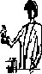
The drinking bird! – a demonstration
Record your observations. …………………………………………………………………..
Can you suggest what is happening here?
An explanation www.sixtysymbols.com/videos/drinkingbird.htm

Equilibria and changes of state

At equilibrium there is no overall change in either direction. There is no change in the entropy of the system or surroundings so:-
At equilibrium the value S reaches a maximum but there is no change in S therefore.
The requirement for equilibrium is that ΔS_{total} = 0

It is important to realise that it is the total entropy change under the actual experimental conditions which must be zero at equilibrium.
If conditions are standard, 298 K, 1 atm. then the standard entropy change ΔSο_{total} will be zero; but the value of standard entropy need not be zero at equilibrium, in fact it rarely is.

At equilibrium:-
ΔS_{total} = ΔS_{system} + ΔS_{surroundings}

= ΔS_{system} − ΔH = 0
T
ΔS_{system} = ΔH or T = ΔH
T ΔS_{system}

Applying this to melting point calculations:-
The melting point of a substance is the temperature at which both the liquid and the solid phases are in equilibrium.

Consider H₂O(s) ⇌ H₂O(l) ΔH = + 6012 J mol⁻¹
ΔS_{system} = S(water) - S(ice) Use your data booklet to complete
From pack p5
DATA
BOOK
=69.9 – ( + 47.99) = +21.9 J mol⁻¹ K⁻¹

Since ΔS_{system} = ΔH = 6012 = 21.9 ∴ T = 6012 = 274.5 K Insert figures
T T 21.9

Then T, the melting temperature of water = 274.5 K. (expect 273, rounding errors from data)

Use your data booklets to calculate the ΔS_{system} for water boiling and hence the enthalpy change of water boiling.
ΔS_{system} = ΔS(H₂O(g)) - ΔS(H₂O(l))
= 188.7 – 69.9
= +118.8 J mol⁻¹ K⁻¹
ΔS_{system} = ΔH ∴ ΔH = ΔS_{system} x T
T
= +118.8 x 374.5
= + 44490.6 J mol⁻¹ = + 44.49 kJ mol⁻¹
This could be confirmed using ΔH_{formation} data:- ΔH = ΔH_{f}H₂O(g) - ΔH_{f}H₂O(l) = 44kJmol⁻¹
Worksheet on ‘Change of state calculations’.
Calculating ΔS_{total} at different temperatures.
For reactions where both ΔS_{system} and ΔS_{surr} are +ve the reaction will be feasible at all temperatures if both are –ve the reaction will never be feasible no matter what we do to the temperature. The interesting reactions are ones where one value is negative and the other positive. These reactions can be made to ‘flip’ by changing the temperature.

We can now use our understanding of entropy to predict at what temperature these reactions will become feasible. We can use the idea that the ‘tipping point’ where the reaction switches from feasible to unfeasible or visa versa is when ΔS_{total} = 0.

1) Is the decomposition of calcium carbonate feasible at (a) 300K (b) 1200 K
CaCO₃ → CaO + CO₂ ΔH_{reaction} = +178 kJ mol⁻¹.
a) Using the data books calculate ΔS_{system}
ΔSο_{system} = Σ n Sο (products) – Σ n Sο (reactants)
= (ΔS(CaO+ ΔS(CO₂) - ΔS CaCO₃
= ( 39.7 + 213.6) – 92.9
= + 160.4 J mol⁻¹ K⁻¹
  - Using ΔH_{reaction} calculate ΔS_{surr} at 300K. (remember to change the kJ into J)
ΔS_{surr} = - ΔH_{r} = -(+ 178 x 1000)
T 300
= - 593.3 J mol⁻¹ K⁻¹
c) Calculate ΔS_{total} at 300K.
ΔSο_{total} = ΔSο_{system} + ΔSο_{surroundings}
= + 160.4 + (- 593.3)
= - 432.9 J mol⁻¹ K⁻¹
d) Is this reaction feasible at 300K? Explain your answer.
No, ΔSο_{total} is less than zero

e) Calculate ΔS_{surr} at 1200K.
ΔS_{surr} = - ΔH_{r} = -(+ 178 x 1000)
T 1200
= - 148.3 J mol⁻¹ K⁻¹
- Calculate ΔS_{total} at 1200K. Assume that ΔH and ΔS_{system} are unaffected by temperature Comment on the value.
ΔSο_{total} = ΔSο_{system} + ΔSο_{surroundings}
= + 160.4 + (- 148.3)
= +12.075 J mol⁻¹ K⁻¹

From your work on ‘Equilibria’
This reaction is reversible in a closed system. From your work on the position of equilibria what would be the effect of raising the temperature on the position of equilibria?
Expect the equilibrium position to more to the right hand side as ΔH is +ve, ie endothermic
This would cause the reaction to ‘use up’ the added heat energy.
How does this relate to the entropy calculations you have just done?
At higher temperatures ΔSο_{total} becomes positive because the - ΔHο/T term becomes smaller

2) For the reaction CaO(s) + 2NH₄Cl (s) → CaCl₂(s) + 2NH₃ (g) + H₂O(l)
Calculate
DATA
BOOK
(a) ΔH_{reaction} (using the enthalpy of formation data from your data booklet)

ΔH_{reaction} = ΣnΔH_{f} products - ΣnΔH_{f} reactants
= (ΔH_{f} CaCl₂(s) + 2 x ΔH_{f} NH₃(g) + ΔH_{f} H₂O(l)) – (ΔH_{f} CaO(s) + 2 x ΔH_{f} NH₄Cl(l))
= + 90.1 kJ mol⁻¹

(b) ΔS_{surr} at 298K
ΔS_{surr} = - ΔH_{r} = -(+ 90.1 x 1000)
T 298
= - 302.35 J mol⁻¹ K⁻¹

(c) Calculate ΔS_{system} (using your data booklet)
ΔSο_{system} = Σ n Sο (products) – Σ n Sο (reactants)
= (ΔSο CaCl₂(s) + 2 x ΔSο NH₃(g) + ΔSο H₂O(l)) – (ΔSο CaO(s) + 2 x ΔSο NH₄Cl(l))
= + 330.2 J mol⁻¹ K⁻¹

(d) Is the reaction feasible at 298K? Explain your answer.
ΔSο_{total} = ΔSο_{system} + ΔSο_{surroundings}
= + 330.2 + (- 302.35)
= +27.85 J mol⁻¹ K⁻¹

ΔSο_{total} is positive so the reaction is feasible
3) For the reaction:-
C₂H₄(g) + H₂(g) → C₂H₆ (g)

Given the following enthalpies of combustion:-
 | ΔH_{c} /kJ mol⁻¹
C₂H₄ (g) | -1411
H₂ (g) | -286
C₂H₆ (g) | -1560
Calculate ΔS_{total} and use it to predict whether the hydrogenation of ethene is feasible at 273K

ΔSο_{system} = Σ n Sο (products) – Σ n Sο (reactants)
= (ΔSο C₂H₆(g)) – (ΔSο C₂H₄(g) + 2 x ΔSο H(g))
= -120.6 J mol⁻¹ K⁻¹

Note you have been given ΔH _{c} data, so:-
ΔH_{reaction}
C₂H₄(g) + H₂(g) → C₂H₆(g)
ΔH _{c} C₂H₄(g)= -1411 kJ mol⁻¹ ΔH _{c} C₂H₆(g)= -1560 kJ mol⁻¹
ΔH _{c} H₂(g)= -286 kJ mol⁻¹
CO₂(g) + H₂O(l)

ΔH_{reaction} = (ΔH _{c} C₂H₄(g)+ ΔH _{c} H₂(g)) - ΔH _{c} C₂H₆(g)
= -137 kJ mol⁻¹

ΔS_{surr} = - ΔH_{r} = -(- 137 x 1000)
T 273
question asks this
= + 501.83 J mol⁻¹ K⁻¹

ΔSο_{total} = ΔSο_{system} + ΔSο_{surroundings}
= +381.2 J mol⁻¹ K⁻¹

ΔSο_{total} is positive so the reaction is feasible

See worksheets ‘Thermodynamics 3’
‘ΔS & ΔH Problems’
Barium Hydroxide Octahydrate and Ammonium Salts demonstration
Ba(OH)₂.8H₂O(s) + 2NH₄Cl(s) → BaCl₂.2H₂O(s) + 2NH₃(aq) + 8H₂O(l)
Write your observations below (What are the reactants like? What do you observe during the reaction? What do the products look like?):
A crystalline white solid and a white powder stirred together No immediate reaction – temp 22.8ºC
Smell of ammonia Solids turned into a white suspension
Temperature decreased Beaker froze to surface
Explain how your observations relate to the value of ΔH_{r} = + 63.6 kJ mol⁻¹.
Endothermic reaction Energy transferred from the surroundings to the system (chemicals
Use information in the equation above to predict whether or not the entropy change in this reaction will be positive or negative.
Solids → liquid so ΔSο_{system} increases = major effect
Crystals → suspension so ΔSο_{system} increases
3 moles → 11 moles so ΔSο_{system} increases
Ba(OH)₂.8H₂O(s) → BaCl₂.2H₂O(s), less complex so ΔSο_{system} decreases but only one mole and crystals forming a suspended solid so probably ΔSο_{system} increasesThermodynamic data:
Compound | Standard Molar Entropy (S^{ο}) (J mol⁻¹ K⁻¹)
Ba(OH)₂⋅8H₂O(s) | 431.7
NH₄Cl(s) | 94.6
BaCl₂·2H₂O(s) | 202.9
NH₃(aq) | 113.4
H₂O(l) | 69.9

ΔH_{r} = + 63.6 kJ mol⁻¹
Using the information you have been given, calculate the value of ΔS_{total}. Use your answer to explain why the reaction occurs spontaneously (note that the temperature of the reaction can be considered to be 298K).
ΔSο_{system} = Σ n Sο (products) – Σ n Sο (reactants)
= Σ(ΔSο BaCl₂.2H₂O(s) + 2 x ΔSοNH₃(aq) + 8 x ΔSοH₂O(aq)
– (ΔSοBa(OH)₂.8H₂O(s) + 2 x ΔSοNH₄Cl(s))
= (202.9 + 2 x 113.4 + 8 x 69.9) – (431.7 + 2 x 94.6)
= + 368 J mol⁻¹ K⁻¹

ΔS_{surr} = - ΔH_{r} = - (+ 63.6 x 1000)
T 298
= - 213.4 J mol⁻¹ K⁻¹
ΔSο_{total} = ΔSο_{system} + ΔSο_{surroundings}
= 368 – 213.4
= +154.6 J mol⁻¹ K⁻¹

b) Calculate the temperature above which this reaction becomes feasible.
ΔSο_{total} = 0 therefore, ΔSο_{system} = - ΔSο_{surroundings}
But ΔSο_{surroundings} = -ΔH
T
So T = ΔH
ΔS^{ο}_{system}
= +63.6 x 1000
+ 368
= +172.8 K
= -100.2 ºC
Burning Magnesium in Air - demonstration
Mg_{(s)} + ½ O_{2(g)} → MgO_{(s)} ΔH_{r} = - 601.7 kJ mol⁻¹
Explain how your observations relate to the value of ΔH_{r} shown above.
Exothermic, energy given out as light and heat energy.

Use information in the equation above to predict whether or not the entropy change in this reaction will be positive or negative, giving your reasons.
gas → solid so ΔSο_{system} decreases = major effect
1½ moles → 1 mole so ΔSο_{system} decreases
Mg metallic lattice → more complex solid so ΔSο_{system} increases
a) Using your data booklet calculate the ΔS_{system}.
ΔSο_{system} = Σ  n Sο (products) – Σ n Sο (reactants)
= (ΔSο MgO(s) – (ΔSο Mg(s) + ΔSο O(g))
= 26.9 – (32.7 + 102.5)
= - 108.3 J mol⁻¹ K⁻¹
b) Using the information you have been given, work out the value of ΔS_{tot} at 298K
ΔS_{surr} = - ΔH_{r} = - (-601.7 x 1000)
T 298
= + 2019 J mol⁻¹ K⁻¹
ΔSο_{total} = ΔSο_{system} + ΔSο_{surroundings}
= - 108.3 + 2019
= +1910.8 J mol⁻¹ K⁻¹
c) As this is an exothermic reaction calculate the temperature above which this reaction becomes non-spontaneous.
ΔSο_{total} = 0 therefore, ΔSο_{system} = - ΔSο_{surroundings}
But ΔSο_{surroundings} = -ΔH
T
T = ΔH .
ΔS^{ο}_{system}
= -601.7 x 1000
- 108.3
= 5555.8 K so above this temperature Mg spontaneously will NOT→ MgO
d) Comment on the factors which allow reactions which result in a significant decrease in entropy of the system (i.e.ΔS_{sys} is –ve) to take place, using this reaction as an example.
For the reaction to take place ΔSο_{total} > 0 ,
ΔSο_{total} = ΔSο_{system} + ΔSο_{surroundings}
this needs to be very +ve > +108.3
= - ΔH very exothermic reaction
T temp(<5555.8K). needed
this is –ve
- 108.3
Why reactions do not occur.
Use the data booklet to calculate the ΔS_{total} for this reaction at 298K.
DATA
BOOK
CH₄(g) + 2O₂(g) → CO₂(g) + 2H₂O(l)
ΔH_{r} = ΔH_{c}(CH₄(g) = - 890 kJ mol⁻¹
ΔSο_{system} = Σ  n Sο (products) – Σ n Sο (reactants)
= Σ (ΔSο CO₂(g) + 2 x ΔSο H₂O(l)) – Σ (ΔSο CH₄(g) + 4 x ΔSοO(g))
= -242.8 J mol⁻¹ K⁻¹
ΔS_{surr} = - ΔH_{r} = - (-890.3 x 1000)
T 298
= + 2986.58 J mol⁻¹ K⁻¹
ΔSο_{total} = ΔSο_{system} + ΔSο_{surroundings}
= - 242.8 + 2986.58
= +2743.78 J mol⁻¹ K⁻¹ thermodynamically feasible.
One could calculate the Temp above which methane will NOT combust = 3667 K = +3344ºC
At room temperature and pressure do methane and oxygen react spontaneously? No

Why does this reaction not occur at room temperature?
Activation energy too high
This reaction should occur spontaneously at room temperature as the total entropy change is positive. However from experience we know that this is not the case. So is it breaking the second law? No, nothing breaks the second law. We need to look back at our definition, it says nothing about the speed of the reaction.
So, something must be holding the reaction back, preventing it from being spontaneous at room temperature.
The ‘holding back’ part is called the activation energy.
The Activation Energy is defined as the minimum investment of energy that must be supplied to enable bonds in reactants to stretch and break as new bonds are formed.

Draw an enthalpy level diagram for the reaction above and label the activation energy.
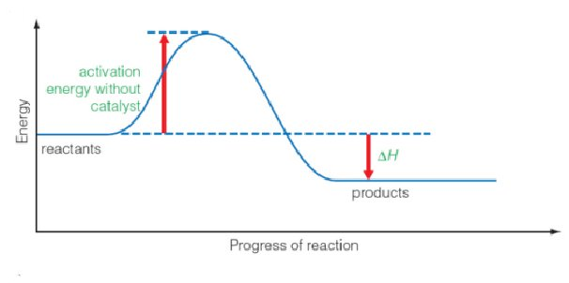

A reaction with a high activation energy is said to be kinetically inert
Thermodynamic stability and chemical inertness
Many reactions are spontaneous when we consider the thermodynamics but do not occur until a source of heat energy is supplied to overcome the activation energy. Reactions which should go thermodynamically but do not are said to be kinetically inert.
We can now move on to look at thermodynamic stability. Draw two enthalpy level diagrams for an endothermic and exothermic reaction.
Reactants
Products
H = Enthalpy
/ kJ mol⁻¹
Progress of reaction
EXOTHERMIC
ΔH = -ve
Reactants
Products
H = Enthalpy
/ kJ mol⁻¹
Progress of reaction
ENDOTHERMIC
ΔH = +ve

In the exothermic reaction the products are at a lower energy level than the reactants. The products are said to be thermodynamically stable with respect to the reactants.

In an endothermic reaction …… the products are at a higher energy level than the reactants
The products are said to be thermodynamically unstable with respect to the reactants
Chemists frequently use the value of ΔH to predict if a reaction is feasible or not. If the ΔH value is very negative the reaction is likely to happen, because the products are energetically more stable than the reactants they are made from. Notice we always use the phrase ‘with respect to’ as we need to be clear that we are comparing specific reactants with specific products or vice versa.
However as we have also seen endothermic reactions can be spontaneous and exothermic reactions are often not spontaneous. There are three main reasons for this:-
1) ΔH tells us nothing about the kinetic inertness of the reactants.
2) ΔH is always quoted for standard conditions, these are rarely standard.
3) The entropy changes are the most important factor to consider.
Thermodynamic stability is determined by ΔS_{total} being negative at the stated conditions of temperature and pressure.

Gibbs (Free) Energy
It is often inconvenient to have to consider the surroundings. It would be much more convenient to only consider changes to the system. So we can recast the total entropy equation in terms of the system only

ΔSο_{total} = ΔSο_{system} + ΔSο_{surroundings}

ΔSο _{surroundings} = - ΔH
T
So ΔSο_{total} = ΔSο_{system} - ΔH
T
- ΔH can be considered as the energy gained or lost by the surroundings at constant pressure, but
we also know that this value must be equal to the energy gained or lost by the system also a
constant pressure, the only thing that changes is the sign. So if we take this into account and
multiply through by –T we get the expression

-TΔSο_{total} = ΔH_{r} - TΔSο_{system}

We now can define -TΔSο_{total} as the Gibbs energy and give it the sign ΔG

ΔG= ΔH - TΔS
This allows us to look only at the system (notice we have dropped the subscript sys) we do not need
to worry directly about the surroundings

What is the relationship between ΔG and ΔSο_{total}
If ΔG is negative then ΔStotal is positive i.e. the entropy of the universe increases and the reaction is spontaneous, if ΔG then ΔStotal is negative and the reaction is not spontaneous (remember spontaneous means the reaction favours the products, it does not tell us how fast the reaction is.)

Gibbs energy is often called Gibbs Free energy, this is because it is he amount of energy that is available to us to do useful work, i.e. not lost as heat or as the amount of non-expansion work that a process can do provided the change is taking place at a constant temperature and pressure.

We can also calculate the temperature at which the reaction becomes feasible because this temperature corresponds to ΔG=0

Calculations involving Gibbs

Thinking about the process of turning water into ice. We know that the enthalpy change is -6012 jmol⁻¹ . Water turning into ice is an exothermic reaction as heat is released as the hydrogen bonds are made. We also know that the entropy change is -22.0 JK⁻¹mol⁻¹ . assuming that none of these values change with temperature. Calculate the Gibbs energy at +5 C and -5 C.

At +5C

ΔG= ΔH - TΔS
ΔG = -6012 – (278 x -22.0)
ΔG = +104 jmol⁻¹
ΔG =+ 0.104 kjmol⁻¹

At -5C

ΔG= ΔH - TΔS
ΔG = -6012 – (268 x -22.0)
ΔG = -116 jmol⁻¹
ΔG = -0.116 kjmol⁻¹

This is why we put water in a freezer to turn it into ice. At +5 the increase in the entropy of the surroundings is not enough to offset the reduction of entropy as the liquid water molecules become a solid lattice of ice. However at -5 the temperature is low enough that it can offset the reduction. The conclusions are the same when using Gibbs or Total entropy, its’ just that the calculations are easier using Gibbs as we only need to consider the system.

How does temp affect feasibility. Fill in the table to show how changing the temp can affect the feasibility of the reaction.

ΔH | ΔS | How feasibility varies with temp | ΔG
-ve | +ve | Feasible at all temperatures | Always negative
-ve | -ve | More feasible at lower temperatures | More likely to be negative at lower temp
+ve | +ve | More feasible at higher temperatures | More likely to be negative at higher temperature
+ve | -ve | Non-feasible at all temperatures | Always positive

More calculations

Calculate the Gibbs energy change for the following reactions at 298K . Then work out the temperature at which the reaction either becomes feasible or stops being feasible (you will need your data booklet)

- N₂(g) + 3H₂ (g) → 2NH₃(g)

ΔG = ΔH - TΔS

ΔH = 2(-46.1 x 1000) = -92200 jmol⁻¹ (twice the enthalpy of formation)

ΔS = 2(192.3) – ((2x95.8) + (6 x 65.3) = -198.8

ΔG = -92200 – (298 x -198.8) = -32957.6 j mol⁻¹
ΔG = -33.0 kjmol⁻¹

ΔG = 0 ΔH = TΔS T=ΔH/ΔS
T = -92200/-198.8
T = 464 K

Temp above which reaction is not feasible 464 K

- CaCO₃(s) → CaO(s) + CO₂(g) ΔH = +178 kjmol⁻¹

ΔG = ΔH - TΔS

ΔH = + 178000 jmol⁻¹

ΔS = (213.6 + 39.7) – 92.9 = +160.4 jmol⁻¹K⁻¹

ΔG = +178000 – (298 x 160.4) = 130200.8 j mol⁻¹
ΔG = +130kjmol⁻¹

ΔG = 0 ΔH = TΔS T=ΔH/ΔS
T = 178000/130
T = 1369 K

Temp above which reaction is feasible 1370 K

This ties in with your work on group 2 chemistry. Calcium carbonate is stable at room temperature but if heated to above 1370 K ( 1096 C) it will decompose. You can try to calculate the other thermal decompositions of the group 2 carbonate or nitrates and you will see the same pattern mathematically that you saw in your experiments.

Summary

- When changes take place in a chemical system there are nearly always accompanying changes occurring in the surroundings.
- To predict whether or not a change will take place spontaneously, we need to take account of the entropy changes in the system and its surroundings.
- The total entropy change for a process is given by:-
ΔSο_{total} = ΔSο_{system} + ΔSο_{surroundings}
- ΔSο_{system} = Σ n Sο (products) – Σ n Sο (reactants)
- ΔSο _{surroundings} can be found using the relationship ΔSο _{surroundings} = - ΔH
T
- The Second Law of Thermodynamics tells us that for a spontaneous chemical change, the total entropy must increase.
ΔS_{total} > 0
- The requirement for equilibrium is ΔS_{total} = 0
- Entropy changes and thermodynamic feasibility.

Thermodynamic feasibility |  | ΔS_{surroundings} (-ΔH/T)
 |  | Positive (exothermic) | Negative (endothermic)
ΔSο_{system} | Positive | Always | If the value of  ΔS^{θ}_{system} > ΔH/T  More likely at high temperatures
ΔSο_{system} | Negative | If the value of  ΔH/T >ΔS^{θ}_{system}  More likely at low temperatures | Never

- Thermodynamic stability is determined by ΔS_{total} being negative.
- Kinetic inertness is determined by the activation energy being high.
Revision Page
Entropy is a large topic in Unit 4 chemistry and an important concept in many areas of science from cosmology to evolution. Using the syllabus statements on the front cover design a mind map or flow diagram to explain the basic concepts
c

Entropy Exam questions.
You will either be expected to look up values in the data book or use values given in the question.
1. Which of the following is true for the exothermic reaction shown below?
Mg(s) + 2HCl(aq) → MgCl2(aq) + H2(g)
A ΔH positive
B√ ΔSsurroundings positive
C ΔSsystem negative
D ΔStotal negative
(Total 1 mark)
2. When ammonium nitrate crystals dissolve in water, the entropy of the system
A remains the same.
B falls, because the hydrated ions are more ordered than the solid.
C rises, because the ions in the crystal become hydrated in the solution.
D√ rises, because the ions are arranged more randomly in the solution than in the crystal.
(Total 1 mark)
3.
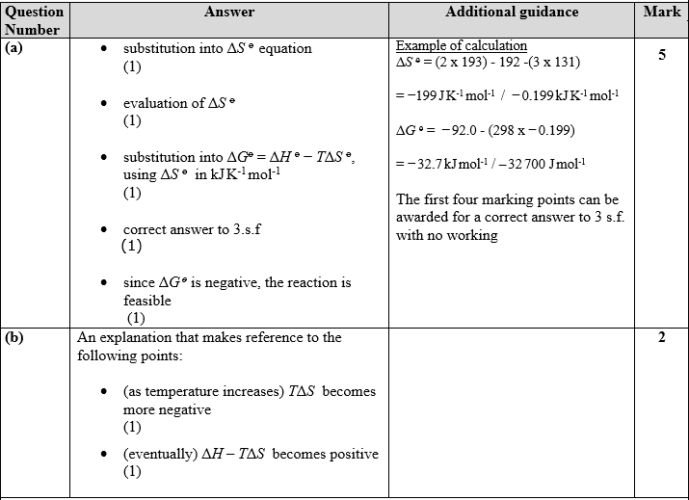

4. When barium nitrate is heated it decomposes as follows:
Ba(NO3)2(s) → BaO(s) + 2NO2(g) + ½O2(g) ΔH = +505.0 kJ mol–1
(a) Use the following data when answering this part of the question.
Substance | Standard entropy,  Sο / J mol⁻¹ K⁻¹
Ba(NO3)2(s) | + 213.8
BaO(s) | + 70.4
NO2(g) | + 240.0
O2(g) | + 205.0
(i) Explain why:
• Sο [NO2(g)] is greater than Sο [BaO(s)]
NO2 is a gas (whereas BaO is a solid) (1)
• Sο [Ba(NO3)2(s)] is greater than Sο [BaO(s)].
Ba(NO3)2 has a more complicated structure than BaO (1)
Allow 2nd mark if a correct statement is combined with a “neutral” wrong statement
Accept Ba(NO3)2 “molecule” has more electrons /is larger than BaO “molecule” (1)
Accept more atoms/ions/particles
Accept more complicated/complex compound
Reject Ba(NO3)2 has a larger molar mass than BaO
Reject more molecules/elements
(2)
(ii) Calculate the entropy change of the system, ΔSοsystem, for this reaction. Include a sign and units in your answer.
∆Sοsystem = 70.4 + (2 × 240.0) + (½ × 205.0) – 213.8 (1)
= +439.1 J mol⁻¹ K⁻¹ (1)
–1 per error 2
Accept +439 J mol⁻¹ K⁻¹
Accept J/ mol /K
(2)
(b) Calculate the entropy change of the surroundings, ΔSοsurroundings, for the reaction at 298 K. Include a sign and units in your answer.
∆Sοsurroundings = (1) =
= – 1700 J mol⁻¹ K⁻¹ (3 s.f.) (1)
Penalise wrong units in (a)(ii) and (b) once only 2
Accept –1690 J mol⁻¹ K–
Accept –1695 J mol⁻¹ K¹
Answers in kJ mol⁻¹ K⁻¹
Reject –1694 J mol⁻¹ K⁻¹
Reject –1694.6 J mol⁻¹ K⁻¹
Reject –1694.63 J mol⁻¹ K⁻¹
(2)

(c) Calculate ΔSοtotal, and explain the significance of the sign for this value.
∆Sοtotal = +439.1 – 1695 = – 1260 (J mol⁻¹ K⁻¹) (1)
Allow TE [follow through working from (a)(ii) and (b)]
Mark consistently with (a)(ii) and (b)
The reaction isn’t spontaneous / doesn’t “go” (at 298K) (1)
Must be consistent with sign in calculation
Accept –1256 J mol⁻¹ K⁻¹
Accept –1261 J mol⁻¹ K⁻¹
Accept –1255.5 J mol⁻¹ K⁻¹
(2)
(d) Calculate the minimum temperature at which the decomposition of barium nitrate should occur.
You can assume that ΔH and ΔSsystem are not affected by a change in temperature.
When just spontaneous, ∆Sοtotal = 0 or implied by calculation i.e (1)
⇒ ∆Sοsurroundings = –439.1 J mol⁻¹ K⁻¹
⇒ T = = 1150 (K) (1)
Accept 1150.1 K
Accept 877 °C
Accept 1151K with no working (1 max)
Reject 1151K for 2nd mark
Reject any negative value for T (in K): no 2nd mark
(2)
5.
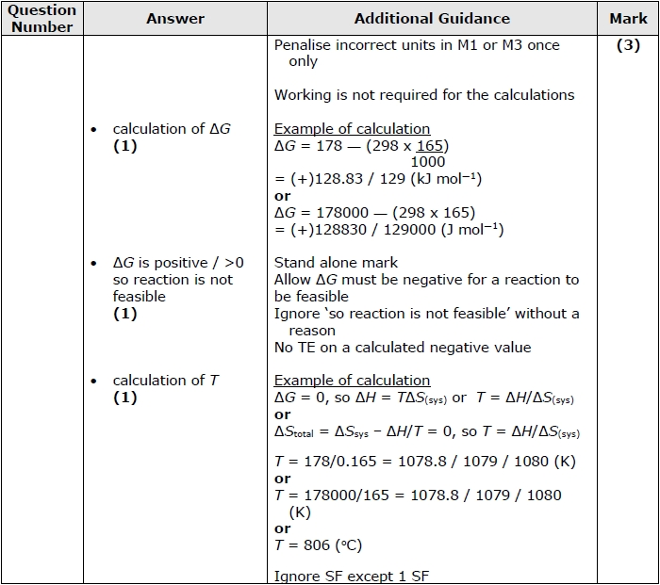
6. Thermochemical data, at 298 K, for the equilibrium between zinc carbonate, zinc oxide and carbon dioxide is shown below.
ZnCO3(s) ZnO(s) + CO2(g) ∆Hο = +71.0 kJ mol–1
Sο[ZnO(s)] = +43.6 J mol–1 K–1
Sο[ZnCO3(s)] = +82.4 J mol–1 K–1
Sο[CO2(g)] = +213.6 J mol–1 K–1
(a) (i) Suggest reasons for the differences between the three standard entropies.
Gases have much higher entropies than solids as there are many more ways of arranging the entities / less ordered / more random(ness)
OR reverse argument (1)
ZnCO3 has more atoms / is more complex than ZnO (1)
(2)
(ii) Calculate the entropy change for the system, ∆Sοsystem, for this reaction. Include the sign and units in your answer.
∆Sοsystem = (+43.6) + (+213.6) – (+82.4)
=+174.8/175 J mol–1 K–1
method (1)
answer, sign and units (1)
(2)
(b) Calculate the entropy change for the surroundings, ∆Sοsurroundings, at 298 K, showing your method clearly.
∆Sοsurroundings =
OR = (1)
= – 238(.3) J mol⁻¹ K⁻¹
answer, sign and units (1)
(2)
(c) (i) Calculate the total entropy change for this reaction, ∆Sοtotal, at 298 K.
= – 63.5 / 64 / 63 / 63.2 / 63.4 J mol⁻¹ K⁻¹
(1)
(ii) What does the result of your calculation in (c)(i) indicate about the natural direction of this reaction at 298 K? Justify your answer.
Natural direction is right to left /reverse as ΔSοtotal /total entropy change is negative / less than zero. 1
MUST be consistent with (i)
(1)
(Total 8 marks)
NAME ...........................……... HOMEWORK DEADLINE .....................
Student Number ………… Chemistry Class ………

Student targets from previous pack

Entropy
Task | Mark
Notes | /10
Revision Notes /Summary page | /10
Final questions | /30  = %
Overall Grade for this work | A B C D E U

Student comments

Tutor comments

Tutor signature Date

Student targets for next pack

