NAME ............................................ Chemistry Class ....................
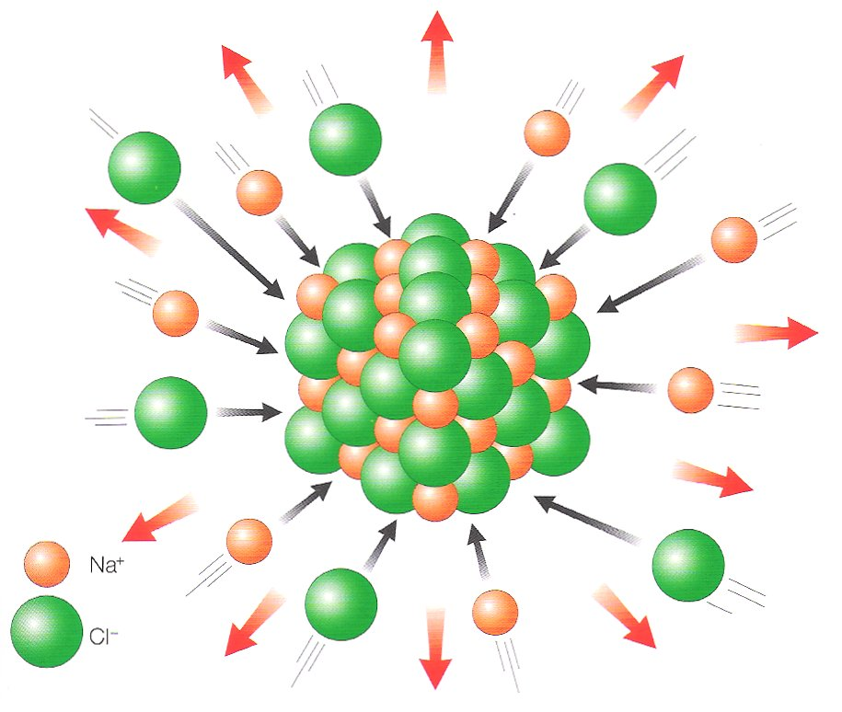
Student Number ……….

Born-Haber cycles

1. be able to define lattice energy as the energy change when one mole of an ionic solid is formed from its gaseous ions
2. be able to define the terms:
i enthalpy change of atomisation, ΔatH
ii electron affinity
3. be able to construct Born-Haber cycles and carry out related calculations
4. know that lattice energy provides a measure of ionic bond strength
5. understand that a comparison of the experimental lattice energy value (from a Born-Haber cycle) with the theoretical value (obtained from electrostatic theory) in a particular compound indicates the degree of covalent bonding
6. understand the meaning of polarisation as applied to ions
7. know that the polarising power of a cation depends on its radius and charge
8. know that the polarisability of an anion depends on its radius and charge

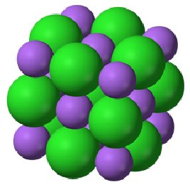

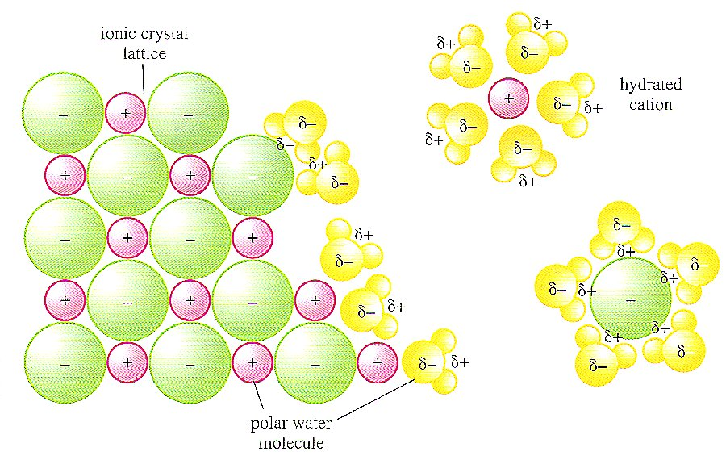
ΔH_{solution}
ΔH_{hydration}
ΔH_{lattice}
IONIC LATTICE
GASEOUS IONS
AQUEOUS IONS

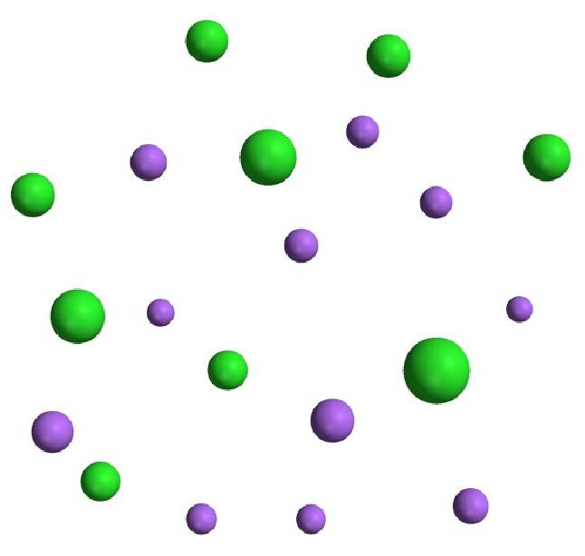
Sodium and chloride ions leaving a crystal lattice and becoming hydrated as they dissolve in water. Here the bond between the ions and the polar water molecules is electrostatic attraction.

ENERGY CHANGES INVOLVED IN FORMING IONIC COMPOUNDS

When we calculate the enthalpy of formation of an ionic compound we cannot use bond energies because an ionic lattice is formed instead of individual molecules.

In this pack we will look at the energy changes as elements react to form a solid ionic lattice. This leads on from both your work with Energetics and your work with ionic structures.

An ionic lattice is a regular arrangement of alternating positive and negative ions. When these oppositely charged ions come together a large amount of energy is released. This is known as the lattice enthalpy.
LATTICE ENTHALPY of an ionic compound is:
The energy released when one mole of an ionic solid compound in its standard state is formed from its constituent gaseous ions starting infinitely far apart.

e.g. Na⁺(g) + Cl⁻(g) → NaCl(s) ΔH_{latt} = -411 KJmol⁻¹

NOTE: Lattice enthalpies are always large negative values. The larger the negative value of the lattice enthalpy the stronger the ionic bonds.

Strong ionic bonding results from ions with:-
- Small ionic radius,
- High charge

Therefore these factors will result in a more negative lattice enthalpy.

Put the following ionic compounds in order of increasing negative lattice enthalpy:
MgCl₂, MgO, NaCl, KCl, and explain the order.

…………………………………………………………………………………………………...

…………………………………………………………………………………………………...

…………………………………………………………………………………………………
Unfortunately it is not possible to accurately measure lattice enthalpy directly. Why not?
…………………………………………………………………………………………………
A theoretical value of the attraction can be calculated from electrostatic theory and the charges and radii of the ions involved. We will come back to this later in this topic.
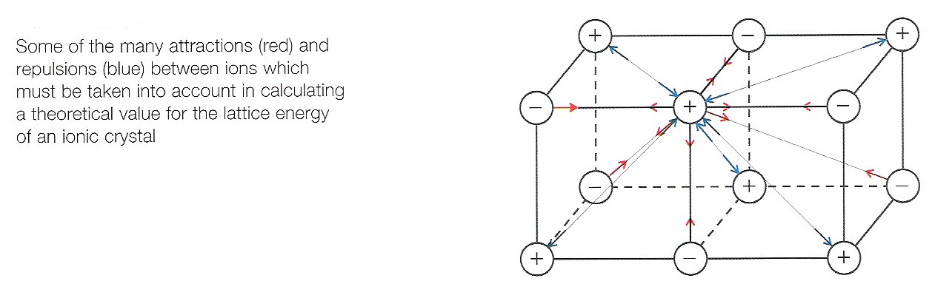

DEFINITIONS
Facer p 34-38 and p108
To understand the enthalpy changes involved in the formation of an ionic compound you need to be familiar with the following definitions
Complete the list of definitions with equations (including state symbols) and LEARN THEM
First ionisation energy ΔHº_{i (1)} …………………………………………………………………..…………………………… ……………………………………………………………………………………………………………………………………………………………………………………………………
e.g. equation for the first ionisation energy of magnesium:

Second ionisation energy ΔHº_{i (2)} ……………………………………………………………………………………………….... ……………………………………………………………………………………………………………………………………………………………………………………………………
e.g. equation for the second ionisation energy of magnesium

Enthalpy of atomisation ΔHº_{a} ……………………………………………………………………............................................... …………………………………………………………………………………………………
e.g. equation for the enthalpy of atomisation of chlorine

First electron affinity ΔHº_{e (1)} ……………………………………………………………………………………………………………………………………………………………………………………………………
e.g. equation for the first electron affinity of chlorine

Enthalpy of formation ΔHº_{f} ….…………………………………………………………………………………………………………………………………………………………………………………………………
e.g. equation for the enthalpy of formation of magnesium chloride

Lattice Enthalpy ΔHº_{latt} ……….………………………………………………………………..…..………………………………………………………………………………………………………………………
e.g. equation for the lattice enthalpy of magnesium chloride
BORN-HABER CYCLES

Because we cannot easily measure the experimental value for the lattice enthalpy we have to construct a version of a Hess cycle called a Born-Haber cycle in order to find lattice enthalpy from other experimentally determined enthalpy changes.
A BORN-HABER CYCLE is an enthalpy cycle/Hess cycle composed of all the enthalpy changes in the steps involved in the formation of 1 mole of ionic compound from its constituent elements in their standard states.

The diagram below shows this cycle in a simple and incomplete form.
There are three enthalpy changes represented:-

- Identify and label the lattice enthalpy, ΔHº_{latt}

- Identify and label the enthalpy of formation, ΔHº_{f}

The remaining enthalpy change represents a multi-step process.
- Identify this change with a multi-headed arrow, →→→

Elements in their standard states
Compound as an ionic crystalline lattice

Ions in their gaseous state

EXAMPLE – CONSTRUCTING A BORN-HABER CYCLE FOR SODIUM CHLORIDE

- Write an equation to represent the enthalpy change of formation of sodium chloride:-
Correct states of matter are essential

- Write an equation to represent the lattice enthalpy of sodium chloride:-

As previously, write the chemical species involved in the formation of NaCl into the correct boxes
and label the arrows with
- ΔH_{f} (enthalpy of formation of sodium chloride)
- and ΔH_{latt} (lattice enthalpy of sodium chloride) as appropriate.
- Identify the multi-step process with a multi-headed arrow.

The next step is to identify the enthalpy changes involved in the multi-step process.

- Conversion of Na(s) → Na⁺(g)

Identify the missing form of sodium and above each arrow write in the name and symbol for the type of enthalpy change involved in the change indicated.

Na(s)
Na⁺(g)

- Conversion of ½ Cl₂(g) → Cl⁻(g)

Identify the missing form of chlorine and above each arrow write in the name and symbols for the enthalpy change

½ Cl₂(g)
Cl⁻(g)

BORN-HABER CYCLE FOR SODIUM CHLORIDE
We are now in a position to complete a Born-Haber cycle using the following values:
Given:- Na(s) → Na(g) ΔHº_{a} = +108 kJ mol⁻¹
Na(g) → Na⁺(g) ΔHº_{i,(1)} = +500 kJ mol⁻¹
½ Cl₂(g) → Cl(g) ΔHº_{a} = +121 kJ mol⁻¹
Cl(g) + e⁻ → Cl⁻(g) ΔHº_{e(1)} = -364 kJ mol⁻¹
Na(s) + ½ Cl₂(g) → NaCl(s) ΔHº_{f} = -411 kJ mol⁻¹
Fill in the NAMES of the changes below:

- ΔHº_{f}[NaCl(s)]……………………………………………………………………………
- ΔHº_{a} [Na(s)]……………………………………………………………………………
- ΔHº_{a} [Cl₂(g)]……………………………………………………………………………
- ΔHº_{i,1} [Na(g)]……………………………………………………………………………
- ΔHº_{e} [Cl(g)]……………………………………………………………………………
- ΔHº_{latt} [NaCl(s)].......................................................................................................
Label each arrow with the correct thermochemical symbols and values
Na(s)
½Cl₂(g)
NaCl(s)
+

Na(g)
Cl(g)

+

Na⁺(g)
Cl⁻(g)
+

Use the Hess cycle constructed above to complete the equation:

ΔHº_{f} [NaCl(s)] = ................. + .................... + ....................... + .................... + ....................

Rearrange, ΔΗ_{latt} = ................. − ..................... − ..................... − .................... − .....................

Insert the values with correct signs to calculate the lattice enthalpy

ΔΗ_{latt} = ................... − ....................... − ......................− .................... − .....................

= ............................................................. (Remember units)
ENTHALPY LEVEL DIAGRAMS
A Born-Haber cycle can be represented as an enthalpy level diagram as shown below.
- Start at the datum line where the enthalpy of elements in their standard states is zero.
- ↑ Arrows represent endothermic reactions and ↓ arrows represent exothermic reactions
- Complete the thermochemical symbols identifying the ΔH changes

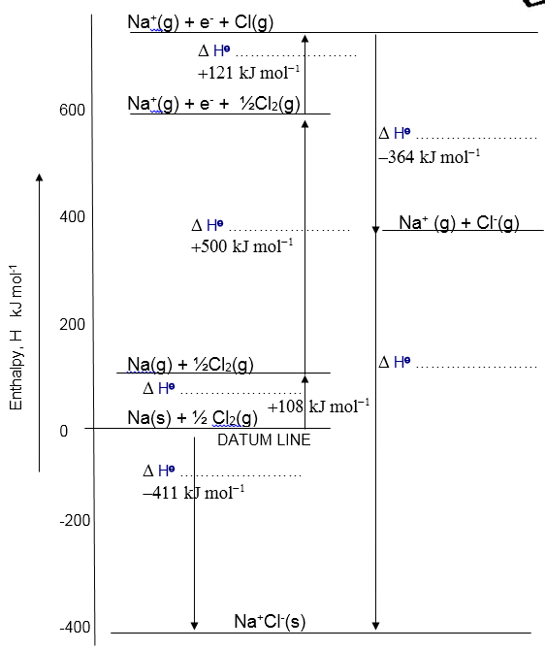

Use this to calculate the lattice enthalpy of NaCl in the space below
(Remember use Hess Law, so clockwise cycle = anticlockwise cycle
Show these arrows on the diagram above)

- Draw a Born Haber cycle for KI and use it to find the Lattice enthalpy of potassium iodide.
K(s) → K(g) ΔHº_{a} = +90 kJ mol⁻¹
K(g) → K⁺(g) ΔHº_{i,(1)} = +418 kJ mol⁻¹
½ I₂(s) → I(g) ΔHº_{a} = +107 kJ mol⁻¹
I(g) + e⁻ → I⁻(g) ΔHº_{e(1)} = -314 kJ mol⁻¹
K(s) + ½ I₂(g) → KI(s) ΔHº_{f} = -411 kJ mol⁻¹

- Draw a Born-Haber cycle and use it to calculate the lattice enthalpy of calcium oxide using the values:
Atomisation enthalpy of Ca = +178.2 kJ mol⁻¹
First ionisation enthalpy of Ca = +590 kJ mol⁻¹
Second ionisation enthalpy of Ca = +1145 kJ mol⁻¹
Atomisation enthalpy of Oxygen = +249.2 kJ mol⁻¹
First electron affinity of Oxygen = -141.1 kJ mol⁻¹
Second electron affinity of Oxygen = +798 kJ mol⁻¹
Enthalpy of formation of Calcium Oxide = -635.1 kJ mol⁻¹


Exam Technique
Correct the following exam responses to the question:
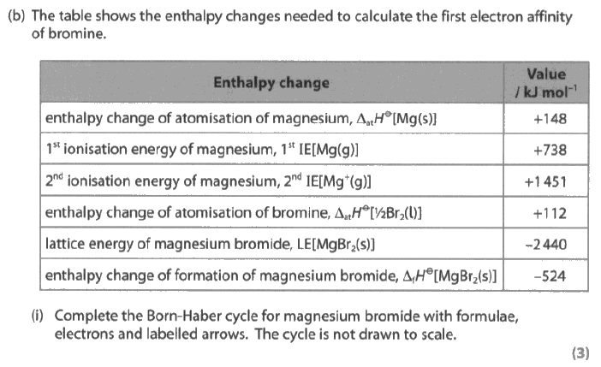
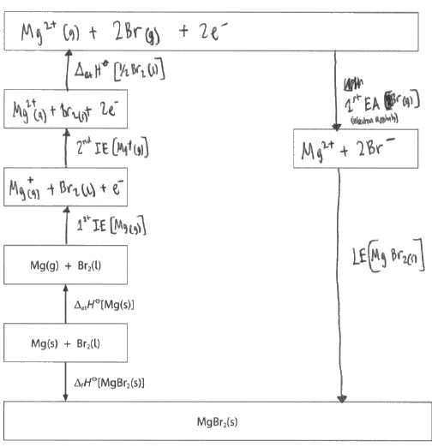

What’s wrong with this calculation?
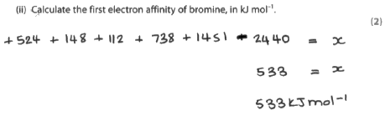
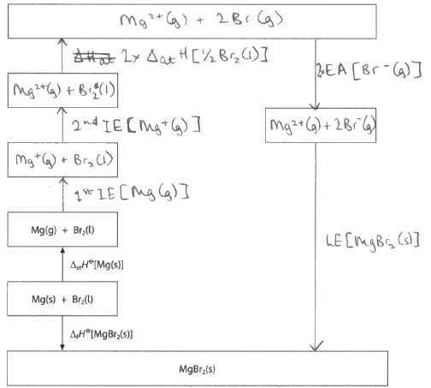

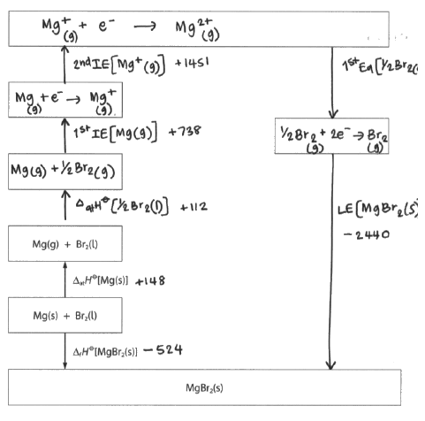

EXPERIMENTAL AND THEORETICAL VALUES OF LATTICE ENTHALPY
So far, all the lattice enthalpies have been calculated from indirect Hess cycles called Born-Haber cycles.
All the data values such as enthalpies of atomisation, ionisation and electron affinity have been determined experimentally
As a result the Born Haber values calculated are referred to as experimental values
Theoretical values can be calculated from the ionic radius and charges of the ions involved. The smaller the ionic radius and the higher the charge on the ion, the stronger the force of attraction between the ions. This calculation assumes a purely ionic model. (see front cover and page 1 diagram)

In most cases there is a good agreement between the two:-

Compound | Lattice Enthalpy kJ mol⁻¹
Compound | Born-Haber | Theoretical
NaF | -918 | -912
NaCl | -780 | -770
NaBr | -742 | -735
NaI | -705 | -687
AgF | -958 | -920
AgCl | -905 | -833
AgBr | -891 | -816
AgI | -889 | -778
Highlight those compounds with a discrepancy.
The theoretical model assumes that the compound is 100% ionic. However with small highly charged cations and large anions a degree of polarisation occurs.
Polarisation is : ...............................................................................................................................................................
.........................................................................................................................................................................................
.........................................................................................................................................................................................

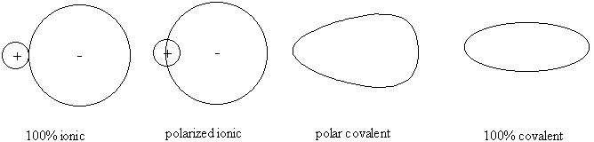

Rather than the 100% ionic model some ionic compounds exhibit a degree of covalency, due to the polarisation of the anion (-ve) by the cation (+ve)
LEARN:
- Cations with a small radius and high positive charge have a high polarising power
- Anions with a large radius and high negative charge are easily polarised.
- The resulting compound will have covalent character (not be purely ionic)
For example, AlCl₃(s) the bonding is mainly covalent. Why?

…………………………………………………………………………………………………………………………………………………………………………………………………………………………………………………………………………………………………………………………….
Use the idea of polarisation to explain the difference between the theoretical and experimental values for MgI₂.


……………………………………………………………………………………………………………………………………………………………………………………………………………………………………………………………………………………………………………………………..
For additional practice ‘Born Haber cycles’ worksheet

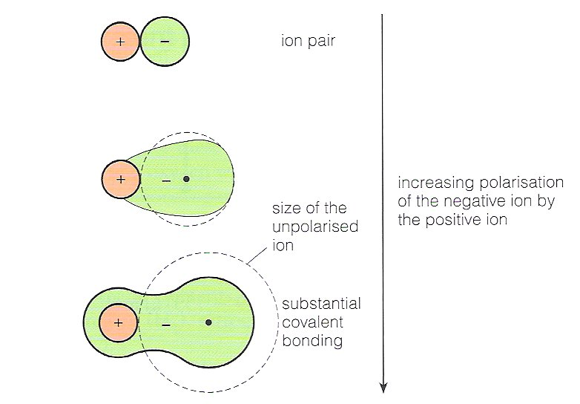
An alternative diagram to show the polarisation of (a large) anion by a (small highly charged) cation:-

Questions
Q1.
The diagram shows a Born-Haber cycle for calcium chloride. It is not drawn to scale.
All units are in kJ mol⁻¹.
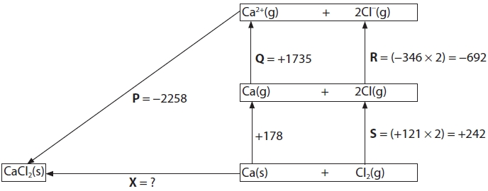
(a) Which enthalpy change is correctly labelled on the diagram?
(1)
A Enthalpy change for the formation of calcium chloride (P).
B First ionization energy of calcium (Q).
C Electron affinity of chlorine (R).
D Twice the enthalpy change of atomization of chlorine (S).
(b) What is the value of X, in kJ mol⁻¹?
(1)
A +795
B −795
C +3721
D −3721

(Total for question = 2 marks)

Q2.
(a) The diagram shows the Born-Haber cycle for the formation of strontium chloride from its elements.
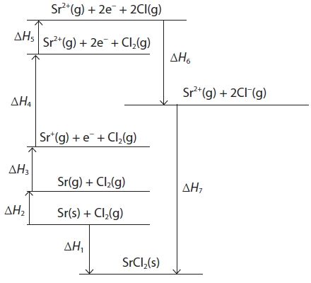
The table gives the values of enthalpy changes ΔH₁ through to ΔH₆.
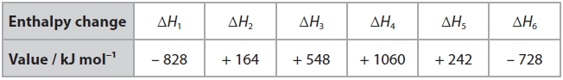
(i) Give the names of the enthalpy changes represented by ΔH₁ and ΔH₂.
(2)
ΔH₁
........................................................................................................................................
ΔH₂
........................................................................................................................................
(ii) Write an expression linking all the enthalpy changes listed in the Born-Haber cycle and use it to calculate a value for ΔH₇.
(2)
(b) Why is the lattice energy of magnesium chloride more exothermic than that of strontium chloride?
(1)
A there are more cation-to-anion interactions in magnesium chloride
B the inter-ionic distance is smaller in magnesium chloride
C magnesium chloride has less covalent character
D the magnesium ion has a greater charge than the strontium ion
Q3.
The diagram shows a Born-Haber cycle for calcium chloride, CaCl₂
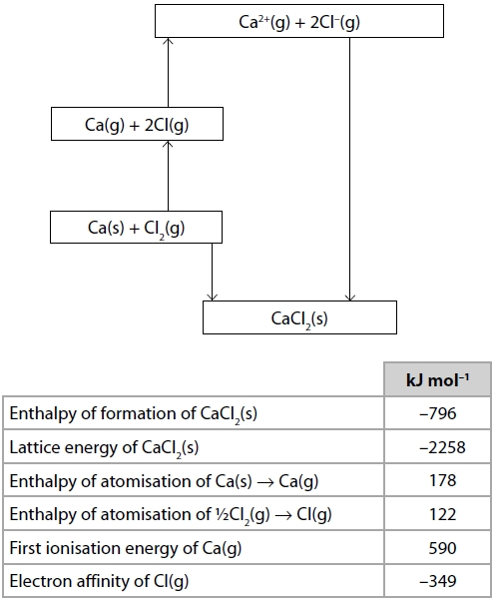

Calculate the second ionisation energy of calcium, in kJ mol⁻¹.
(2)

Q4.
Which of the equations below represents the first electron affinity for oxygen?
A O₂(g) + 2e⁻ → 2O⁻(g)
B O₂(g) − 2e⁻ → 2O⁻(g)
C ½O₂(g) + e⁻ → O⁻(g)
D O(g) + e⁻ → O⁻(g)
(Total for Question = 1 mark)
Q5.
This question is about energy changes involved in the formation of ionic compounds.
(a) What is the order of increasing first ionisation energy for the elements beryllium, helium and lithium?
(1)
A lithium < helium < beryllium
B beryllium < lithium < helium
C helium < beryllium < lithium
D lithium < beryllium < helium
(b) The second ionisation energy of calcium has a magnitude of 1150 kJ mol⁻¹.
Which of the following represents the second ionisation energy of calcium?
(1)
A Ca(g) → Ca²⁺(g) + 2e⁻ H = +1150 kJ mol⁻¹
B Ca⁺(g) → Ca²⁺(g) + e⁻ H = +1150 kJ mol⁻¹
C Ca(g) → Ca²⁺(g) + 2e⁻ H = −1150 kJ mol⁻¹
D Ca⁺(g) → Ca²⁺(g) + e⁻ H = −1150 kJ mol⁻¹

(c) The formation of potassium ions can be represented by the equation
K(s) → K⁺(g) + e⁻
Which statement corresponds to the energy change for this process?
(1)
A the first electron affinity of potassium
B the first ionisation energy of potassium
C the sum of the enthalpy change of atomisation of potassium and the first electron affinity of potassium
D the sum of the enthalpy change of atomisation of potassium and the first ionisation energy of potassium

Q6.
This question is about lithium iodide, an ionic salt.
(a) Draw dot and cross diagrams for the lithium and iodide ions. Show all the electrons in the lithium ion but only outer shell electrons in the iodide ion.
(2)

(b) On the Born-Haber cycle below, fill in the missing formulae (including state symbols) and the missing enthalpy change.
(3)
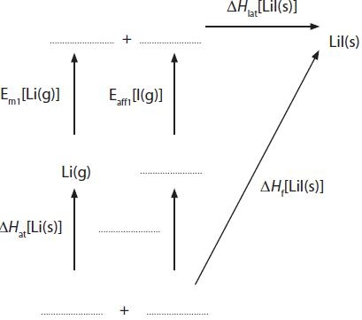
(c) Calculate the electron affinity of iodine, E_{aff1}[I(g)], using the data below.
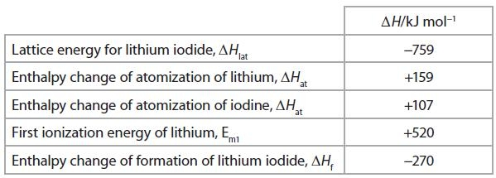
(2)
(d) The experimental lattice energy for lithium iodide is −759 kJ mol⁻¹. The theoretical lattice energy is different from this value.
Will the experimental lattice energy be more negative or less negative than the theoretical lattice energy? Justify your answer.
(3)
........................................................................................................................................
........................................................................................................................................
........................................................................................................................................
........................................................................................................................................
........................................................................................................................................
........................................................................................................................................

(e) State and explain how electron affinity values change as you go down Group 7 from chlorine to iodine.
(2)
........................................................................................................................................
........................................................................................................................................
........................................................................................................................................
........................................................................................................................................
(Total for question = 12 marks)
Q7.
Which of the following quantities, used in the calculation of the lattice energy of lithium oxide, Li₂O, has a negative value?
A The enthalpy change of atomization of lithium.
B The first ionization energy of lithium.
C The first electron affinity of oxygen.
D The second electron affinity of oxygen.

Q8.
The table shows the ionic radius and charge of each of six ions.
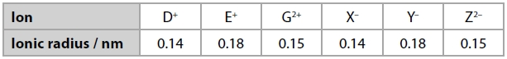
The ionic solids DX, EY and GZ have the same lattice structure.
Deduce the order of magnitude of their lattice energies, giving the most exothermic first.
Justify your answer.
(3)
........................................................................................................................................
........................................................................................................................................
........................................................................................................................................
........................................................................................................................................
........................................................................................................................................
Q9.
In which of the following compounds is the anion most polarized?
A LiF
B LiI
C LiI
D KI
(Total for Question = 1 mark)
Q10.
In the Born-Haber cycle for potassium iodide, which of the following steps is exothermic?
A K(s) → K(g)
B K(g) → K⁺(g) + e⁻
C ½I₂(s) → I(g)
D I(g) + e⁻ → I⁻(g)
(Total for Question = 1 mark)

NAME ...........................……... HOMEWORK DEADLINE .....................
Student Number ………… Chemistry Class ………
2018
Student targets from previous pack

Born Haber Cycles

Task | Mark
Notes completed | /10
Revision Notes | /10
Exam questions | /31
Overall Grade for this work | A B C D E U

Student comments

Tutor comments

Tutor signature Date

Student targets for next pack

Student targets for next pack

