**NAME** ............................................ Chemistry Class ....................

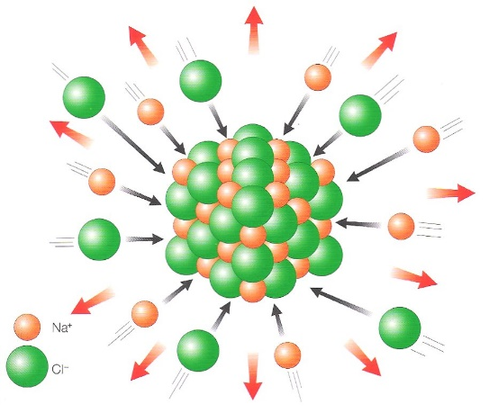Student Number ……….

Born-Haber cycles

Answers

1. be able to define lattice energy as the energy change when one mole of an ionic solid is formed from its gaseous ions

2. be able to define the terms:

i enthalpy change of atomisation, Δat*H*

ii electron affinity

3. be able to construct Born-Haber cycles and carry out related calculations

4. know that lattice energy provides a measure of ionic bond strength

5. understand that a comparison of the experimental lattice energy value (from a Born-Haber cycle) with the theoretical value (obtained from electrostatic theory) in a particular compound indicates the degree of covalent bonding

6. understand the meaning of polarisation as applied to ions

7. know that the polarising power of a cation depends on its radius and charge

8. know that the polarisability of an anion depends on its radius and charge

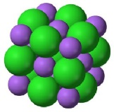

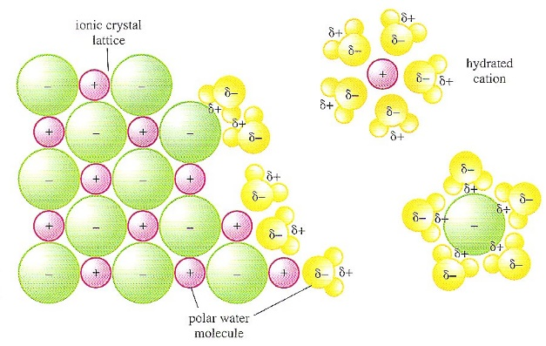

***H*solution**

***H*hydration**

***H*lattice**

IONIC LATTICE

GASEOUS IONS

AQUEOUS IONS

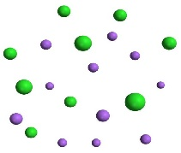

Sodium and chloride ions leaving a crystal lattice and becoming hydrated as they dissolve in water. Here the bond between the ions and the polar water molecules is electrostatic attraction.

**ENERGY CHANGES INVOLVED IN FORMING IONIC COMPOUNDS**

When we **calculate the enthalpy of formation of an ionic compound** we cannot use bond energies because an ionic lattice is formed instead of individual molecules.

In this pack we will look at the energy changes as elements react to form a solid ionic lattice. This leads on from both your work with Energetics and your work with ionic structures.

An ionic lattice is a regular arrangement of alternating positive and negative ions. When these oppositely charged ions come together a **large amount of energy is released**. This is known as the **lattice enthalpy.**

**LATTICE ENTHALPY** of an ionic compound is:

The **energy released** when **one mole** of an **ionic solid** compound in its standard state is formed from its **constituent gaseous ions** starting infinitely far apart.

e.g. Na+(g) + Cl-(g) 🡪 NaCl(s) ΔHlatt = -411 KJmol-1

**NOTE:**  Lattice enthalpies are always **large negative** values. The **larger** the negative value of the **lattice enthalpy** the **stronger the ionic bonds.**

Strong ionic bonding results from ions with:-

* Small ionic radius,
* High charge

Therefore these factors will result in a **more negative lattice enthalpy.**

New exercisePut the following ionic compounds in order of increasing negative lattice enthalpy:

MgCl2, MgO, NaCl, KCl, and explain the order.

KCl < NaCl < MgCl2 < MgO ions with a higher charge 🡪 more exothermic Hlatt

ionic radius Mg2+ < Na+ < K+ < and O2- < Cl- smaller ions 🡪 more exothermic Hlatt .

Unfortunately it is not possible to accurately measure lattice enthalpy directly. Why not?

It is not possible to obtain gaseous ions practically

A **theoretical value** of the attraction can be calculated from electrostatic theory and the charges and radii of the ions involved. We will come back to this later in this topic.

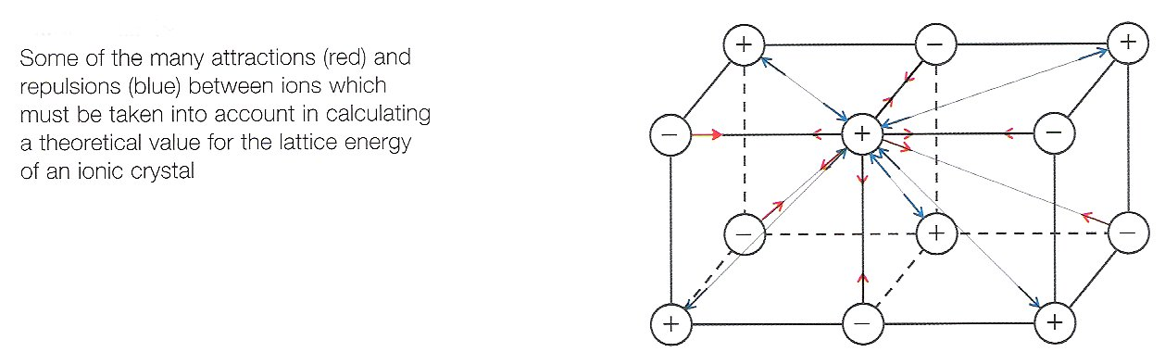

**DEFINITIONS**



Facer p 34-38 and p108

New exerciseTo understand the enthalpy changes involved in the formation of an ionic compound you need to be familiar with the following definitions

Complete the list of definitions with equations (including state symbols) and **LEARN THEM**

**First ionisation energy** H~~o~~i (1) The amount of energy required to remove one mole of electrons from one mole of atoms in the gas phase to produce one mole of gaseous ions of +1 charge, 100 kPa and usually 298K

e.g. equation for the first ionisation energy of magnesium: Δi1 H [Mg]

Mg(g) 🡪 Mg+(g) + e- ΔHi(1) = +ve

**Second ionisation energy** H~~o~~i (2) The amount of energy required to remove one mole of electrons from one mole of gaseous ions of +1 charge to produce one mole of gaseous ions of +2 charge, 100 kPa and usually 298K

e.g. equation for the second ionisation energy of magnesium Δi2 H [Mg+]

Mg+(g) 🡪 Mg+2(g) + e- ΔHi(2)= +ve

**Enthalpy of atomisation** H~~o~~a  The enthalpy change for the production of **one mole of atoms in the gas phase** from the element in its standard state, 100 kPa and usually 298K.

e.g. equation for the enthalpy of atomisation of chlorine ΔeaH [1/2Cl2]

½Cl2(g) 🡪 Cl(g) ΔHat = +ve

**First electron affinity** H~~o~~e (1)  The enthalpy change when one mole of electrons is added to one mole of gaseous atoms to produce one mole of gaseous ions of –1 charge, 100 kPa 298 K

e.g. equation for the first electron affinity of chlorine Δea(1) H [Cl]

Cl(g) + e- 🡪 Cl-(g) ΔHe(1) = -ve/+ve

**Enthalpy of formation** H~~o~~f  The enthalpy change when one mole of a compound in its standard state is formed from its **elements in their standard states** at 100 kPa.,and a specified temperature usually 298K

e.g. equation for the enthalpy of formation of magnesium chloride Δf H [MgCl2]

Mg(s) + Cl2(g) 🡪 MgCl2(s) ΔHfor = -ve/+ve

**Lattice Enthalpy** H~~o~~latt The energy released when one mole of an ionic solid lattice in its standard state is formed from its constituent gaseous ions

e.g. equation for the lattice enthalpy of magnesium chloride Δlatt H [MgCl2(s)]

Mg2+(g) + 2Cl-(g) 🡪 MgCl2(s) ΔHlatt = -ve

**BORN-HABER CYCLES**

Because we cannot easily measure the experimental value for the lattice enthalpy we have to construct a version of a Hess cycle called a **Born-Haber** cycle in order to find lattice enthalpy from other experimentally determined enthalpy changes.

A **BORN-HABER CYCLE** is an **enthalpy cycle**/Hess cycle composed of **all the enthalpy changes** in the **steps** involved in the **formation of 1 mole of ionic compound** from its constituent **elements in their standard states.**

The diagram below shows this cycle in a simple and incomplete form.

There are three enthalpy changes represented:-

* New exerciseIdentify and label the lattice enthalpy, H~~o~~latt
* Identify and label the enthalpy of formation, H~~o~~f

The remaining enthalpy change represents a multi-step process.

* Identify this change with a multi-headed arrow, 🡪🡪🡪

ΔH~~o~~f

Compound as an ionic crystalline lattice

Elements in their standard states

ΔH~~o~~latt

Ions in their gaseous state

**EXAMPLE – CONSTRUCTING A BORN-HABER CYCLE FOR SODIUM CHLORIDE**

* Write an equation to represent the enthalpy change of formation of sodium chloride:-

**Correct states of matter are essential**

Na(s) + ½Cl2(g) 🡪 NaCl(s)

* Write an equation to represent the lattice enthalpy of sodium chloride:-

Na+(g) + Cl-(g) 🡪 NaCl(s)

New exerciseAs previously, write the chemical species involved in the formation of NaCl into the correct boxes and label them.

Identify the multi-step process with a multi-headed arrow.

ΔH~~o~~f

NaCl(s)

Na(s) + ½Cl2(g)

ΔH~~o~~latt

Na+(g) + Cl-(g)

The next step is to identify the enthalpy changes involved in the multi-step process.

* Conversion of Na(s) 🡪 Na+(g)

Identify the missing form of sodium and above each arrow write the **name** and **symbol for the type of enthalpy change** involved in the change indicated.

ΔH~~o~~~~i~~(1)

ΔH~~o~~at

Na(g)

Na+(g)

Na(s)

* Conversion of ½ Cl2(g) 🡪 Cl-(g)

Identify the missing form of chlorine and above each arrow write in the name and symbols for the enthalpy change

ΔH~~o~~~~e~~(1)

ΔH~~o~~at

Cl(g)

½ Cl2(g)

Cl-(g)

**BORN-HABER CYCLE FOR SODIUM CHLORIDE**

We are now in a position to complete a **Born-Haber** cycle using the following values:

**Given**:- Na(s) 🡪 Na(g) H~~o~~a = +108 kJ mol-1

Na(g) 🡪 Na+(g) H~~o~~i,(1) = +500 kJ mol-1

½ Cl2(g) 🡪 Cl(g) H~~o~~a  = +121 kJ mol-1

Cl(g) + e- 🡪 Cl-(g) H~~o~~e(1) = -364 kJ mol-1

**New exercise** Na(s) + ½ Cl2(g) 🡪 NaCl(s) H~~o~~f = -411 kJ mol-1

**Fill in the NAMES of the changes below:**

* H~~o~~f [NaCl(s)] Enthalpy of formation of NaCl
* H~~o~~a [Na(s)] Enthalpy of atomisation of Na
* H~~o~~a [Cl2(g)] Enthalpy of atomisation of Cl
* H~~o~~i,1 [Na(g)] First ionisation energy of Na
* H~~o~~e [Cl(g)] First electron affinity of Cl
* H~~o~~latt [NaCl(s)] Lattice enthalpy of NaCl

**Label each arrow with the correct thermochemical symbols and values**

Na(s)

½Cl2(g)

NaCl(s)

Na(g)

Cl(g)

Na+(g)

Cl-(g)

ΔH~~o~~f

ΔH~~o~~at

ΔH~~o~~at

ΔH~~o~~~~i~~(1)

ΔH~~o~~~~e~~(1)

ΔH~~o~~latt

**+**

**+**

**+**



Use the Hess cycle constructed above to complete the equation:

H~~o~~f [NaCl(s)] = ΔHatNa + ΔHiNa + ΔHat½Cl2 + ΔHeCl + ΔHlattNaCl

Rearrange, to give latt = H~~o~~f [NaCl(s)] – (ΔHatNa + ΔHiNa + ΔHat½Cl2 + ΔHeCl)

Insert the values with correct signs to calculate the Lattice Enthalpy

So, latt = ( – 411 ) – (+108) + (+500) + (+121 ) + (–364))

= – 776 kJ mol-1 units

**ENTHALPY LEVEL DIAGRAMS**

A Born-Haber cycle can be represented as an enthalpy level diagram as shown below.

* Start at the datum line where the enthalpy of elements in their standard states is zero.
* ↑ Arrows represent endothermic reactions and ↓ arrows represent exothermic reactions
* New exerciseComplete the thermochemical symbols identifying the H changes

Na+(g) + e- + Cl(g)

 H~~o~~ atomisation Cl

 kJ mol

Na+(g) + e- + ½Cl2(g)

600

 H~~o~~ electron affinity Cl

 kJ mol

Enthalpy, H kJ mol-1

400

 H~~o~~ ionisation Na

Na+ (g) + Cl-(g)

 kJ mol

200

 H~~o~~ lattice NaCl

Na(g) + ½Cl2(g)

 H~~o~~ atomisation Na

 kJ mol

Na(s) + ½ Cl2(g)

elements 0

DATUM LINE

 H~~o~~ formation NaCl

 kJ mol

-200

Na+Cl-(s)

-400

Use this to calculate the lattice enthalpy of NaCl

Remember use Hess Law, so clockwise cycle = anticlockwise cycle

Show these arrows on your diagram

ΔHatNa + ΔHiNa + ΔHat½Cl2 + ΔHeCl + ΔHlattNaCl = H~~o~~f [NaCl(s)]

ΔHlattNaCl = H~~o~~f [NaCl(s)] – (ΔHatNa + ΔHiNa + ΔHat½Cl2 + ΔHeCl)

= (– 411) – ((+108) + (+500) + (+121) + (–364)

=– 411 – (+365) = – 776 kJ mol-1

1. Draw a Born Haber cycle for KI and use it to find the Lattice enthalpy of potassium iodide.

New exerciseK(s) 🡪 K(g) H~~o~~a = +90 kJ mol-1

K(g) 🡪 K+(g) H~~o~~i,(1) = +418 kJ mol-1

½ I2(s) 🡪 I(g) H~~o~~a  = +107 kJ mol-1

I(g) + e- 🡪 I-(g) H~~o~~e(1) = -314 kJ mol-1

K(s) + ½ I2(g) 🡪 KI(s) H~~o~~f = -411 kJ mol-1

K(s)

½I2(s)

KI(s)

K(g)

I(g)

K+(g)

I-(g)

ΔH~~o~~f

ΔH~~o~~at

ΔH~~o~~at

ΔH~~o~~~~i~~(1)

ΔH~~o~~~~e~~(1)

ΔH~~o~~latt

**+**

**+**



H~~o~~f [KI(s)] = ΔHatK + ΔHiK + ΔHat½I2 + ΔHeI + ΔHlattKI

                     = ((+90) + (+418) + (+107) + (-314)) + ΔHlattKI

= (+301) + ΔHlattKI

ΔHlattKI = H~~o~~f [KI(s)] – (+301)

= – 411 – 301 = – 712 kJ mol-1

**2**. Draw a Born-Haber cycle and use it to calculate the lattice enthalpy of calcium oxide using the values:

Atomisation enthalpy of Ca = +178.2 kJ mol-1

First ionisation enthalpy of Ca = +590 kJ mol-1

Second ionisation enthalpy of Ca = +1145 kJ mol-1

Atomisation enthalpy of Oxygen = +249.2 kJ mol-1

First electron affinity of Oxygen = -141.1 kJ mol-1

Second electron affinity of Oxygen = +798 kJ mol-1

Enthalpy of formation of Calcium Oxide = -635.1 kJ mol-1

Ca(s)

½O2(s)

CaO(s)

Ca(g)

O(g)

Ca+(g)

O-(g)

ΔH~~o~~f

ΔH~~o~~at

ΔH~~o~~at

ΔH~~o~~~~i~~(1)

ΔH~~o~~~~e~~(1)

ΔH~~o~~latt

**+**

**+**

Ca2+(g)

ΔH~~o~~~~i~~(2)

O2-(g)

ΔH~~o~~~~e~~(2)

H~~o~~f [CaO(s)] = ΔHatCa + ΔHi(1)Ca + ΔHi(2)Ca +ΔHat½O2 + ΔHe(1)O + ΔHe(2)O +ΔHlattCaO

                     = ((+178.2) + (+590) + (+1145) + (+249.2) + (-141.1) + (+798)) + ΔHlattCaO

= (+2819.3) + ΔHlattCaO

ΔHlattCaO = H~~o~~f [KI(s)] – (+2819.3)

= – 635.1 – 2819.3 = – 3454.4 kJ mol-1

Explain why the value of lattice enthalpy for CaO is very different to that of KI.

WorksheetBoth ions Ca2+ and O2- have greater charges than K+ and I- and the ionic radii are smaller so the electrostatic attraction will be greater resulting in a more exothermic Hlatt.

See worksheet [lattice enthalpy questions](http://moodle.godalming.ac.uk/learning/file.php/1008/Unit%201/2009%20Packs/Worksheets/Lattice%20enthalpy%20questions.doc)

**Exam Technique**

Correct the following exam responses to the question:

**Taken from A-level paper 1 2016 question 6(b)**

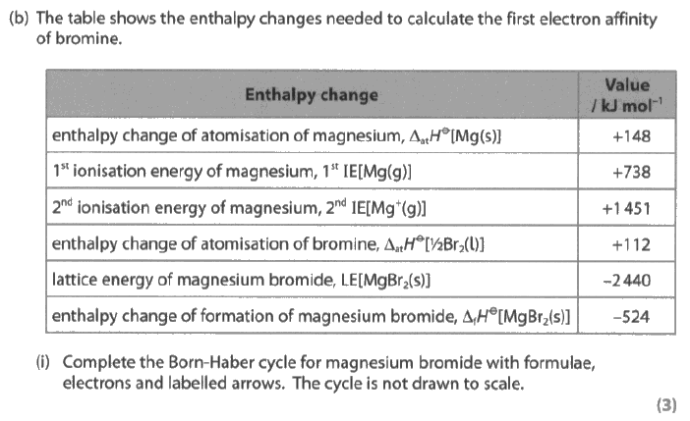

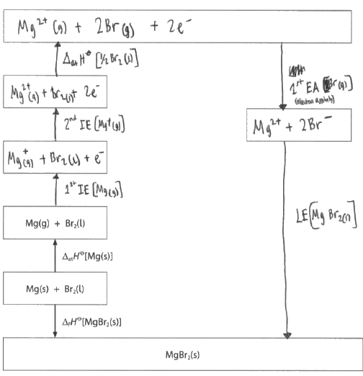

**1 mark awarded, have not doubled Br enthalpy changes and no state symbols.**

What’s wrong with this calculation?

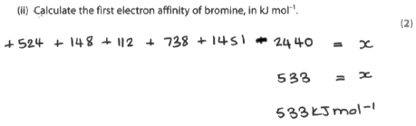

**1 mark - Missed doubling the changes for bromine, and then halving at the end**

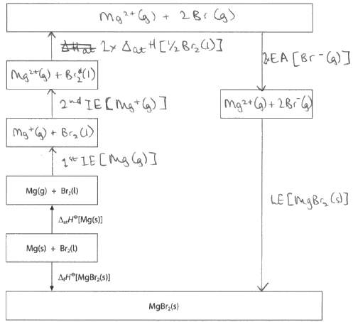

**All correct – 3 marks awarded**

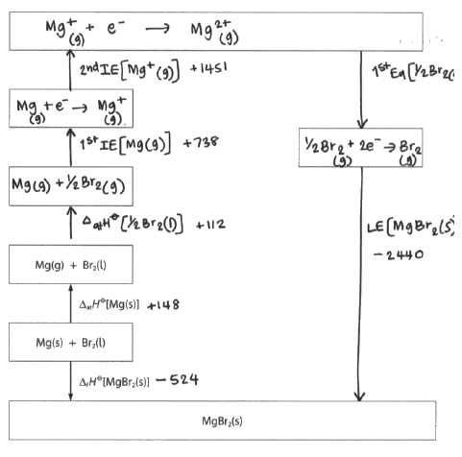

**1 mark – didn’t double bromine changes and missing Br from some of the boxes**

**EXPERIMENTAL AND THEORETICAL VALUES**

So far, all the lattice enthalpies have been calculated from indirect Hess cycles called Born-Haber cycles.

All the data values such as enthalpies of atomisation, ionisation and electron affinity have been determined experimentally

As a result the **Born Haber values calculated are referred to as experimental values**

**Theoretical values** can be calculated from the ionic radius and charges of the ions involved. The smaller the ionic radius and the higher the charge on the ion, the stronger the force of attraction between the ions. This calculation **assumes a purely ionic model.** (see front cover and page 1 diagram)

In most cases there is a good agreement between the two:-

|  |  |  |
| --- | --- | --- |
| Compound | Lattice Enthalpy kJ mol-1 | |
| Born-Haber | Theoretical  **Small Ag+ cation** polarises the larger anions more  Increased size of anion but large cation does not polarise it much |
| NaF | -918 | -912 |
| NaCl | -780 | -770 |
| NaBr | -742 | -735 |
| NaI | -705 | -687 |
| AgF | -958 | -920 |
| AgCl | -905 | -833 |
| AgBr | -891 | New exercise-816 |
| AgI | -889 | -778 |

Highlight those compounds with a discrepancy. Can you suggest a reason? Bonding must be stronger

The theoretical model assumes that the compound is 100% ionic. However with small highly charged cations and large anions a degree of [polarisation](http://www.webchem.net/notes/chemical_bonding/polarisation_of_bonds.htm) occurs.

Polarisation is : when small highly charged cations distort (attracts the electron clouds of) large highly charged anions leading to a degree of covalency.

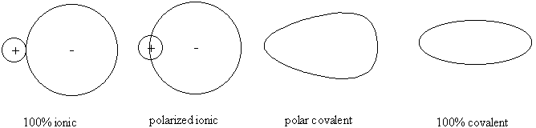Polarization of ionic compounds occurs when the cation is very small and the anion is very large and polarisable.

Rather than the 100% ionic model some ionic compounds exhibit a degree of covalency, due to the polarisation of the anion (-ve) by the cation (+ve)

Cations with a small radius and high charge have a high polarising power

Anions with a large radius and high charge are easily polarised.

For example, AlCl3(s) the bonding is mainly covalent. Why?

Al3+ ion has a very small ionic radius and a high charge (high charge density)

It polarises the large Cl- anions leading to covalent bonding

Use the idea of polarisation to explain the difference between he theoretical and experimental values for MgI2.

Theoretical value assumes 100% ionic bonding.

Actual (experimental) value is more exothermic with stronger bonding.

WorksheetSmall highly charged Mg2+ polarises the large I- anion resulting in covalent character of the bonding.

For additional practice ‘Born Haber cycles’ worksheet

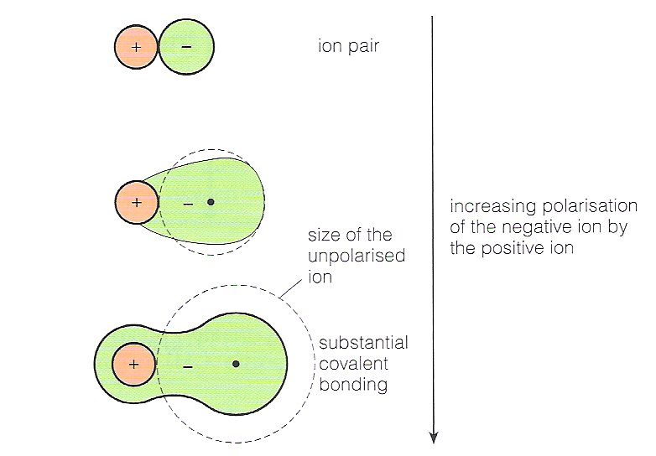An alternative diagram to show the polarisation of (a large) anion by a (small highly charged) cation:-

New exercise**Revision page**

**Mark Scheme**

Q1. a) D

b) B

**Q2.**

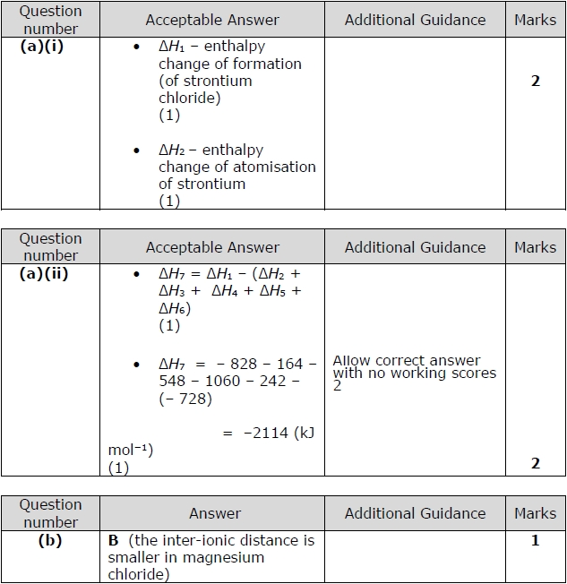

**Q3.**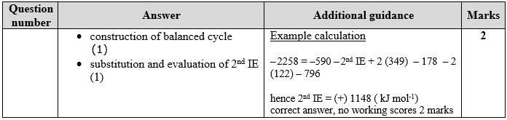

**Q4. D**

**Q5.a) D**

**b) B**

**c) D**

**Q6.**

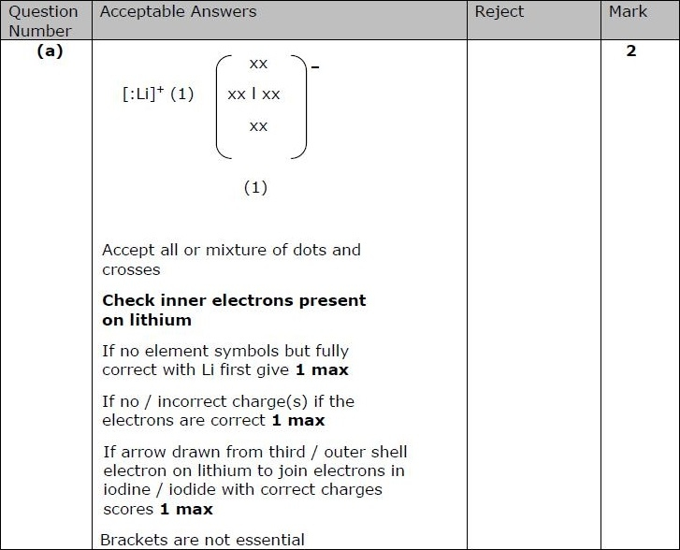

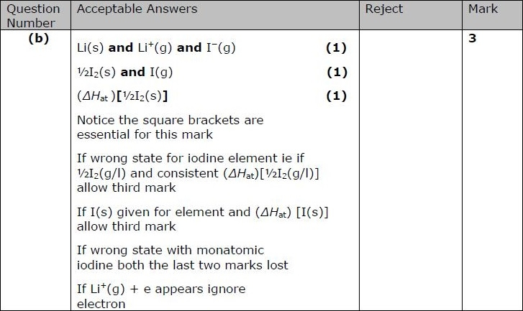

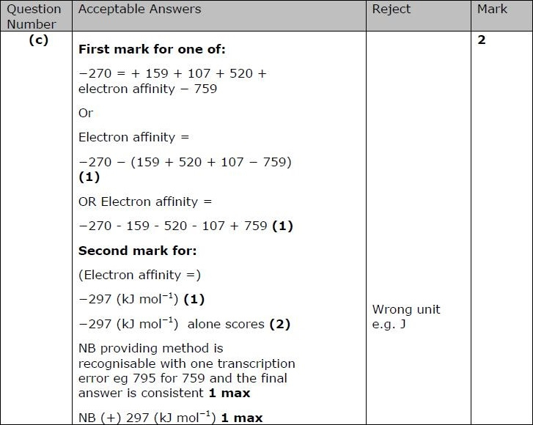

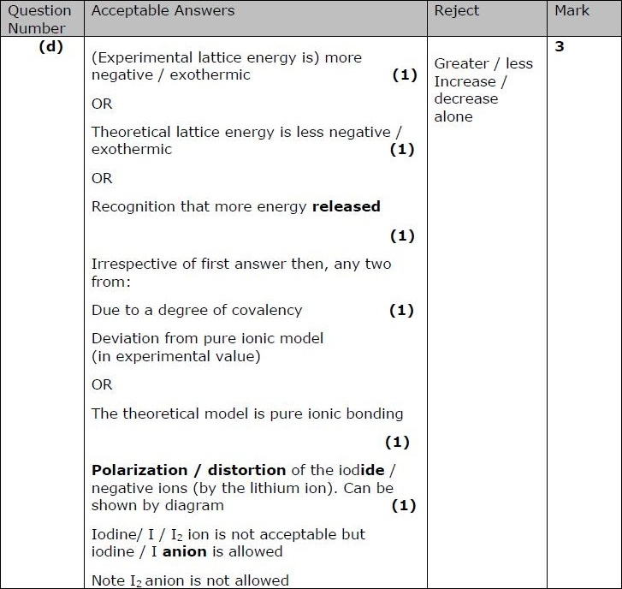

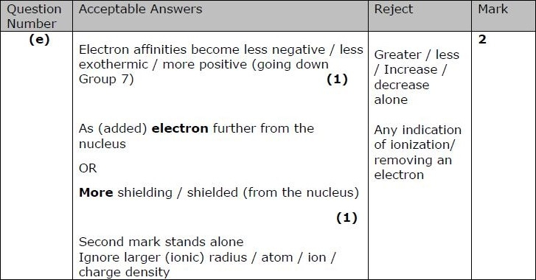

**Q7. C**

**Q8.**

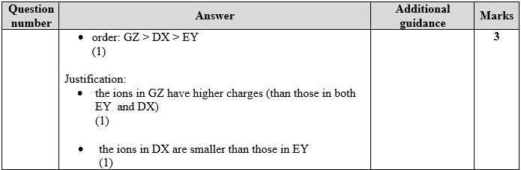

**Q9.**



**Q10.**

