**(Unit 12 Contemporary Dance Technique)**

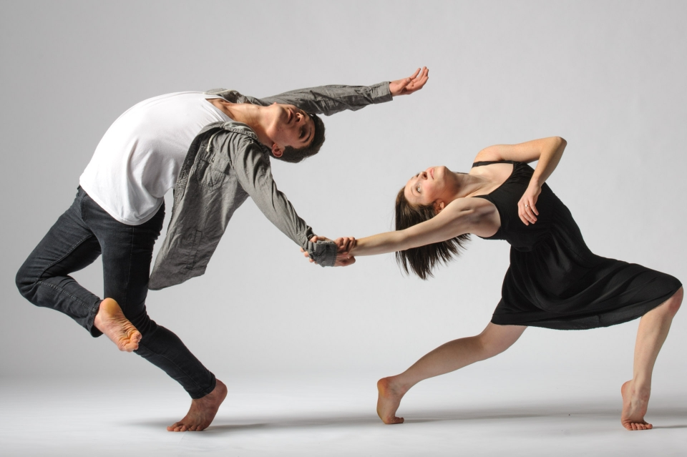

**Learning Aim A:**

**Understand the development of contemporary dance**

|  |  |
| --- | --- |
| Name: |  |

A.P1 Explain the development of contemporary dance practice through exploration.

A.M1 Analyse the development of contemporary dance practice through effective exploration comparing key features of practitioner performance styles.

A.D1 Evaluate the development of contemporary dance practice through effective exploration comparing and contrasting well-chosen examples of practitioner performance styles to support findings.

**The Development of Dance -**

**P1 | M1 | D1**

|  |  |
| --- | --- |
|  | Loie Fuller  Brief biography. Describe and analyse her work. Share your initial personal response to her work  **650-750 words** |

**P1 | M1**

|  |
| --- |
| **What are the key features of Fuller’s styles and your personal response to it?** 400-500 words |
|  |

**M1 (D1)**

|  |  |  |  |  |  |  |  |  |  |  |  |  |  |  |
| --- | --- | --- | --- | --- | --- | --- | --- | --- | --- | --- | --- | --- | --- | --- |
| **WHAT SKILLS HAVE YOU EMPLOYED DURING YOUR INVESTIGATION** | | | | | | | | | | | | | | |
| Physical skills | Used | + | = | - |  | Used | + | = | - |  | Used | + | = | - |
| 1.Posture |  |  |  |  | 8. Positions/use of the spine |  |  |  |  | 15. Focus |  |  |  |  |
| 2.Alignment |  |  |  |  | 9. Fluidity |  |  |  |  | 16. Musicality |  |  |  |  |
| 3.Balance/Stability |  |  |  |  | 10. Elevation |  |  |  |  | 17. Timing |  |  |  |  |
| 4.Co-ordination |  |  |  |  | 11. breath |  |  |  |  | 18. Dynamics |  |  |  |  |
| 5.Flexibility |  |  |  |  | 12.Fall & Recover |  |  |  |  | 19. Spatial awareness |  |  |  |  |
| 6.Strength |  |  |  |  | 13. Shifting of body weight |  |  |  |  | 20. Use of Prop |  |  |  |  |
| 7.Stamina |  |  |  |  | 14. Isolations |  |  |  |  | 21.Expression |  |  |  |  |

**KEY STYLISTIC TECHNIQUES EXPLORED DURING YOU INVESTIGATION**

**M1 / D1**

|  |  |  |
| --- | --- | --- |
| **Technique** | **Description** 100-150 words per technique | **Evaluation**  150 words per technique |
| 1. |  |  |
| 2. |  |  |
| 3. |  |  |
| 4. |  |  |
| 5. |  |  |
| 6. |  |  |

**M1 / D1 (A well-argued / evaluative commentary)**

|  |
| --- |
| **How did Loie Fuller ‘break the mould’ for audiences attending her Paris performances? Refer to dance styles which came before. 500 words** |
|  |

**M1 / D1 (A well-argued / evaluative commentary)**

|  |
| --- |
| **Loie Fuller’s role in dance history is often understated, despite being critical in the development of Isadora Duncan’s practice. Consider why this might be and how Duncan came to be considered the ‘Mother of Modern Dance’ instead of Fuller. 500 words** |
|  |

**M1 / D1 (A well-argued / evaluative commentary)**

|  |
| --- |
| **Explain how the did social/historical context impacted on the work of Fuller (with particular reference to technology) and Duncan (with reference to feminism/suffrage) 650-750words** |
|  |