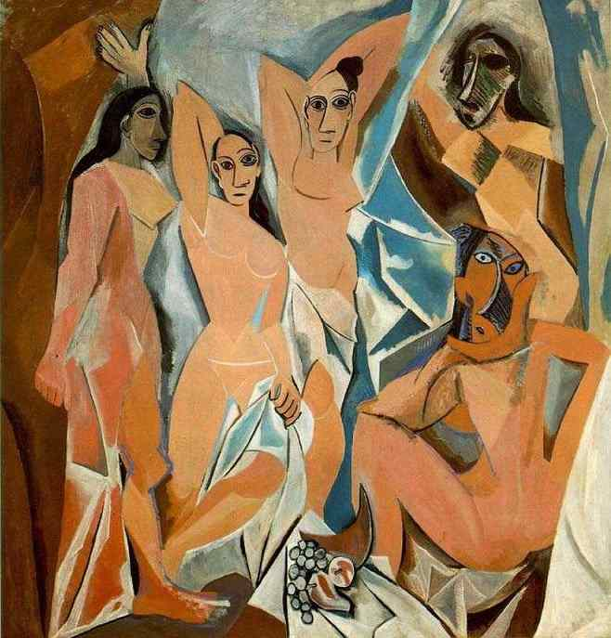**Picasso's African-influenced Period - 1907 to 1909**

During the early 1900s, the aesthetics of traditional African sculpture became a powerful influence among European artists who formed an avant-garde in the development of modern art. In France, [Henri Matisse](http://www.henrimatisse.org), Pablo Picasso, and their School of Paris friends blended the highly stylized treatment of the human figure in African sculptures with painting styles derived from the post-Impressionist works of [Édouard Manet](http://www.manet.org), [Paul Cézanne](http://www.paulcezanne.org) and [Paul Gauguin](http://www.gauguin.org). The resulting pictorial flatness, vivid color palette, and fragmented Cubist shapes helped to define early modernism. While these artists knew nothing of the original meaning and function of the West and Central African sculptures they encountered, they instantly recognized the spiritual aspect of the composition and adapted these qualities to their own efforts to move beyond the naturalism that had defined Western art since the Renaissance.   
  
Picasso's African Period lasted from 1907 to 1909. This period, which followed his Blue Period and Rose Period, was also called the Negro Period or Black Period.

As [Henri Matisse](http://www.henrimatisse.org) exhibited his [Blue Nude](http://www.henrimatisse.org/blue-nude.jsp) in 1907 and [The Dance](http://www.henrimatisse.org/the-dance.jsp) in 1909, Picasso countered with the work that become one of the cornerstones of his fame, which we now know as [Les Demoiselles d'Avignon](http://www.pablopicasso.org/avignon.jsp). In this work, he began to incorporate African influences into his work.   
  
Before Picasso started his Back Period he came into the possession of some ancient Iberian sculptures that he got from an acquantaince who had stolen them from the Louvre museum in Paris. In [Les Demoiselles d'Avignon](http://www.pablopicasso.org/avignon.jsp) the faces of the three women on the left are based on the Iberian sculptures. So as to avoid compositional monotony, Picasso based the faces of the two women on the right on the African totem art, that he had also collected.

Throughout Picasso's career, periods would be concluded by a major artwork that contained all the new things he had learned. The painting Life concluded and summarized his blue period and [The Family of Saltimbaques](http://www.pablopicasso.org/saltimbanques.jsp) did the same for his rose period. Now it was up to the Demoiselles to show what he had been up to during his black period.

Later in his life, Picasso would deny he had been inspired by African art, while making the Demoiselles (partly because of political, patriotic reasons - Picasso preferred to emphasize the Iberian nature of the painting), but there seems to be ample evidence that he was familiar with, and was already collecting African art while making the Demoiselles.

Picasso acknowledged that a visit to the Trocadero museum changed him, but he didn't say why, he never gave African art the credit it deserves. Some pieces of African art in the Trocadero are as much "wonders of the world" as the pyramid of Giza or the works of [Rembrandt](http://www.erembrandt.org), not technically of intellectually, but for their incredible emotional intensity. Throughout Picasso's work you can see references to some of the African masks he saw at the Trocadero, but rather as pale, timid caricatures, totally lacking the power of the originals - maybe that's why Picasso always was so secretive about his African influences. Picasso's unique gift to art was his unparallelled flexibility, that allowed him to identify, absorb and use in his own art, much of what the history of human art had to offer.

After painting *Les Demoiselles d'Avignon*, Picasso began painting in a style influenced by the two figures on the right side of the painting, which were based on African art. Although the painting is seen as the first Cubist work, before beginning the Cubist phase of his painting, he spent several years exploring African art. During this time the French empire was expanding into Africa, and African artifacts were being brought back to Paris museums. The press was abuzz with exaggerated stories of cannibalism and exotic tales about the African kingdom of Dahomey. Also talked about was the mistreatment of Africans in the Belgian Congo with Joseph Conrad's popular book Heart of Darkness. It was natural therefore in this climate of African interest that Picasso would look towards African artifacts as inspiration for some of his work.

Picasso's African influenced period was followed with the style known as Analytic Cubism, which had also developed from Les Mademoiselle Mignonne's. Specifically Picasso's interest was sparked by [Henri Matisse](http://www.henrimatisse.org) who showed him a mask from the Dan region of Africa. Scholars maintain that Matisse purchased this piece from Emile Heymenn's shop of non-western artifacts in Paris.

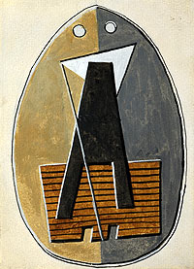Source: <http://www.pablopicasso.org/africanperiod.jsp>

## Picasso and Africa: Africa's magic that transformed modern art

# An exhibition in South Africa reveals the depth of African influence on Picasso

Feb 9th 2006 | The Economist johannesburg

PABLO PICASSO never went to Africa. But more than three decades after his death, his art is travelling to the continent that so deeply affected his work. “Picasso and Africa”, the most extensive exhibition of the artist's work ever assembled in the region, was due to open at the Standard Bank Gallery in Johannesburg on February 10th, and will travel to the Iziko South African National Gallery in Cape Town in April. The show, which highlights Africa's influence on Picasso's work, brings more than 80 of his paintings, drawings and sculptures together with a selection of African masks and statues similar to those that he had around him as he worked.

Picasso said that the “virus” of African art stayed with him throughout his life. He caught it in June 1907, when stumbling upon the African and Oceanic collection at the Ethnographic Museum of the Trocadéro in Paris. The fateful encounter was a revelation: “The masks were not simply sculptures like any other. Not at all. They were magical objects.” That day, he later said, he understood what painting really meant. “It is not an aesthetic process; it's a form of magic that interposes itself between us and the hostile universe, a means of seizing power by imposing a form on our terrors as well as on our desires.”

He had been working on “Les Demoiselles d'Avignon”, which became one of his most famous paintings. The visit to the museum gave him the answers he had been looking for. This portrait of five prostitutes, which he described as his first “exorcism painting”, was his first work to bear signs of African influence, with two of the women's faces shown as African masks.

Many other signs were to follow. The exhibition shows how Picasso absorbed Africa's abstract, expressive representations of faces and bodies, and made them his own. He started fragmenting and faceting the human figure, which eventually gave birth to cubism. He was later inspired by African power masks from Congo—wood carvings used by diviners to help them communicate with the spirits—which used everyday materials, such as nails and mirrors. Picasso created one of the sculptures in the exhibition, “Head of a Woman”, out of a colander and springs; nails and newspapers find their way into other works.

The show offers visitors a glimpse into Picasso's genius at work. Many of the pieces exhibited are drawings, sculptures and studies that the artist kept in his studio and which document and dissect his experiments with a new art form. His fascination for African art had turned into a collecting bug, which he fed as he wandered the flea markets of Paris and Marseilles. He gathered over 100 African statues and masks, and kept them by him. Visitors to the exhibition, surrounded by work in progress and with African artefacts beaming their magic, feel transported to his studio.

Many of Picasso's contemporaries shared his fascination with African art. Artists such as André Derain, Maurice de Vlaminck, Georges Braque and Henri Matisse were also avid collectors. In the early 20th century, France's colonial push into Africa encouraged an interest in the tales and objects from mysterious, exotic lands, which travelled back with soldiers, traders and missionaries. Picasso and his fellow avant-garde artists, who had been searching for a new artistic language to break the mould of conventional representation, were exposed to forms rich in symbols.

Africa found its way in varying degrees into their work. Yet, explains Marilyn Martin, one of the exhibition's curators, Picasso had a unique understanding of the magical and ritualistic power of African art, which influenced him far beyond form. That encounter at the Ethnographic Museum transformed his artistic vision, and with it the direction of modern art.