BTEC Assignment Brief
Qualification | Pearson BTEC Level 3 National Diploma in Creative Digital Media Production (Film and Television Production)
Unit number and title | Unit 35: Multi Camera Techniques
Learning aim(s) (For NQF only) | A: Understand different types of multi-camera production and the role of the crew
Assignment title | Introducing Multi Camera Production
Assessor | Mark Piper, Matt Toogood
Issue date | 11th September 2023
Hand in deadline | 13th October 2023
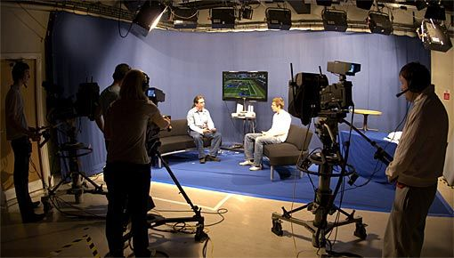
Vocational Scenario or Context | Godalming College has received funding to create a local, digital broadcast, TV channel – Godalming TV - and wants to invest some of its resources in live studio-based TV programming.  They would like some information about how they can use a range of multi camera programmes to best serve its audience and have asked you to provide an illustrated report that explains the medium in detail.
Task 1 | - You must produce either;  - an illustrated blog report with video clips and diagrams, that demonstrates your knowledge and understanding of the purposes and formats of multi camera productions, or;  - an interactive power-point presentation with audio commentary, video clips and diagrams, that demonstrates your knowledge and understanding of the purposes and formats of multi camera productions.  As the organisation wishes to explore non-narrative and narrative programming using a studio, you will need to demonstrate your understanding of both types of multi camera productions. To do this you should review two different programmes of each type and analyse how the producers use the multi-camera format and why this is beneficial to the productions.  You should illustrate this with diagrams of studio sets showing camera positions and other equipment.  - The organisation needs to build a team who will be able to carry out the production of multi camera programmes so need a detailed explanation of the roles and responsibilities of production staff that would be required to do this. You should use the examples of the programmes that you review to illustrate how the roles work together to make the programme.  You need to include:  - narrative formats such as soap operas, situation comedies and live drama recordings;  - non-narrative formats such as news programming, game shows, chat shows, live events recording;  - roles and responsibilities of studio floor staff;  - roles and responsibilities of gallery staff.  You should evaluate the importance of each in role to the outcome, giving appropriate examples of how they interrelate.
Checklist of evidence required | You should submit your work towards this task in one of the following digital formats:  - a blog report (with video clips and diagrams where necessary);  - an illustrated power-point presentation with audio commentary
Criteria covered by this task:
Unit/Criteria reference |  | To achieve the criteria you must show that you are able to:
Unit 35 / A.D1 |  | Evaluate the roles of team members employed in the different multi camera production teams using examples of multi camera production use.
Unit 35 / A.M1 |  | Analyse effectively how different types of multi camera programmes are used, employing correct terminology.
Unit 35 / A.M2 |  | Explain in detail how the roles and responsibilities of a multi camera production team interact effectively.
Unit 35 / A.P1 |  | Explain how multi cameras are used in producing non-narrative and narrative multi camera programmes using relevant terminology.
Unit 35 / A.P2 |  | Explain how the roles and responsibilities of a multi camera production team interact.
Sources of information to support you with this Assignment | Books  - Kindem G – Introduction to Media Production (4th edition), Focal Press, 2009 ISBN 978-0240810829  This is a text book that covers all media sectors and the requirements of producers.  - Stradling L – Production Management for TV and Film (1st edition), Methuen Drama , 2010, ISBN 978-1408121801  This book gives a comprehensive account of the tasks associated with managing a range of TV and Film projects.  Websites  - www.bbc.co.uk/dna/filmnetwork/Filmmakingguide – BBC information about film making  - www.bectu.co.uk – BECTU Broadcasters Union - roles in the media industries  - www.celtx.com – free pre-production software  - www.primary-film-focus.co.uk/filmpreproduction.html – information about film production techniques  - http://www.theguardian.com/tv-and-radio/interactive/2013/sep/25/reader-tv-pitch/review - The Guardian examples of film pitch and proposal
Other assessment materials attached to this Assignment Brief | Unit 36: Lighting Techniques

