## 01 Macroeconomic Policies:

## Fiscal Policy and Supply Side Policies

[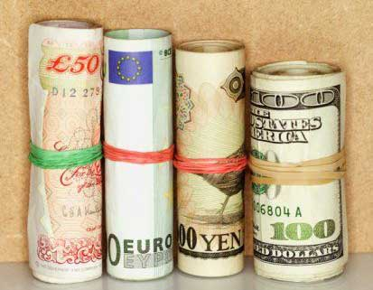](http://www.google.co.uk/url?sa=i&rct=j&q=&esrc=s&source=images&cd=&cad=rja&uact=8&ved=0ahUKEwjricPpzP_OAhVCRhQKHbA8CDsQjRwIBw&url=http://economics4bastudents.blogspot.com/2013/06/fiscal-policy.html&psig=AFQjCNFPk2ZcFJcPmjmHh-DzyXLBpuf92A&ust=1473418164808283)

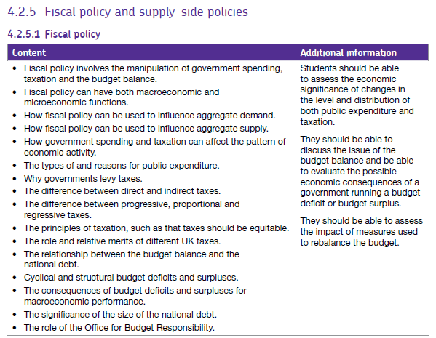

**Starter 1**: Answer the questions below and grade your answer 1 to 5: (1 =excellent: 5= poor)

1. What is Fiscal Policy?
2. What is expansionary Fiscal policy?
3. What are the aims of Fiscal Policy?

**Starter 2:** Decide if the following statements are true or false. (Circle the correct answer)

1. In any given year government spending must equal the total amount of tax that a government collects. (T/F)
2. VAT raises the largest amount of tax revenue for the government (T/F)
3. Countries have a budget deficit when G is less than T (T/F)
4. The National Debt is another word for the Public Debt (T/F)
5. The highest spending Government Department is welfare (T/F)
6. G is made up of two broad categories, current spending and capital spending (T/F)
7. In the UK, consumption as a proportion of GDP is approximately 30% (T/F)
8. Fiscal Policy can only affects the Aggregate Demand curve (T/F)
9. Fiscal Policy is the primary tool for controlling inflation in the economy (T/F)
10. VAT is an example of a specific tax (T/F)

**Extension activity**

1. The multiplier effect is when a change in a component of AD leads to a larger overall change in GDP (T/F)
2. A budget deficit is where a country imports more than it exports (T/F)
3. A budget deficit means that the national income of the economy is falling (T/F)
4. The formula for the circular flow of income is: Income = output = expenditure (T/F)
5. In economics we assume that progressive taxes provide incentive for people to work harder (T/F)

**Fiscal policy Stretch and Challenge**

**Extension activity 1**: i) Draw 2 diagrams that are appropriate for each event (one macro, one micro). ii) Then write an explanation that links the two events.

**Scenario 1**: An increase in Trade Union power causing cost pushes inflation.

Micro Diagram Macro Diagram



**Example answer**:

There has been an increase **in trade union power** which has pushed up wages (micro diagram). This means there has been **an increase in firm’s costs** which in turn leads to a **fall in the SRAS**, resulting in **cost push inflation**.

**Scenario 2**: An increase in **population** causing an increase in Aggregate Demand

Micro Diagram Macro Diagram

Write your explanation here:

………………………………………………………………………………………………………………………………………………………………………………………………………………………………………………………………………………………………………………………………………………………………………………………………………………………………………………………………………………………………………………………………………………………………………………………………………………………………………………………………………………………………………………………………………………………………………………………………………………………………………………………………………………………………………………………………………………………………………………………………………………………………………………………………………………………………………………

1. **Title**: Increase in firm’s wages

**2. Title**: Cost push inflation

**2. Title:** Increase in Aggregate demand

1. **Title**: Increase in Population

.

**Hint**: Increases in the Population may affect the demand and/or the supply-side of the economy.

**Extension activity 2**: For each of the scenarios below show the effects on an AD-AS diagram. Explain your answers!

**Explanation**

……………………………………………………………………………………………………………………………………………………………………………………………………………………………………………………………………………………………………………………………………………………………………………………………………………………………………………………………………………………………………………………………………………………………………………………………………………………………………………………………………………………………………………………………………………………………………..

**Scenario 1**: In a given fiscal year Public spending rises to £800bn whilst tax receipts are reduced to £600bn.

**Diagram**

**Explanation**

……………………………………………………………………………………………………………………………………………………………………………………………………………………………………………………………………………………………………………………………………………………………………………………………………………………………………………………………………………………………………………………………………………………………………………………………………………………………………………………………………………………………………………………………………………………………………..

**Scenario 2**: A Government cuts income tax by £10bn whilst at the same time reducing government spending by £10bn.

**Diagram**

**Explanation**

……………………………………………………………………………………………………………………………………………………………………………………………………………………………………………………………………………………………………………………………………………………………………………………………………………………………………………………………………………………………………………………………………………………………………………………………………………………………………………………………………………………………………………………………………………………………………..

**Scenario 3**: An economy experiences a sustained period of low and stable prices.

**Diagram**

**Activity 1:** Draw and label i) the trend rate of economic growth ii) the actual growth rate iii) both kinds of output gaps and iv) the 4 phases of the economic cycle: recovery, slowdown, boom, recession

Real GDP

Time

**Activity 2:** Complete the table below to show what is happening in the economy. Hint: Use the following terms: “**increasing / decreasing/ high /low”**

|  |  |  |  |  |
| --- | --- | --- | --- | --- |
|  | **Boom** | **Recession** | **Slump** | **Recovery** |
| **Output** |  |  |  |  |
| **Inflationary pressure** |  |  |  |  |
| **Unemployment** |  |  |  |  |
| **Welfare payments** |  |  |  |  |
| **Tax Revenue** |  |  |  |  |

**Automatic Stabilisers**

Automatic stabilisers include changes in tax revenues and government spending that occur automatically as the economy moves through the business cycle.

* **Tax revenues:** When the economy is expanding rapidly, tax revenue increases which takes money out of the circular flow of income and spending
* **Welfare spending:** When the economy is growing, the government does not have to spend on means-tested welfare benefits such as unemployment benefits
* **Budget balance and the circular flow:** A fast-growing economy tends to lead to a net outflow of money from the circular flow. Conversely during a slowdown or a recession, the government normally ends up running a larger budget deficit.

**Activity 3**:

1. Country A has recently decided to introduce taxes and welfare spending. In the space below draw:
2. The actual rate of growth without the effect of automatic stabilisers.
3. The actual rate of growth taking into account the effect of automatic stabilisers.

Use the ‘your attempt’ diagram for both drawings.

Exemplar

Your attempt

1. Explain the effects of automatic stabilisers on the business cycle

……………………………………………………………………………………………………………………………………………………………………………………………………………………………………………………………………………………………………………………………………………………………………………………………………………………………………………………………………………………………………………………………………………………………………………………………………………………………………………………………………………………………………………………………………………………

**Extension activity**: What factors might determine the effectiveness of automatic stabilisers in reducing the amplitude of the business cycle.

………………………………………………………………………………………………………………………………………………………………………………………………………………………………………………………………………………………………………………………………………………………………………………………………………………………………………………………………………………………………………………………………………………………………

**Public spending (G)**

What are the types of G?

|  |  |
| --- | --- |
| **Type of Spending** | **Definition** |
| Transfer | Welfare payments made available through the social security system including the Jobseekers’ Allowance, Child Benefit, State Pension, Housing Benefit, Income Support and the Working Families Tax Credit. The main aim of transfer payments is to provide a basic floor of income or minimum standard of living for low income households. And they allow the government to change the final distribution of income. |
| Current | Spending on state-provided goods & services that are provided on a recurrent basis - for example salaries paid to people working in the NHS and resources for state education and defense. The NHS is the country’s biggest employer with over one million people working within the system! |
| Capital | Includes infrastructure spending such as new motorways and roads, hospitals, schools and prisons. This investment spending adds to the economy’s capital stock and can have important demand and supply side effects in the long term. |

Why do we have public spending?

1.

2.

3.

4.

**Explain the Macroeconomic and Microeconomic benefits of Fiscal Policy? At least 3 for each side!**

|  |  |
| --- | --- |
| **Macroeconomic benefits** | **Microeconomic benefits** |
| **Hint:** Can Fiscal Policy affect the productive potential? Can Fiscal Policy help influence the business cycle?  Can Fiscal Policy help unemployment? | **Hint:** Think about the services Government provides. Could any other organisation provide some of the services Government provides? How might Government spending affect poorer households? |

**Fiscal Austerity**

**Activity 1**

The Coalition government came to power outlining a plan to close the Budget deficit in 4 years. To do this they announced a series of changes to UK tax structure and cut the overall amount of Government spending. With the aim of closing the £91bn deficit. Using the Government spending data, decide how you would close the budget deficit in 1 year.

1. In the table below, outline the changes you would make to G and T.

|  |  |
| --- | --- |
| **Government Spending (£bn)** | **Taxation (£bn)** |
| Total - | Total - |

1. Prepare a 5 minute presentation, explaining how you would balance the budget and why you would do it in this way (your presentation should evaluate the positive and negative consequences of your actions).

Notes

**Concerns about rising public sector spending?**

Doubts about the efficiency of the public sector

* Waste – not all funding improves front line services
* Increased cost of administration
* Higher wage inflation in the public sector

Higher government spending has to be paid for

* Prospect of rising taxation
* Increased budget deficit
* May crowd out the private sector of the economy

**Activity 2:** Read the extracts below and answer questions 1 & 2 on the following notes page

Extract A

BBC director general Mark Thompson has dismissed claims that the BBC is crowding commercial rivals out of the media market. He also rejected suggestions that the BBC's radio stations, including Radio 1 and Radio 2, were a factor in the dismal performance of the commercial radio sector.

Thompson said questions had to be asked of commercial radio's own management and investment in talent. He said the rise of online advertising was far more significant to the health of commercial radio than the BBC. Thompson said that Radio 1 and Radio 2 were strong and distinctive services and that presenters such as Chris Moyles and Jonathan Ross were different from anything commercial radio could offer.

Thompson said it was not in the BBC's long-term interest to damage commercial media companies. 'The BBC doesn't want to steal other people's lunch. ***Broadcast magazine, 2006***

Extract B

In Osbornomics, crowding out is both the explanation for the mess the UK is in, and the key to how we get out of it. In his budget speech this June, the chancellor described the government as "crowding out private endeavour". That is, the government uses resources – tax money, workers, even loans – which should go towards private businesses. His remedy is simple: take the boot of the public sector off the neck of the private sector by slashing the size of the state and cutting taxes. That will enable businesses to grow and, hey presto, you have a flourishing economy ***Guardian 5th October 2010***

1. *“That is, the government uses resources – tax money, workers, even loans – which should go towards businesses”.* How do the factors identified in italics negatively affect the growth of private firms?
2. What do you think is meant by the term ‘crowding out’?

**Notes Page**



**What is Resource crowding out?**

The **“crowding-out hypothesis”** is an idea that became popular in the 1970s and 1980s when free-market economists argued against the rising share of GDP being taken by the public sector. The crowding out view is that a rapid growth of government spending leads to a transfer of scarce productive resources from the private sector to the public sector where productivity might be lower

<http://www.youtube.com/watch?v=PHaMaQ5271o>

**Activity 1**: Watch the video and answer the following questions

1. How much does the BBC receive in public funding?
2. How do the activities of the BBC activities impact on other firms in the media sector (e.g. BskyB)
3. What is a hypothecated tax?
4. How are other media organisations funded?
5. What economic arguments can it be suggested could be used for maintain the current government funding of the BBC?
6. Use a diagram to show the possible effects of resource crowding out in a PPF diagram

**Write your answers to the questions above in the space below**:

**Activity 2:**

1. Use a diagram to show the possible effects of resource crowding out in a PPF diagram
2. Explain why resource crowding out may not occur (hint: what if an economy is not operating on the PPF?)

……………………………………………………………………………………………………………………………………………………………………………………………………………………………………………………………………………………………………………………………………………………………………………………………………………………………………………………………………………………………………………………………………………………………………………………………………………………………………………………………………………………………………………………………………………………

……………………………………………………………………………………………………………………………………………………………………………………

**Financial Crowding Out**

The theory of financial crowding out is an important way of explaining how a budget deficit can **lower** the levels of private sector investment in an economy.

If the government runs a big budget deficit, it will have to sell **debt** (gilts) to the private sector. Selling this debt to individuals and institutions may require higher interest rates due to a higher demand for loanable funds (see diagram below). A rise in interest rates may then ‘crowd-out’ private investment, causing a negative impact on AD (and LRAS).

**Activity**: Answer question 1- 7 below.

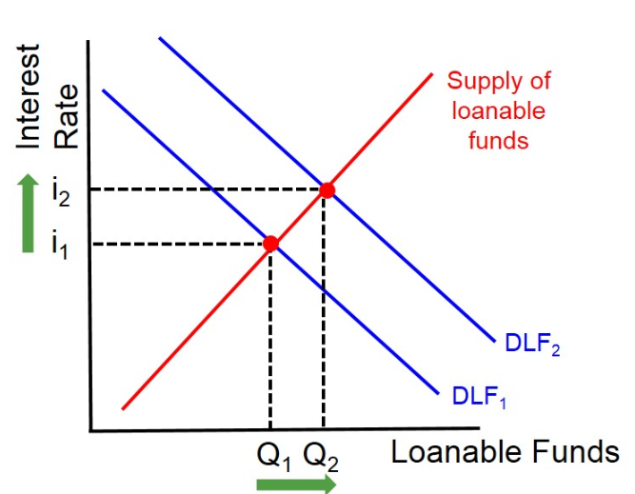

1. Which institutions provide loanable funds?
2. Which institutions demand loanable funds?
3. Explain why the demand for loanable funds curve slope downwards from left to right.
4. Explain why the supply of loanable funds curve slope upwards from left to right.
5. Explain why an increase in the budget deficit causes an increase in the demand for loanable funds.

……………………………………………………………………………………………………………………………………………………………………………………

……………………………………………………………………………………………………………………………………………………………………………………

……………………………………………………………………………………………………………………………………………………………………………………

……………………………………………………………………………………………………………………………………………………………………………………

……………………………………………………………………………………………………………………………………………………………………………………

1. Explain why an increase in the demand for loanable funds causes interest rates to rise.

……………………………………………………………………………………………………………………………………………………………………………………

……………………………………………………………………………………………………………………………………………………………………………………

……………………………………………………………………………………………………………………………………………………………………………………

……………………………………………………………………………………………………………………………………………………………………………………

……………………………………………………………………………………………………………………………………………………………………………………

……………………………………………………………………………………………………………………………………………………………………………………

……………………………………………………………………………………………………………………………………………………………………………………

……………………………………………………………………………………………………………………………………………………………………………………

1. How do firms in the private sector respond to the increase in interest rates? Why?

……………………………………………………………………………………………………………………………………………………………………………………

……………………………………………………………………………………………………………………………………………………………………………………

……………………………………………………………………………………………………………………………………………………………………………………

……………………………………………………………………………………………………………………………………………………………………………………

……………………………………………………………………………………………………………………………………………………………………………………

……………………………………………………………………………………………………………………………………………………………………………………

……………………………………………………………………………………………………………………………………………………………………………………

**Extension activity**: Can you think of any reasons why Financial crowding out may not occur? Write your answer in the space below.

(Hint: Do all firms need to borrow to invest?)

………………………………………………………………………………………………………………………………………………………………………………

………………………………………………………………………………………………………………………………………………………………………………

………………………………………………………………………………………………………………………………………………………………………………

………………………………………………………………………………………………………………………………………………………………………………

………………………………………………………………………………………………………………………………………………………………………………

………………………………………………………………………………………………………………………………………………………………………………

**Extended Reading:**

**Other approaches to crowding out**

**Rational Expectations View**

* According to a school of economic thought that believes in **‘rational expectations’**, when the government sells debt (gilts) to fund a tax cut or an increase in G, a rational individual will realise that at some future date he will face higher tax liabilities to pay for the interest repayments. (However, are individuals rational!?)
* Thus, one should increase one’s savings as there has been no increase in permanent income.
* Therefore, any change in fiscal policy will have no impact on the economy if all individuals are rational. Fiscal policy in these circumstances may become ineffective.

**Balanced budget fiscal expansion**

This concept has become a major topic of conversation in the debate over the economic effects of fiscal austerity in many countries in the European Union and beyond. Put simply, a balanced budget fiscal expansion occurs when a change in G is matched by an equal change in T so that there is a neutral effect on the annual budget deficit but with the hope that real national income will expand.

Central to the concept is that the fiscal multiplier effects of say a £10bn rise in G are higher than the negative multiplier effects of an equivalent £10bn rise in T.

**Crowding In**

An [economic](http://www.investorwords.com/1639/economic.html) [principle](http://www.investorwords.com/3845/principle.html) in which [private](http://www.investorwords.com/3850/private.html) [investment](http://www.investorwords.com/2599/investment.html) [increases](http://www.investorwords.com/10007/increase.html) as debt-financed [G](http://www.investorwords.com/16458/government.html) increases. This is caused by G boosting the [demand](http://www.investorwords.com/1396/demand.html) for [goods](http://www.investorwords.com/2209/goods.html), which in [turn](http://www.investorwords.com/11363/turn.html) increases investment through the multiplier effect and accelerator effect. This is in contrast to [crowding out](http://www.investorwords.com/1226/crowding_out.html).

**Other aspects of crowding in**

**Dr Marianna Muzzucato** (“The Entrepreneurial State”)

In her 2013 book (The Entrepreneurial state) Marianna argues that the idea of the State as a static bureaucratic organisation only needed to ‘fix’ market failures, leaving dynamic entrepreneurship and innovation to the private sector, is wrong. She outlines a number of case studies across different sectors, including biotech, pharmaceuticals and clean technology, to show that the high-risk investments are being made by the state before the private sector gets involved. In a chapter examining the iPhone, she outlines how the technologies that make it ‘smart’ – the internet, GPS, its touchscreen display and the voice-activated SIRI– were all Government funded.

[**http://www.ted.com/talks/mariana_mazzucato_government_investor_risk_taker_innovator?language=en**](http://www.ted.com/talks/mariana_mazzucato_government_investor_risk_taker_innovator?language=en)

Watch the TED talk above and make notes in the space below.

**Government Borrowing**

* The public-sector net cash requirement (PSNCR) is how much the government needs to borrow each financial year
* The national debt is the total amount of borrowing undertaken by the government that has not yet been repaid.

**Concerns over higher government borrowing**

1. **Push up long-term rates of interest** and therefore create some “crowding-out effects” on the private sector of the economy
2. **Increases accumulated national debt** which increases the future interest payments which burdens future generations of taxpayers
3. **Inter-generational equity issues** involved with budget deficits –each generation should meet the costs of the benefits they derive from current government spending
4. Increased government borrowing **may eventually require higher taxation**

**Activity 3: Analyse the negative effects a high budget deficit might have on UK economic growth?**

Answer the question below, use the hints provided to help you construct your answer(hint: use the financial crowding out argument in your analysis).

**Use 6 – 8 chains of analysis to help explain your answer**

***Large budget deficits can lead to a decrease in economic growth because***

(Hint: Use the following words in your answer: *loanable funds, private sector demand, public sector demand, interest rates, crowding ou*t, *investment,*)

**Benefits of a rising budget deficit**

1. A budget deficit might be caused by cyclical factors which will unwind at later stages of the economic cycle
2. Government borrowing helps to stabilise aggregate demand during a downturn (it is a form of Keynesian demand management) – it is an important tool of “counter-cyclical” policy
3. Borrowing to finance capital investment is perfectly legitimate – because it adds to the economy’s stock of capital and can support long-term growth (i.e. an increase in LRAS)
4. Government debt is currently low, expressed as a percentage of GDP – there is plenty of scope for higher borrowing without any upward pressure on interest rates – the UK government rarely has a problem finding people to buy their debt. Japan and America’s debt to GDP ratio are much higher.
5. Crowding in!!!

[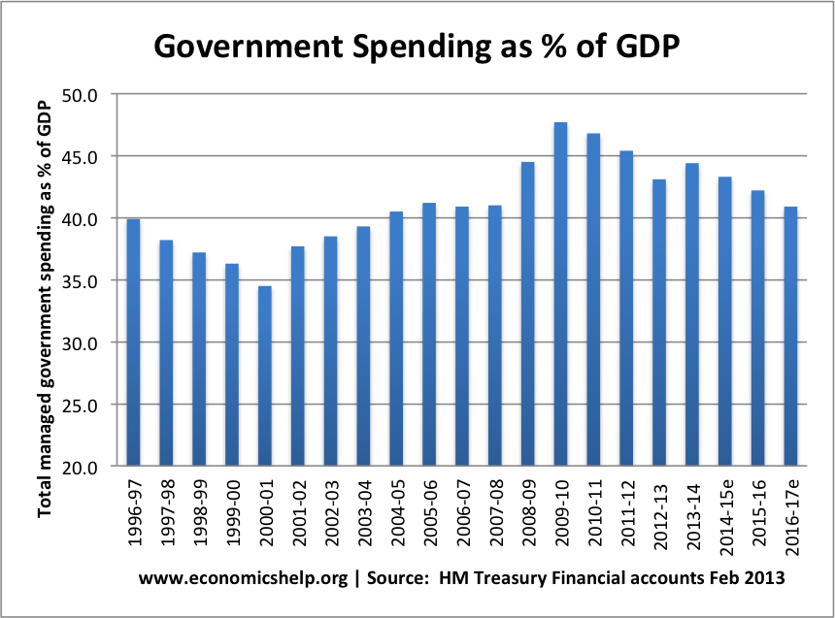](http://www.google.co.uk/url?sa=i&rct=j&q=&esrc=s&source=images&cd=&cad=rja&uact=8&ved=0ahUKEwjY-8CHx__OAhXHORQKHW0LBDUQjRwIBw&url=http://www.economicshelp.org/blog/5326/economics/government-spending/&psig=AFQjCNG-143LpauRbAOU-nybHG4yEmG1Tg&ust=1473416692718536)

**Activity 4:** ‘The level of public sector spending grew from 34% of GDP in 2000/01, to over 47% of GDP in 2009/10.’

To what extent is this damaging to the UK economy? (Hint: evaluate!)

Write your answer in the space below. Continue on a notes page if necessary.

**Notes Page**



**Fiscal Policy (The micro and macro-economic significance of Taxation)**

“In this world nothing can be said to be certain, apart from Death and Taxes” (Benjamin Franklin 1706-1790)

**What are the main objectives of the UK tax system?**

1. **Funding Government spending**: Government must raise finance for their various expenditures. They are able to borrow money up to a certain extent, but the majority of the finance must come from taxation, in order to avoid inflationary pressure.

2. **Managing the economy as a whole**: Taxation can be used to influence the UK’s macroeconomic performance. The government may alter taxes and their rates in order to influence economic growth, inflation, unemployment and, to a lesser extent, the balance of payments. Governments also appreciate that reducing certain taxes can lead to important microeconomic supply-side improvements.

3. **Redistribution of income**: If a government judges the distribution of income to be unfair, or inequitable, it may levy taxes to reduce the income and wealth of some groups in society, in order to boost the income and wealth of other groups.

4. **Correcting market failure:** At a microeconomic level, the UK government often uses taxes to improve the workings of the markets. For example taxes on cigarettes may be used to reduce the consumption of a demerit good.

**Direct and Indirect taxes:** Two broad category of tax.

|  |  |
| --- | --- |
| **Direct** | **Indirect** |
| Direct taxes are levied on the income of an individual or organisation | Indirect taxes are taxes on spending. |

**Activity 1:** Which of these taxes are indirect and which are direct taxes? Add them to the table above!

1. Income tax b) National insurance contribution c) Inheritance tax

d) Corporation tax e) Capital gains tax f) Council tax g)VAT h) Excise duties

**The principles of taxation**

In making an assessment of whether a tax is ‘good’ or ‘bad’ from an economic point of view, a useful starting point is Adam Smith’s Canons of Taxation, by which he argues that a good tax satisfies the following conditions:-

1. **Economical**: A tax should be simple and cheap to collect, so that the revenue is maximized compared to the cost of collection.
2. **Equitable**: Tax should be fair and based on the taxpayer ability to pay.
3. **Convenient:** The payment method and timing should be convenient to the taxpayer.
4. **Certain:** Taxpayers should understand how the system works and should be clear about, when, how and what to pay. Taxes should also be difficult to evade.
5. **Efficient:** An efficient tax system meets its aims whilst minimising negative distortions such as reducing individual incentives to work or for firms to invest.
6. **Flexible:** The structure and rates of taxation must be capable of easy alteration in response to changing economic conditions.

**Activity:** Anderton, page 512, Q3: Discuss and make notes on the following notes page

**Hypothecation**

This means that taxes are raised for a particular purpose that is they are earmarked for a specific use. In the last decade, for example, the government has announced that a large proportion of tobacco duty would be used by the NHS to tackling smoking related problems.

**Arguments for indirect taxation**

* **Flexibility:** Indirect taxescan be changed more easily than direct taxes, since direct taxes can be changed once a year at the time of the budget.
* **Influencing spending patterns:**  tax changes can be effective in changing the overall pattern of demand for particular goods or services, by changing relative prices.
* **Correcting externalities**: Indirect taxes can correct the spill over effects of economic transactions, for example ‘making the polluter pay’ by ‘internalising’ the external costs of production and consumption.
* **Incentive effect**: Indirect taxes have less impact upon individual work leisure choices. Therefore, governments could levy higher indirect taxes to allow a reduction in direct taxation.
* **Choice**: People have a choice about whether to buy products that attract indirect taxes whereas direct taxes inevitably leave people with less of their take-home pay in their pockets, plus they are hard to avoid.

**Arguments against indirect taxation**

* **Distribution effects:** The regressive nature of many indirect taxes means that they can make the distribution of income more unequal
* **Inflationary effects:** Increases in indirect taxation can trigger cost push inflation, and a subsequent rise in expectations of inflation.
* **Crime**: High levels of indirect taxation create incentives to avoid them

**Progressive Tax** – means that the proportion of a person’s income paid in tax increases as income increases.

**Regressive Tax** – means that the proportion of tax falls as income increases

**Proportional Tax** –the proportion of income paid in tax remains the same as income increases.

**Notes Page**



**Activity:** Decide which of the tax regimes you prefer. Explain and justify your answer in the space below.

|  |  |  |  |
| --- | --- | --- | --- |
| **Income** | **Tax A**  **(% tax paid at each level of Income)** | **Tax B**  **(% tax paid at each level of Income)** | **Tax C**  **(% tax paid at each level of Income)** |
| **£0 - £10,000** | **0** | **20** | **20** |
| **£10,001 - £20,000** | **10** | **20** | **15** |
| **£20,001- £50,000** | **20** | **20** | **12.5** |
| **£50,001 - £100,000** | **30** | **20** | **10** |
| **£100,001 - £200,001** | **50** | **20** | **5** |

………………………………………………………………………………………………………………………………………………………………………………………………………………………………………………………………………………………………………………………………………………………………………………………………………………………………………………………………………………………………………………………………………………………………………………………………………………………………………………………………………………………………………………………………………………………………………………………………………………………………………………………………………………………………………………………………………………………………………………………………………………………………………………………………………………………………………………………………………………………………

……………………………………………………………………………………………………………………………………………………………………………………………………………………………………………………………………………………………………………………………………………………………………………………

……………………………………………………………………………………………………………………………………………………………………………………………………………………………………………………………………………………………………………………………………………………………………………………

……………………………………………………………………………………………………………………………………………………………………………………………………………………………………………………………………………………………………………………………………………………………………………………

**Possible exam questions**

Explain how budget deficits in an economy might help to influence the rate of inflation in that economy. (June 2012)(15 marks)

Explain possible economic reasons for changes in the level and distribution of government expenditure. (June 2010)(15 marks)

The level of UK Public Sector spending grew from 37% of GDP in 1997 to over 45% in 2008.

To what extent do you regard such an expansion of the public sector as beneficial to the UK economy? (Jan 10)(25 marks)

**Cyclical v Structural Budget Deficits and Surpluses**

* + 1. **Cyclical reasons**

For many countries **a rising budget deficit** is the inevitable result of experiencing a recession or a sustained period of slow growth. In a downturn, revenue flows fall from direct and indirect taxes whilst at the same time, the government is required to pay more out in welfare benefits such as the means-tested income support, unemployment benefits and other welfare handouts. Therefore, part of a fiscal deficit may be the consequence of the **automatic stabilisers** at work. These are the tax and government spending changes that happen automatically at different stages of the business cycle. The governments of most developed countries are prepared to allow the automatic stabilisers to work through because, when their economy recovers, the cyclical component of a fiscal deficit will diminish, indeed in an economic boom, the government may run a budget surplus.

* + 1. **Structural reasons**

For some countries, fiscal deficits seem an almost permanent feature, rarely is the government able to find enough tax revenue to cover the annual spending budgets. What structural problems / issues might lead to persistent fiscal deficits?

1. **High levels of tax avoidance and tax evasion** - the deliberate evasion of tax is illegal - in some countries governments are less effective than they might be in countering shadow markets where no tax is paid or in tracking down agents who are not paying the tax that is due.
2. **High levels of income and wealth inequality** - some economists argue that highly unequal societies also end up with a worsening fiscal position for the government. The uber-rich are liable for higher taxes in a progressive system (and top rate taxpayers in the UK clearly pay a high % of total revenues) but they also have an incentive to use all of the legal tax avoidance schemes open to them. At the bottom end of the labour market, if millions of people are in low-paid, insecure work, many will not earn enough to pay much in tax and even more may remain dependent on top-up welfare benefits, adding to the pressure on government spending.
3. **Demographic pressures** - these can affect the fiscal position too, for example an ageing population will cause an increase in government spending on the state pension; a fast-growing population (perhaps boosted by net inward migration) will also put more pressure on the government to fund essential public and merit goods.
4. **Government inefficiency** - if the state sector is relatively less efficient in supplying public services, then value for money will be lower and more will have to be spent in total to provide the cover that people need. Free market economists favour a smaller government sector with many activities out-sourced or privatised to the private sector to supply.
5. **High levels of government subsidy / financial support** - over time, total government spending can rise because of the many competing demand placed upon politicians and the effects of lobbying by (often influential / powerful) pressure groups. In some countries, public spending is bloated by very generous systems of farm / food / energy subsidies that are politically hugely difficult to remove. The state might also get locked into providing financial support for loss-making businesses and industries such as airlines.

**Activity:** Explain one cyclical factor and one structural factor behind the UKs budget deficit:

………………………………………………………………………………………………………………………………………………………………………………………………………………………………………………………………………………………………………………………………………………………………………………………………………………………………………………………………………………………………………………………………………………………………………………………………………………………………………………………………………………………………………………………………………………………………………..………………………………………………………………………………………………………………………………………………………………………………………………………………………………………………………………………………………………………………………………………………………………………………………………………………………………………………………………………………………………………………………………………………………………………………………………………………………………………………………………………………………………………………………………………………………………………..……………………………………………………………………………………………………………………………………………………………………………………………………………………………………………………………………………………………………………………………………………………………………………………

**Extension:** What could explain the deterioration in the Saudi government’s budget?

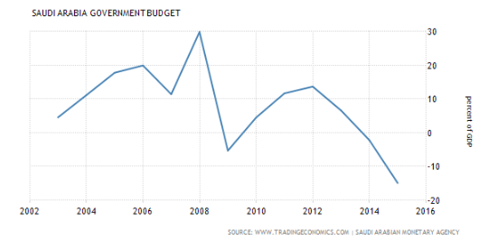

………………………………………………………………………………………………………………………………………………………………………………………………………………………………………………………………………………………………………………………………………………………………………………………………………………………………………………………………………………………………………………………………………………………………………………………………………………………………………………………………………………………………………………………………………………………………………..

**Relationship between budget deficit and national debt**

* The **budget deficit** is the annual difference between government spending and tax revenues.
* The UK government has run a budget deficit since the 2000/2001 fiscal year.
* The **national debt** is the accumulated government debt that has not yet been repaid.

**Questions**

What is the UKs budget deficit: £

UK budget deficit as % GDP: £

What is the UKs national debt: £

UK national debt as % GDP: £

**The Role of the Office for Budget Responsibility**

The independent UK Office for Budget Responsibility was established in 2010 to monitor the public sector’s finances. Twice a year – alongside each Budget and Autumn Statement – the OBR produces detailed forecasts for the coming five years, assessing the likely impact of policy decisions and expected developments in the UK economy.

**Supply-side Policies**

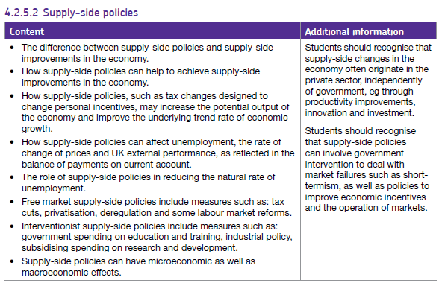

**What are Supply side policies?**

………………………………………………………………………………………………………………………………………………………………………………………………………………………………………………………………………………………………………………………………………………………………………………………………………………………………………………………………………………………………………………………………………………………………

Many Supply side improvements come from the private sector, not just from government policy changes. Firms look to increase productivity to reduce their own costs in order to remain competitive or increase profits. The role of the government is to promote the ideal conditions in which supply side improvements can flourish.

The position of the Aggregate Supply curves depends on the quantity and quality of factor inputs and on the efficiency with which those factors are utilised. Supply-side improvements therefore focus on affecting the determinants of AS in order to shift the LRAS curve to the right.

**Activity 1:** Draw the effects of Supply Side policy from the Keynesian and Classical perspectives

Classical Keynesian

**Supply-side Policies**

Listed below are policies that are associated with improving the productive capacity of the economy:

* + 1. **Market based measures**

**i) Labour market measures**

* 1. Lower rates of income tax
  2. Reducing state benefits
  3. Improved education and training
  4. Trade Union reforms

**ii) Product market measures**

* 1. Privatisation and deregulation
  2. Tougher competition policy
  3. Lower rates of business taxes
  4. Allowing tax relief on capital spending
  5. Opening up the economy to overseas trade and investment
     1. **Interventionist policies**
  6. Regional policy assistance in depressed areas (enterprise zones)
  7. Increased spending on infrastructure
  8. Tax incentives and welfare reforms can encourage more people into work
  9. A commitment to a fair minimum wage / living wage to improve work incentives
  10. Some case for selective import controls to allow domestic industries to expand

**Activity 1:** Write two evaluation points for each supply-side policy in the space below:

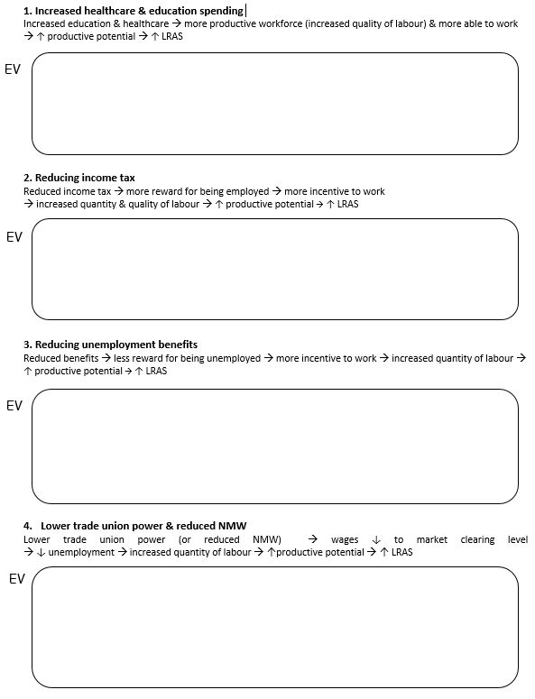

**Activity 2:** Analyse each supply-side policy (explain how it increases the LRAS/PPF)

**Top Tip**: Try to make 6 chains of analysis per point

1. **Reduced corporation tax**

**Ev** = The extent to which a fall in the rate of corporation tax will cause an increase in the LRAS depends upon the magnitude of the change in the rate. If there is only a small change such as 20% to 19% then firms may not be willing to invest in more capital stock.

An

1. **Subsidies for investment and R&D**

**Ev** = However, subsidies are a form of government spending and will result in the UK government running a larger budget deficit, adding to the staggering national debt of £1.7 trillion. This may result in financial crowding out of private investment and a fall in AD.

An

1. **Encourage competition (free trade, privatisation, competition policy, small business support & loans)**

**Ev** = However, reducing the size and power of monopoly firms could lead to a loss of economies of scale and therefore higher prices for consumers. Furthermore, less profits for the monopoly firm means that consumers are less likely to benefit from dynamic efficiency e.g. research and development.

An

EV

EV

EV

**The Laffer Curve**

[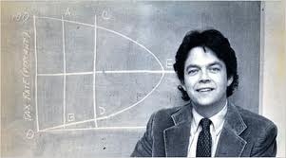](http://news.bbc.co.uk/today/hi/today/newsid_9732000/9732502.stm)

Watch the clip and answer the following questions

[**https://www.youtube.com/watch?v=fw5rp7MfD-Q**](https://www.youtube.com/watch?v=fw5rp7MfD-Q)

1. What does Arthur Laffer (and the Laffer curve) suggest are the reasons for a fall in the tax receipts (amount of money collected from taxes) when income tax rates go up.
2. What do you think the Laffer curve looks like? Use the space below and the **hint**.
3. How might supply side economists use the Laffer curve to support tax cuts?

Draw the Laffer curve here:

What does the Laffer curve look like? (**Hint**: On one axis there is total tax revenue and on the other is tax rate)

Write your answers here:

**Laffer curve (continued)**

Questions on the Laffer curve

1. What is the amount of tax revenue when the tax rate is 0%?
2. What is the amount of tax revenue when the tax rate is 100%?
3. What is the tax rate when tax revenues are maximized and how much revenue is raised?
4. How might Supply-side economist use the Laffer curve to support their arguments?

EXTENSION

1. Which is preferable, a tax rate of t4 or a tax rate of t2 (explain your answer)

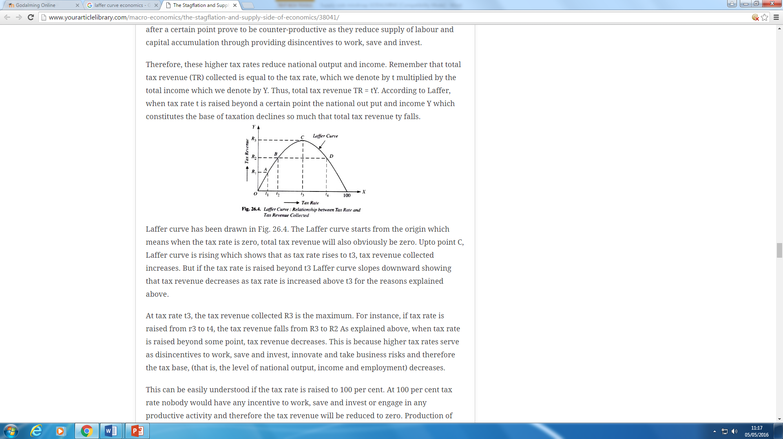

Your answers:

1. **Trade Union Reforms**



[**https://www.youtube.com/watch?v=vSLajVt_n7k**](https://www.youtube.com/watch?v=vSLajVt_n7k)

**Listen to the clip and answer the following questions**

1. What is a Trade Union
2. Other than increased pay what other benefits do train drivers get?
3. What powers do trade unions have to bargain with?

Write your answers below:

**Margaret Thatcher’s Union reforms**

Margaret Thatcher's demolition job on the industrial might of the British trade union movement helped to generate an economic revolution. In the late 1970s, millions of days a year were being lost through strike action but at the end of her premiership stoppages were a fraction of what they had once been. Slowly but surely the unions' strike weapon was emasculated. Strike ballots were required by law; walkouts were no longer possible on a show of hands in a car park; flying pickets and secondary action had been outlawed; and most importantly of all, a union's assets were at risk if there was "unlawful" action, as the NUM president Arthur Scargill discovered to his cost in the 1984-85 pit dispute.

Mr Scargill, like other union leaders of his era, had grown used under the previous Labour governments of Harold Wilson and James Callaghan to employers giving way. But Mrs Thatcher, backed by a largely supportive national press, was able to prove that the disputes of the 1980s would be won or lost not just on the picket line but also on the back of public opinion, and much of the media's coverage was turned against the unions. The 1986 Big Bang and the deregulation of financial markets in the City of London only served to underline the demise of the trade unions. The end of nationalisation and the take-up of shares by workers in the newly privatised industries was a stark reminder of the shift that had taken place.

Share ownership trebled in the Thatcher decade and so did the growth in home ownership after the sale of council houses. By the late 1980s the all-out strike was history; no union could ask its heavily mortgaged members to contemplate anything more than a one or perhaps two-day strike. Organisationally the killer blow for the unions was the end of the closed shop and withdrawal of "check-off" agreements that required employers to deduct union contributions.

Today union membership is half what it was: in 1979, when Mrs Thatcher became prime minister, the TUC's affiliated membership stood at just over 12 million, the highest it had ever been.

**BBC website, 10 April 2013.**

**Questions (answer these on the following page):**

1. How did Mrs Thatcher reduce trade union power? List the actions taken.
2. Explain how reducing trade union power is a supply-side policy.

**Your notes**

**Extension:** Have commuters from Brighton to London been happy with Southern Trains recently? Why have Southern Rail gone on strike? How has the trade union action prevented an increase in productive potential?

………………………………………………………………………………………………………………………………………………………………………………………………………………………………………………………………………………………………………………………………………………………………………………………………………………………………………………………………………………………………………………………………………………………………………………………………………………………………………………………………………………………………………………………………………………………………………………………………………………………………………………………………………………………………………………………………………………………………………………………………………………………………………………………………………………………………………………………………

**Product Market Measures**

Supply-side policies in the product market are designed to increase competition and efficiency

* Privatisation and Deregulation
* Toughening up Competition Policy
* A Commitment to Free International Trade
* Encouraging Enterprise and Capital Spending

1. **Privatisation and Deregulation**

**Key Term:**

The sale of Government owned assets to the private sector are examples of privatisation - British Gas,

British Telecom (BT), British Airways. There was a wave of privatisations since 1979, with many firms going from

public to private ownership in the 1980’s and early 90’s.

**Why is privatisation a supply side policy?**

It is argued that under private ownership, firms are more efficient, more competitive and less of a drain on

government resources. Therefore breaking up state run monopolies creates more competition.

1. **Deregulation *The process of removing government controls from markets***

This can be removing legal barriers to entry, leading to more competitive markets where previous state-owned

monopolies existed.

**Activity 1:** Bank deregulation leads to disaster - shout it from the rooftops

*As recently as the 1970s, mortgage lending and credit were controlled by a panoply of sensible rules. The cause of our subsequent distress is not hard to diagnose*

"With the benefit of hindsight," he said, "we should have shouted from the rooftops that a system had been built in which banks were too important to fail, that banks had grown too quickly and borrowed too much, and that so-called 'light touch' regulation hadn't prevented any of this." admitted Mervyn King (Governor of the Bank of England)

The governor admitted the Bank should have done "more to prevent the disaster" but then complained: "The power to regulate banks had been taken away from us … Our power was limited to that of publishing reports and preaching sermons."

The power to regulate may have been taken away. But the responsibility for financial stability was still there. And no objective observer can avoid reaching the conclusion that the Bank ran down its resources in this area and took its eye off the ball.

On both sides of the Atlantic in the 1980s and 1990s, deregulation became the name of the game; Alan Greenspan was almost deified; and the Greenspan doctrine – that financial engineering spread and virtually eliminated risk – was widely accepted.

In the 1960s and 70s, strict capital reserve and liquidity ratios were applied to banks, and there was a panoply of sensible rules limiting the taking-on of excessive risks in mortgage lending. The authorities had a whole bag of policy clubs – but the lessons of history were forgotten and the rest of the clubs were thrown away.

**Discussion:** Summarise your discussion on the following page.

1. What do you believe the benefits of deregulation in the banking sector might have been?
2. What do you think the drawbacks of deregulation in the banking sector might have been?

**Notes Page**



1. **Toughening up competition policy**

The dynamic effects of competition create incentives for firms to be more efficient in the way they use their scarce resources and increase their productivity and reduce costs, which can be passed onto consumers in the form of lower prices.

Toughening up competition policy is designed to ensure that monopolies do not abuse their dominant market position by charging consumers more for their products and reducing choice. In the UK, the competition commission has a crucial role in trying to encourage competition in markets.

“The Competition Commission (CC) is an independent public body which helps to ensure healthy competition between companies in the UK for the ultimate benefit of consumers and the economy. It conducts in-depth investigations into mergers and markets and also has certain functions with regard to the major regulated industries”

**Activity 2:** Explain how toughening up competition policy might have a positive effect on Economic growth (use all of the words in your answer: *productive efficiency, monopoly, competition, lower prices, long run growth)*

…………………………………………………………………………………………………………………………………………………………………………………………………………………………………………………………………………………………………………………………………………………………………………………………………………………………………………………………………………………………………………………………………………………………………………………………………………………………………………………………………………………………………………………………………………………………………………………………………………………………………………………………………………………………………………………………………………………………………………………………………………………………………………………………………………………………………………………………………………………………………………………………………………………………………………………………………………………………………………………………………………………………………………………………………………………………………………………………………………………………………………

1. **Free International Trade (no import taxes)**

Trade creates competition and should be a catalyst for improvements in costs and lower prices for consumers. Firms that do not offer their consumers the lowest prices may find that competition from firms overseas may drive them out of business.

Being part of the EU (a single market, within which there is free trade) signals a commitment which the UK government has taken towards increasing free trade

1. **Encouraging enterprise and capital spending**

Measures to encourage entrepreneurship and capital spending, such as:

* loan guarantees for new start-ups
* Reducing rates of corporation tax for small businesses
* Allowing tax relief on capital spending

**Discussion:** Look at the table and decide if the UK Government’s Fiscal, Monetary and Supply side reforms have been successful in encouraging capital spending and productivity growth. Does the data show a link between capital spending and productivity gains?

Write brief answers in the space below.

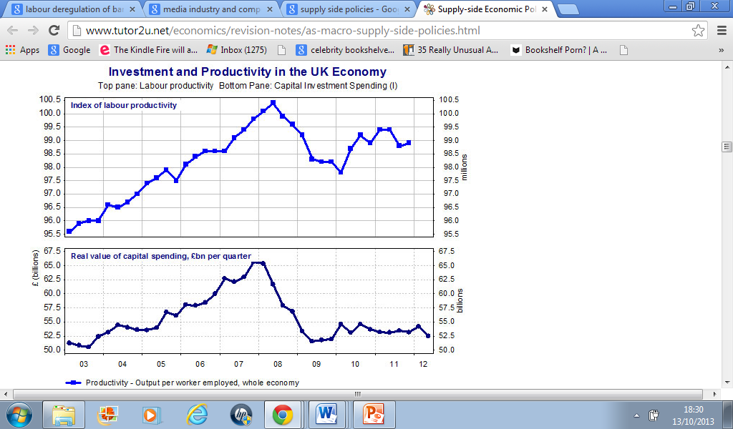

**Extension activity:** Which other supply side policy should in theory result in an increase in Capital spending?

……………………………………………………………………………………………………………………………………………………………………………………………………………………………………………………………………………………………………………………………………………………………………………………………………………………………………………………………………………………………………………………………………………………………………………………………………………………………………………………………………………………………………………………………………………………

**Limitations of Supply-side policies**

Whilst it is generally accepted that supply-side policies can have the desirable effect of achieving all 4 macroeconomic objectives, there are limitations to its effectiveness as a policy tool.

1. Supply-side policies can often take a long time to work.
2. Some supply-side policies can be costly to implement. For example large infrastructure projects may add considerably to the PSNCR.
3. Supply-side policies require enough aggregate demand in the economy to enable access to the increase in productive potential.
4. Some supply-side policies have a negative effect on AD in the short run (e.g. reduction in welfare payments)

**Notes Page**



**What is the relationship between the following curves (PPF, LRAS and the trend line of growth)?**

Draw each in the space below

Briefly explain how you would show SR economic growth on this diagram.

Briefly explain how you would show a negative output gap on this diagram

A production possibility frontier (capital goods and consumer goods)

How would you show positive and negative output gap?

**Extension**: What is the relationship between the actual rate and the level of aggregate demand?

A business cycle (economic cycle diagram)

How would you indicate unemployment on this diagram?

Briefly explain how you would show SR economic growth on this diagram.

The long run monetarist (classical) equilibrium

**Extension activity** **discussion**:

Monetarist economists believe that economies (left alone) will correct themselves so that they will tend towards a full employment level. If this is the case what is the relationship between the LRAS, PPF and trend line of growth?

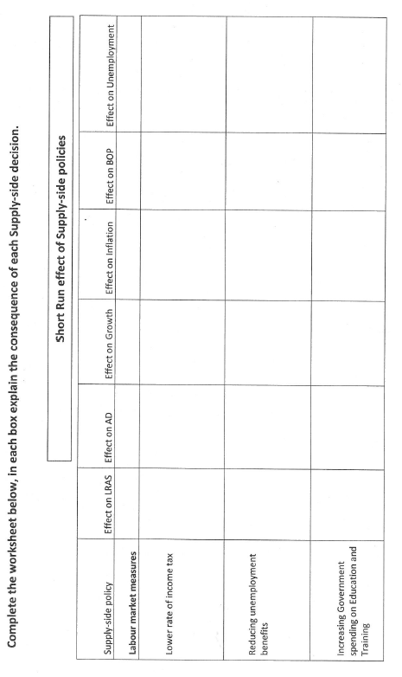

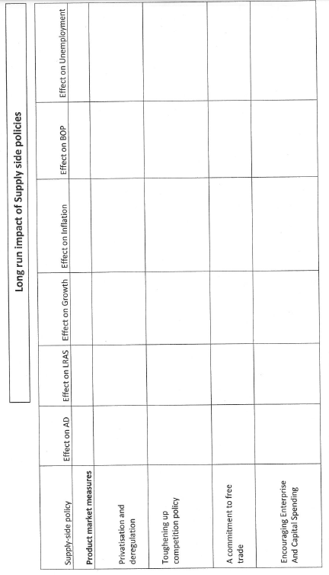

**Extension Material**



**Budget 2016:** Key Points at a glance

<http://www.bbc.co.uk/news/uk-politics-35819797>



|  |  |  |  |
| --- | --- | --- | --- |
| **Do you understand Fiscal policy?** |  | | ✓ |
| **Can you :** | | | |
| Explain expansionary and contractionary fiscal policy | |  |  |
| Explain reflationary and deflationary fiscal policy | |  |  |
| Explain Automatic stabilisers | |  |  |
| Recall the three types of Government spending | |  |  |
| Identify the four main aims of fiscal policy | |  |  |
| Explain fiscal austerity | |  |  |
| Explain Resource Crowding out | |  |  |
| Explain Resource crowding in | |  |  |
| Explain Financial crowding out | |  |  |
| Identify the 4 major concerns over high Government Borrowing | |  |  |
| Identify the benefits of running a budget deficit | |  |  |
| Explain the difference between direct and indirect taxes | |  |  |
| Explain what Progressive, Regressive and Proportional taxes are | |  |  |
| Explain the differences between cyclical & structural deficits and surpluses | |  |  |
| Identify the main causes of a structural deficit | |  |  |
|  | |  |  |
| **Help can be found in the following places … ?:** | |  |  |
| Read pages and answered the “mastered this topic questions” on Godalming Online | |  |  |
| Watched recommended videos from Godalming online | |  |  |
| Attend a support session in rm 206 (Mon, Wed and Fri 1300) | |  |  |

**Boost exam performance:**

|  |  |  |
| --- | --- | --- |
| Complete 4 & 9 marker questions on Godalming online |  |  |
| Complete the 25 marker questions on Godalming online |  |  |
| Read economics related news, and find articles on Fiscal and supply side policies |  |  |