02 Financial Markets and Monetary Policy

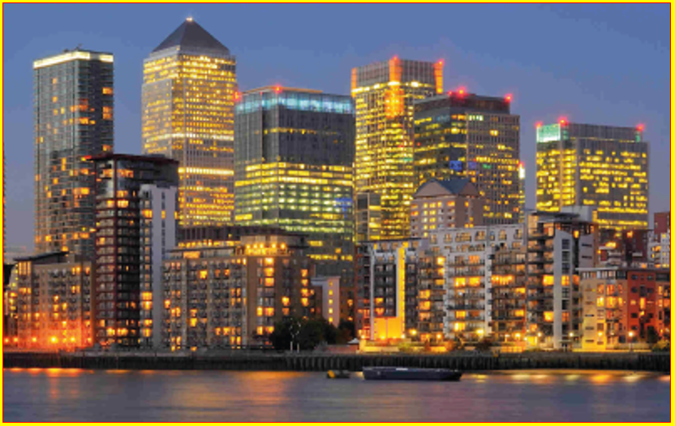

1. **Central Banks & Monetary Policy**
2. **Financial Markets & Monetary Policy**
3. **Commercial Banks & Investment Banks**
4. **Regulation of the Financial System**

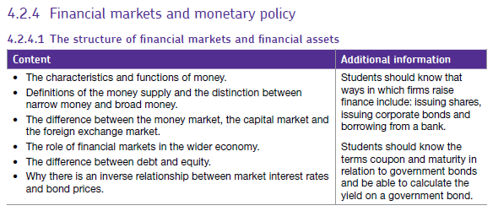

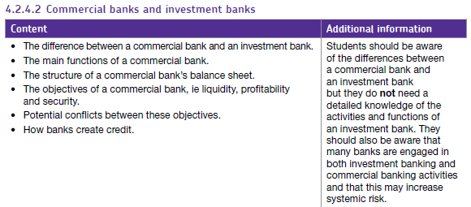

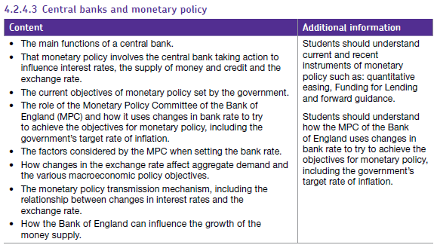

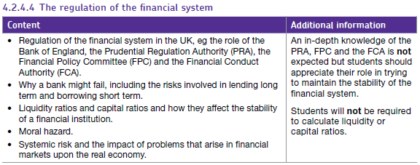

**A A**

**a**

**Central Banks & Monetary Policy**

**Starter Quiz – Write your answers in the space below.**

1. The primary impact of Monetary Policy is on the demand side of the economy – T/F?
2. Monetary Policy only affects the demand side of the economy – T/F?
3. Who is the current Governor of the Bank of England?
4. What is the current Bank of England bank rate a.k.a. base rate?
5. Which organisation sets interest rates for Portugal and France?
6. Which organisation sets interest rates for Germany and Spain?
7. Identify the 3 strands of Monetary Policy.
8. How much Quantitative Easing has been pumped into the UK economy so far?
9. What is the current rate of inflation as measured by CPI?
10. What name is given to the central bank in the USA?

**Ext**: **i)** What was the ‘Forward Guidance’ set by the Bank of England in 2013? **ii)** Explain the Macroeconomic benefits of having ‘Forward Guidance’ in place.



**Monetary Policy**

|  |  |
| --- | --- |
| **a) Interest Rates** | “The cost of borrowing and the reward for saving” |
| **b) Money Supply** | “The total amount of money in circulation in a country”  **Narrow Money** = notes and coins in circulation (**M0**)  **Broad Money** = notes and coins + bank savings, bonds and gilts (**M4**) |
| **c) Forward Guidance** | “Making a promise about the future, particularly, interest rates. Used by Central Banks to calm uncertainty in markets” |

**Activity 1:** Explain (with a diagram) how Monetary Policy can be used to achieve each Macroeconomic Objective.

1. High Economic Growth



1. Low and Stable Inflation



1. Low Unemployment



1. Balanced Balance of Payments



**Ext:** Pick one of Macroeconomic objectives above and write 2 evaluative points in the space below.



**Functions of a Central Bank**

**Activity 2**: Produce a mind-map to explain the functions of a Central Bank

a) Macroeconomic

Stability

b) Financial

Stability

**EXTENSION CHOICE!**

**Option A:** Why is the Banks inflation target 2% CPI? **Option B**: Explain what you think is meant by a ‘liquidity trap’.

……………………………………………………………………………………………………………………………………………………………………………………………………………………………………………………………………………………………………………………………………………………………………………………………………………………………………………………………………………………………………………………………………………………………………………………………………………………………………………………………………………………………………………………………………………………

**Central Banks & Monetary Policy (a. QE, b. Base Rate, c. Forward Guidance, d. Funding for Lending Scheme)**

Video Notes on QE



**Activity 3:**

1. **Money Supply (Quantitative Easing)**

**i)** Draw a diagram to show how QE reduces interest rates for commercial banks

**ii)** Explain why QE causes a fall in interest rates (refer to diagram in your explanation)

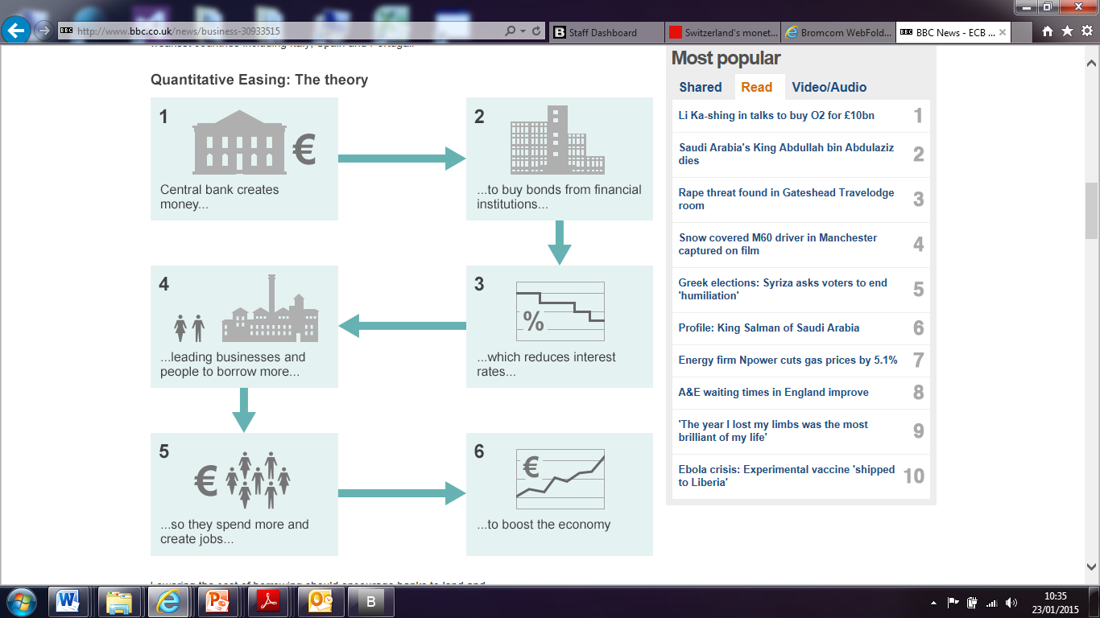

|  |  |
| --- | --- |
| **iii)** The UK has injected the economy with £435bn of QE since the financial crisis of 2007/08. **TO WHAT EXTENT** has this had a positive impact on the macroeconomic objectives (continue on the next page if necessary). | |
| **Analysis (Explain benefits of QE)** | **Evaluation (Balance)** |
|  |  |

**Notes Page**



1. **Setting the Base (interest) Rate**

[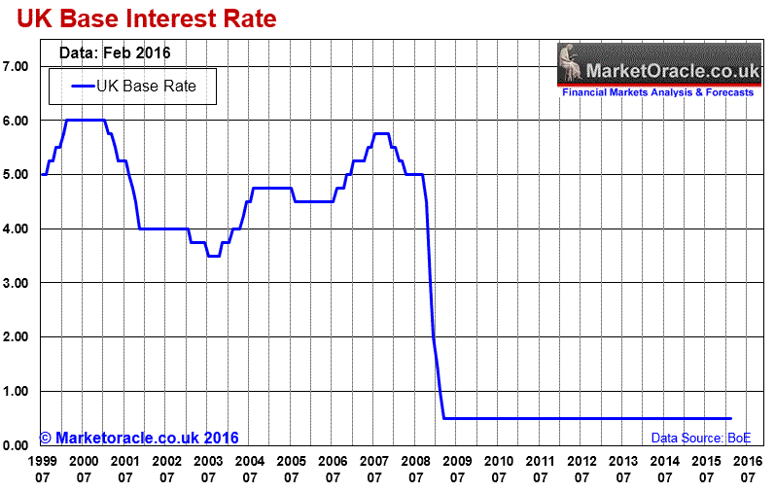](http://www.google.co.uk/url?sa=i&rct=j&q=&esrc=s&source=images&cd=&cad=rja&uact=8&ved=0ahUKEwj51O2DmbfPAhWE1xQKHWPfAYAQjRwIBw&url=http://www.marketoracle.co.uk/Article53952.html&bvm=bv.134495766,d.ZGg&psig=AFQjCNGU558-vlCXB8pTLU3b1B_7YXK8OA&ust=1475328440491610)

1. Identify is the name of the team that meets monthly to set the Bank Rate. What is the current Bank Rate?
2. Evaluate the impact of a rise in the BoE base rate. One evaluation per point (Ext: 2 evaluations per point)

|  |  |
| --- | --- |
| **Analysis of a change in the BoE base rate** | **Evaluation (why might this not be the case)** |
| **a) Market rate:** A rise in the BoE base rate means that other lenders will increase their interest rates, thereby dampening C and I due to a higher incentive to save and a rise in the cost of borrowing. This causes a fall in AD. |  |
| **b) Asset prices**: An increase in r means that mortgages become more expensive and the demand for houses falls, resulting in lower house prices. This negative wealth effect causes a fall in C and AD. |  |
| **c) Business confidence**: Under normal circumstances, firms may react a to higher r by reducing I due to a rise in the cost of borrowing. |  |
| **d) Exchange rates:**  Higher r cause an inflow of ‘hot money’ due to a rise in demand for savings in UK banks. This increases the demand for Sterling which causes the exchange rate to rise. The price of imports will therefore fall reducing costs and therefore cause SRAS to increase. |  |

|  |  |
| --- | --- |
| 1. **ASSESS** (evaluate) the **MACROECONOMIC benefits** of the Bank of England cutting the BASE RATE from 4.5% in October 2008 to 0.5% in March 2009 (continue on the next page if necessary).   (**Top Tip**: This is an essay plan for a 25 marker – you need 4 points of analysis and 2 evaluative points for each if you want to get 25 ☺). | |
| **Analysis** | **Evaluation** |
|  |  |

**Notes Page**



1. **Forward Guidance**



<http://www.bbc.co.uk/news/business-23145755>

**The governor of the Bank of England, Mark Carney, has overhauled his policy of "forward guidance", just six months after it was first implemented.**

**What is forward guidance?**

It is making a promise about the future, particularly about future interest rates.

The Bank of England, like other central banks, directly controls the short-term interest rate at which it lends to or borrows from the High Street banks overnight.

This is the interest rate that gets set at each of the Bank of England's monthly Monetary Policy Committee meetings.

**What's the point of forward guidance?**

The Bank can only directly control the short-term interest rate. But this rate has already been cut to the lowest level that the Bank feels comfortable with.

Given that it has exhausted the more traditional option of short-term interest rate cuts, another way for the Bank to support the economy has been to offer this indicator, by which companies and mortgage borrowers can estimate for how long such low interest rates may be around for in terms of months or years.

Forward guidance is thus a way of converting low short-term interest rates into lower long-term interest rates.

The thinking is that if the High Street banks can be convinced that they will be able to borrow overnight from the Bank of England at just 0.5% for many nights - indeed many months or years - to come, then they will hopefully be willing to lend money out to the rest of us for the longer term at a commensurately lower interest rate as well.

**Isn't that what Quantitative Easing is supposed to be for?**

QE also seeks to reduce longer-term borrowing costs, but in a different way.

[**QE involves the Bank buying up debts**](http://www.bankofengland.co.uk/education/Pages/inflation/qe/video.aspx) (specifically, UK government debt in the form of gilts) from the market, in return for newly created money in the form of a deposit at the Bank.

By reducing the available supply of long-term debts for them to invest their money in, the hope is that this will make banks and other financial institutions diversify into other long-term investments - including new loans to the rest of us.

Or, to put it another way, by reducing the supply of long-term debt in the financial system, the Bank hopes to drive up the value of the remaining long-term debts, which is mechanically the same thing as driving down the "yield" or interest rate on such long-term debts.

**Then why not just rely on QE?**

There is no either/or here. The Bank of England can restart its QE purchases if it wants, while also providing forward guidance about its interest rate and QE plans.

However, recent market jitters over plans by the Federal Reserve (the Bank's US counterpart) to "taper" or slow down the rate of its own QE purchases has highlighted two problems with QE:

* Firstly, it has played on fears, expressed by many bankers, that QE merely inflates bubbles in the prices of other investments, such as risky loans and share prices, which will then burst as soon as the QE stimulus is withdrawn
* Secondly, the surprisingly strong reaction of markets to the change in tone from the Federal Reserve highlights how important market expectations- as opposed to the mechanics of supply and demand - are for the effectiveness of QE

**How did the original version of forward guidance look?**

In August, the Bank told the market that it intended to keep the Bank rate at its current historically low 0.5%, at least until the unemployment rate fell to 7% or below.

Mr Carney did not say that interest rates will automatically rise when that threshold is reached, rather that it is a "way station" for further consideration of the issue.

The Bank also added some conditions that would "knock out" forward guidance. These included any sign of runaway inflation, or threats to financial stability.

**So what has happened since the summer?**

In Mr Carney's own words: "The unemployment rate has fallen much faster than anticipated... and is likely to reach 7% by the spring."

This jobs growth has meant that the Bank has had to take a [**fresh look at its forward guidance policy**](http://www.bbc.co.uk/news/business-26153122).

As a result Mr Carney said that, instead of just the unemployment rate, the next phase of the Bank's interest rate policy would be determined by a range of different indicators. These included aspects such as the output gap - the gap between potential and actual output - and broad terms such as income and spending.

All this has made the policy somewhat more confusing.

i) What is Forward Guidance? ii) Create a mind-map/table to explain the benefits and drawbacks of Forward Guidance



1. **Funding for Lending Scheme**



**Funding for Lending Scheme (F4L)**

<http://www.bbc.co.uk/news/business-18460302>

**Funding for Lending (FLS), the Bank of England and Treasury scheme, initially to boost bank lending to households and companies, opened for business at the beginning of August 2012.**

The aim of [**the scheme**](http://www.bankofengland.co.uk/markets/Pages/FLS/default.aspx) was to increase bank lending by up to £70bn.

The government changed the rules in January 2014, with this type of funding is no longer used to support mortgage lending.

The scheme aimed to bolster the economy, by halting a downward spiral of lending and borrowing that the UK had experienced since the onset of the credit crunch and international banking crisis.

Banks and building societies are able to access the funds until the end of January 2015.

**How does it work?**

In essence, the Bank of England is letting commercial banks borrow funds from it cheaply, so that the banks then pass this on in the form of cheap loans to firms.

**What is the point?**

The point is to encourage the UK's commercial banks to borrow more money, and more cheaply than at present, so they can then in turn lend it to companies who wish to borrow.

**Is it working?**

The debate is fierce. Some report banks are still unwilling to lend to business. Others say businesses are unwilling to take on new debt and are paying back loans. Either way, repayments are rising faster than borrowing, leaving the latest "net" lending figure (for the first quarter of 2014) down.

**So what are the mechanics of FLS?**

Banks and other lenders approach the Bank of England, if they want. They swap assets they already have, such as loans, with the Bank. It in turn provides them with pieces of paper known as Treasury bills, for a four-year period.

The commercial banks are then able to use these bits of paper as top quality backing with which to borrow cash in the wholesale financial markets, from other lenders. With the Treasury's backing, the idea is that they will be able to borrow funds at very cheap rates.

**How will the taxpayer be protected in this arrangement?**

The collateral pledged by commercial banks will have to be worth more than the high-grade paper being offered by the Bank of England. So, for every £1 of Treasury bills they borrow, the assets being pledged will have to be worth, say, £1.10 or £1.20. Thus if the value of that asset subsequently falls, the Bank of England will not suffer from the top slice of any loss.

**What about savers?**

They have suffered an unforeseen knock-on effect of FLS. The availability of cheap funds from the Bank means that lenders do not need to try so hard to attract funds from the general public, to then lend on to borrowers. That is why it is now almost impossible to find a savings account offering more than 3% interest.

i) What is the F4L Scheme? ii) Create a mind-map/table to explain the benefits and drawbacks of F4L



**A B**

**a**

**Financial Markets & Monetary Policy**

Financial markets exist for two main reasons. **Firstly, they provide services to households, firms and government, such as a firm wanting to gain a bank loan**. **Secondly, they exist because they allow participants to speculate and make financial gains, such as foreign exchange traders buying and selling currency to make a financial return**.

There are a wide variety of financial institutions that operate in financial markets in order to fulfil these two main purposes. It is worth noting that in the UK, Europe and the US, the largest banks will offer combined retail, commercial and investment banking services.

**Financial Institutions**

* **Commercial banks (a.k.a. retail banks):** are banks that provide services to households and firms, such as savings accounts, loans, mortgages, credit cards, foreign exchange and insurance.
* **Investment banks:** are banks do not accept deposits from most households. Investment banks engage in a variety of activities in different financial markets, such as the foreign exchange market, the money markets, the capital markets and the derivatives market. They also provide advice to companies about raising share capital and when considering takeovers and mergers.
* **Saving vehicles:** these come in many forms and their primary function is to help individuals make a return on their savings, such as pension funds and hedge funds.
* **Speculators:** although investment banks engage in speculative activities, there are a large number of smaller firms whose sole purpose is to speculate on financial markets.
* **Insurance companies:** provide insurance services to insure against risks by charging their customers a premium.

The financial market which these financial institutes operate in can themselves be sub-divided into a number of different types of financial markets. An understanding of these should help provide an overview of the nature of financial markets.

**Financial Markets**

* **Money markets:** these provide short-term borrowing and lending, usually up to a year, such as interbank lending or credit offered to businesses.
* **Capital markets:** these provide medium to longer-term financing, usually defined as being longer than a year, such as the trading of bonds and shares. Primary market where firms ‘float’ (raising share capital) via an initial public offering (IPO). Secondary market where existing bonds and shares are traded – most of this trading is undertaken by financial institutions, such as investment banks.
* **Foreign exchange markets:** this is where different currencies are traded. These could be spot markets (where the currency is traded now) or forward markets (where currency contracts are made for some time in the future, like three months). Although some currency is traded for holidays, foreign direct investment and exporting/importing, the majority is of transactions is speculative, such as by investment banks.
* **Commodity markets:** these trade commodities, such as the London Metal Exchange. These could be spot or futures contract and although some contracts are for real commodities, the vast majority are again speculative in nature.
* **Derivatives markets:** these trade derivatives, which are financial instruments based on the value of other financial instruments, such as collateralised debt obligations (CDOs) in the financial crisis.

**The Characteristics & Functions of Money**

**Activity 1**: Create mind-maps for the areas below.

1. Functions of Money

2. Characteristics of Money

3. Assets v Liabilities

**Ext 1**: Differentiate between the ‘assets’ and ‘liabilities’ to a commercial bank, such as NatWest.

*Deposits (customer savings), Mortgage, Loan from Bank of England, Overdraft, Share Capital, Business Loan*

|  |  |
| --- | --- |
| **Assets** | **Liabilities** |
|  |  |

**Ext 2:** Explain what is meant by the term ‘banking liquidity crisis’………………………………………………………………………………… …………………………..………………………………………………………………………………………………………………………………………………………………………………………………………………………………………………………………………………………………………………………………………………..

**Ext 3:** Outline an argument against QE based on the ‘liquidity crisis’……………………………………………………………………………. ………………………………………………………………………………………………………………………………………………….………………………………….……………………………………………………………………………………………………………………………………………………………………………….…….**Ext 4**: Define ‘negative equity’ ………………………………………………………………………………………………….……………………………..….. ……………………………………………………………………………………………………………………………………………………………………………………..

**Definitions of the Money Supply**

|  |  |
| --- | --- |
| **Narrow Money** | **Broad Money** |
| **Narrow Money** is the amount of notes and coins in circulation (**M0**) | **Broad Money** includes **Narrow Money** (**M0**), but also includes deposits in savings accounts, bonds and gilts (**M4**) |

**Money Markets, Capital Markets and Foreign Exchange (FX) Market**

**Activity 2**: Create mind-maps to explain the different 3 types of markets below

a. Money Market

b. Capital Market

c. FX Market

**Ext:** Evaluate the benefits to Jaguar Land Rover growing their business through **equity** instead of **debt** (answer overleaf).

* **Debt Finance** is money raised from taking out a loan (i.e. corporate bonds, government bonds). The debt holder receives a coupon in exchange for their debt finance (fixed rate of interest).
* **Equity Finance** is money raised as a result of selling part of the ownership of a business (i.e. equities). The equity holder receives dividends (a share of the profits) in exchange for their equity finance.

**Notes Page**



**The Inverse Relationship between INTEREST RATES and BOND PRICES**

* This analysis can help to explain why QE causes a fall in interest rates.

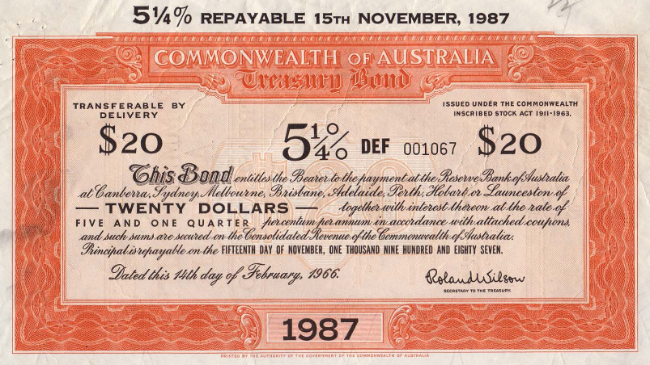

Bond yield formula:

Coupon x 100

Market Price

**Activity 3:** Answer the following questions in the space provided overleaf.

**Core Questions**

a) What is the difference between a ‘Corporate Bond’ and a ‘Government Bond’ a.k.a. ‘Gilt’?

b) Identify the i) Nominal Value, ii) Coupon and iii) Maturity Date for the Australian Government Bond (above).

c) Explain how the nominal value, coupon and maturity date are ‘inter-related’.

d) Explain the difference between the PRIMARY and SECONDARY capital markets for bonds.

e) Explain the impact of the Bank of England creating new money (QE) in the secondary market for bonds.

f) What impact does this have on the price of bonds?

g) Is the ‘coupon’ a fixed rate of interest or a variable rate of interest?

h) Assume that an increase in demand for bonds (due to QE) has caused the price of the bond (above) to double to a market price of $40. Use the formula provided to calculate the current yield of the bond. Show your workings.

i) Lower yields on Corprate Bonds and Gilts in turn push down the borrowing costs of banks, resulting in lower borrowing costs, which in theory stimulate the demand side of the economy.

**Extension Questions**

**Ext 1**: Make 2 evaluative points to explain why may the success of QE may be limited in reality (**hints**: savers, banks liquidity shortage, inflation, exchange rate).

**Ext 2**: Calculate the current yield on a Greek 10 year Government bond (gilt) which has a nominal value of £100 and a coupon of 8.2%. The current market price of the bond is £170.

**Ext 3**: Explain what you think will happen to the price of a 10 year UK Gilt, which has a nominal value of £100, a coupon of 2% and a maturity date of 01/01/2017. The current market price of the gilt is £120!

**Ext Reading**: Impact of QE on Exchange Rates: (<http://www.tutor2u.net/economics/blog/economax-how-does-quantitative-easing-affect-the-exchange-rate)>

**Notes Page**



**Notes Page**



**A C**

**a**

**Commercial Banks & Investment Banks**

* **Commercial banks (a.k.a. retail banks):** are banks that provide services to households and firms, such as savings accounts, loans, mortgages, credit cards, foreign exchange and insurance.
* **Investment banks:** are banks do not accept deposits from most households. Investment banks engage in a variety of activities in different financial markets, such as the foreign exchange market, the money markets, the capital markets and the derivatives market. They also provide advice to companies about raising share capital and when considering takeovers and mergers.

**How Commercial Banks make Create Credit (and profit… in theory…)**

**Activity 1**: Answer the following questions in the space below.

a) Explain how Commercial Banks make profit according to the traditional banking model.

b) How does ‘Credit Creation’ differ between the two models?

**Ext**: Explain a downside of the modern banking model (**hint**: what caused the ‘credit crunch’).



**Activity 2**: Answer the following questions in the space below.

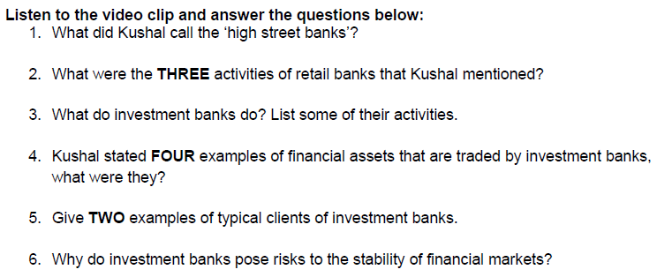

<https://www.youtube.com/watch?v=eTqT0psuSjk>



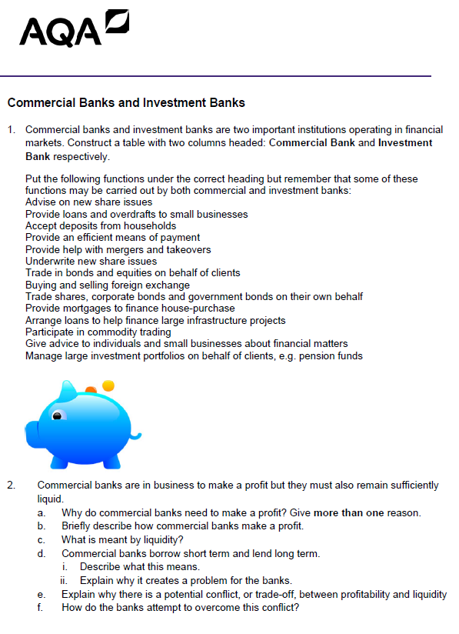

**Notes Page**



**Notes Page**



**Regulation of the Financial System**

**A D**

**a**

**Activity 1**: Produce a mind-map to explain the role of each regulatory body below.

a. Financial Policy Committee

b. Prudential Regulation Authority

c. Financial Conduct Authority

**Ext:** Explain a drawback to having these regulators in place (**hint**: financial services are a very profitable industry)

………………………………………………………………………………………………………………………………………………………………………………………………………………………………………………………………………………………………………………………………………………………………………………………………………………………………………………………………………………………………………………………

**Systemic Risk**

* **Systemic risk** is the possibility that an event at the micro level of an individual bank / insurance company for example, could trigger a collapse an entire industry or economy.
* The Global Financial Crisis (Credit Crunch) illustrated how interconnected the financial world has become.
* Shocks in one location (e.g. the USA) or asset class (e.g. sub-prime mortgages) can have a detrimental impact on the stability of institutions and markets around the world.
* Since the crisis, financial regulators have tried to make the banking system less vulnerable to economic shocks and create “firewalls” to prevent damage from systemic risk

**Video:** Analyse how the ‘wobbly’ Millennium Bridge helps to explain the concept of ‘systemic risk’…

<http://www.tutor2u.net/economics/blog/how-a-wobbly-bridge-helps-to-explain-financial-instability>

**The Credit Crunch Explained!**

**Traditional Banking**

**a) How to make a profit**

* Banks pay interest on deposits from savers who put money in (lower r)
* Banks receive interest on the loans that they provide (higher r)
* The bigger the difference between the two interest rates, the larger the banks profit.

**b) Capital, risk & profit**

* Banks need to keep some of the money they take from savings. This is their reserve money in case things go wrong. They also have ‘share capital’ from their shareholders too.
* The more capital & reserves they have the less risky the bank, HOWEVER, this limits their profitability!
* The lower capital & reserves they have will increase profitability as they are lending this money out… HOWEVER the bank has taken on more risk!

**LOANS**

**INVESTMENTS**

**BANK**

**SAVINGS**

**INTER-BANK LENDING**

*Pay interest*

*e.g. 3%*

*Earn interest*

*e.g. 5%*

**a  
CAPITAL & RESERVES**

**Modern Banking**

* From the 1970s banks used a technique called securitisation in order to increase their profitability.
* What this meant was that they still leant money out to earn money. However, they did not bother to wait for the loan to be repaid. Instead they sold the debt off to another financial institution and got part of the money up front.

**SAVINGS**

**INTER-BANK LENDING**

**NORTHERN ROCK**

**PROVIDES A LOAN TO A CUSTOMER**

**LEHMAN BROTHERS**

Sells loan to another bank, who waits for the loan to come good

Gets money from sales of loan & can re-lend this money & earn more profit

**Where it all went wrong…**

**a) Who they were lending to (sub-prime loans creating toxic debt)**

* In the economic boom there was pressure on bankers to earn high returns for their shareholders.
* Indeed, bankers’ bonuses were structured as to encourage high risk lending (without any downside for the banker).
* Banks decided to lend to people who previously had not received loans  
  i.e. poor households in America (sub-prime).
* In the **good times** banks continued to gain profit from these loans due to the house price boom in America. If the mortgage payer could not afford the loan the bank could just repossess the more valuable house.
* However, in the **bad times** (when house prices crashed) there was no back-up collateral for the bank and these turned into toxic or bad debt which would never be repaid.

**Good Times:**

**NORTHERN ROCK**

**a  
LOANS TO SUB- PRIME BORROWER DURING HOUSING BOOM**

**If borrower cannot pay, repossess their valuable house £☺£**

**NORTHERN ROCK**

**a  
LOANS**

**TO SUB PRIME DURING HOUSING BUST**

**a  
If borrower cannot pay, toxic debt created ☹**

**Bad Times:**

**Bad Times:**

**b) Passing the Buck: they didn’t care if the loan failed**

* There were other factors causing sub-prime lending, not only bonuses and shareholders.
* The fact that the original bank (Northern Rock in the above example) were not the people chasing up the loan gave little incentive to lend responsibly.

**c) Information Failure: no-one understood securitisation**

* Banks did not often sell off loans individually. Indeed, they often bundled good debt with bad debt: these were called collateralised debt obligations (CDOs) which even the people writing them did not fully understand them due to the complex maths involved.
* In the good times, banks bought these CDOs and got good returns but failed to understand the risks. Therefore in the bad times they were unaware of the toxic debt they were buying into.

**d) Failure of Regulation and Ratings Agencies: no-one stopped risky banks**

* To some extent regulators (at the time called the Financial Services Authority [FSA]) were using a light touch approach to regulation. This did not allow them to check up on the risky business models being pursued.
* Furthermore, ratings agencies did not give an accurate rating to many securities that the banks were selling. Indeed they often rated them as safe (AAA) when they contained sub-prime, risky lending as well as safer loans.

**The Consequences**

**a) Northern Rock & Lehman Brothers**

* Banks left with these toxic debts were the ones who were in danger of going out of business.
* So it is no surprise that the major casualties were Northern Rock and Lehman Brothers. This is because they themselves were not only buying and selling CDOs with sub-prime lending leaving but they were left with the CDOs that no-one else wanted to buy (the ones most risky & likely to fail).

**b) The Banking System**

* Virtually all banks were buying and selling CDOs with sub-prime loans within them. This meant that the problem spread to become a global problem.
* Overnight the inter-bank lending disappeared. Banks were too scared to lend to each other as they might not be able to pay them back due to the toxic debt they may or may not have.
* With banks unable to get finance from each other and with saving at an all time low, banks stopped lending to businesses and consumers.

**c) The global recession**

Without a functioning banking system, credit availability non-existent and confidence of consumers and businesses at an all time low this helped cause the global recession, including the UK.

Banks were bailed out to try and stop the damage getting any worse and economic policies expanded aggressively in order to prevent a depression akin to the 1930s. However, as we can see below, for countries like the UK the impact was devastating. We have also seen the implications for national debt in recent times with the Eurozone debt crisis.

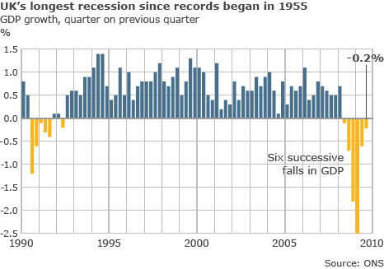

**The Credit Crunch**

**Comic Book Task: i)** Read p33-35 **ii)** Produce a comic book strip to summarise the Credit Crunch

(**Hint**: This is essentially 6 chains of analysis… include the term ‘systemic risk’)

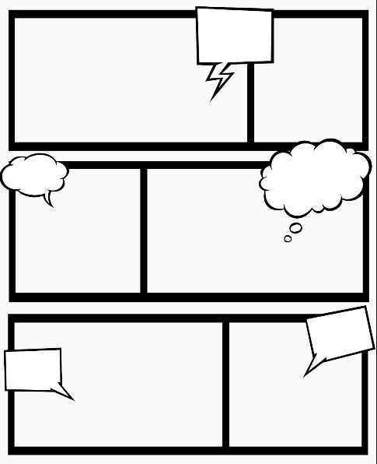

**Moral Hazard**

Moral Hazard is when a party with superior information alters their behavior in order to benefit themselves, whilst imposing costs on those with inferior information.

**Activity 1:** Explain how the Global Financial crisis shows the concept of ‘Moral Hazard’

………………………………………………………………………………………………………………………………………………………………………………………………………………………………………………………………………………………………………………………………………………………………………………………………………………………………………………………………………………………………………………………………………………………………

**Capital Ratio (7%)**

Measures the ‘good stuff on the balance sheet’ (retained earnings) against ‘risk weighted assets’ (e.g. loans to businesses and consumers).

Key Terms:

* **Solvency** is the degree to which the current assets of an individual or entity exceed the current liabilities of that individual or entity
* **Leverage** is ‘borrowed capital’ (debt) used to increase the potential return on an investment. A firm that is financed with significantly more debt (bonds) than equity (share capital) is considered ‘highly leveraged’.

The UK has a capital ratio of 7% (this has been increased from 2% pre financial crisis)...

This means that commercial banks must hold **£7 in deposits** for every **£100 that it lends**.

**Activity 2:** Answer the following question, continue on the next page if necessary.

|  |  |
| --- | --- |
| **“Assess (evaluate) the macroeconomic benefits of increasing the capital ratio to 7%”** | |
| Analysis | Evaluation |
|  |  |

**Notes Page**



**Extension Material**

The following 2 charts (see overleaf) were taken from the Bank of England’s quarterly bulletin publication: (<http://www.bankofengland.co.uk/publications/Documents/quarterlybulletin/2013/qb130302.pdf>)

A) Solvency problems (Explain how the financial regulators can prevent solvency problems from occurring)

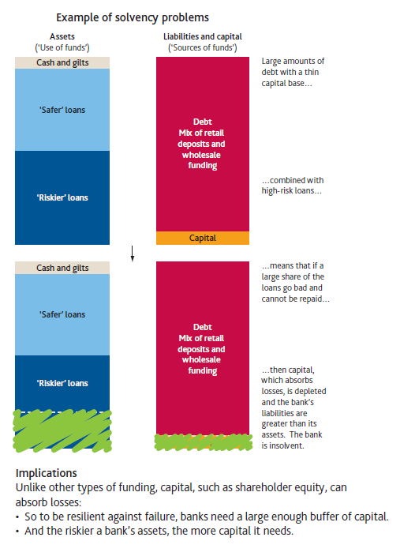

B) Liquidity Problems (Explain how the financial regulators can prevent liquidity problems from occurring)

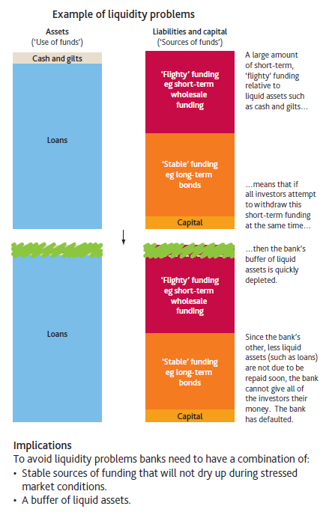

|  |  |  |  |
| --- | --- | --- | --- |
| **Do you understand Monetary Policy & Financial Markets?** |  | | ✓ |
| **Can you :**  **Interest Rates** | | | |
| Define interest rates | |  |  |
| Explain how changes in interest rates affect each of the macro economic objectives | |  |  |
| Explain how changes in interest rates can affect AD, AS and LRAS | |  |  |
| **Quantitative Easing** | |  |  |
| Explain how QE is supposed to boost the economy (three ways) | |  |  |
| Explain QE and how it affects every financial market | |  |  |
| Explain how QE impacts on pensions | |  |  |
| Explain the inverse relationship between interest rates and bond prices | |  |  |
| Explain the difference between the primary and secondary markets for Bonds | |  |  |
| **Broader Monetary Policy** | |  |  |
| Explain the main 3 tools of monetary policy and who is responsible for implementation | |  |  |
| Define the money supply and know the difference between Narrow & Broad money | |  |  |
| Explain the concept of forward guidance and its intended outcome | |  |  |
| Explain the funding for lending scheme | |  |  |
| **Wider Financial Market** | |  |  |
| Explain how commercial banks create credit | |  |  |
| Explain the difference between a commercial bank and an investment bank | |  |  |
| Explain the difference between money markets, the capital markets and FE markets | |  |  |
| Explain why a bank might lend long and borrow short and identify the risks involved | |  |  |
| Explain liquidity & capital ratios and how they affect the stability of financial institutions | |  |  |
| Explain systemic risk | |  |  |
| Identify the three organisations set up to regulate the financial system | |  |  |
| Explain what a moral hazard is terms of financial markets | |  |  |
|  | |  |  |
| **Help can be found in the following places … ?:** | |  |  |
| Read pages 225-263 of the course textbook (AQA A-level Economics, Powell & Powell) | |  |  |
| Watched recommended videos from Godalming online | |  |  |
| Attend a support session in rm 206 (Mon, Wed and Fri 1300) | |  |  |

**Boost exam performance:**

|  |  |  |
| --- | --- | --- |
| Complete 4 & 9 marker questions on Godalming online |  |  |
| Complete the 25 marker questions on Godalming online |  |  |