Fiscal Analysis

Write 4-6 chains of analysis and draw a diagram that explains how the change in fiscal policy has led to the stated outcome

Example

Increased government spending – leading to improved Balance of payments

Increased G on infrastructure – improves quality & quantity of uk infrastructure – leading to more efficient transportation – reduces the price of UK goods – UK goods become more competitive on world markets – exports increase – improved Balance of payments

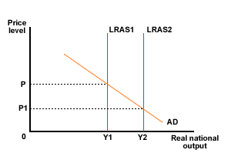

This is illustrated by shifts from LRAS1 to LRAS2 due to improved infrastructure leading to the price level to drop to pl2, meaning UK exports are more competitive on world markets

1. Increased Government spending – leading to short run economic growth (through AD)
2. Increased Government spending(hint:capital) – leading to long run economic growth
3. Increased Government spending (hint: fiscal supply policy) – leading to short run economic growth (through AS)
4. Increased corporation tax – leading to higher unemployment
5. Decreased corporation tax – leading to long run economic growth
6. Decreased income tax – leading to inflation