

03 Economic Growth

**Homework Booklet**

**Due W/C 3rd December**

**Activity 2**: For each of the scenarios illustrate the economic growth(the correct type). Explain your answers using a logical chain. Try to use a range of diagrams and only use the same diagram to illustrate a different point.

**Explanation**

……………………………………………………………………………………………………………………………………………………………………………………………………………………………………………………………………………………………………………………………………………………………………………………………………………………………………………………………………………………………………………………………………………………………………………………………………………………………………………………………………………………………………………………………………………………………………..

**Diagram 1**: In a given fiscal year Public spending rises to £800bn whilst tax receipts reduced to £600bn. Illustrate _________ run economic growth

**Diagram**

**Explanation**

……………………………………………………………………………………………………………………………………………………………………………………………………………………………………………………………………………………………………………………………………………………………………………………………………………………………………………………………………………………………………………………………………………………………………………………………………………………………………………………………………………………………………………………………………………………………………..

**Diagram 2**: Increased consumption caused by increased house prices leads to factors of production being utilised fully including Unemployment falling to a record low of 4.2%, illustrate on a diagram.

**Diagram**

**Explanation**

……………………………………………………………………………………………………………………………………………………………………………………………………………………………………………………………………………………………………………………………………………………………………………………………………………………………………………………………………………………………………………………………………………………………………………………………………………………………………………………………………………………………………………………………………………………………………..

**Diagram 3**: An economy experiences the effect of a positive multiplier on ___________ economic growth and an increase in the price level.

**Diagram**

**Explanation**

……………………………………………………………………………………………………………………………………………………………………………………………………………………………………………………………………………………………………………………………………………………………………………………………………………………………………………………………………………………………………………………………………………………………………………………………………………………………………………………………………………………………………………………………………………………………………..

**Diagram 4**: A fall in interest rates leads to increased investment – illustrate _____________economic growth

**Diagram**

**Explanation**

……………………………………………………………………………………………………………………………………………………………………………………………………………………………………………………………………………………………………………………………………………………………………………………………………………………………………………………………………………………………………………………………………………………………………………………………………………………………………………………………………………………………………………………………………………………………………..

**Diagram 5**: A sudden wave of animal spirits leads to firms investing to expand output. Illustrate _______________economic growth

**Diagram**

**Explanation**

……………………………………………………………………………………………………………………………………………………………………………………………………………………………………………………………………………………………………………………………………………………………………………………………………………………………………………………………………………………………………………………………………………………………………………………………………………………………………………………………………………………………………………………………………………………………………..

**Diagram 6**: An economy is able to achieve economic growth with sustained low prices

**Diagram**

**Activity 3:** Draw and label i) the trend rate of economic growth ii) the actual growth rate iii) both kinds of output gaps and iv) the 4 phases of the economic cycle: recovery, slowdown, boom, recession

Real GDP

Time

**Activity 2:** Complete the table below to show what is happening in the economy. Hint: Use the following terms: “**increasing / decreasing/ high /low”**

|  |  |  |  |  |
| --- | --- | --- | --- | --- |
|  | **Boom** | **Recession** | **Slowdown** | **Recovery** |
| **Output** |  |  |  |  |
| **Inflationary pressure** |  |  |  |  |
| **Unemployment** |  |  |  |  |
| **Welfare payments** |  |  |  |  |
| **Tax Revenue** |  |  |  |  |

Why do Some Countries Grow Faster than Others?

1. Differences in growth rates in any given year may simply **reflect the current stage of the economic cycle** and the strength of aggregate demand in a particular country
2. Differences may also **reflect the stage of long-run economic development / maturity** - growth rates tend to converge over time
3. Differences in the trend **growth of labour and capital productivity**
4. Some countries are **better at exploiting their natural resource** endowment more effectively (and at higher prices …. creating revenue for future development)

Activity Research the UK Trend rate of growth, then explain what’s happened to the UK’s trend rate recently

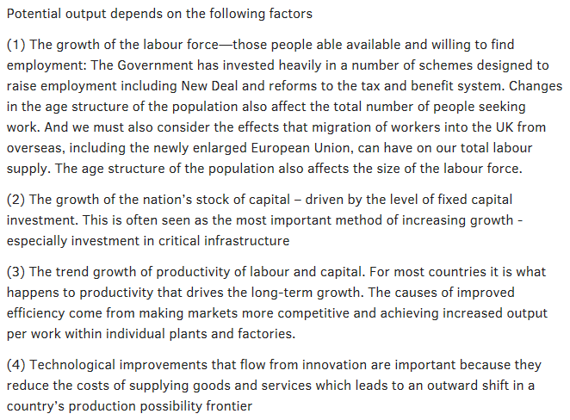

Activity – What policies could the UK government implement to increase the Long run aggregate supply?

**Keynesian AGGREGATE SUPPLY**

Keynesian AS curve

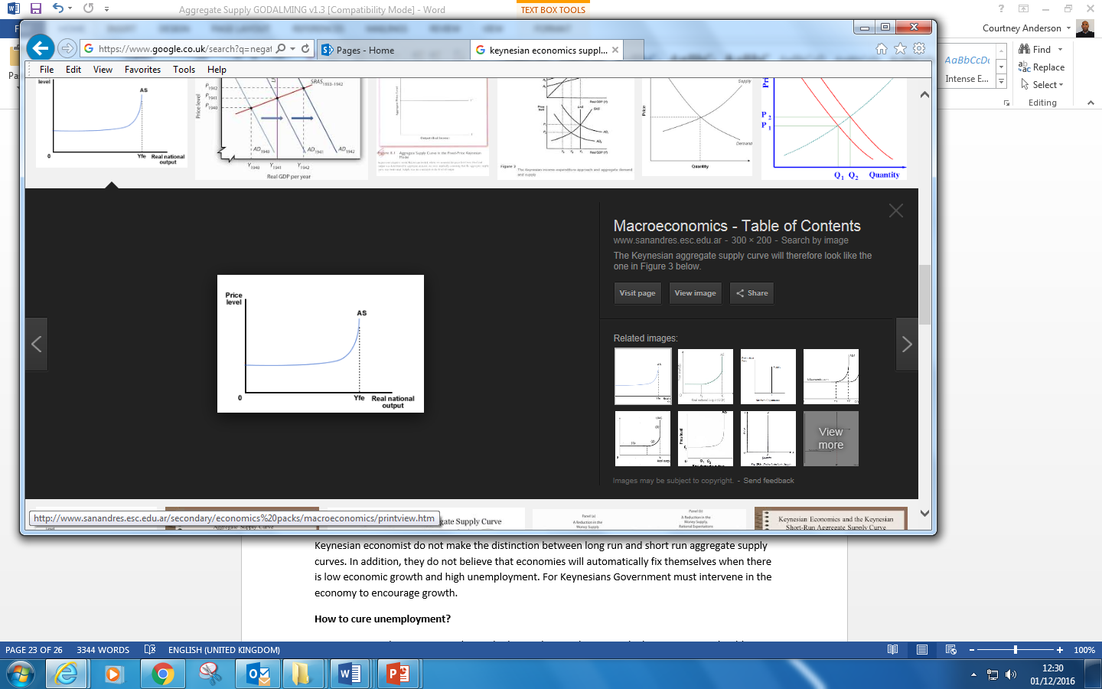

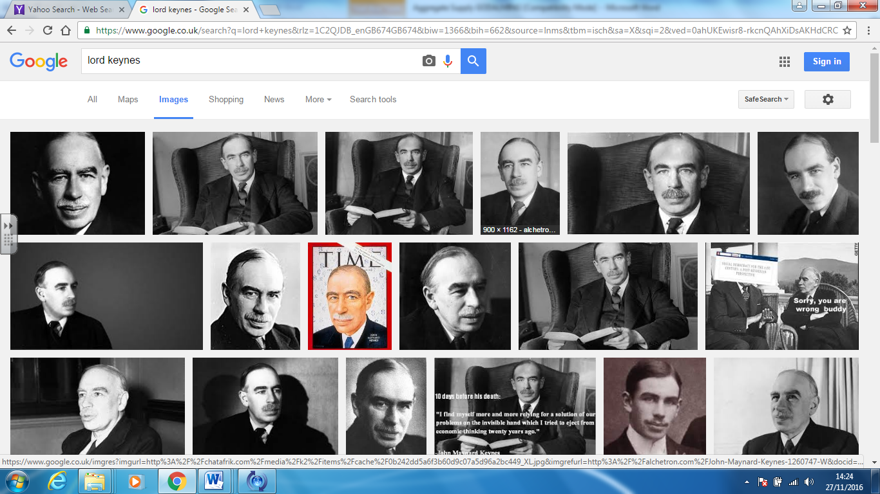

**Keynesian Aggregate Supply**

Keynesian economist do not make the distinction between long run and short run aggregate supply curves. In addition, they do not believe that economies will automatically fix themselves when there is low economic growth and high unemployment. For Keynesians Government must intervene in the economy to encourage growth.

**How to cure unemployment?**

For Keynesian when Aggregate demand is low and unemployment is high governments should examine ways in which to increase Aggregate Demand. For example this could be through increasing government spending on infrastructure projects (such as HS2). Such an increase in government spending will immediately increase the amount of people in work (added to further by the multiplier effect).

For Keynesians, initially the Aggregate supply curve is quite elastic, showing that as Aggregate Demand in the economy increases there are sufficient unutilized resources in the economy (land, labour and capital) that can be quickly used by firms to increase output. This government can expand aggregate demand with little impact on inflation until the economy reaches its productive capacity – where all resources are being used. At this point any increase in Aggregate Demand will not add to output but will increase inflation.

**Classical equilibrium**

Classical economist believe that the economy always operates at or near its full capacity. They therefore believe that the economy is always at or near a point, on or near to the Long Run Aggregate Supply Curve (LRAS). These economist believe that the economy is able to correct itself in those periods where aggregate demand is either too high or too low.

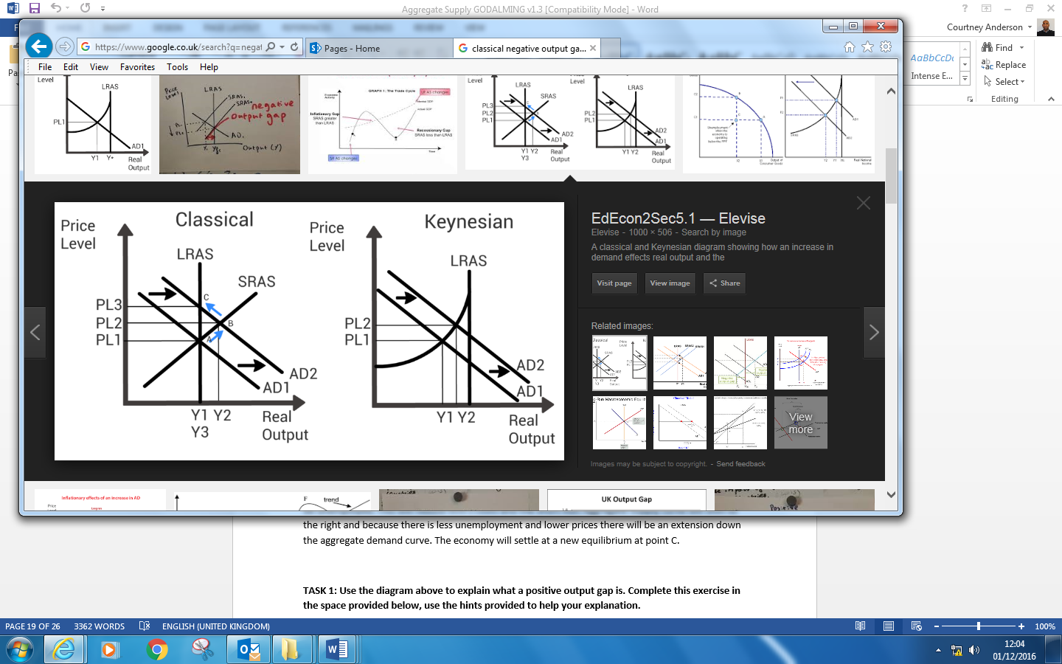

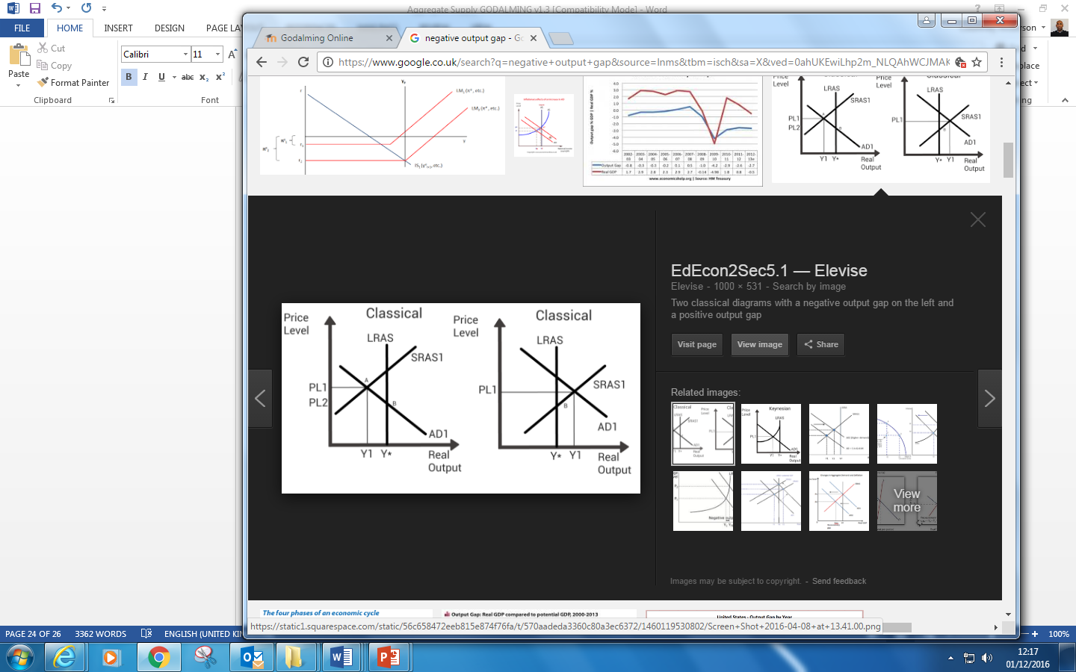

**How do classical economists explain a correction from a negative output gap?**

When aggregate demand is too low (shown by point A on the diagram), the economy is said to be operating with a negative output gap. At this point Aggregate Demand is not high enough to ensure that the factors of production including labour are fully employed. However for classical economists this situation will correct itself as unemployed labour will agree to work for lower wages rather than be unemployed. This will reduce firm’s costs and the Short Run Aggregate Supply curve will shift to the right. The economy will settle at a new equilibrium at point B.

**How do classical economists explain a correction from a positive output gap?**

Classical economist argue that when aggregate demand is too high a positive output gap will occur.(this can be seen at point B). At this point output in the economy has increased beyond its full capacity. In such a situation the economy is over-heating, labour is working overtime and factories are running machinery for much longer. Further as firms are desperate to get more workers, they start to pay workers more to encourage them to work for them and they also start to pay more for raw materials and machinery as they are in short supply. Because the firms costs are now rising, they will put up the prices of their products and services - there is increased inflationary pressure in the economy due to cost push inflation. Furthermore because firms costs are rising we assume that the firms Short run Aggregate Supply curve will shift left as less firms decide to reduce output or exit the industry in the face of reduced profits (leading to point C). And consumers faced with higher priced products will buy less goods and services contracting up the Aggregate Demand curve to a new equilibrium at point C.

Summarise the two schools of thought on how to achieve short run economic growth (Keynesian & Classical model) and include the key differences between them?



|  |  |
| --- | --- |
| Keynes | Classical Model |
|  |  |

Activity – 15 Mark Practise



………………………………………………………………………………………………………………………………………………………………………………………………………………………………………………………………………………………………………………………………………………………………………………………………………………………………………………………………………………………………………………………………………………………………

………………………………………………………………………………………………………………………………………………………………………………………………………………………………………………………………………………………………………………………………………………………………………………………………………………………………………………………………………………………………………………………………………………………………

………………………………………………………………………………………………………………………………………………………………………………………………………………………………………………………………………………………………………………………………………………………………………………………………………………………………………………………………………………………………………………………………………………………………

………………………………………………………………………………………………………………………………………………………………………………………………………………………………………………………………………………………………………………………………………………………………………………………………………………………………………………………………………………………………………………………………………………………………

………………………………………………………………………………………………………………………………………………………………………………………………………………………………………………………………………………………………………………………………………………………………………………………………………………………………………………………………………………………………………………………………………………………………

………………………………………………………………………………………………………………………………………………………………………………………………………………………………………………………………………………………………………………………………………………………………………………………………………………………………………………………………………………………………………………………………………………………………