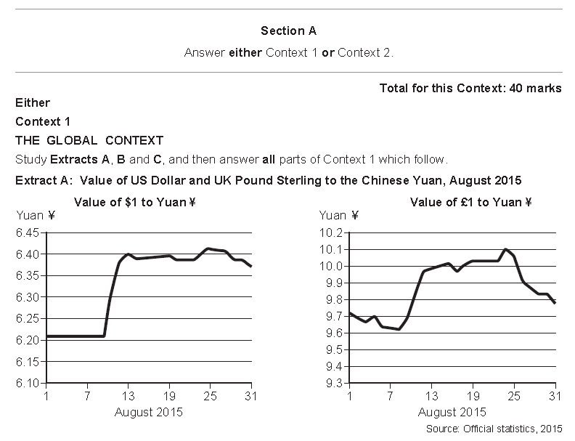

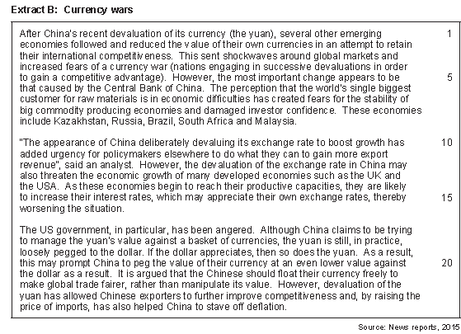

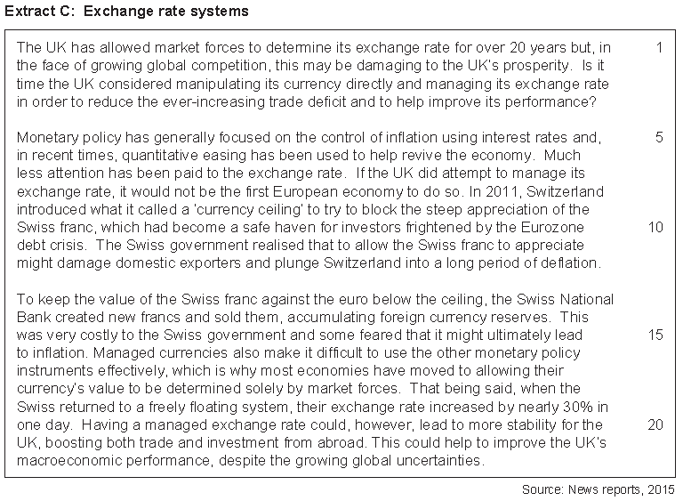

01 Using the data in extract A calculate (to one decimal place) the percentage change in the exchange rate between the US Dollar and the Chinese Yuan between the 1st and 13th August **(2 marks)**

03 With the help of a diagram explain how a decrease in the exchange rate would affect the UK balance of trade in goods **(9 marks)**

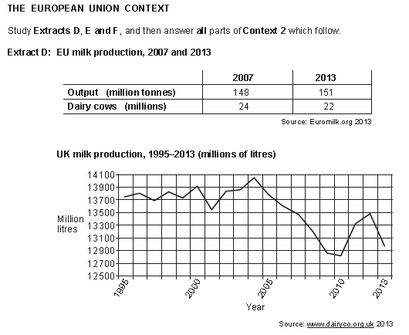

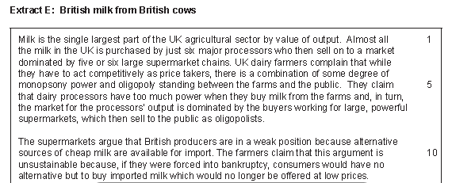

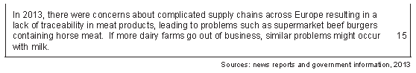

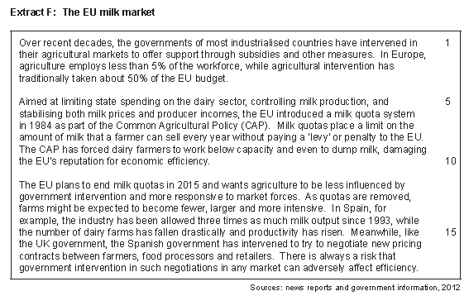

01 Using the table in extract D calculate to two decimal places the percentage change in UK milk production between 1991(13700) and 2010 (12800) **(2 Marks)**

02 Explain how the data in extract D shows that there has been an improvement in productivity within EU milk production **(4 Marks)**

03 Explain with the help of a diagram how the market power of the supermarkets can affect the profitability of dairy farms. **(9 Marks)**