04 Inflation and Unemployment

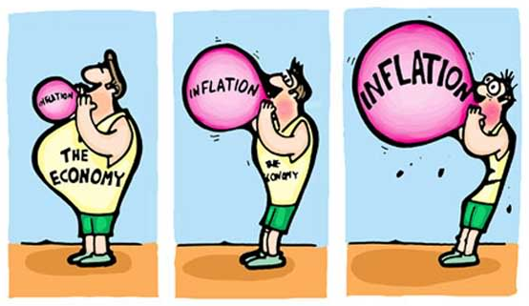

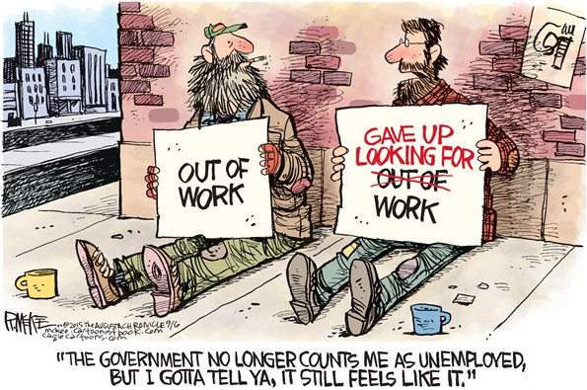

- Inflation
- Unemployment
- The Phillips Curve

A. Inflation
Starter: True or false?
- The two types of inflation are ‘cost-pull inflation’ and ‘demand-push inflation’
- Inflation can be defined as “an increase in the price of all goods and services in within a country”
- Inflation increases the purchasing power of money
- If inflation is 5%, and interest rates are 1% then ‘real interest rates’ are 4%
- The UK inflation target is 2% RPI
- The Chancellor of the Exchequer is responsible for achieving the target rate of inflation
- The CPI measure of inflation accounts for housing related costs, such as mortgage repayments
- A weak exchange rate is more inflationary than a strong exchange rate
- Disinflation can be defined as “a fall in the average price level”
- High inflation will reduce ‘real incomes’ of pensioners on a fixed income
Notes


Activity 1: To one decimal place, calculate the rate of inflation from 2006 to 2007 (2 marks)

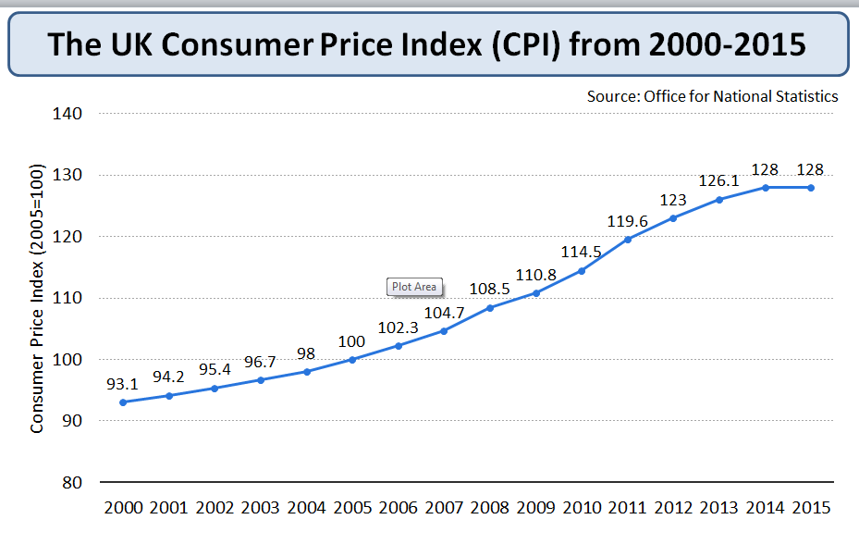
Show your workings:
Activity 2: Fill in the blanks in the table below by providing the missing index number (round to 1 d.p.)
Hint: Index = current year x 100
base year

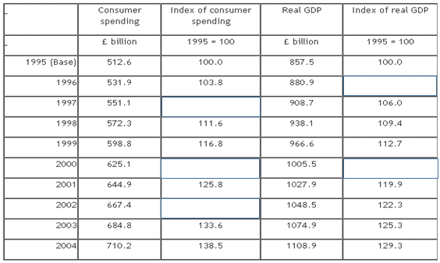
Show your workings here

Activity 3: Fill in the missing words
The RPI, ___________ ___________ Index measures the average household __________ ____ ____________. The weighted index is based on the spending decisions of ______________ households (taken from across regions and income levels) surveyed via the _________________ _____ _________ Survey. Weights are allocated to the top ___________ goods and services, with the weight determined by the amount spent on that good. Therefore goods that take up a _______________ proportion of income have a larger impact on the RPI. The contents and weights of items in the basket are reviewed each _________ and 120,000 price estimates are taken each ____________. The average price for each good is used in the index. The top 4% of income earners and low-income pensioners (reliant on the state pension) are excluded from the survey, as they are likely to have a distorting impact.
Missing words: cost of living, year, large, 6785, Retail Price, Expenditure & Food, 650, month
Activity 4: Answer the following questions in the space provided
1a. Draw demand-pull inflation on a i) Keynesian and ii) Classical ADAS diagram
b. Identify 4 factors that would cause demand-pull inflation (e.g. low interest rates causing high consumption)
c. Explain one of your policies above in detail… Make sure you link your explanation to one of your diagrams
Ext: Evaluate your policy x3
i) Keynesian AD-AS ii) Classical Diagram AD-AS

2a. Draw cost-push on a i) Keynesian and ii) Classical ADAS diagram
b. Identify 4 factors that would cause cost-push inflation (e.g. an increase in the rate of VAT from 20% to 25%)
c. Explain one of your policies above in detail… Make sure you link your explanation to one of your diagrams
Ext 1: Evaluate your policy x3
Ext 2: Why don’t we have a 0% inflation target? Why is it 2% CPI?
i) Keynesian AD-AS ii) Classical Diagram AD-AS

Notes Page
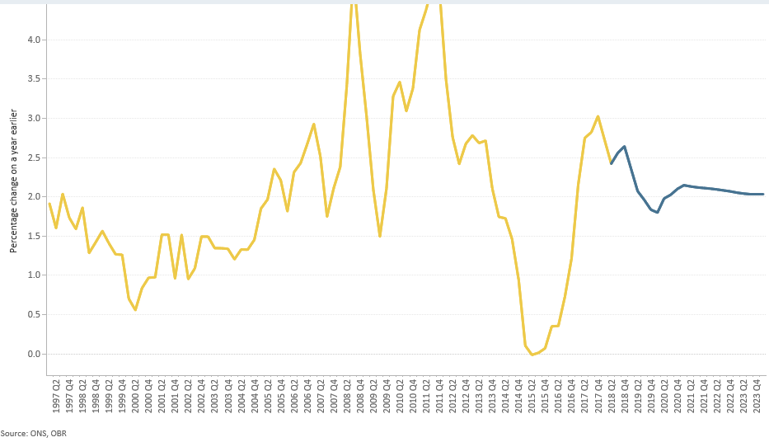
Activity 5: Inflation was 2.4% (CPI) in the year to October 2018. Price slowed for transport and food but rose faster for housing, utilities, recreation and culture. Use bullet points to explain how the following groups are most likely to have been affected by the change?
- A pensioner on a fixed income of £40k pa
- A bank deposit saver, assume bank deposit savings rates were 0.5% during this period
- Teachers in the state sector, who received a 1% pay rise in the academic year 2016/17
- A family on a variable rate mortgage, assume mortgage rates were 0.5% during this period
Ext: Come up with a scenario of your own and test your learning partner

Activity 6: Explain the following consequences of high (above target) inflation
(Top Tip: link these consequences to ADAS diagrams)

Impact on… | Explanation
Consumption (and expectations of future inflation) | If workers expect future inflation, they are more likely to bargain for higher wages to compensate for the increased cost of living. If workers are successful, their higher will cause cost-push inflation and a resultant fall in SRAS. If workers expect high inflation to be persistent, this could actually encourage consumption (in a similar way, deflation often has the result of postponing consumption).  Furthermore, the ‘money illusion’ could lead to more consumption through more disposable income, resulting in higher consumption and AD.  - ‘Money illusion’:
International Competitiveness

Investment

Costs of Production

The Exchange Rate

Ext: A negative impact of your own

The Quantity Theory of Money
(https://www.youtube.com/watch?v=XSilTPId7-o)

Monetarists believe that if the Money Supply rises faster than the rate of growth of national income then there will be demand-pull inflation.

Fisher Equation (M V = P Q)
M x V = P x Q
M = Money Supply
V = Velocity of circulation
P = Price Level
Q = GDP

Key Points
Monetarists believe that in the short term velocity (V) is fixed. This is because the rate at which money circulates is determined by institutional factors e.g. how often workers are paid does not change very much. Milton Friedman (King of the Monetarists) admitted it may vary a little but not very much so it can be treated as fixed.
Monetarists also believe Real GDP a.k.a. RNO is fixed. They state it may vary in the short run (+ve and –ve outputs gaps) but not in the long run the economy always returns to long run equilibrium (where LRAS is perfectly inelastic).
Increase in the Money Supply → increase in AD → demand-pull inflation

Example
Assume the Money Supply is initially £1000, the Velocity of circulation is 5 and level of output is 5000 units.
- The equation is 1000 x 5 = 1 x 5000
Assume that the Money Supply now doubles to 2000…
- New equation =

Milton Friedman predicted an increase in the money supply would take about 9-12 months to lead to higher output

Notes Page
Deflation

Activity 1: Answer the questions below in the space provided
1. Draw the Keynesian ADAS Diagram depicted in the explanation below | 2. Inflation caused by a fall in AD can lead to a deflationary spiral (malign deflation) Explain why.

Explanation: The economy is in originally in equilibrium at point A where AD and AS are equal. A reduction in Government current spending will lead to a decrease in money spent on public services like education and maintaining roads. Some of the people who were employed to do these jobs may find that they become unemployed. As their income falls, this results in less money being spent on consumption in the economy, a negative multiplier effect. Therefore, AD will fall from AD1 to AD2. There is now excess supply in the economy and in order to maintain profit levels firms will reduce prices (P1 to P2) and output (Y1 to Y2). The economy falls back into a new equilibrium at where AD and AS are once again equal at point B.

3. Draw the Keynesian ADAS Diagram to show deflation caused by a rise in AS | 4. Inflation caused by a rise in AS is less likely to lead to a deflationary spiral (benign deflation) Explain why.

Ext: Explain how an increase in productivity might lead to deflation in the economy (refer to your diagram)
Malign Deflation
Malign deflation occurs when prices fall because of a structural lack of demand which creates huge excess capacity in an economic system. If there is a slump in demand, companies go out of business and sack people, and hence demand falls again – the negative multiplier and deflationary spiral starts to have its effect.

Benign Deflation
If falling prices are caused by higher productivity, then it can go hand in hand with robust growth. On the other hand, if deflation reflects a slump in demand and persistent excess capacity, it can be dangerous, as it was in the 1930s, triggering a downward spiral of demand and prices. If the falling prices are simply the result of improving technology or better managerial practices, that is fine.

Activity 2: In the space provided, explain what is meant by the terms i) negative multiplier and ii) deflationary spiral

Drawbacks of Deflation
- Holding back on spending: Consumers may opt to postpone demand if they expect prices to fall further in the future. If they do, they might find prices are cheaper in 6 months.
- Debts increase: The real value of debt rises when the general price level is falling and a higher real debt mountain can be a drag on consumer confidence and people’s willingness to spend.
- The real cost of borrowing increases: Real interest rates will rise if nominal rates of interest do not fall in line with prices. For example UK policy interest rates were slashed to 0.5% in 2009 but realistically they cannot go any lower. If inflation is negative, the real cost of borrowing increases.
- Lower profit margins: Lower prices can mean reduced revenues and profits for businesses - this can lead to higher unemployment as firms seek to reduce their costs by shedding labour.
- Confidence and saving: Falling asset prices such as price deflation in the housing market hit personal sector wealth and confidence – leading to further declines in aggregate demand.

With low inflation stalking the Eurozone, how have Japanese consumers come to terms with years of deflation?
(The Guardian, Jan 2014)

Europeans wondering what life might be like under sustained deflation need look no further than a bowl of gyudon – the Japanese comfort food of rice topped with beef and onions.
The price of gyudon has become an unofficial indicator for the health of the world’s third biggest economy, which has been beleaguered by more than two “lost decades” of stagnation as consumers have resolutely refused to start spending and lift their economy out of trouble.
This is why last month’s decision by Yoshinoya, Japan’s largest chain of gyudon restaurants, to raise the price of a standard-size dish is not all it seems. Far from heralding a new era of inflation, the price rise, from ¥300, to a still very affordable ¥380 (about £2.11), simply highlights the deflationary depths into which Japan has sunk: this, after all, was the first gyudon price hike for almost a quarter of a century.
If Japan’s experience is any indication, living in a deflationary spiral can be complicated. Conventional wisdom tells us deflation is bad for jobs and growth, and that it causes the debt burden to weigh more heavily on households, companies and governments.
But for the average Japanese person, life under two decades of falling prices has had its compensations. Having seen so many false dawns, consumers have reached their own accommodation, of sorts, with the scourge that is now threatening the Eurozone.
First, it has shattered Tokyo’s undeserved reputation as a prohibitively expensive city. It wasn’t so long ago that McDonald’s there was selling a ¥100 hamburger (that’s about 56p), and clothing retailer Uniqlo has built a global empire on selling cheap, no-fuss garments.
Expensive hostess clubs, harking back to Japan’s 1980s bubble era, still exist, but they share premises with izakayas (pubs) where a glass of beer costs a paltry ¥180 (£1). Visitors from London and Sydney can barely believe how little they pay, comparatively, for a decent meal and a few drinks in Tokyo.
Yet it would be wrong to overlook the damage done to the Japanese psyche in the immediate aftermath of the bursting of the bubble in the early 1990s, a decade of excess and ostentation sustained by a shared illusion that the economy would remain for ever on an upward trajectory. The rows of black taxis waiting for businessmen on generous expense accounts to pour out of the exclusive restaurants did not go away, but their story became a very different one – of corporate restructuring or, in ordinary language, cost-cutting.
The boom gave way to rising unemployment and the emergence of a new generation that flitted between poorly paid contract jobs, resentful that the postwar dividend of savings and generous pensions appeared to have ended with their parents’ generation.
Now, as the prime minister, Shinzo Abe, enters the third year of his deflation-busting mission, anger and insecurity in the country have given way to resignation.
His campaign to devalue the yen has proved double-edged. A weaker currency may have improved the bottom line for exporters, but the dividends have not been passed on in wage increases. Furthermore, quantitative easing has been largely ineffective. For the time being, Japan’s companies, like the people they employ, prefer to sit on their cash rather than spend it.
This has given rise to growing doubts about the Bank of Japan’s inflation target of 2%. Abe, meanwhile, is hedging his bets on delaying a second planned rise in the consumption tax (to 10%) in an attempt to encourage spending and lift the country out of yet another recession.
But Japan is facing problems that the Eurozone does not necessarily share – yet. Its population is ageing more rapidly than almost anywhere else in the world. That, coupled with a low birth rate, lends weight to predictions of dramatic population decline in the coming decades. And the idea of boosting consumption though mass immigration is anathema to all but a tiny group of policymakers, none of whom has the ear of the prime minister. And that leaves an ageing, shrinking, cautious consumer base that is learning to live with deflation while the central bank embarks on periodic binges of quantitative easing.
Spending habits honed over 20 years die hard. And if Japan’s experience can teach Europe anything, it is that government attempts to haul consumers out of the deflationary abyss are fraught with difficulty.
An entire generation has come to embrace the deflationary devil they know. For the population at large, what started life as a reluctant thrift habit borne of necessity has quietly become the economic version of the Stockholm syndrome. And even at its new, elevated price, a steaming bowl of tasty gyudon is still an absolute steal.

Activity 2: Having read the article on p13, answer the following questions in the space provided
- Para 3: To one decimal place, calculate the percentage change in the price of gyudon (2m)
- Para 2: Referring to the article, explain what is meant by the term ‘stagnation’ (4m)
- Para 11: Explain 2 policies undertaken by Japan to tackle their deflationary spiral (9m)
Ext 1: Essay Plan: Evaluate the economic costs and benefits to an economy, such as the UK, of deflation (25m)
Ext 2: Essay Plan: Evaluate policies that might be used to help an economy solve a problem of deflation (25m)
Notes Page
Ext 3
- Explain why deflation can lead to an increase in the real value of debts
………………………………………………………………………………………………………………………………………………………………………………………………………………………………………………………………………………………………………………………………………………………………………………………………………………………………………………………………………………………………………………………………………………………………………………………………………………………………………………………………………………………………………………………………………………………………………………………………………………………………………………………………………………………………………………………………………………………………………………………………………………………………………………………………………………………………………………………………………………………………………………………………………………………Hint: Think! The nominal value of the debt does not change, and a constant interest rate of 0.5%.

- Explain why deflation can lead to an increase in the real value of borrowing?
………………………………………………………………………………………………………………………………………………………………………………………………………………………………………………………………………………………………………………………………………………………………………………………………………………………………………………………………………………………………………………………………………………………………………………………………………………………………………………………………………………………………………………………………………………………………………………………………………………………………………………………………………………………………………………………………………………………………………………………………………………………………………………………………………………………………………………………………………………………………………………………………………………………Hint: Think! If inflation is – 5% CPI and the nominal interest rate is 0.5% what is the real interest rate?

B. Unemployment
Starter: To one decimal place, calculate the rise in unemployment between 2008 and 2012 (2 marks)
Show your workings below!

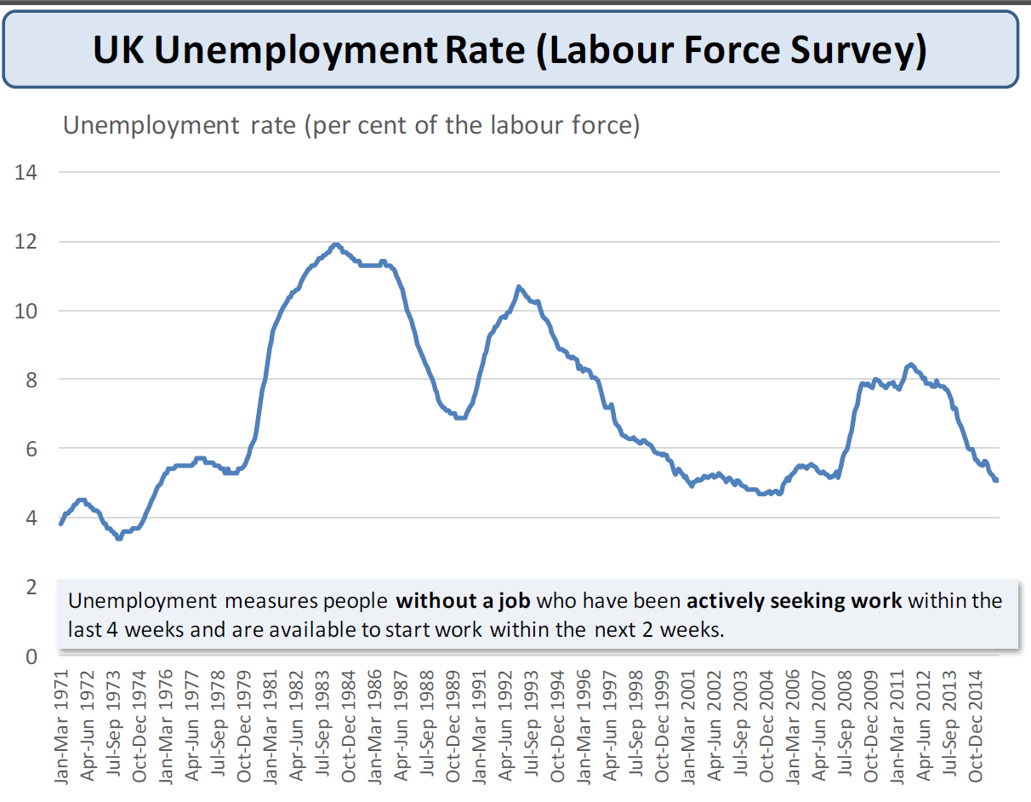

Activity 1: Answer the following questions in the space provided
- The LFS is one measure of U… Identify and explain the other measure of U
- Use an example to explain the 5 main different types of unemployment
- Identify the 5 types of unemployment (above) as either voluntary or involuntary
Ext: PTO
Ext 1: Identify the type of unemployment depicted in each case



Ext 2: Create a case study of your own (including a picture and text) and test your learning lartner ☺

Activity 2: Show Unemployment that exists on 4 diagrams (hint: negative output gap)
Ext: Explain the demand and supply side causes of unemployment (think of the 5 main types of U)

Diagrams Causes of Unemployment (Demand v Supply side factors)

Activity 3: Explain three Govt. policies that do the following (continue on the next page):
i) reduce cyclical unemployment ii) improve occupational mobility iii) improve geographical mobility
Top Tip: Show off as much Year 2 subject knowledge as possible e.g. tariffs, QE, etc.
Ext: Evaluate Each Policy 3 times

An Ev

Notes Page
Real Wage Unemployment
Real Wage unemployment occurs when wages are above the equilibrium level (SL > DL)
The basis of classical economics (monetarists) revolves around labour markets and the assumption of labour markets which perfectly clear. One fundamental idea is that wages above the market clearing equilibrium will cause unemployment.
Some economists go so far as to say that all unemployment reflects disequilibrium in the labour market. – If wages were allowed to fall to the market clearing level, then unemployment would be solved. Therefore, classical economists place great emphasis on reducing the power of trades unions and legislation which leads to artificially high real wages.

Activity 4: Answer the questions below in the space provided
A. Draw a (labour market) diagram to show real wage unemployment

B. Draw a labour mkt in equilibrium… Show the impact a demand-side shock and resulting real wage unemployment

Ext 1: Explain how the market depicted in the diagram above would clear in the eyes of a classical economist

Ext 2: Explain why the excess supply of labour would not clear through the eyes of a Keynesian economist

C) An (Explain why classical economists believe that labour markets clear in a free market) | D) Ev (Explain why Keynesians believe that labour markets do not always clear)

Ext 3: Evaluate a policy to reduce real wage unemployment
An (Explain how the policy works) | Ev (Balance)
Ext 4: Research the ‘Paradox of Thrift’ on your phone
Notes Page
The Natural Rate of Unemployment (NRU)
The natural rate of unemployment (NRU) is defined as the equilibrium rate of unemployment i.e. the rate of unemployment where real wages have found their free market level and where the aggregate supply of labour is in balance with the aggregate demand for labour. The NRU is 4-5% of the working population.
At the NRU, all those wanting to work at the prevailing real wage rate have found employment and there is no involuntary unemployment. There remains some voluntary unemployment as some people remain out of a job searching for work offering higher real wages or better conditions. In other words, it is the same level as the full employment level of output (YF).
Some economists simply do not believe in the validity of a simple natural rate of unemployment when the labour market is in balance and where a rate of unemployment “settles” at a level consistent with stable wage and price inflation. The natural rate concept is supported by economists who believe in the power of markets to clear at an equilibrium price and who view the labour market much as any other market in the economy.
Policies to reduce the NRU focus on improving the efficiency of the labour market, removing “labour market imperfections” through policies such as the following:
Policies
- Reform the system of welfare benefits so as to reduce the risk of the “poverty trap”
- Reforming trade unions to reduce their collective bargaining power and also reducing some of the barriers to labour mobility put up by professional bodies and associations which have the effect of limiting the supply of labour into an occupation
- Reducing income tax to improve the incentives to look for and accept paid work
- Adopting a more relaxed approach to labour migration

Activity 5: Analyse and evaluate one of the policies above
An | Ev
Hint: Think about the following groups of people: households, government, local communities
Activity 6: Explain the consequences of Unemployment
Ext: Evaluate each consequence…. The extent to which…

Extension Material: The Economist explains what full employment really means

Why some economists worry when unemployment gets too low
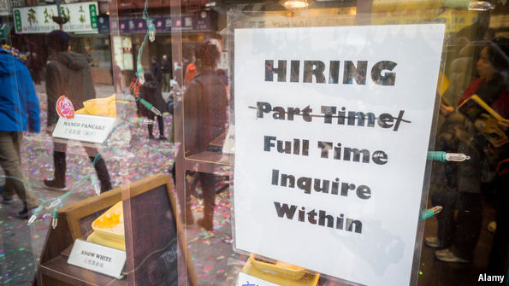
Jan 29th 2017
In 1977 America's government gave the Federal Reserve what seems like a straightforward goal: maximum employment. Janet Yellen, the current chairman of the Fed, thinks America is pretty close; at 4.7%, the unemployment rate is quite low by historical standards. But firms continue to hire, and American adults, of whom only about 69% have a job, seem less than maximally employed. Most governments set themselves or their central banks a guideline of full or maximum employment. But what exactly counts as full?
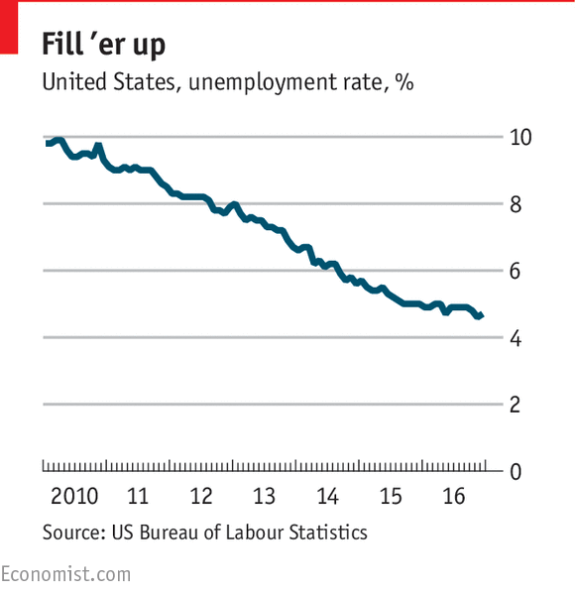
Ms Yellen has a particular definition of maximum employment in mind, built on the economic experience of the past half-century. Macroeconomists reckon that governments can only push unemployment so low. Push the unemployment rate below some (unobserved) “natural rate”, and it will soon rise back up, along with prices. At the natural rate, all the workers who can easily or usefully be hired are working, and new hires can only occur by luring people from other jobs by offering them higher wages. Central bankers take a guess at the natural rate and at how quickly unemployment that is “too low” will spark inflation, then seek the sweet spot: when the labour market is as tight as it can be without runaway price rises. The natural rate of umemployment depends mostly on what economists label “frictional unemployment”: which occurs when people switch from one job to another, or when they enter the workforce (after finishing university, for example, or returning from leave). Barriers to job switching, like occupational licensing, increase friction and push up the natural rate. Other factors grease the gears. The lower natural rate of the 1990s might have been down to more efficient hiring thanks to information technology. The rise of “gig economy” work might also push the natural rate down.
But the boundary between long-term structural unemployment and the temporary, cyclical kind is not clear-cut. In the 1980s and 1990s economists argued that short-term unemployment could become long-term unemployment: a phenomenon known as "hysteresis". As a worker’s time without a job grows, his professional connections might weaken and his skills might become obsolete. Workers not laid off during a downturn might bargain for greater job security, which might in turn make firms reluctant to rehire those who were laid off (since they could not easily be sacked during the next recession). Hysteresis also works in reverse, at least to some degree. As America’s unemployment rate has fallen below 5%, wages have finally started rising at a faster pace. Better pay will entice some people who had given up on the labour force to look for work again. Better economic conditions might lead firms to offer temporary workers permanent positions, or to give more hours to part-time employees. As firms find it harder to hire new workers, they might offer existing workers more hours, or convert part-time or temporary positions to full-time or permanent ones. Bosses might even try to raise output per worker, by investing in training or in new equipment. The rub is that policymakers cannot know how much slack remains in the system until they see inflation spiralling up—and they would rather it didn't. So central banks often end up slowing growth before full employment is reached because of an excessive aversion to inflation.
To treat full employment as a purely economic phenomenon is not quite right, however. If the goal of full employment is a happy society, then the quality as well as the quantity of jobs matters. Employment rates in subsistence societies are extremely high. In richer countries, more people would be in work were governments to withdraw unemployment benefits and repeal the minimum wage. Yet society would be worse off for it. Technological change complicates matters. A scarcity of workers could drive investment in machines, allowing each worker to produce more. Yet it might also lead to more automation. If robots can easily replace lots of workers (and it increasingly seems that they can) then full employment is not simply a matter of making sure the economy is growing fast enough so that all willing workers have a job. It will also depend on the decisions societies make, regarding when workers can be given the means to refuse poor, low-pay jobs which could instead be done by machines.

Notes Page
C. The Phillips Curve (Inflation & Unemployment)
Starter: Answer the Questions in the space provided
- What are the 4 macroeconomic objectives?
- How is each objective measured?
Ext 1: What is the current measure for each of these objectives (e.g. what is current UK inflation)
Ext 2: Explain how the achievement of one macroeconomic objective can conflict with others

Activity 1: True or False?
- Demand pull inflation is generally associated with a rise in short run economic growth
- The BoEs inflation target is 2% RPI (+/- 1%)
- High economic growth in the EU is likely to improve the UKs BoP current account
- Cyclical unemployment occurs when workers are moving between jobs
- The Fisher equation is MV = PQ
- Cost push inflation is generally associated with a rise in short run economic growth
- A budget deficit is where M > X
- Structural unemployment is caused by real wages above the market clearing wage
- The J-Curve states that a currency depreciation will cause the BoP current account to get worse before it gets better
- A weak exchange rate is more inflationary than a strong exchange rate

Inflation, Unemployment & the Phillips Curve
Unemployment falling
Inflation rising

Background to the Phillips Curve

- The Phillips Curve shows the relationship between inflation and unemployment. It was originally proposed in 1958 by A.W.Phillips who found an inverse relationship between the percentage change in inflation and the level of unemployment in the UK economy over many decades.

Explaining the Phillips Curve Relationship

You can show the inverse relationship between inflation and unemployment on a Phillips curve. This can be explained using a Keynesian AD/AS diagram. If aggregate demand is rising (and is on the upward part of AS) then this will cause a rise a fall in unemployment as the economy is operating nearer to full employment/full capacity. However, there will also be demand-pull inflation in the economy due to rising aggregate demand. This also shows a conflict between economic growth & inflation.

Short Run Phillips Curve Keynesian AD/AS Diagram

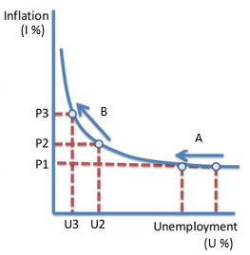

Activity 2: Answer the following questions in the space provided
- Draw the Keynesian AD/AS diagram (above) – label your points A and B
- Which is more desirable, A or B? Justify your answer! (Hint: refer to inflation and unemployment)
- Explain the inverse relationship between the level of unemployment and the rate of inflation (Hint: use the following terms in your explanation: rise in AD, expansion in AS, increase in production, unemployment, labour, derived demand for production, demand-pull inflation)
- Explain why at a HIGH level of unemployment (point A), an increase in AD causes a large fall in unemployment and only a minimal inflation (Hint: Use the following terms: spare capacity/negative output gap, unutilised FoP, AS is elastic, rise in AD, expansion in AS, minimal inflation)
Ext 1: Explain why at a LOW level of unemployment (point B), an increase in AD causes a smaller fall in unemployment and much larger rise in inflation (Tip: relate your answer to the Keynesian AS curve)
Ext 2: Why might the relationship identified with the Phillips Curve not hold true?
Ext 3: What implications does the SR Phillips Curve have on Govt. spending in a boom/recession?
Write your answers in the space below
Long-Run Phillips Curve
Notes Page


Tick list of tasks you must complete to finish this module:
Do you understand Inflation, Deflation & Unemployment fully? |  |  | ✓
Inflation: can you
Define inflation
Draw and explain demand pull inflation
Identify the causes of demand pull inflation
Explain cost push inflation
Identify the causes of cost push inflation
Define and explain disinflation
Explain what reflationary policies are, and when you might implement them
Deflation: can you
Define deflation
Draw and explain deflation
Explain what deflationary policies are, and when you might implement them
Explain the goal of deflationary policies (which is not deflation)
The money Supply & Inflation: can you
Define the money supply
Explain the quantity theory of money
Give a rough over view of the monetarist view of the money supply
Unemployment: can you
Identify the two main measures of unemployment
Explain the concepts of voluntary and involuntary unemployment
Identify the four main types of unemployment
Identify both demand and supply side factors that affect the level of employment
Explain classical & Keynesians beliefs on how labour markets clear
Explain the NRU and the NAIRU
Explain real wage unemployment and identify the factors that determine it
Explain the consequences of unemployment for individuals and the economy
Help can be found in the following places … ?:
Read pages 206 – 224 in the year 2 course text book
Watched recommended videos from Godalming online
Attend a support session in room 206 (Mon, Wed and Fri 1300)

