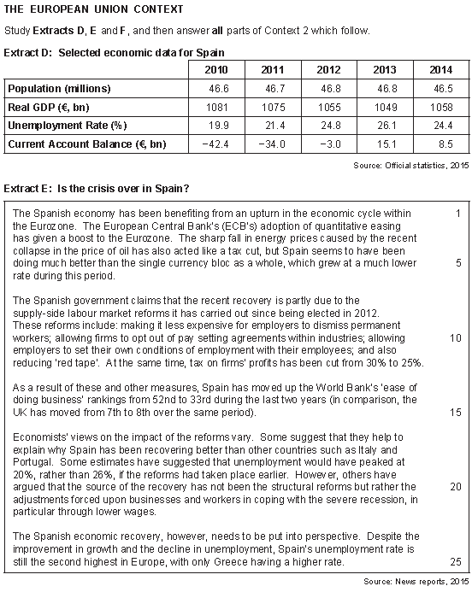



03 Using the data in **Extract A** calculate to **two** decimal places, the percentage growth rate for the Spanish economy from 2010 to 2014. **(2 marker)**



**(4marker)**

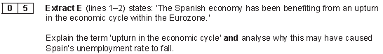

**(9 Marker)**

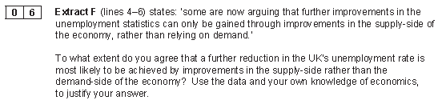

**(25 marker)**