Tariffs

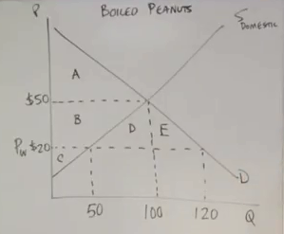

1. Consumer surplus before trade
2. Producer surplus before trade
3. Consumer surplus after trade
4. Producer surplus after trade
5. Overall net gain from trade (hint what has happened to the total surplus)

Assume that the government now places a $5 tariff on this product

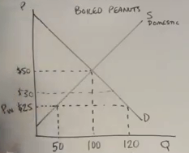

As a result of the tariff what has happened to

1. Consumer surplus
2. Producer surplus
3. Tax revenue gained

**Quotas**

Draw the Quota diagram below (without looking in your Trade Booklet!)

1. Label the dead weight loss of efficiency
2. Label the deadweight loss of consumer surplus
3. Label the quantity of the quota
4. After the imposition of the quota what is the price and illustrate the excess demand
5. Why does the supply curve shift?
6. What is domestic supply after the quota?
7. Explain why there is a dead weight loss of efficiency
8. Explain why there is a dead weight loss of consumer surplus

**Trade Creation**

Draw the Trade creation diagram below (without looking in your Trade Booklet!) assume that the UK has a competitive advantage in producing “Spokes”

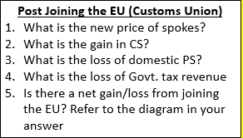

**Trade Diversion**

Draw the Trade Diversion diagram below (without looking in your Trade Booklet!) assume that New Zealand has a competitive advantage in producing “butter”

**QUESTIONS**

1. Before joining the EU, who did the UK buy its butter from and at what P?
2. What is the loss in CS from joining the EU? What is the gain in UK domestic PS?
3. Which section illustrates the loss of EU efficiency?
4. Which section illustrates the loss of domestic efficiency?
5. Which section illustrates the loss of consumer surplus