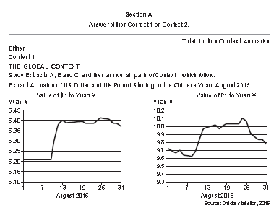

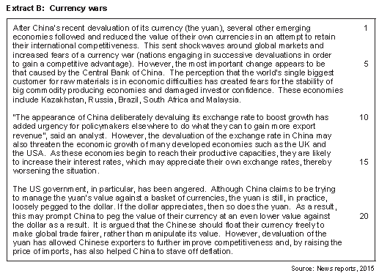

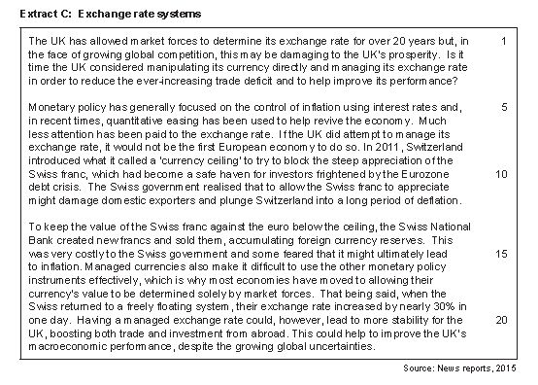

01 Using extract A calculate correct to two decimal places the increase in the value of the dollar from 1st August (6.21)– 13th August (6.4) **(2 Marks)**

02 Explain with the use of a diagram how a devaluation of the Chinese currency will impact economic growth in the UK

**(9 Marks)**

03

