From the Classical to the Gothic Era in Art and Architecture
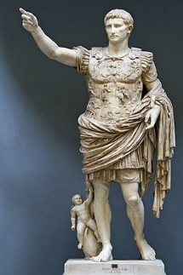 | 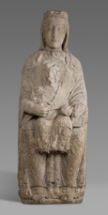 | 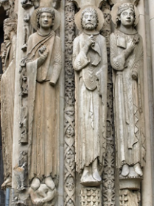
Classical Era | Romanesque  Dates: | Gothic  Dates:
Definition: Art and architecture from the Greek and Roman Empires. Greek Empire would eventually collapse to Rome circa the 1st Century BC.  Greek Classical era divided into three distinct styles: Archaic, Classical, Hellenistic. | Definition: | Definition:
Characteristics: Figurative sculpture from the height of the Classical periods were typically idealised, with an attention to detail, often a focus on mythological characters or leaders. Roman Empire succeeded that of Ancient Greece. Introduction of contrapposto from Greek Classical sculpture. | Characteristics: | Characteristics:
Find an example of a bronze Classical era sculpture and include here. | Find an example of a Romanesque era building and include here. | Find an example of a Gothic era building and include here.
 | Find an example of a Romanesque era figurative sculpture and include here. | Find an example of a Gothic era figurative sculpture and include here.
Find a definition for ‘International Gothic’.
Include an example of an International Gothic style painting here.

