BTEC yr1

Screenwriting – lessons 1 & 2

*The majority of lessons now, for the foreseeable, will involve lecture and task based session, with you typing up your results / answers / research onto your blog pages.*

Last week we made a start with criteria A1 a. please ensure you have:

i Defined what each role is (producer, director etc.)

ii Referred to a professional example for each role

iii Written a brief statement about what a writer’s ‘relationship’ might be with each of the professional roles.

Then…

i Write a short paragraph describing and explaining what it is a screenplay writer does. Remember to include knowledge you’ve picked up over the past few weeks. What aspects do they include in script? What aspects of the production are they involved in? You are encouraged to go into as much detail as possible.

Then…

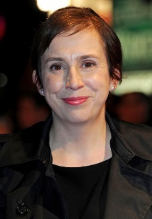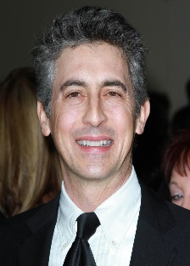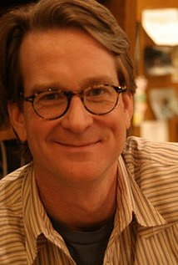i Research THREE different types of famous writers (again, this is still part of A1 a.):

David Koepp Abi Morgan Alexander Payne

American – commercial British – independent American – independent

– works with a co-writer

ii Display your research detailing the relevant information:

* Biography and background
* Successes and failures
* Types of screenplay (genres, adaptations, originals, TV, films, etc.)
* Think about how all three writer’s work is different.

Remember, the whole purpose of a blog is that it is meant to be fun, informative and interactive- so make the most of the options to include links, clips, images, posters etc.