**Holman Hunt, *The Shadow of Death*, 1873, oil on canvas.**

* 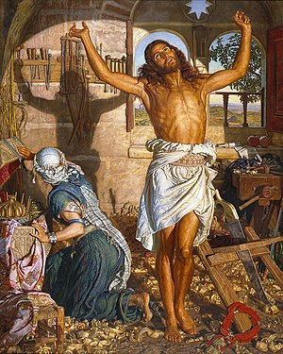**Scope of Work: Religious Painting (British).**
* **Specified Painter**

Use the PowerPoint on Godalming Online to answer the following questions for this key work.

**Powerpoint here**: <https://online.godalming.ac.uk/mod/folder/view.php?id=59723>

1. In 80 - 100 of YOUR OWN words, explain the story/meaning of this work. Look at characters, setting, symbolism, props/objects.
2. In approx 60-80 of YOUR OWN words explain the term ‘Muscular Christianity’.
3. Now apply the concept of ‘Muscular Christianity’ to this painting. What evidence do we see and what is Holman Hunt’s aim?
4. In YOUR OWN words find a definition for ‘typology’.
5. Identify five examples of typology within this painting. Choose examples which help explain the painting’s meaning.
6. In five bullet points explain how this painting is typical of the Pre-Raphaelite style?
7. Where did Holman Hunt produce this work and why?
8. How does this work suit the values of Victorian Britain?