**REPRESENTATION**

***Kiss of the Vampire* (1963)**

Traditional **stereotypes** of women as passive victims of men and more modern ‘male fears’ of women challenging male dominance could both be seen to be **encoded** in this film poster.

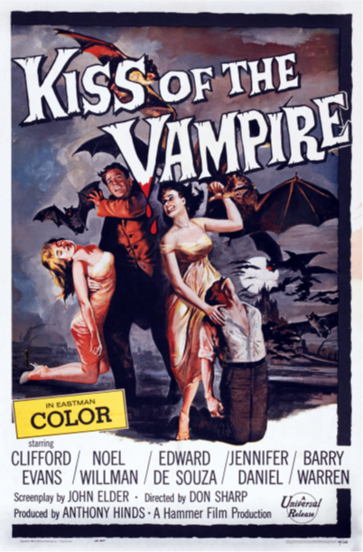

**TASK 4** –

*Consider how* ***representations*** *of* ***gender*** *are constructed through the selection and combination;*

*Dress codes*

*Gestures*

*Generic Iconography (vampires)*

Other areas worth considering;

1. Who is in ***control*** of the text? Look at the director, writer and producer of the film – what do they all have in common? How may this affect the representations of gender on offer?
2. What kind of ***world*** is being constructed by the poster? Is it realistic / exotic / fantastical etc.?
3. Does the poster conform to a ***dominant ideologies*** of the early 1960s(for example, does it support 1960s commonly held ideas of gender)?

**TASK 5**

***Now construct your ideas on representation of gender into a paragraph of approx. 200 words. Consider social-historical gender roles and remember to the use terminology you have learnt.***

**REPRESENTATION & THEORY**

**STUART HALL’S THEORY OF REPRESENTATION**

* The idea that representation is the production of meaning through language, with language defined in its broadest sense as a system of signs
* The idea that the relationship between concepts and signs is governed by codes
* The idea that stereotyping, as a form of representation, reduces people to a few simple characteristics or traits
* The idea that stereotyping tends to occur where there are inequalities of power, a subordinate or excluded groups are constructed as different or ‘other’.

***Consider***

* + ***Have stereotypes been followed/subverted?***
  + ***Who has the power in this poster?***
  + ***Is anyone portrayed as different or ‘other’?***

**DAVID GAUNTLETT’S THEORY OF IDENTITY**

David Gauntlett suggests that **representations** offer an opportunity to audiences to think about their own identify and role in society.

* The idea that the media provide us with ‘tools’ or resources that we use to construct our identities
* The idea that whilst in the past the media tended to convey singular, straightforward messages about ideal types of male and female identities, the media today offer us a more diverse range of stars, icons and characters from whom we may pick and mix different ideas.

Gauntlett also pointed out that whilst media **role models** hold some influence on audiences, we are more likely to be shaped by parents, friends, colleagues, teachers etc.

***Consider***

* + ***How could Kiss of the Vampire inform and affect the identities of women at the time?***
  + ***What variety of representations could women pick from?***

**TASK 6**

***Now add these theoretical ideas to your previous paragraph of approx. 200 words. Be sure to apply these theories to the poster not just state them.***