**ANALYSING MOVIE POSTERS**

Label up your set text poster using the codes and conventions of contemporary movie posters.

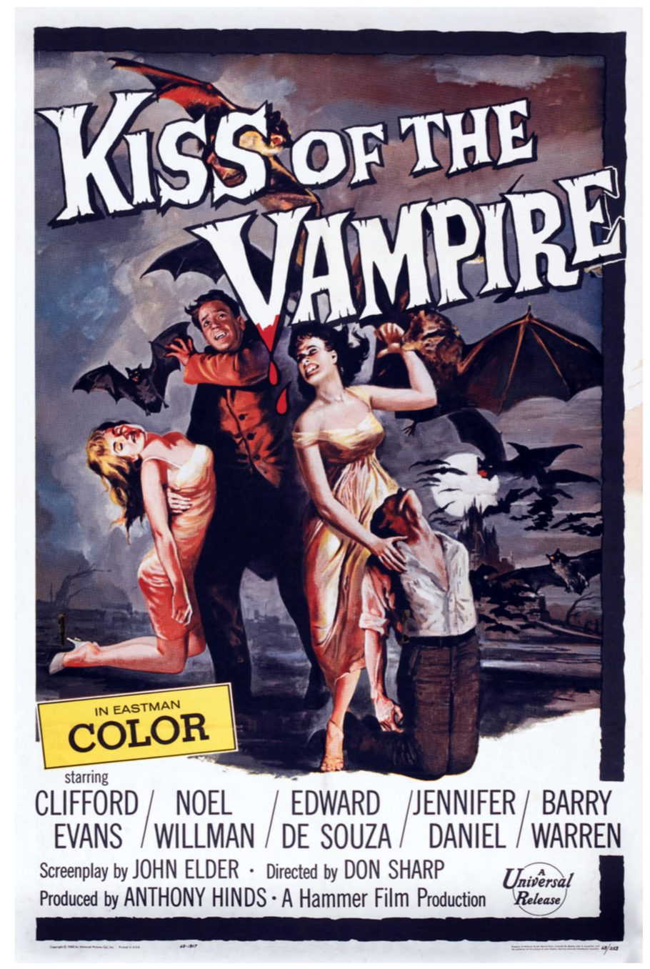

**Follow up questions:**

1. What is similar or different between this and contemporary movie posters?
2. Why?