C3 Rebellion and revival: the British and French Avant-Garde (1848‒99).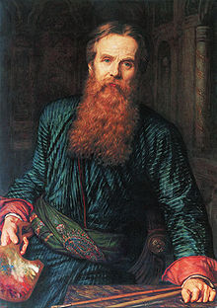

**Name**: William Holman Hunt  
**Life dates**: 1827-1910  
**Nationality**: British  
**Art movement/style**: Pre-Raphaelite

**About Holman Hunt:**

1. Founding member of the revolutionary and avant-garde Victorian movement, the Pre-Raphaelites.
2. Born in England. He entered the Royal Academy schools where he met John Everett Millais and together with Dante Gabriel Rossetti they formed the Pre-Raphaelite Brotherhood in 1848.

3. These artists rejected the Royal Academy’s conservative and prescriptive approach to art, as advocated by Sir Joshua Reynolds, an 18th Century artist and founder of the Royal Academy.

4. Holman Hunt was deeply religious and the majority of his works relate to Christian iconography including scenes from the life of Christ and Biblical events.

5. Holman Hunt journeyed to the Holy Land a number of times, as well as other countries including Egypt, to search for locations which would act as backdrops in his paintings and models whose ethnicity was the same as the characters he wished to paint. This shows the level of authenticity he was hoping to achieve and highlights the influence of art critic John Ruskin.

6. Holman Hunt also painted contemporary genre scenes and these have a moralizing tone or message. This demonstrates his desire that art should not simply be aesthetically pleasing but instead have a function. These works also contain themes and issues which relate directly to contemporary Victorian life and Holman Hunt was using art in an effort to instruct or inform the viewer.

7. As with Millais and Rossetti, Holman Hunt also used literary subjects for his work and these works would still contain a spiritual message within the narrative of the painting. The theme of the ‘fallen woman’, popular in Victorian culture, appears throughout his work and he found ways of applying this concept to various literary characters.

**Holman Hunt and The Pre-Raphaelites.**

1. Holman Hunt and the Pre-Raphaelites felt that art had become superficial, concerned only with surface effect and lacked the integrity of art in the age before Raphael.
2. They considered art after Raphael to consist of contrived and idealized forms which were ‘dishonest’ and lacking a genuine message.
3. They instead admired artists of the early Italian Renaissance such as Botticelli and also Northern European painters including Jan Van Eyck. Works by these artists appeared more honest and attempted to tell a story through details, symbols, clear forms and direct painting technique.

4. Holman Hunt and Millais followed the advice of the Victorian art critic John Ruskin who advised artists to “go to nature in all singleness…rejecting nothing, selecting nothing”. What Ruskin meant was that artists should replicate on canvas exactly what they see without idealizing or ‘editing’. Holman Hunt’s work is thus characterized by intense levels of detail, accurate observation of figures and forms as well as symbolism which would help convey the message behind his works.

5. As was typical of Pre-Raphaelite painting, his works are intensely coloured. This was due to their method of applying paint to a wet white ground, thus making the colours appear more vibrant. Prior to this artists typically applied paint to a background of red or brown. However the Pre-Raphaelites took their working methods from early 15th Century artists, once again deliberately abandoning the influence of Joshua Reynolds and the Royal Academy’s training.

6. Holman Hunt pioneered painting en plein air, alongside Millais. Prior to this artists traditionally painted in their studios, completing works from sketches begun outdoors. However Holman Hunt insisted on topographical accuracy to ensure his scenes appear as authentic as possible.

7. As the Pre-Raphaelite style developed and became more accepted by the Victorians, Hunt was to achieve great critical and commercial success. His painting ‘*The Finding of the Saviour in the Temple’* had sold to the Victorian art dealer Ernst Gambart for £5,500 (approx. £2m in today’s money) when Holman Hunt was only 33. This was the highest price paid for a work of art by a living British artist.

8. Reproduction prints of his works sold around the world, making him a household name and art dealers outbid each other to acquire his latest work. Throughout however he remained a spiritual and devout individual.

**Ensure you understand the highlighted words on the previous page and can apply those that are relevant to your analysis of the career and works of Holman Hunt.**

These are three of the aims devised by Holman Hunt and the Pre-Raphaelites regarding their art. Paraphrase them into your own writing.

1. To have genuine ideas to express,
2. To study Nature attentively, so as to know how to express them,
3. To sympathise with what is direct and serious and heartfelt in previous art, to the exclusion of what is conventional and self-parading and learned by rote,

Holman Hunt and the Pre-Raphaelites were influenced by early Renaissance artists from the **Quattrocento** including Fra Angelico and later Renaissance artists including Bellini, Michelangelo and also Raphael (despite the group’s name).

Find a definition for **Quattrocento** and include an image and title for works by Fra Angelico, Raphael and Michelangelo.

The Pre-Raphaelites were also inspired by artists from the Northern Renaissance including Jan Van Eyck and Rogier Van Der Weyden. What was the Northern Renaissance and include an image and title for works by each.

The Nazarenes style of painting was closely linked to the Pre-Raphaelites. Find dates and locations for this group of artists and a definition for this group. Find images for this group and include their titles.

These are the three key works we are studying for Holman Hunt. In each case note the genre of the work, give a summary description, indicate how it is Pre-Raphaelite in style. What influences from other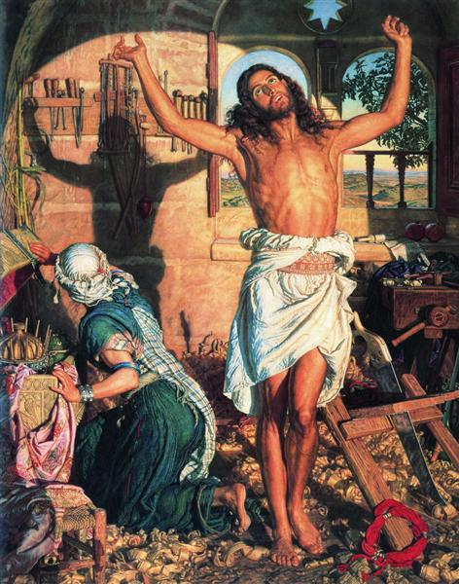 artists can you find in these works?

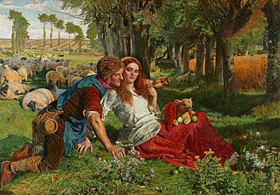

*The Hireling Shepherd*, 1851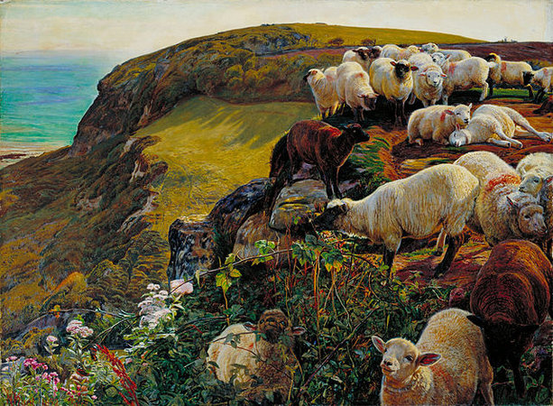

*The Shadow of Death*, 1873

*Strayed Sheep, Our English Coasts*, 1852

* The social thinker, Thomas Carlyle, had criticised Hunt’s ‘*The Light of the World*’, in particular the figure of Christ which he described as ‘effeminate’. Find an image of this work and compare it to the figure of Christ in Hunt’s next major religious work ‘*The Shadow of Death*’.
* Holman Hunt’s obituary in The Times compared him to other deceased artists buried in St Paul’s Cathedral (where Holman Hunt would also be interred) and contrasted him to them by stating: *“none of them ever worked more strenuously or more successfully than he to inspire his fellow man with lofty ideals, and to wed beauty to religion*”.

What does the writer tell us about Holman Hunt and his art?

* How/why does Holman Hunt’s work suit a Victorian audience? Would his work have the same reception in France? How does his work differ to those by French artists we have looked at? What can we tell about Victorian attitudes to art at that time?
* Why was Holman Hunt considered avant-garde?
* The art critic Frederic George Stephens wrote in 1860 that Hunt was “the first figure painter who gave the true colour of sun-shadows, made them partake of the tint of the object in which they were cast, and deepened such shadows to pure blue”.   
    
  Both Millais and Holman Hunt had exhibited in the 1855 Paris ‘Exposition Universelle’.   
    
  Can the above quote and fact be attributed to developments in painting in France in the years which followed?
* How does British ‘modernity’ differ to that in France at the time? How do the avant-garde artists of both countries differ in their treatment of the modern world?

<https://www.tate.org.uk/art/artists/william-holman-hunt-287>

<http://www.visual-arts-cork.com/famous-artists/william-holman-hunt.htm>

<http://www.english-heritage.org.uk/visit/blue-plaques/holman-hunt-william-o.m.-1827-1910>

<https://en.wikipedia.org/wiki/William_Holman_Hunt>

<https://www.theguardian.com/artanddesign/2008/sep/16/holman.hunt.damien.hirst>

<https://www.independent.co.uk/arts-entertainment/art/features/preacher-man-the-art-of-william-holman-986196.html>

<http://www.english-heritage.org.uk/visit/blue-plaques/holman-hunt-william-o.m.-1827-1910>

<http://www.victorianweb.org/painting/whh/replete/shadow.html>

<https://en.wikipedia.org/wiki/The_Shadow_of_Death>