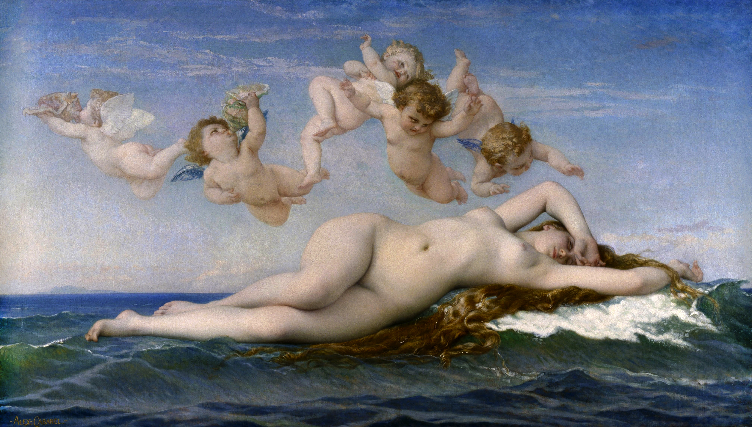
Alexandre Cabanel, The Birth of Venus, 1863, oil on canvas, 130 x 225cm
Theme/Scope of Work: Mythological and Literary Subjects in Painting

Explain the mythological story depicted in this painting.

Provide a definition for the term ‘putto’. What is the plural of ‘putto’?

Explain how this work is Academic in style.

Émile Zola described this depiction of Venus as a “goddess, drowned in a sea of milk, resembles a delicious courtesan, but not of flesh and blood – that would be indecent – but made of a sort of pink and white marzipan…” What is Zola implying?

How does this representation of Venus differ to examples by such artists as Sandro Botticelli?

Where did Cabanel train? What subjects did he specialise in? Who did he sell ‘The Birth of Venus’ to? How did Cabanel feel about Impressionism and the work of Edouard Manet?

This work was shown to great acclaim at the 1863 Paris Salon. It hung alongside other depictions of Venus. What does this tell us about art in the French Second Empire? See the link below:

https://en.wikipedia.org/wiki/Paris_during_the_Second_Empire#The_arts_during_the_Second_Empire_-_the_Paris_Salon

This painting coincides in the revival of 18th Century Rococo art and decorative arts. Why might the French Second Empire be interested in that era?

Describe the figure/form of Venus. How has she been painted/presented to the viewer?

