BTEC Assignment Brief
Qualification | Pearson BTEC Level 3 National Diploma in Creative Digital Media Production (Film and Television Production)
Unit number and title | Unit 35: Multi Camera Techniques
Learning aim(s) (For NQF only) | B: Prepare material for a multi camera programme in a recognisable genre and format  C: Carry out a key role in the production of a multi camera programme in a recognisable genre and format
Assignment title | Studio Production
Assessor | Matt Toogood / Mark Piper
Issue date | 28th September 2020
Hand in deadline | 11th December 2020
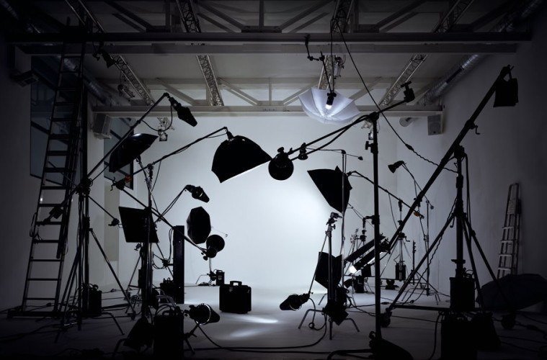
Vocational Scenario or Context | A community group has received funding to create a local, digital broadcast, TV channel and wants to invest some of its resources in live studio-based TV programming.  Following your report on the possibilities of multi camera productions it has decided to commission a studio-based multi camera production for its channel.
Task 1 | Working in a production group you must now decide upon a genre for a multi camera programme, produce content for it and then carry out pre-production activities before recording commences.  Once the type and content of the programme has been decided you will need to contribute to creating content for it. You will need to demonstrate your individual contribution to creating VT inserts, title sequences, scripts, research into guests and interview questions, audio stings or graphics etc.  You will then need to assemble a planning portfolio that documents the pre-production process for the programme.  This might include scripts, proposals, studio layout plans, running orders with timings of each segment, crew call sheets, schedules, budgets, risk assessments or lighting plans.  You need to include:  - The agreed brief for the multi camera programme (including genre, format and duration);  - your evidence that demonstrates how you have produced content for the multi-camera production;  - planning documentation towards the multi-camera production;  - a production diary detailing what you achieved over each stage of the project.  As the organisation will want to employ people who are able to make significant contributions to the productions, it is important that you comprehensibly record your activities within a production diary/log.
Checklist of evidence required | You should submit your work towards this task in the following digital formats:  - a record of the agreed brief;  - the finished material for use in the programme;  - planning documentation;  - a production diary or blog.
Criteria covered by this task:
Unit/Criteria reference |  | To achieve the criteria you must show that you are able to:
Unit 35 / B.D2 |  | Prepare comprehensive planning documentation for use in managing a multi camera programme in a recognisable format.
Unit 35 / B.M3 |  | Develop appropriate production material for a multi camera programme in a recognisable format.
Unit 35 / B.M4 |  | Prepare detailed planning documentation for use in managing a multi camera programme.
Unit 35 / B.P3 |  | Develop production material for a multi camera programme in a recognisable format.
Unit 35 / B.P4 |  | Present planning documentation for use in managing a multi camera programme.
Task 2 | Following the production of your planning materials towards the multi camera programme, you now need to work in a significant production role to record the footage before submitting it for review by the community organisation.  You need to demonstrate how you have managed the production throughout the different stages (planning, rehearsal, recording, transmission etc.) so you will need to continue to record your contributions within a production diary or blog and retain minutes of production meetings etc.  Where there are not enough significant production roles for the size of the production team, teams have to be split or additional episodes of the programme will need to be made until each have covered one of the roles listed below.  Finally, you should review the success of the production as a whole and your contribution to it.  You need to include:  - evidence of you working as a Production Assistant, Director, Vision Mixer, Floor Manager or Camera Operator;  - evidence of your management of the production process;  - the final recorded multi camera production;  - your review of the production and your own contribution;  - a tutor observation.
Checklist of evidence required | You should submit your work towards this task in the following digital formats:  - clearly labelled video of the production;  - a blog or production diary;  - records of the management of the production;  - a written report reviewing the production and your own contribution;  - a tutor observation of your performance.
Criteria covered by this task:
Unit/Criteria reference |  | To achieve the criteria you must show that you are able to:
Unit 35 / C.D3 |  | Demonstrate a comprehensive contribution to the success of a multi camera production in a recognisable format.
Unit 35 / C.M5 |  | Work effectively in a key role to produce a fit-for purpose multi camera programme in a recognisable format.
Unit 35 / C.P5 |  | Work competently in a key role to produce a multi camera production in a recognisable format.
Sources of information to support you with this Assignment | Books  - Kindem G – Introduction to Media Production (4th edition), Focal Press, 2009 ISBN 978-0240810829  This is a text book that covers all media sectors and the requirements of producers.  - Stradling L – Production Management for TV and Film (1st edition), Methuen Drama , 2010, ISBN 978-1408121801  This book gives a comprehensive account of the tasks associated with managing a range of TV and Film projects.  Websites  - www.bbc.co.uk/dna/filmnetwork/Filmmakingguide – BBC information about film making  - www.bectu.co.uk – BECTU Broadcasters Union - roles in the media industries  - www.celtx.com – free pre-production software  - www.primary-film-focus.co.uk/filmpreproduction.html – information about film production techniques  - http://www.theguardian.com/tv-and-radio/interactive/2013/sep/25/reader-tv-pitch/review - The Guardian examples of film pitch and proposal
Other assessment materials attached to this Assignment Brief | Unit 36: Lighting Techniques

