Q1.
Scientists investigated treatment of a human bladder infection caused by a species of bacterium. This species of bacterium is often resistant to the antibiotics currently used for treatment.
They investigated the use of a new antibiotic to treat the bladder infection. The new antibiotic inhibits the bacterial ATP synthase enzyme.
(a) Place a tick (✔) in the appropriate box next to the equation which represents the reaction catalysed by ATP synthase.

ATP ⟶ ADP + P_{i} + H₂O | 
ATP + H₂O ⟶ ADP + P_{i}
ADP + P_{i} ⟶ ATP + H₂O
ADP + P_{i} + H₂O ⟶ ATP
(1)
(b) The new antibiotic is safe to use in humans because it does not inhibit the ATP synthase found in human cells.
Suggest why human ATP synthase is not inhibited and bacterial synthase is inhibited.
___________________________________________________________________
___________________________________________________________________
___________________________________________________________________
(1)
(c) The scientists tested the new antibiotic on mice with the same bladder infection. They divided these mice into three groups, C, R and A.
• Group C was the control (untreated).
• Group R was treated with an antibiotic currently used against this bladder infection.
• Group A was treated with the new antibiotic.
They removed samples from the bladder of these mice after treatment and estimated the total number of bacteria in the bladder.
Their results are shown in the graph.
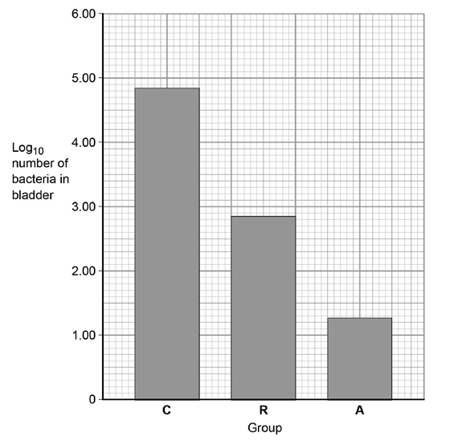
The antibiotics were given to the mice at a dose of 25 mg kg⁻¹ per day.
Calculate how much antibiotic would be given to a 30 g mouse each day.
Show your working.
Answer = ____________________ mg
(2)
(d) Calculate the percentage difference in actual numbers of bacteria in group A compared with group R. The actual number of bacteria can be calculated from the log₁₀ value by using the 10^{x} function on a calculator.
Show your working.
Answer = ____________________ %
(2)
(e) The scientists suggested that people newly diagnosed with this bladder infection should be treated with both the current antibiotic and the new antibiotic.
Explain why the scientists made this suggestion.
Use information from the graph in part (c) and your knowledge of evolution of antibiotic resistance in bacteria in your answer.
___________________________________________________________________
___________________________________________________________________
___________________________________________________________________
___________________________________________________________________
___________________________________________________________________
___________________________________________________________________
___________________________________________________________________
___________________________________________________________________
(3)
(Total 9 marks)
Q2.
A technician investigated the effect of temperature on the rate of an enzyme-controlled reaction. At each temperature, he started the reaction using the same concentration of substrate.
The following graph shows his results.
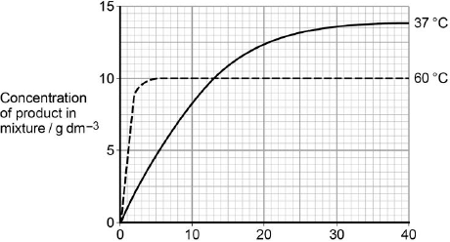
Time after start of reaction / minutes
(a) Give two other factors the technician would have controlled.
1. _________________________________________________________________
2. _________________________________________________________________
(1)
(b) Draw a tangent on each curve to find the initial rates of reaction.
Use these values to calculate the ratio of the initial rates of reaction at 60 °C : 37 °C.
Show your working.

Ratio = ____________________ :1
(2)
(c) Explain the difference in the initial rate of reaction at 60 °C and 37 °C.
___________________________________________________________________
___________________________________________________________________
___________________________________________________________________
___________________________________________________________________
(2)
(d) Explain the difference in the rates of reaction at 60 °C and 37 °C between 20 and 40 minutes.
___________________________________________________________________
___________________________________________________________________
___________________________________________________________________
___________________________________________________________________
___________________________________________________________________
___________________________________________________________________
___________________________________________________________________
___________________________________________________________________
(Extra space) _______________________________________________________
___________________________________________________________________
___________________________________________________________________
___________________________________________________________________
(4)
(Total 9 marks)
Q3.
The graph shows the effect of substrate concentration on the rate of an enzyme-controlled reaction.
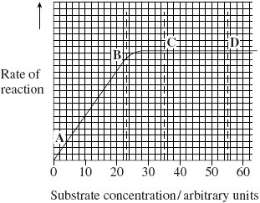
(a) (i) Describe what the graph shows about the effect of substrate concentration on the rate of this enzyme-controlled reaction.
______________________________________________________________
______________________________________________________________
______________________________________________________________
______________________________________________________________
(2)
(ii) What limits the rate of this reaction between points A and B? Give the evidence from the graph for this.
______________________________________________________________
______________________________________________________________
______________________________________________________________
______________________________________________________________
(2)
(iii) Suggest a reason for the shape of the curve between points C and D.
______________________________________________________________
______________________________________________________________
(1)
(b) Sketch a curve on the graph to show the rate of this reaction in the presence of a competitive inhibitor.
(1)
(c) Methotrexate is a drug used in the treatment of cancer. It is a competitive inhibitor and affects the enzyme folate reductase.
(i) Explain how the drug lowers the rate of reaction controlled by folate reductase.
______________________________________________________________
______________________________________________________________
______________________________________________________________
______________________________________________________________
______________________________________________________________
(2)
(ii) Methotrexate only affects the rate of the reaction controlled by folate reductase.
Explain why this drug does not affect other enzymes.
______________________________________________________________
______________________________________________________________
(1)
(Total 9 marks)
Q4.
Imatinib is a drug used to treat a type of cancer that affects white blood cells. Scientists investigated the rate of uptake of imatinib by white blood cells. They measured the rate of uptake at 4°C and at 37°C.
Their results are shown in the table.

 | Mean rate of uptake of imatinib into cells / μg per million cells per hour
Concentration of imatinib outside cells / μmol dm^{–3} | 4°C | 37°C
0.5 | 4.0 | 10.5
1.0 | 10.7 | 32.5
5.0 | 40.4 | 420.5
10.0 | 51.9 | 794.6
50.0 | 249.9 | 3156.1
100.0 | 606.9 | 3173.0
(a) The scientists measured the rate of uptake of imatinib in μg per million cells per hour. Explain the advantage of using this unit of rate in this investigation.
___________________________________________________________________
___________________________________________________________________
___________________________________________________________________
___________________________________________________________________
___________________________________________________________________
(2)
(b) Calculate the percentage increase in the mean rate of uptake of imatinib when the temperature is increased from 4°C to 37°C at a concentration of imatinib outside the cells of 1.0 μmol dm⁻³ .
Give your answer to one decimal place.

Answer ____________________
(2)
(c) Imatinib is taken up by blood cells by active transport.
(i) Explain how the data for the two different temperatures support this statement.
______________________________________________________________
______________________________________________________________
______________________________________________________________
______________________________________________________________
______________________________________________________________
(2)
(ii) Explain how the data for concentrations of imatinib outside the blood cells at 50 and 100 μmol dm⁻³ at 37°C support the statement that imatinib is taken up by active transport.
______________________________________________________________
______________________________________________________________
______________________________________________________________
______________________________________________________________
______________________________________________________________
(2)
(Total 8 marks)
Q5.
Some autism spectrum disorders (ASDs) are associated with a mutation affecting the neuroligin-3 gene. This gene codes for a protein called NL3, that is found in synapses.
Scientists investigated the effects of a mutation affecting NL3 in mice. They obtained brains from mice with the mutation and from mice without the mutation. For each type of mouse they:
• obtained a solution containing all of the proteins from synapses in one part of the brain
• separated these proteins using gel electrophoresis
• identified and measured the amount of three proteins from the solution using three different labelled antibodies.
The three proteins are parts of a postsynaptic membrane receptor.
The diagram below shows the scientists’ results. Each band shows the presence of a protein. The size of a band shows the amount of the protein present.
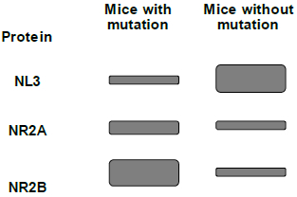
(a) The mutation affecting NL3 in these mice was a substitution in the neuroligin-3 gene.
What is a substitution mutation?
___________________________________________________________________
___________________________________________________________________
___________________________________________________________________
(1)
(b) Suggest how gel electrophoresis separated the proteins obtained from the synapses.
___________________________________________________________________
___________________________________________________________________
___________________________________________________________________
___________________________________________________________________
___________________________________________________________________
(2)
(c) Each type of labelled antibody binds specifically to one of the proteins.
Explain why.
___________________________________________________________________
___________________________________________________________________
___________________________________________________________________
___________________________________________________________________
___________________________________________________________________
___________________________________________________________________
___________________________________________________________________
(3)
(d) What do these data show about the effects of the mutation on the proteins?
___________________________________________________________________
___________________________________________________________________
___________________________________________________________________
___________________________________________________________________
___________________________________________________________________
(2)
(e) These proteins are part of a receptor found in synapses in the part of the brain called the hippocampus. A high ratio of NR2B to NR2A protein in this receptor has been associated with good memory.
Using all of the information, suggest how the mutation affecting the NL3 protein may affect a mouse.
___________________________________________________________________
___________________________________________________________________
___________________________________________________________________
___________________________________________________________________
___________________________________________________________________
(2)
(Total 10 marks)
Q6.
A student investigated the effect of substrate concentration on the initial rate of an enzyme-catalysed reaction.
She added 10 cm³ of an enzyme solution to 10 cm³ of substrate solutions of different concentrations. At 30-second intervals, she tested samples of each mixture for the presence of substrate.
• A – in the absence of an inhibitor.
• B – with a competitive inhibitor added to the substrate solution.
• C – with a non-competitive inhibitor added to the substrate solution.
Her results are shown in the graph below.
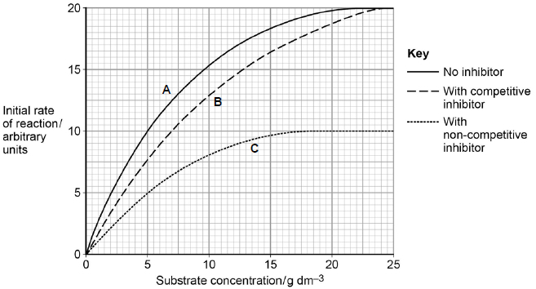
(a) Explain the results without inhibitor (curve A) shown in the graph.
___________________________________________________________________
___________________________________________________________________
___________________________________________________________________
___________________________________________________________________
___________________________________________________________________
___________________________________________________________________
(2)
(b) The graph shows that the maximum initial rate of reaction (V_{max}) when a competitive inhibitor was present (curve B) is different from that when a non-competitive inhibitor was present (curve C).
Explain this difference.
(4)
(c) The Michaelis constant (K_{m}) is the substrate concentration at which the initial rate of reaction is half its maximum value (V_{max}).
How could you use the Michaelis constant to determine the type of inhibition occurring in an enzyme-catalysed reaction?
Use information from the graph to support your answer.
___________________________________________________________________
___________________________________________________________________
___________________________________________________________________
(1)
(Total 7 marks)
Q7.
(a) Discs of carrot were placed in a solution containing potassium ions (K⁺). The concentration of oxygen in air bubbled through the solution was changed and the rates of respiration and uptake of potassium ions were measured. The results are shown in the table.

Concentration of oxygen / % | Rate of respiration / arbitrary units | Rate of uptake of potassium ions /  arbitrary units
2.7 | 31 | 29
12.2 | 69 | 72
20.8 | 90 | 80
Describe and explain the link between oxygen concentration, rate of respiration and rate of uptake of potassium ions.
___________________________________________________________________
___________________________________________________________________
___________________________________________________________________
___________________________________________________________________
___________________________________________________________________
___________________________________________________________________
___________________________________________________________________
___________________________________________________________________
___________________________________________________________________
___________________________________________________________________
(4)
(b) Cylinders of potato were cut using a cork borer. Their initial lengths were measured. Each cylinder was then put in a different concentration of sucrose solution for 12 hours. The graph shows the changes in length of the potato cylinders in the different sugar solutions.
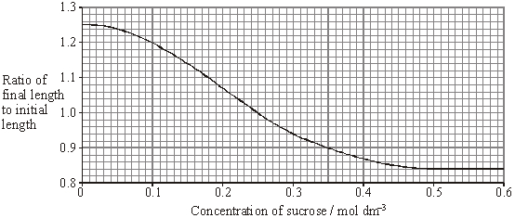
(i) In what concentration of sucrose did the length of the potato cylinder remain the same?
______________________________________________________________
(1)
(ii) The initial length of the potato cylinder in the solution of concentration 0.1 mol dm^{–3} was 90 mm. Calculate its final length. Show your working.

Final length = ____________________ mm
(2)
(iii) Explain the change in length which occurs in a sucrose solution of concentration 0.5 mol dm^{–3}.
______________________________________________________________
______________________________________________________________
______________________________________________________________
______________________________________________________________
(2)
(Total 9 marks)

Q8.
The graph shows the absorption of different wavelengths of light by three photosynthetic pigments in a red seaweed.
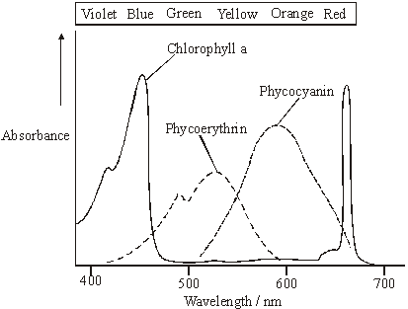
(a) (i) Describe what the graph shows about the properties of chlorophyll a.
______________________________________________________________
______________________________________________________________
(1)
(ii) Describe the part played by chlorophyll in photosynthesis.
______________________________________________________________
______________________________________________________________
______________________________________________________________
______________________________________________________________
______________________________________________________________
______________________________________________________________
(3)
(b) The red seaweed lives under water at a depth of 2 metres. Suggest an advantage to the red seaweed of having other pigments in addition to chlorophyll a.
___________________________________________________________________
___________________________________________________________________
___________________________________________________________________
___________________________________________________________________
(2)
(Total 6 marks)
Mark schemes
Q1.
(a)
ATP ⟶ ADP + P_{i} + H₂O
ATP + H₂O ⟶ ADP + P_{i}
ADP + P_{i} ⟶ ATP + H₂O | 
ADP + P_{i} + H₂O ⟶ ATP
1
(b) 1. Human ATP synthase has a different tertiary structure to bacterial ATP synthase
OR
Human ATP synthase has a different shape active site to bacterial ATP synthase
OR
Antibiotic cannot enter human cells/mitochondria
OR
Antibiotic not complementary (to human ATP synthase);
1
(c) 0.75;
One mark for showing 30 g = 0.03 kg;
One mark for showing 0.025 mg g⁻¹
2
(d) Answer in range 97.0 − 97.8%;
OR
Answer in range 3288 − 4368%;
2. 1 mark for correct log₁₀ readings from graph converted to actual numbers
(16.98 − 19.50 and 660.7 − 758.6)
2
(e) 1. (From the graph in part c) New / old antibiotic does not kill all bacteria;
OR
(From the graph in part c) Some bacteria are resistant to the new / old antibiotic;
2. Resistant bacteria will reproduce to produce (more) resistant bacteria;
3. (Use of both) one antibiotic will kill bacteria resistant to the other antibiotic;
OR
Unlikely that bacteria are resistant to both the new and the old antibiotic;
OR
Use of both antibiotics (likely to) kill all / most bacteria;
Accept use of ‘A’ for ‘new antibiotic’ and ‘R’ for ‘old antibiotic’.
1. Must relate to the bacteria that are still present – ‘some bacteria are killed’ or ‘the bacteria number is reduced ’ is insufficient.
2. Accept ‘resistant bacteria reproduce to pass on resistance gene / allele’
3. ‘Use of both antibiotics will be more effective’ is insufficient.
3
[9]
Q2.
(a) Any two of the following:
Concentration of enzyme
Volume of substrate solution
pH.
Allow same concentration of substrate
1
(b) Ratio between 5.18:1 and 5.2:1
Initial rates incorrect but correctly used = 1 mark.
Allow 1 mark if rate at:
60°C = 0.83g dm^{–3} s^{–1} /49.8g dm^{–3} minute^{–1}
OR
37°C = 0.16g dm^{–3} s^{–1} /9.6g dm^{–3} minute^{–1}
2
(c) At 60 °C:
1. More kinetic energy;
2. More E–S complexes formed.
Allow converse for 37 °C
2
(d) Different times:
1. Higher temperature / 60 °C causes denaturation of all of enzyme;
Accept converse for 37 °C
2. Reaction stops (sooner) because shape of active site changed;
Reject if active site on substrate
Different concentrations of product (at 60 °C)
3. Substrate still available (when enzyme denatured);
4. But not converted to product.
4
[9]
Q3.
(a) (i) Increases then plateaus / constant / steady / rate does not change;
Neutral: ‘peaks’ / ‘reaches a maximum’ / ‘stops increasing’ / ‘no effect’ instead of ‘plateaus’
Reject: rate decreases / reaction stops
Correct reference. to 27 / 28 units;
e.g. increases up to / plateaus at 27 / 28
2
(ii) Substrate concentration / amount of substrate;
As substrate concentration increases, rate increases / positive correlation (between rate and substrate concentration);
2
(iii) All active sites occupied / saturated / enzyme limiting (rate of reaction) / maximum number of E-S complexes;
Reject: enzymes used up
Reject: substrate limits rate of reaction
Neutral: substrate no longer limits the reaction
Neutral: reference to temperature
1
(b) Curve is lower and plateaus at a higher substrate concentration
(it must also start at zero);
Accept: curve lower and joins existing curve at final point (with no plateau)
Reject: if curve plateaus before original
Reject: if curve plateaus lower than original
1
(c) (i) Methotrexate / drug is a similar shape / structure to substrate so binds to / fits / is complementary to active site;
Q Reject: same structure / shape
Q Reject: reacts with active site
Less substrate binds / less enzyme-substrate complexes formed;
Accept: substrate cannot bind / enzyme-substrate complex not formed
2
(ii) Methotrexate / drug is only similar shape to specific substrate / only fits this active site;
Assume that ‘it’ refers to the drug
OR
Methotrexate / drug is a different shape to other substrates / will not fit other active sites;
1
[9]
Q4.
(a) 1. To allow comparison;
2. Because different number of cells in samples / different times for incubation / numbers become easier to manipulate;
2
(b) 203.7(%);;
Allow 1 mark for 21.8 / 10.7
Allow 1 mark for correct answer (203.74) but not correctly to 1 dp
204 = 1 mark
2
(c) (i) 1. (At every concentration) uptake is faster at 37°C / at higher temperature;
2. Due to faster respiration / ATP production;
2
(ii) 1. Uptake at 37°C only small increase / levelling off / almost constant as carrier proteins full;
Accept ‘no (significant) change’
Ignore use of numbers
2. Concentration of imatinib is not the limiting factor;
2
[8]
Q5.
(a) 1. Replacement of a base by a different base (in DNA);
1
(b) 1. (Depends on) size / mass (of protein);
2. (Depends on) charge (of protein);
Accept for 2 marks ‘Smaller / more highly charged move further’
2 max
(c) 1. Each protein has a different tertiary structure;
2. (Each) antibody has a specific antigen / binding / variable region / site;
3. So, (each antibody) forms different antigen-antibody complex
OR
(each antibody) only binds to complementary (protein);
3
(d) 1. Less NL3;
2. More NR2A and NR2B;
2
(e) 1. Higher ratio NR2B to NR2A with mutation;
Accept ‘more’ as equivalent to ‘ratio’
2. (Perhaps) better memory in mice with mutation;
2
[10]
Q6.
(a) 1. Increases because more enzyme-substrate complexes formed;
Neutral; more collisions
2. Levels off because all enzyme molecules involved in enzyme-substrate complexes (at a given time)
1. and 2. Accept ES
2. Reject enzymes are used up
OR
Levels off because no free active sites (at a given time)
OR
Levels off because enzyme (concentration) is limiting factor.
2
(b) 1. Competitive inhibitor binds to active sites of enzyme but non-competitive inhibitor binds at allosteric site / away from active site;
2. (Binding of) competitive inhibitor does not cause change in shape of active site but (binding of) non-competitive does (cause change in size of active site);
3. So with competitive inhibitor, at high substrate concentrations (active) enzyme still available but with non-competitive inhibitor (active) enzymes no longer available;
4. At higher substrate concentrations likelihood of enzyme-substrate collisions increases with competitive inhibitor but this is not possible with non-competitive inhibitor;
4
(c) Reaction with non-competitive inhibitor has the same value of K_{m} as with no inhibitor / value is 5 (g dm^{–3}) / reaction with competitive inhibitor has higher K_{m} value than with no inhibitor / value is 7 (g dm^{–3}).
1
[7]
Q7.
(a) greater rate of oxygen consumption / leads to greater rate of respiration and greater rate of uptake;
(allow this mark even if spread through account but cause and effect must be within the correct context)
oxygen required for respiration;
respiration produces ATP / releases energy;
(ignore ref to producing or making energy)
potassium ions taken up by active transport / against concentration gradient;
4
(b) (i) 0.25 (mol dm^{–3});
1
(ii) 1 mark Incorrect answer but derived from ratio of 1.2 and initial
length of 90 mm
2 marks Correct answer of 108 mm;
2
(iii) water potential inside potato higher / less negative than in solution;
water moves out by osmosis;
2
[9]
Q8.
(a) (i) pigment reflects / does not absorb green or yellow or orange;
pigment absorbs blue or violet;
pigment absorbs red;
(accept correct wavelengths instead of colours)
(any 2 for 1 mark)
1
(ii) light (energy) absorbed by chlorophyll;
raises energy level of electrons / electrons are excited / emitted;
ATP formed;
3
(b) more wavelengths / colours absorbed;
more (efficient) photosynthesis can occur at these depths / low light intensities
or
more (efficient) photosynthesis can occur when some wavelengths are not
present;
2
[6]

