Q1.
Figure 1 shows the effect of wavelength on the percentage of light absorbed by the chlorophyll from these seaweeds.
Figure 1
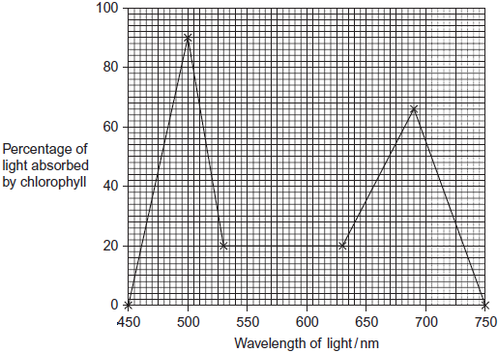
Some scientists investigated the growth of these seaweeds in artificial conditions.
They investigated the effect of different lamps on the rate of photosynthesis of the seaweeds.
• Lamp P produced light containing all wavelengths of visible light. (450 to 750 nm)
• Lamp Q only produced light of wavelength 460 nm.
The scientists measured photosynthesis by recording the rate of oxygen production. Their results are shown in Figure 2.
Figure 2

 | Mean rate of photosynthesis/arbitrary units (± standard deviation)
Species | Lamp P  Light of all wavelengths of visible light | Lamp Q  Light of wavelength 460nm
Ulva pertusa | 1300.9 ( ± 125.4) | 776.6 ( ± 105.6)
Mastocarpus yendoi | 318.9 ( ± 69.5) | 299.6 ( ± 83.2)
(a) Between 500 and 700 nm, what range of wavelengths of light is absorbed least by chlorophyll?
___________________________________________________________________
(1)
(b) The scientists measured the oxygen produced by the light-dependent reaction of photosynthesis. Name two other substances produced by the light-dependent reaction.
1. _________________________________________________________________
2. _________________________________________________________________
(2)
(c) (i) The scientists measured the rate of photosynthesis of the seaweeds in this investigation in terms of oxygen produced.
Suggest the units they should use.
______________________________________________________________
(2)
(ii) This investigation was carried out in bright light. Explain why reducing the light intensity would affect the amount of oxygen released by the seaweeds.
______________________________________________________________
______________________________________________________________
______________________________________________________________
______________________________________________________________
______________________________________________________________
______________________________________________________________
(Extra space)___________________________________________________
______________________________________________________________
______________________________________________________________
(3)
(d) In this investigation, the scientists kept the temperature at 15 °C. A student suggested that repeating the investigation at 20 °C would not affect the amount of oxygen released by the seaweed. Evaluate this suggestion.
___________________________________________________________________
___________________________________________________________________
___________________________________________________________________
___________________________________________________________________
___________________________________________________________________
___________________________________________________________________
(Extra space)________________________________________________________
___________________________________________________________________
___________________________________________________________________
(3)
(e) (i) Did the type of lamp used affect the rate of photosynthesis in M. yendoi? Explain the evidence for your answer.
______________________________________________________________
______________________________________________________________
______________________________________________________________
______________________________________________________________
______________________________________________________________
(2)
(ii) The different lamps resulted in different rates of photosynthesis by U. pertusa. Explain why there was a higher rate of photosynthesis when the seaweed was illuminated with lamp P.
______________________________________________________________
______________________________________________________________
______________________________________________________________
______________________________________________________________
______________________________________________________________
______________________________________________________________
(Extra space)___________________________________________________
______________________________________________________________
______________________________________________________________
(3)
(Total 16 marks)
Q2.
A scientist investigated the use of a new source of carbohydrate in the production of ethanol for biofuel. He wanted to find the optimum time to leave a mixture of yeast and this carbohydrate to produce ethanol. The scientist set up an airtight container containing yeast and this carbohydrate. He then measured the oxygen, carbon dioxide and ethanol concentrations over 8 hours.
The results of his investigation are shown in the graph below.
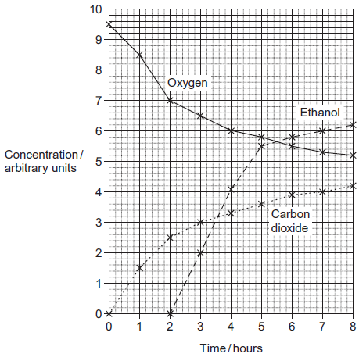
(a) The scientist used a container that was airtight.
Give two explanations why the container had to be airtight.
1. _________________________________________________________________
___________________________________________________________________
___________________________________________________________________
___________________________________________________________________
2. _________________________________________________________________
___________________________________________________________________
___________________________________________________________________
___________________________________________________________________
(4)
(b) Explain the relationship between the concentration of oxygen and the concentration of carbon dioxide between 0 and 3 hours.
___________________________________________________________________
___________________________________________________________________
___________________________________________________________________
___________________________________________________________________
___________________________________________________________________
___________________________________________________________________
(2)
(c) The scientist concluded that yeast starts to respire anaerobically when the oxygen concentration falls below a certain concentration. What is the oxygen concentration when the yeast starts to respire anaerobically? Explain your answer.
___________________________________________________________________
___________________________________________________________________
___________________________________________________________________
___________________________________________________________________
___________________________________________________________________
(2)
(d) (i) The scientist worked for a biofuel company. Give two suggestions for further work he should do to make sure that the results he presented to the company were reliable.
Explain how each of your suggestions would make the results more reliable.
Suggestion_____________________________________________________
______________________________________________________________
Explanation ____________________________________________________
______________________________________________________________
Suggestion_____________________________________________________
______________________________________________________________
Explanation ____________________________________________________
______________________________________________________________
(4)
(ii) The scientist recommended that when the ethanol is produced commercially as biofuel the reaction should be stopped at 6 hours. Use the graph to suggest why.
______________________________________________________________
______________________________________________________________
______________________________________________________________
______________________________________________________________
______________________________________________________________
(2)
(iii) The scientist’s work was funded by a biofuel company. Explain why the source of funding can cause problems with scientific work.
______________________________________________________________
______________________________________________________________
______________________________________________________________
______________________________________________________________
______________________________________________________________
(2)
(Total 16 marks)
Q3.
Scientists measured the rate of carbon dioxide release by three groups of insects of the same species at 10 °C, 20 °C and 30 °C. They also determined the mean mass of each group of insects.
The scientists results are shown in the table.

Temperature / °C | Mean mass / g | Rate of carbon dioxide release / µdm³ minute⁻¹ | Rate of carbon dioxide  release per gram /  µdm³ g⁻¹ minute⁻¹
10 | 0.047 | 0.12
20 | 0.046 | 0.33
30 | 0.048 | 0.56
(a) Complete the table above and plot a graph of your calculated values against temperature on the graph paper. Express your calculated rates with the appropriate number of significant figures.

(3)
The body temperature of the insects was largely determined by the temperature they were kept at. At each temperature, the scientists recorded rate of carbon dioxide release by individual insects over time. This rate depends upon spiracles opening or closing.
The graphs below show results for three insects.
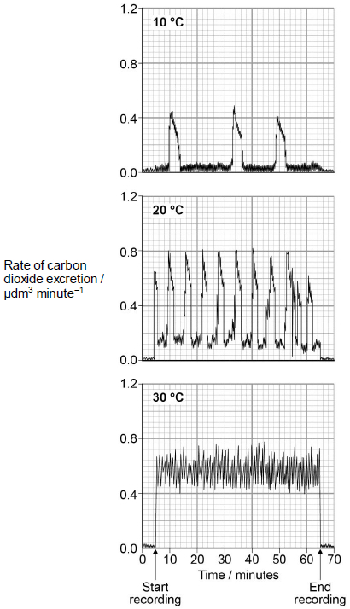
(b) Calculate the change in the rate per hour of opening of the spiracles between 10 °C and 20 °C.
___________________________________________________________________
___________________________________________________________________
(1)
(c) Explain how you could determine the total amount of carbon dioxide secreted at 30 °C during the period of recording.
___________________________________________________________________
___________________________________________________________________
(1)
(d) Suggest an explanation for the effect of temperature on the rate of carbon dioxide release.
___________________________________________________________________
___________________________________________________________________
___________________________________________________________________
___________________________________________________________________
___________________________________________________________________
___________________________________________________________________
___________________________________________________________________
(3)
(Total 8 marks)
Q4.
During photosynthesis, carbon dioxide reacts with ribulose bisphosphate (RuBP) to form two molecules of glycerate 3-phosphate (GP). This reaction is catalysed by the enzyme Rubisco. Rubisco can also catalyse a reaction between RuBP and oxygen to form one molecule of GP and one molecule of phosphoglycolate. Both the reactions catalysed by Rubisco are shown in Figure 1.
Figure 1
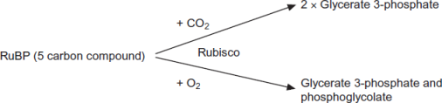
(a) (i) Where exactly in a cell is the enzyme Rubisco found?
______________________________________________________________
(1)
(ii) Use the information provided to give the number of carbon atoms in one molecule of phosphoglycolate.

(1)
(b) Scientists investigated the effect of different concentrations of oxygen on the rate of absorption of carbon dioxide by leaves of soya bean plants. Their results are shown in Figure 2.
Figure 2
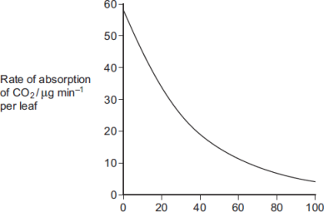
Concentration of oxygen / %
Use Figure 1 to explain the results obtained in Figure 2.
___________________________________________________________________
___________________________________________________________________
___________________________________________________________________
___________________________________________________________________
___________________________________________________________________
(2)
(c) Use the information provided and your knowledge of the light-independent reaction to explain why the yield from soya bean plants is decreased at higher concentrations of oxygen. Phosphoglycolate is not used in the light-independent reaction.
___________________________________________________________________
___________________________________________________________________
___________________________________________________________________
___________________________________________________________________
___________________________________________________________________
(Extra space)________________________________________________________
___________________________________________________________________
___________________________________________________________________
(3)
(Total 7 marks)
Q5.
Beech trees have two types of leaves called sun leaves and shade leaves. Sun leaves grow on branches exposed to direct sunlight, shade leaves grow on branches exposed to light that has passed through leaves. An ecologist collected sun leaves and shade leaves from beech trees and determined the mean mass of each photosynthetic pigment in both types of leaf. His results are shown the table below.

Photosynthetic pigment | Mean mass of each pigment per m² of leaf area / μg  (± standard deviation)
Photosynthetic pigment | Sun leaves | Shade leaves
Chlorophyll a | 299.3 (± 2.1) | 288.9 (± 0.1)
Chlorophyll b | 290.7 (± 2.1) | 111.1 (± 0.1)
Chlorophyll c | 0.10 (± 0.01) | 0.07 (± 0.01)
(a) Describe how you would present the data in the table as a graph.
___________________________________________________________________
___________________________________________________________________
___________________________________________________________________
___________________________________________________________________
___________________________________________________________________
(2)
(b) The ecologist collected shade leaves at random from a branch.
Suggest a method he could have used to collect shade leaves at random from a branch.
___________________________________________________________________
___________________________________________________________________
___________________________________________________________________
___________________________________________________________________
___________________________________________________________________
(2)
(c) The ecologist concluded that there is a significant difference between the amounts of chlorophyll b in sun leaves and shade leaves of beech trees.
Do you agree with this conclusion?
___________________________________________________________________
___________________________________________________________________
___________________________________________________________________
___________________________________________________________________
___________________________________________________________________
(2)
(d) Each type of chlorophyll is produced by a specific enzyme-controlled pathway.
Use this information to suggest how the same beech tree can produce more chlorophyll b in some leaf cells than others.
___________________________________________________________________
___________________________________________________________________
___________________________________________________________________
___________________________________________________________________
___________________________________________________________________
(2)
(Total 8 marks)
Q6.
Plants have pigments that absorb light energy for photosynthesis. These pigments include two types of chlorophyll and a group of pigments known as carotenoids. Different species of plant contain different amounts of these pigments. The pigments that each plant species has are adaptations to where and how they live; their ecological niche.
Figure 1 shows the absorption of light of different wavelengths by chlorophyll a, chlorophyll b and carotenoids.
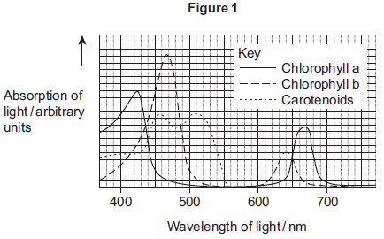
A scientist investigated the energy in light of different wavelengths reaching the ground in a forest. She measured the energy in
• direct sunlight
• sunlight that had passed through the leaves of trees.
Figure 2 shows her results.
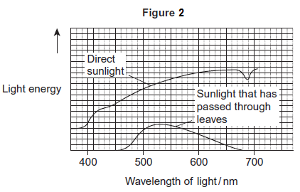
(a) Use Figure 1 to describe the absorption of light of different wavelengths by chlorophyll a.
___________________________________________________________________
___________________________________________________________________
___________________________________________________________________
___________________________________________________________________
___________________________________________________________________
(2)
(b) Few species of plant can live below large trees in a forest.
Use the information in Figure 1 and Figure 2 to suggest why.
___________________________________________________________________
___________________________________________________________________
___________________________________________________________________
___________________________________________________________________
___________________________________________________________________
___________________________________________________________________
(Extra space) ________________________________________________________
___________________________________________________________________
___________________________________________________________________
(3)
(c) In leaves at the top of trees in a forest, carbon dioxide is often the limiting factor for photosynthesis.
Use your knowledge of photosynthesis to suggest and explain one reason why.
___________________________________________________________________
___________________________________________________________________
___________________________________________________________________
___________________________________________________________________
___________________________________________________________________
(2)
(Total 7 marks)
Q7.
Scientists investigated the effect of iron deficiency on the production of triose phosphate in sugar beet plants. They grew the plants under the same conditions with their roots in a liquid growth medium containing all the necessary nutrients. Ten days before the experiments, they transferred half the plants to a liquid growth medium containing no iron. The scientists measured the concentration of triose phosphate produced in these plants and in the control plants:
• at the end of 6 hours in the dark
• then for 16 hours in the light.
Their results are shown in the graph.
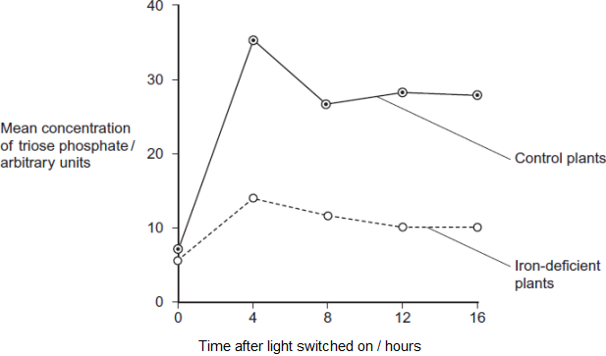
(a) (i) The experiments were carried out at a high carbon dioxide concentration. Explain why.
______________________________________________________________
______________________________________________________________
______________________________________________________________
(1)
(ii) Explain why it was important to grow the plants under the same conditions up to ten days before the experiment.
______________________________________________________________
______________________________________________________________
______________________________________________________________
(1)
(iii) The plants were left in the dark for 6 hours before the experiment. Explain why.
______________________________________________________________
______________________________________________________________
______________________________________________________________
(1)
(b) Iron deficiency reduces electron transport. Use this information and your knowledge of photosynthesis to explain the decrease in production of triose phosphate in the iron-deficient plants.
___________________________________________________________________
___________________________________________________________________
___________________________________________________________________
___________________________________________________________________
___________________________________________________________________
___________________________________________________________________
___________________________________________________________________
___________________________________________________________________
(Extra space)________________________________________________________
___________________________________________________________________
___________________________________________________________________
___________________________________________________________________
(4)
(c) Iron deficiency results in a decrease in the uptake of carbon dioxide. Explain why.
___________________________________________________________________
___________________________________________________________________
___________________________________________________________________
___________________________________________________________________
(2)
(Total 9 marks)
Q8.
Chloroplasts contain chlorophyll a and chlorophyll b. Scientists found tobacco plants with a mutation that caused them to make more chlorophyll b than normal tobacco plants. They investigated the effect of this mutation on the rate of photosynthesis.
The scientists carried out the following investigation.
• They grew normal and mutant tobacco plants. They grew some of each in low light intensity and grew others in high light intensity.
• They isolated samples of chloroplasts from mature plants of both types.
• Finally, they measured oxygen production by the chloroplasts they had isolated from the plants.
The figure below shows the scientists’ results.
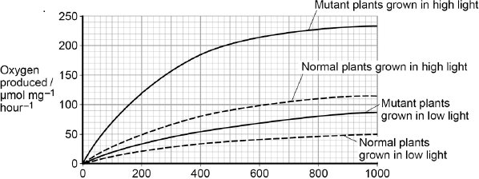
Light intensity / μmol photons m⁻²s⁻¹
(a) Explain why the scientists measured the rate of production of oxygen in this investigation.
___________________________________________________________________
___________________________________________________________________
___________________________________________________________________
___________________________________________________________________
(2)
In each trial, the scientists collected oxygen for 15 minutes.
(b) Calculate the difference in the oxygen produced by the chloroplasts from mutant plants grown in low and high light intensities at a light intensity of 500 μmol photons m^{–2} s^{–1}.
Show your working.

Difference ____________________ μmol O₂ mg^{–1} hour^{–1}
(2)
(c) The scientists suggested that mutant plants producing more chlorophyll b would grow faster than normal plants in all light intensities.
Explain how these data support this suggestion.
___________________________________________________________________
___________________________________________________________________
___________________________________________________________________
___________________________________________________________________
___________________________________________________________________
___________________________________________________________________
___________________________________________________________________
___________________________________________________________________
(Extra space) _______________________________________________________
___________________________________________________________________
___________________________________________________________________
___________________________________________________________________
(4)
(Total 8 marks)
Q9.
Herbicides can be used to reduce the growth of weeds.
Scientists completed seven studies to determine how the use of the herbicide Atrazine affected the yield of sugarcane. In each study, some plots were treated with Atrazine and some plots were not treated with Atrazine.
The graph below shows the scientists’ results. (1 hectare = 10 000 m²)
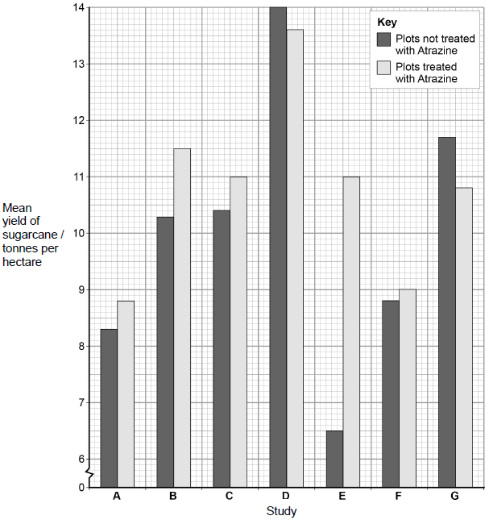
(a) Calculate the percentage decrease in yield caused by the use of Atrazine in study G.
Answer = _________________ %
(1)
(b) A teacher studying these data with her students told her class that no definite conclusions could be drawn when comparing the mean values in the graph.
Suggest why the teacher said this.
___________________________________________________________________
___________________________________________________________________
___________________________________________________________________
___________________________________________________________________
___________________________________________________________________
(2)
(c) Atrazine binds to proteins in the electron transfer chain in chloroplasts of weeds, reducing the transfer of electrons down the chain.
Explain how this reduces the rate of photosynthesis in weeds.
___________________________________________________________________
___________________________________________________________________
___________________________________________________________________
___________________________________________________________________
___________________________________________________________________
___________________________________________________________________
___________________________________________________________________
___________________________________________________________________
___________________________________________________________________
___________________________________________________________________
___________________________________________________________________
(4)
(d) When treated with Atrazine, weeds have been shown to give off small amounts of heat.
Suggest an explanation for this observation.
___________________________________________________________________
___________________________________________________________________
___________________________________________________________________
___________________________________________________________________
(1)
(Total 8 marks)
Q10.
Scientists investigated the effect of the water potential of soil water on plant growth. They investigated the effect of this water potential on several plant processes.
The figure below shows their results in the form they were presented. The bars show whether or not each process was occurring.
The plants stopped growing when the water potential of the soil water was below –0.7 mPa. All of the changes in the plants were related to the ability of the roots to take up water from the soil.
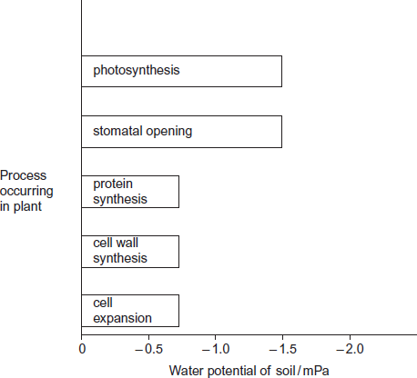
(a) Describe the results in the figure.
___________________________________________________________________
___________________________________________________________________
___________________________________________________________________
___________________________________________________________________
___________________________________________________________________
(2)
(b) Explain the relationship between stomatal opening and photosynthesis.
___________________________________________________________________
___________________________________________________________________
___________________________________________________________________
___________________________________________________________________
___________________________________________________________________
(2)
(c) Although photosynthesis is still occurring, plants stop growing when the soil water potential falls below –0.7 mPa.
Use information from the figure above to suggest two reasons why.
___________________________________________________________________
___________________________________________________________________
___________________________________________________________________
___________________________________________________________________
___________________________________________________________________
___________________________________________________________________
(3)
(Total 7 marks)
Q11.
Researchers investigated the effect of cyanide on oxygen uptake by mitochondria. They prepared a suspension of mitochondria from animal cells and a suspension of mitochondria from plant cells. They placed the suspensions in separate flasks containing isotonic solution, started the timer and began recording the concentration of oxygen in each flask.
• After 5 minutes, they added a respiratory substrate and ADP to each flask.
• After 13 minutes, they added cyanide solution to each flask.
The graph below shows their results. From P to R the curves for animal and plant mitochondria overlap.
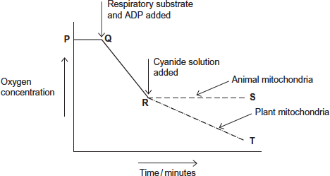
(a) Explain the line between P and Q.
___________________________________________________________________
___________________________________________________________________
___________________________________________________________________
___________________________________________________________________
(2)
(b) (i) Explain the line between Q and R.
______________________________________________________________
______________________________________________________________
______________________________________________________________
______________________________________________________________
(2)
(ii) The respiratory substrate and ADP added after 5 minutes (Q) were part of a buffered isotonic solution.
What other substance would the buffer or solution have to contain?
______________________________________________________________
______________________________________________________________
(1)
(c) Describe and explain the difference between line R to S (animal mitochondria) and line R to T (plant mitochondria).
___________________________________________________________________
___________________________________________________________________
___________________________________________________________________
___________________________________________________________________
___________________________________________________________________
___________________________________________________________________
___________________________________________________________________
___________________________________________________________________
[Extra space] _______________________________________________________
___________________________________________________________________
(4)
(Total 9 marks)
Mark schemes
Q1.
(a) 530 to 630;
1
(b) 1. Reduced NADP;
Accept NADPH or rNADP
2. ATP;
Reduced NAD is incorrect
2
(c) (i) 1. Unit of volume and unit of time;
Accept any reasonable unit of volume
E.g. cm³ or ml
Accept any reasonable unit of time
E.g. s, min or h
2. Unit of area / mass;
Accept any reasonable unit of area or mass
E.g. cm² or g
Symbols should be correct. Do not accept m for minutes.
2
(ii) 1. (Light intensity) limiting factor;
2. Fewer electrons (released) from chlorophyll;
3. Less photolysis therefore (less) oxygen from water;
3
(d) Will not affect (no mark):
1. Photolysis / splitting of water does not use enzymes;
Will affect (no mark):
2. May increase respiration;
3. Respiration uses oxygen;
3
(e) (i) 1. Overlap in standard deviations;
2. Unlikely that any difference is significant;
2
(ii) 1. P / visible light has more wavelengths;
2. Q has only light of wavelength 460 nm;
3. Wavelengths over 460 nm can also be used for photosynthesis / wavelengths over 460 nm can also be absorbed;
3
[16]
Q2.
(a) 1. No oxygen can enter;
2. Ethanol produced during anaerobic respiration;
OR
3. No ethanol / carbon dioxide can escape;
4. Allows accuracy of measuring;
OR
5. To prevent entry of / contamination with microorganisms;
6. Prevent competition with yeast;
Any two pairs of answers
Second mark of each pair must be related to the first point of the pair.
4 max
(b) 1. Yeast respiring aerobically;
2. Oxygen used equal to carbon dioxide produced;
2
(c) 1. 7.0 / 7;
2. Ethanol production starts;
2
(d) (i) 1. Repeat;
2. Identify anomalies / see if results are similar / enough results for statistical test / give more reliable mean;
3. Carry out statistical test / statistical analysis;
4. Ensure results are significant / find probability of results being due to chance;
5. Peer review;
6. Allows procedure to be checked / see if other scientists get similar results;
Two pairs of linked points, each pair a suggestion and an explanation. The explanation must relate to the suggestion to gain the second point of the pair.
4
(ii) 1. Curve levelling off / rate of increase is decreasing / very little extra ethanol produced;
2. Becomes less cost effective / less profit;
2. Accept a description of cost effectiveness
2
(iii) 1. (Funding agency) might want particular results;
2. Results may be withheld / results may not be published / results may be confidential;
2 max
[16]
Q3.
(a) 1. Line graph with rate on y axis and temperature on x axis and linear scales;
2. Values calculated to appropriate sf;
3. Rates correctly calculated and plotted, with ruled line connecting points and no extrapolation;
3
(b) 8 or 9;
1
(c) 1. Determine the area under the curve;
1
(d) 1. Enzymes / metabolism faster;
2. Higher rate of respiration and carbon dioxide production / release;
3. Spiracles open more often / remain open to excrete / get rid of carbon dioxide / get more oxygen;
Note – explanation required
3
[8]
Q4.
(a) (i) Stroma (of chloroplasts);
Reject: stoma
1
(ii) 2;
1
(b) 1. As oxygen (concentration) increases less Rubisco / RuBP reacts / binds with carbon dioxide;
1. Accept - as oxygen (concentration) increases more Rubisco / RuBP reacts / binds with oxygen
1. Accept – less GP / more phosphoglycolate formed as oxygen (concentration) increases
2. Competitive inhibition / competition between oxygen and carbon dioxide for rubisco / enzyme / active site (therefore) less RuBP formed / regenerated (to join with carbon dioxide);
2. Accept oxygen and carbon dioxide are complementary to active site
2
(c) 1. Less glycerate 3-phosphate / GP produced;
1. Accept one GP formed rather than two GP
2. (Less) triose phosphate to form sugars / protein / organic (product) / any named photosynthetic product;
3. Less RuBP formed / regenerated;
3. Accept RuBP takes longer to form
3
[7]
Q5.
(a) 1. Bar chart;
2. Error bars to represent standard deviation (of mean);
3. Photosynthetic pigment on x axis and mass of pigment on y axis;
Accept suitable sketch
2 max
(b) 1. Number leaves on the branch;
2. Use random number table / calculator / pick numbers from bag to determine which leaf to pick;
Accept use of random number generator
OR
3. Collect large number of leaves;
4. Pick out of bag with some idea of randomness;
2
(c) No (no mark)
1. No stats test carried out;
2. Standard error / 95% confidence interval calculation identified;
If awarded, student scores 2 marks – for points 1 and 2
Yes (no mark)
3. No overlap shown by the standard deviations;
4. Ranges around mean stated;
88.6-92.8 and 111.0-111.2 (1 × SD) or 86.5-94.9 and 110.9-111.3
(2 × SD)
2 max
(d) In shade leaves:
1. Greater amount of enzyme / enzyme activity (for production of chlorophyll b);
2. Greater gene expression / transcription of the gene / more mRNA produced / gene switched on;
3. Greater translation;
4. Enzyme / substrate is light sensitive – faster rate of reaction with lower light;
2 max
[8]
Q6.
(a) 1. Peaks at 420-430 and 660-670;
2. No absorption of light between approximately 500 and 600;
3. Highest peak at 420-430;
2 max
(b) 1. Less (light) energy passes through leaves / reaches ground;
2. Smaller range of wavelengths passes through leaves;
Accept reference to only green (and yellow) light pass through
3. Little light for chlorophyll to absorb;
Accept carotenoids can absorb this light
4. So insufficient photosynthesis (for growth);
Sufficient photosynthesis for plants with carotenoids
5. Photosynthesis unlikely to exceed respiration;
3 max
(c) 1. Light not limiting / lots of light (as no shading);
2. Light-dependent reaction not limiting / fast;
OR
3. Temperature not limiting / Warm (as no shading);
4. Fast reactions of enzymes in light-independent reaction;
OR
5. High use of CO₂;
6. Light-independent reaction is limiting;
Mark as a pair
2
[7]
Q7.
(a) (i) So it / CO₂ is not a limiting factor (on growth / photosynthesis);
Accept: CO₂ is a limiting factor
1
(ii) So any difference is due to iron (deficiency);
Accept: iron is the variable
1
(iii) Amount of triose phosphate / TP will be similar / same / low (at start);
Accept: to allow triose phosphate to stabilise / become constant
Reject: so all triose phosphate is used up
Reject: so no triose phosphate
1
(b) 1. (Less) ATP produced;
Accept: alternatives for reduced NADP ie NADP with hydrogen / s attached
2. (Less) reduced NADP produced;
3. ATP / reduced NADP produced during light-dependent reaction;
4. (Less) GP to triose phosphate / TP;
4
(c) 1. Less triose phosphate converted to RuBP;
Accept: less triose phosphate so less RuBP
2. CO₂ combines with RuBP;
2
[9]
Q8.
(a) 1. Oxygen produced in light-dependent reaction;
2. The faster (oxygen) is produced, the faster the light-dependent reaction.
2
(b) 35–36 μmol Oxygen per mg chlorophyll.
Correct difference at 500 μmol photons m^{–2} s^{–1} or incorrect difference but division by 4 shown = 1 mark.
2
(c) At all light intensities, chloroplasts from mutant plants:
1. Have faster production of ATP and reduced NADP;
2. (So) have faster / more light-independent reaction;
3. (So) produce more sugars that can be used in respiration;
4. (So) have more energy for growth;
5. Have faster / more synthesis of new organic materials.
Accept converse points if clear answer relates to non-mutant plants
4 max
[8]
Q9.
(a) 7.7(%);
1
(b) 1. No error bars / SD;
2. To show if overlap occurs so difference (in means) is not significant / due to chance
OR
To show if no overlap occurs so difference (in means) is significant / is not due to chance.
Do not accept ‘no statistical test performed’ as Chi squared / Spearman’s rank would be inappropriate.
Ignore references to sample size as it can be assumed that scientists completed the study using appropriate methodology.
2
(c) 1. Reduced transfer of protons across thylakoid membrane
OR
Reduced chemiosomotic gradient / proton gradient across thylakoid membrane;
2. (So) less ATP produced;
3. (So) less reduced NADP produced;
Accept NADPH / NADPH₂ / NADPH⁺
Reject reduced NAD
4. (So) light-independent reaction slows / stops;
OR
Less reduction of GP to triose phosphate.
4
(d) Idea that energy is released from high energy / excited electron/s (that were lost from chlorophyll)
1
[8]
Q10.
(a) 1. Protein synthesis and cell wall synthesis and cell expansion
stop at −0.7 / at a higher water potential than other two;
If all 3 are correctly identified in marking point 1, accept ‘the others / the other two’ in marking point 2, and vice versa
2. Photosynthesis and stomatal opening stop at -1.5 / at a lower water potential than other three;
Correct processes must be named in at least one of marking point 1 or marking point 2
Where reference to water potential differences are made, they must be comparative, eg ‘higher’
2
(b) 1. Stomata allow uptake of carbon dioxide;
2. Carbon dioxide used in / required for photosynthesis;
2
(c) 1. Growth involves cell division / cell expansion / increase in mass;
Marking point 1 is for the principle
2. Protein synthesis stops so no enzymes / no membrane proteins / no named protein (for growth / division);
Marking points 2, 3 and 4 require appreciation of ‘why’ before credit can be awarded
‘named’ protein must relate to proteins involved in growth or cell division
3. Cell wall synthesis stops so no new cells can be made;
Full credit is possible without a statement of the principle
(marking point 1)
4. No cell expansion / increase in mass because (cells) stop taking up water;
3 max
[7]
Q11.
(a) 1. No aerobic respiration / electron transfer / oxidative phosphorylation;
Reject reference to anaerobic respiration.
2. (Because) no (respiratory) substrate / nothing to respire;
Reject idea of ‘little’ or ‘less’ − this would result in a change in oxygen concentration.
Accept the idea of no residual respiratory substrate in the mitochondria.
2
(b) (i) (Oxygen concentration falls because)
1. Aerobic respiration (uses oxygen);
Accept ‘oxidative phosphorylation / electron transfer takes place’.
2. Oxygen is terminal / electron acceptor;
3. (oxygen combines with) protons / H⁺ and electrons / e⁻ to form water / H₂O;
All aspects are required to gain mark.
2 max
(ii) Phosphate (ions) / inorganic phosphate / P_{I};
Reject ‘phosphorus’ or ‘P’.
Accept ‘PO₄’.
1
(c) 1. Oxygen concentration continues to fall in plants but stays constant
in animals;
For ‘plants’ accept ‘line R to T’, for ‘animals’ accept ‘line R to S’.
MP1 and MP2. Accept answers in terms of ‘use’ of oxygen rather than change in concentration.
2. (Oxygen concentration) falls more slowly in plants than before
cyanide added;
3. (Because aerobic) respiration continues in plant (mitochondria);
Accept (because aerobic) respiration stops in animal (mitochondria).
4. (Because) electron transfer / oxidative phosphorylation continues in plant (mitochondria);
Accept (because) electron transfer stops in animal (mitochondria).
Accept for one additional mark
(up to 4 max) use of Resource A i.e: idea that plant cytochrome oxidase is (more) resistant to cyanide
OR
idea that animal cytochrome oxidase not resistant to cyanide.
4
[9]

