**REPRESENTATION – TIDE PRINT ADVERTISEMENT**

In the 1950s, while men were being targeted for the post-war boom in America’s car industry, women were the primary market for the technologies and products being developed for the home. In **advertising** for these types of texts, **stereotypical representations** of domestic perfection, caring for the family and servitude to the ‘man of the house’ became linked to a more modern need for speed, convenience and a better standard of living than the women experienced in the pre-war era.

During WWII, resources were scarce and rationing dominated the household right up until 1954. Whilst domestic products were still being aimed at women through advertising, they were also being asked to engage with the war effort. In these propaganda advertisements, very different representations of gender were on offer;

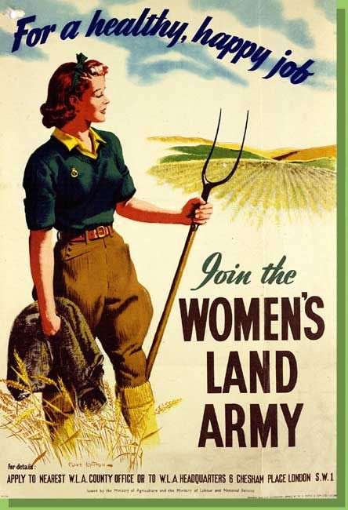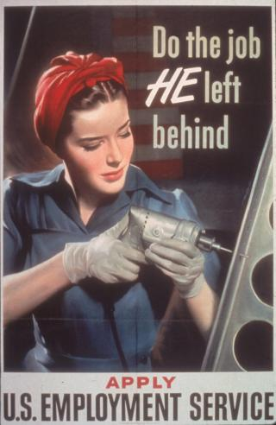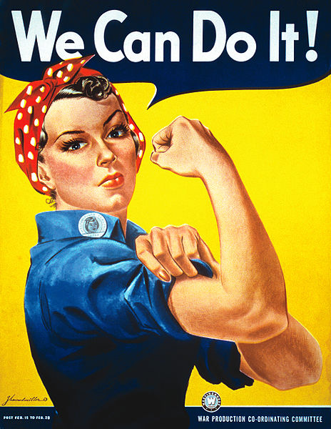

**TASK 1**

**As a contrast to the Tide advertisement, comment on how gender is constructed in the three posters above through the use of:**

* **Body language**
* **Facial expressions**
* **Costume**

* **Props**

* **Setting**

***Do these representations challenge dominant ideology? Consider your response in relation to the period in which they were produced.***

**TASK 2**

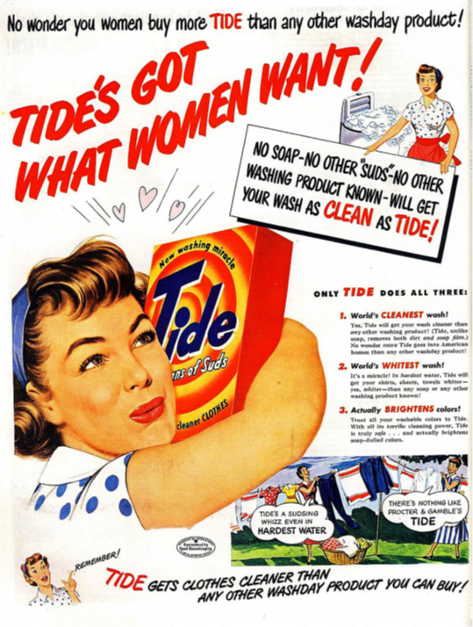

**Now consider the *Tide* advertisement:**

**In what ways do these representations differ from the above representations?**

**Are there any similarities between the representations?**

**TASK 3**

**REPRESENTATION & THEORY**

**STUART HALL’S THEORY OF REPRESENTATION**

* The idea that representation is the production of meaning through language, with language defined in its broadest sense as a system of signs
* The idea that the relationship between concepts and signs is governed by codes
* The idea that stereotyping, as a form of representation, reduces people to a few simple characteristics or traits
* The idea that stereotyping tends to occur where there are inequalities of power, a subordinate or excluded groups are constructed as different or ‘other’.

***Consider***

* + ***Have stereotypes been followed/subverted?***
  + ***Who has the power in this advert?***
  + ***Is anyone portrayed as different or ‘other’?***

***APPLY TO TIDE:***

**DAVID GAUNTLETT’S THEORY OF IDENTITY**

David Gauntlett suggests that **representations** offer an opportunity to audiences to think about their own identify and role in society.

* The idea that the media provide us with ‘tools’ or resources that we use to construct our identities
* The idea that whilst in the past the media tended to convey singular, straightforward messages about ideal types of male and female identities, the media today offer us a more diverse range of stars, icons and characters from whom we may pick and mix different ideas.

Gauntlett also pointed out that whilst media **role models** hold some influence on audiences, we are more likely to be shaped by parents, friends, colleagues, teachers etc.

***Consider***

* + ***How could Tide inform and affect the identities of women at the time?***
  + ***What variety of representations could women pick from?***

***APPLY TO TIDE:***

**Further representation questions**

***Does the gender representations in Tide follow or challenge dominant ideology? Provide evidence in your response***

***Which images represented in the advert’s scenario may have been familiar to a 1950s audience as a representation of their own lives? Do you think this representation is still accurate or relevant today?***