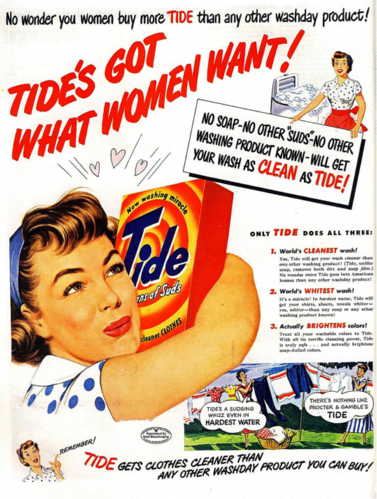**AUDIENCE – TIDE PRINT ADVERTISEMENT**

Despite women having seen their roles in society change during the second world war (where they were needed in medical, military support and other roles outside of the home) domestic products of the 1950s continued to be aimed at female audiences. The likely **target audience** of increasingly **affluent** lower-middle class women were, at this point in the 1950s, being appealed to because of their supposed need for innovative domestic technologies and products. The increasing popularity of supermarkets stocking a wider range of products led to an increased focus by corporations on brands and their **unique selling points (USP)**.

**TASK 1**

**Complete the table below to identify the target audience**

***Explore the poster in detail and highlight the techniques being used to target the audience. Consider its use of language, visual codes (image, colour, layout etc.), written codes (font, mode-of-address) endorsements, USP.***

|  |  |  |  |
| --- | --- | --- | --- |
| **Demographics** | **Category** | **Answer** | **Examples from the text, supporting you points.** |
| **Gender** |  |  |
| **Ethnicity** |  |  |
| **Age** |  |  |
| **Socio-economic segmentation** |  |  |
| **Psychographic** | **Cross Cultural Consumer Characteristics (4C’s)** |  |  |

**TASK 2**

Use Audience Theories ppt from GoL or your work books and present to the class

1. Get into pairs

2. Prepare a PPT on either Bandura (Effects), Gerbner (Cultivation Theory Hall), Hall (Reception Theory) that you’ll present to the class

Slide 1. Explain the theory **IN YOUR OWN WORDS**Slide 2. Apply the theory to Tide (use prompt questions below to help)

|  |  |  |  |
| --- | --- | --- | --- |
| **Theorist** | **Albert Bandura: Effects models** | **George Gerbner: Cultivation Theory** | **Stuart Hall: Reception Analysis** |
| **Prompt questions** | According to Bandura what impact may advertising have on audiences?  How may a passive audience ‘read’ this advert? | According to Gerbner what impact may advertising have on audiences?  What messages/ideas are Tide trying to cultivate within this advert?  In what ways would the repetition of these ideas help to shape an ideology within the audience? | What techniques have been used to encourage a preferred reading? How are they trying to convince the audience that Tide is the best?  Why may audiences not decode the advert as intended?  What might a negotiated reading be? Why might an audience have this response?  What might an oppositional reading be? Why might an audience have this response? |

**TASK 3**

Now look at the following two washing powder adverts – another example from the 1950s and a contemporary example. In the table below, and written in full sentences apply just Gerbner’s and Hall’s theories to the two adverts.

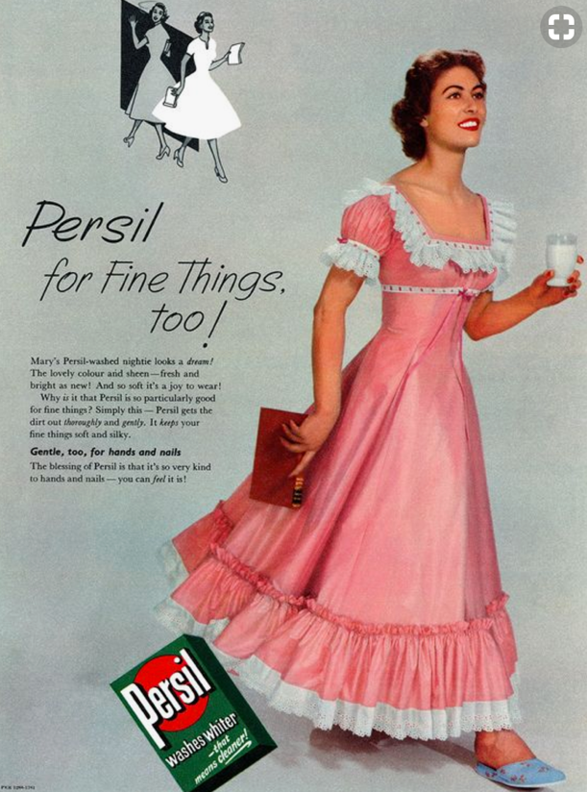

|  |  |  |
| --- | --- | --- |
| **George Gerbner: Cultivation Theory** | **Persil 1950’s** | **Persil Contemporary** |
| According to Gerbner what impact may advertising have on audiences?  What messages/ideas are Persil trying to cultivate within this advert?  In what ways would the repetition of these ideas help to shape an ideology within the audience? |  |  |
| **Stuart Hall: Reception Analysis** | **Persil 1950’s** | **Persil Contemporary** |
| What techniques have been used to encourage a preferred reading? How are they trying to convince the audience that Persil is the best?  Why may audiences not decode the advert as intended?  What might a negotiated reading be? Why might an audience have this response?  What might an oppositional reading be? Why might an audience have this response? |  |  |

***What changes in the adverts have you identified?***

***Why might there be changes? Consider audience in your response***