**A LEVEL MEDIA: SOUND**

*Watch the relevant attached clips (you will need to watch most of the clips more than once) and answer the subsequent questions.*

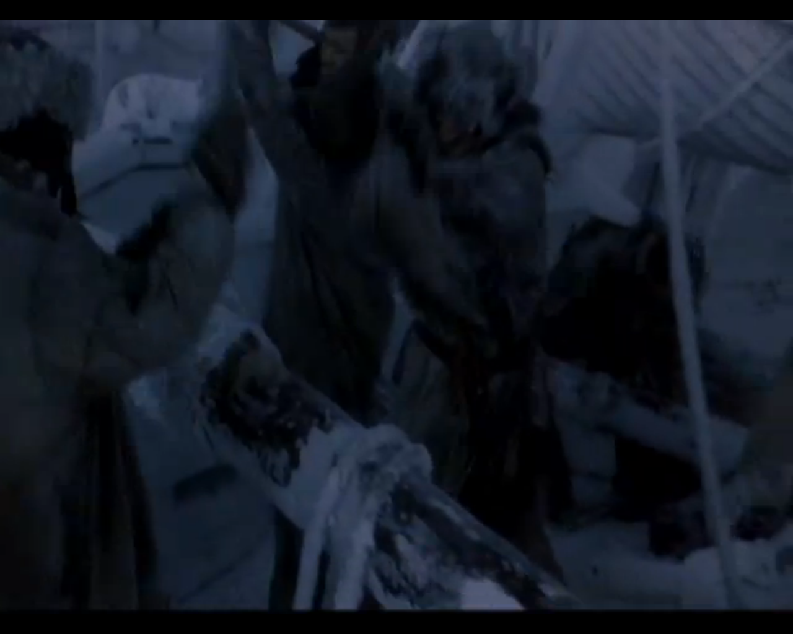

1. *Mary Shelly’s Frankenstein* (Kenneth Bragnah, 1994) – eStream no. 2576, chapter title ‘sound task’.  
<http://estream.godalming.ac.uk/View.aspx?id=2576~4u~vy7eUON4&chapID=11295>

Identify and list the **diegetic** and **non-diegetic** sounds in this clip.

[Grab your reader’s attention with a great quote from the document or use this space to emphasize a key point. To place this text box anywhere on the page, just drag it.]

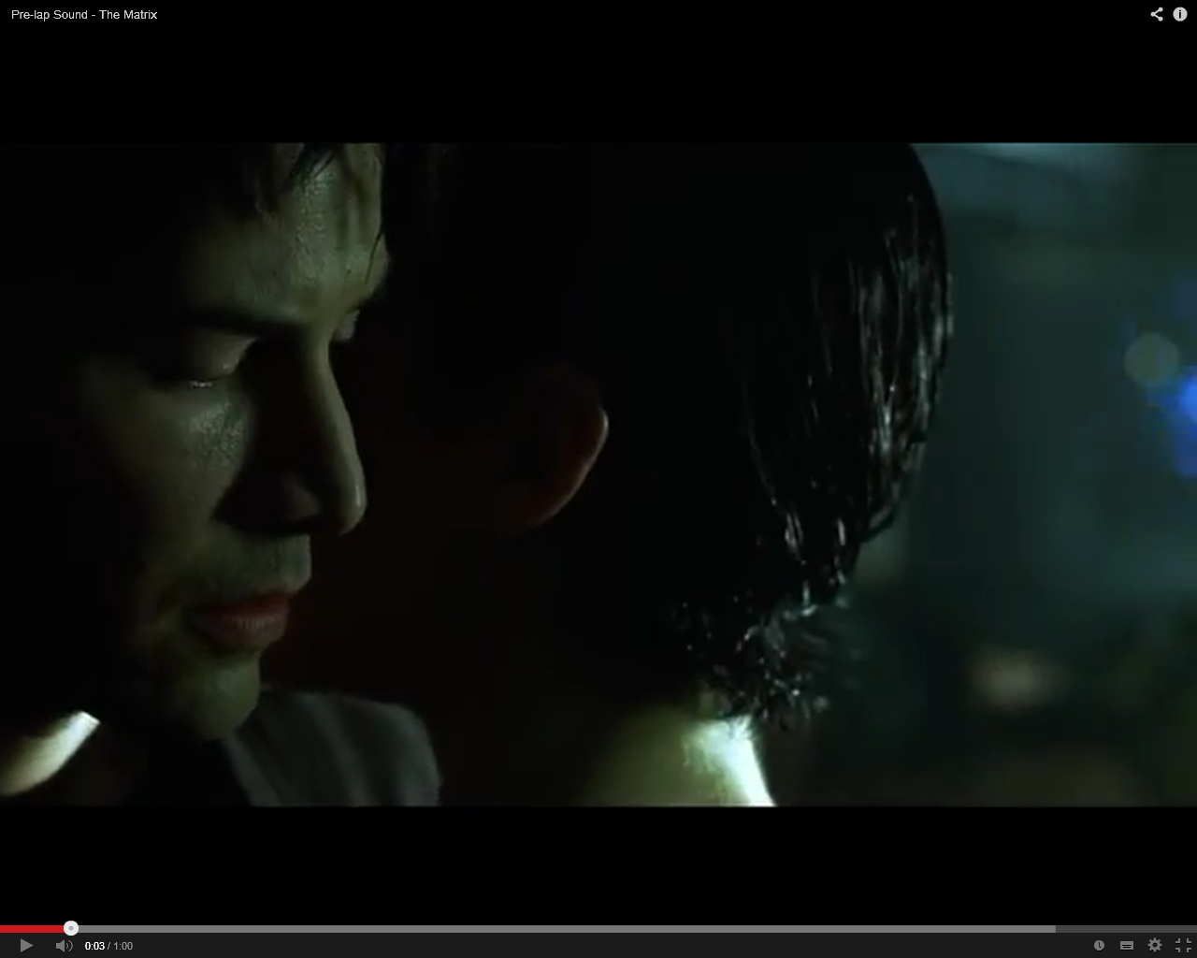

2. *The Matrix* ([Andy Wachowski](http://www.imdb.com/name/nm0905152/?ref_=tt_ov_wr) & [Lana Wachowski](http://www.imdb.com/name/nm0905154/?ref_=tt_ov_wr), 1999) YouTube clip <http://www.youtube.com/watch?v=zJZ-gPQ0ew8>

Identify the **two** Sound Bridges in this clip. What is their purpose? How do they work to connect the two shots, the two scenes?

[Grab your reader’s attention with a great quote from the document or use this space to emphasize a key point. To place this text box anywhere on the page, just drag it.]

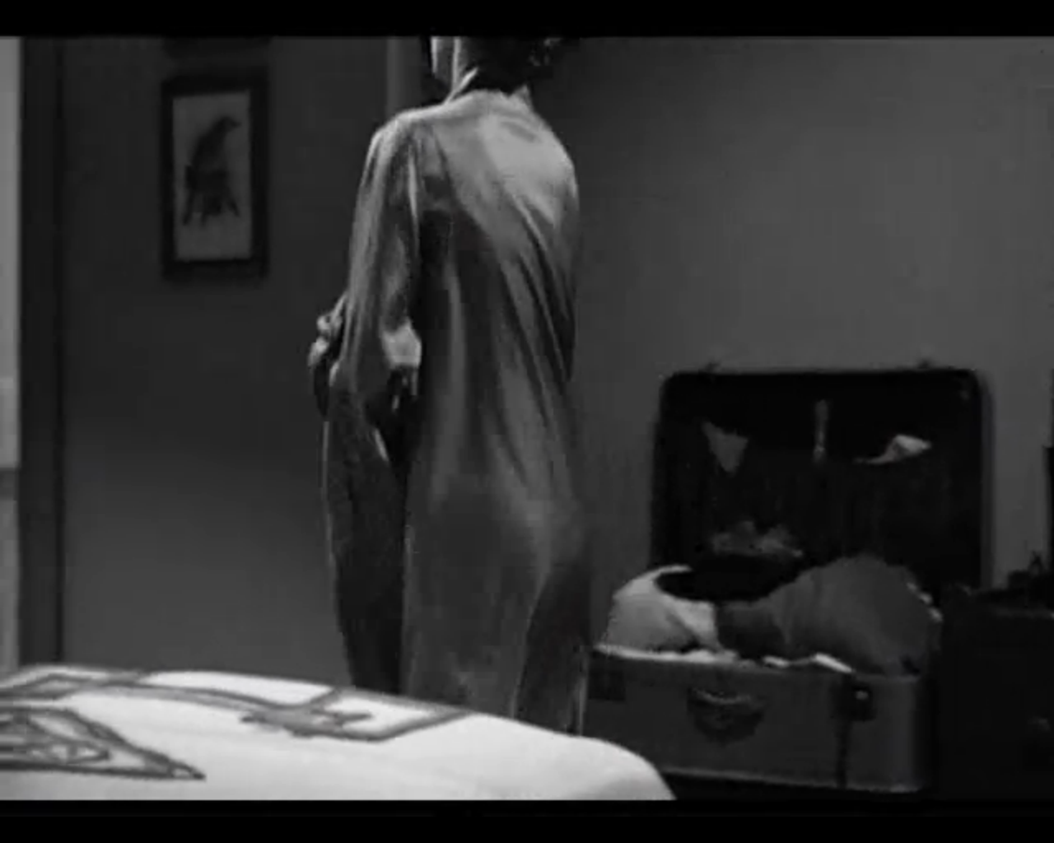

3. *Psycho* (Alfred Hitchcock, 1960) eStream no. 13, chapter title ‘shower scene’.  
<http://estream.godalming.ac.uk/View.aspx?id=13~2E~Vweu&chapID=4302>

Describe the music in this scene (the instruments used, chords, tone, mood etc.)? Is it parallel or contrapuntal to the on screen action? Explain your answers.

[Grab your reader’s attention with a great quote from the document or use this space to emphasize a key point. To place this text box anywhere on the page, just drag it.]

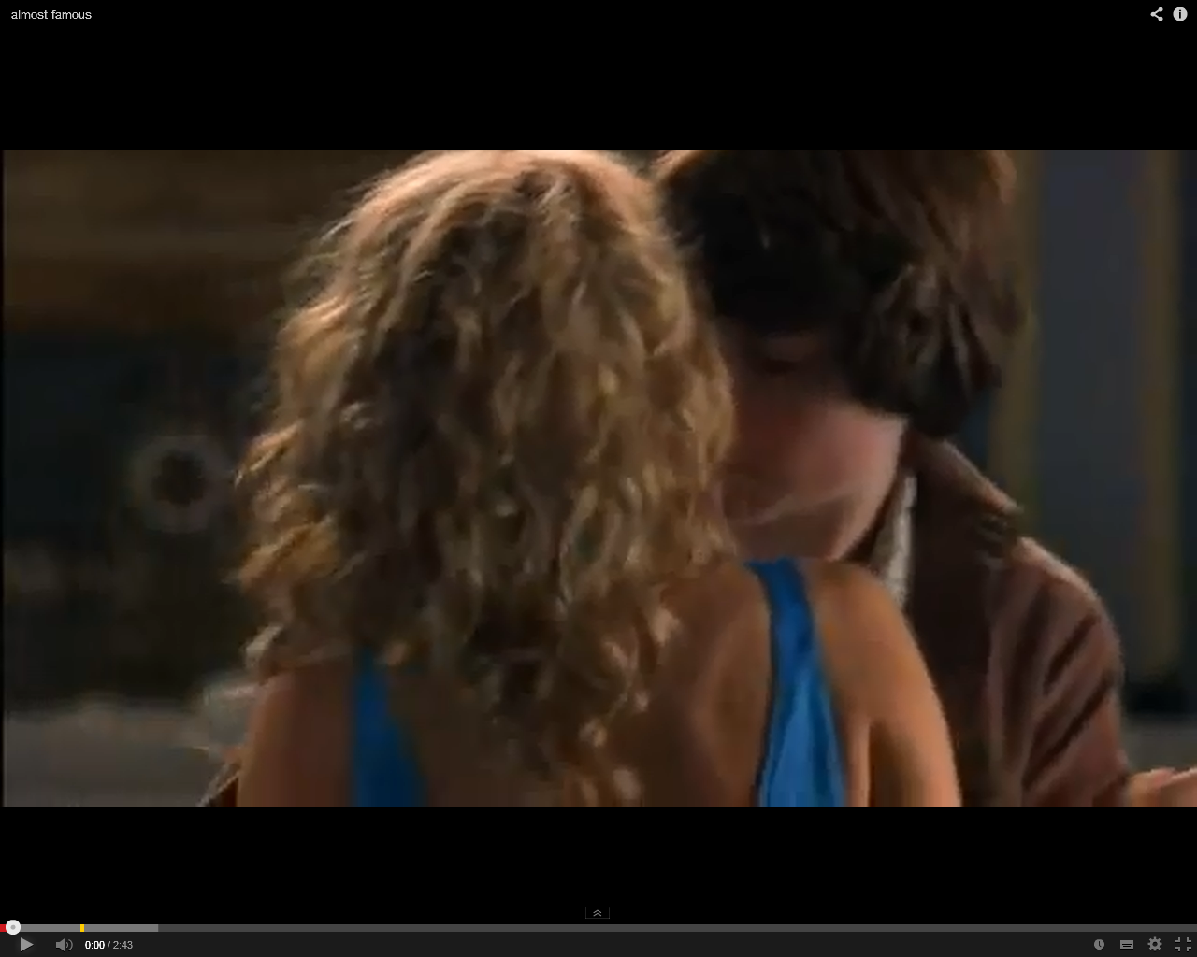

4. *Almost Famous* (Cameron Crowe, 2000) YouTube clip

<http://www.youtube.com/watch?v=ObdOyhv6cZ0&feature=player_embedded>

Describe the use of music in this scene (towards the end of the clip)? Is it parallel or contrapuntal? Explain your answer.

[Grab your reader’s attention with a great quote from the document or use this space to emphasize a key point. To place this text box anywhere on the page, just drag it.]

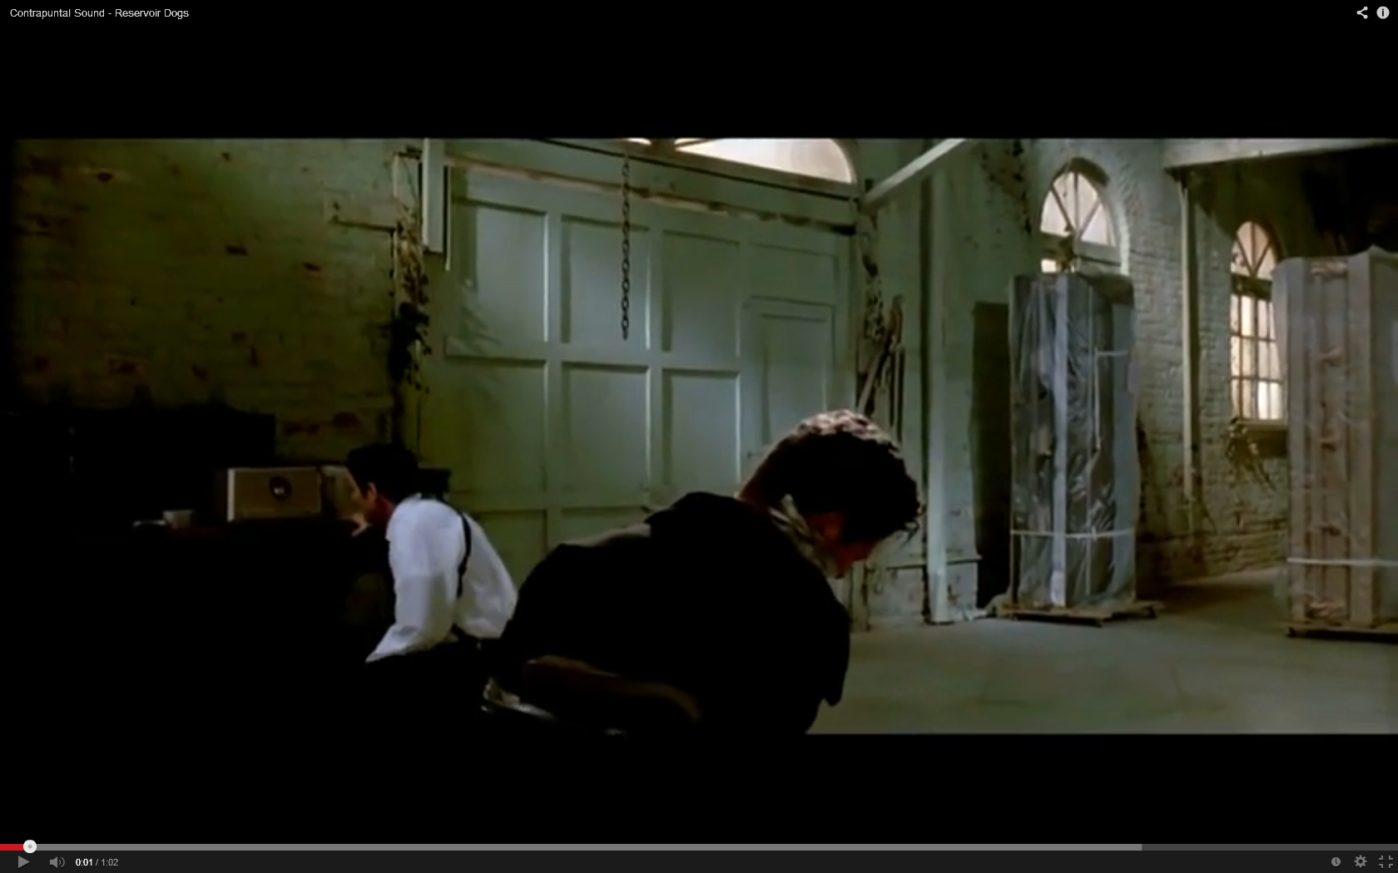

5. *Reservoir Dogs* (Quentin Tarantino, 1992) YouTube clip <http://www.youtube.com/watch?v=P0EXHvbsnJ8>

Describe the use of music in this scene? Is it parallel or contrapuntal? How does it differ from the above clip?

[Grab your reader’s attention with a great quote from the document or use this space to emphasize a key point. To place this text box anywhere on the page, just drag it.]

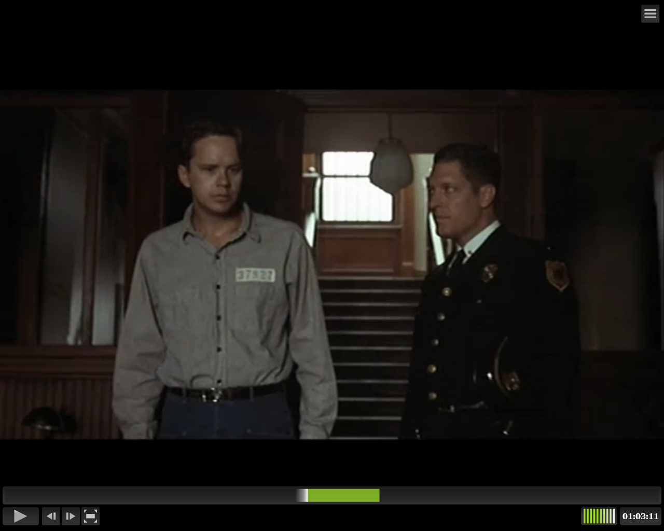

6. *The Shawshank Redemption* (Frank Darabont, 1994) eStream no.10387, chapter title ‘Sound task’.  
<http://estream.godalming.ac.uk/View.aspx?id=10387~5g~7ONdMTOMdA&chapID=11307>

Describe the main piece of music in this scene. Is it diegetic or non-diegetic? What effect (or affect) does the piece of music have on the characters (the prison inmates) and us the audience?

[Grab your reader’s attention with a great quote from the document or use this space to emphasize a key point. To place this text box anywhere on the page, just drag it.]

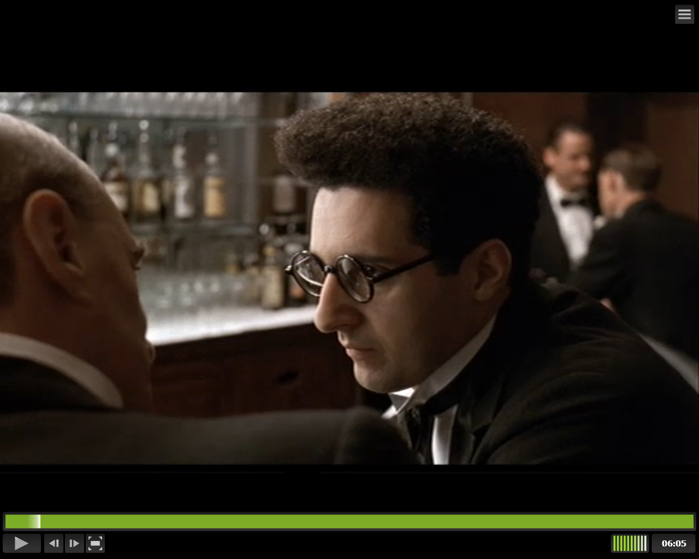

7. *Barton Fink* (Joel Coen, 1991) eStream no.10384, chapter titles ‘Sound task’   
<http://estream.godalming.ac.uk/View.aspx?id=10384~5d~uPTzHJgILR&chapID=11308>   
‘Sound task 2’.  
<http://estream.godalming.ac.uk/View.aspx?id=10384~5d~uPTzHJgILR&chapID=11309>

Describe the use of sound effects in the 2 sequences / chapters in the above film? Are they natural or exaggerated? As an audience member, how are we encouraged to read the 2 sequences?

[Grab your reader’s attention with a great quote from the document or use this space to emphasize a key point. To place this text box anywhere on the page, just drag it.]



Extension task

*Hunger* (Steve McQueen, 2008) eStream no.10431, chapter title ‘Sound task’

*Hunger* is the story of Bobby Sands (Michael Fassbender), an IRA political prisoner on hunger strike. This section is the climax of the film.

**1.** Look at the extract and write down the sounds that you hear. Why do you think that the filmmakers chose to include these sounds? What atmosphere do these sounds give? Are they soft or harsh sounds?

………………………………………………………………………………………………………………………….

………………………………………………………………………………………………………………………….

**2.** What is happening in the extract when there is only silence? What does the camera focus on?

………………………………………………………………………………………………………………………….

………………………………………………………………………………………………………………………….

**3.** There are two key sounds in the extract – the sound of birds and the sound of breathing. How do these relate not only to what we see but also to the story that we see unfold (the death of Bobby Sands)?

…………………………………………………………………………………………………………………………

………………………………………………………………………………………………………………………….

**4.** Towards the end of the extract there is a flashback sequence when Bobby thinks back to his childhood (represented by the young boy in his cell). It is at this moment that music first appears in the sequence. How would you describe the music? How does it reflect what we are seeing on the screen?

………………………………………………………………………………………………………………………….

………………………………………………………………………………………………………………………….