**AS COMPONENT 1: INVESTIGATING THE MEDIA**

***Formation* music video (2016), Beyoncé**

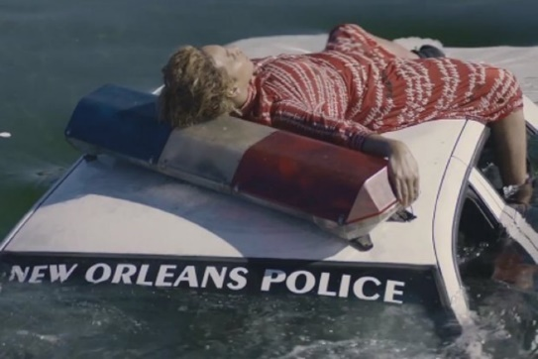

**SOCIAL AND CULTURAL CONTEXT RESEARCH**

*Formation*, lead single for the album *Lemonade*, was released the day before Beyoncé performed at the Super Bowl final in February 2016.

The singer and media mogul commands a huge online following: On Instagram alone her BeyHive includes more than 119 million followers. And Beyoncé has increasingly used that platform and her art to address racial inequality, especially in the wake of police-involved deaths of black men that have dominated headlines in recent years #blacklivesmatter #blm

1. What is the Black Lives Matter Movement?
2. Why did it begin?
3. What have the BLM movement accomplished? (https://blacklivesmatter.com/resource/4-year-anniversary-report/)
4. Conduct research into at least 1 of the infamous acts of police brutality, what happened to both parties involved? What happened afterwards? Etc… What your response to these acts?
5. What part have Beyonce and Jay-Z played in the BLM movment?
6. Why is Beyonce’s voice in this matter so important?