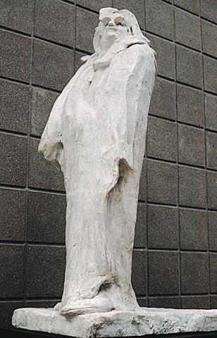Auguste Rodin, *Monument to Balzac,* 1892-1897, plaster, 282cm high

**Excerpts from gallery and museum articles:**

*Monument to Balzac* is a bronze sculpture which was requested by the Societé des Gens de Lettres to commemorate the literary achievements of the famous French novelist Honoré de Balzac who had died in 1850. After one artist failed to complete the commission Rodin accepted the Societé’s request. He promised to deliver a three meters tall bronze sculpture within 18 months. However Rodin then became obsessed with trying to achieve a likeness of the writer not based on physical accuracy but a portrait which would capture the character and persona of Balzac as a *thinker*. There then followed almost five long years of gestation.

Rodin hesitated over the clothing the figure of Balzac would wear and focused initially on trying to realise the pose Balzac would be depicted in. Rodin made *sketches* in clay of male figures. These were nude males in a variety of both static and active poses. These poses were modelled in a realistic way before Rodin moved on to simplifying and stylising the physique and facial features of Balzac. The clay models would be cast in plaster and the plaster versions shown to the commissioners/patrons. If the patrons were satisfied with the work a bronze version would then be made.

For the head of Balzac, Rodin made several trips to Balzac's home region. He made clay portrait sketches of local men with a similar physiognomy to the writer in an attempt to capture an accurate likeness of Balzac’s facial features. However in the final work the facial features of Balzac have been simplified and almost abstracted.

Rodin finally completed the structure for the figure in 1895, and shifted his focus to the drapery. Balzac was renowned for wearing a dressing gown while he worked on his writing and the Société des Gens de Lettres wished to see him depicted in one. To remain as authentic as possible to Balzac’s character, Rodin ordered a replica of a dressing gown from Balzac’s tailor. He then soaked the dressing gown in plaster and *dressed* the plaster figure of Balzac in it. Rodin created an almost abstract representation of the author's power. Only the head remains visible, dominating a body that arches backwards. Balzac stands with his huge head thrown back, alert like a wild animal.

When the plaster was exhibited at the 1898 Salon the critics went wild, pouring scorn on what they saw as a formless block. They compared it to a statue still wrapped in protective cloth, a block of salt caught in a shower of rain. They nicknamed it *the snowman*. The Société refused to accept this work that broke with all the traditional conventions for a commemorative monument, and which ignored the requirement for a realistic portrait. Because of the Societe’s rejection of the work Rodin decided to keep the statue, returned the money to the Societe, and refused all offers to sell it. It was not until 1939 that a bronze cast was erected in Paris.

The work is not an accurate likeness of the writer, what Rodin instead tries to achieve is a depiction of Balzac as a writer, thinker and intellectual. Balzac is shown with hollow eyes, they make him appear as if deep in thought, his hair is thick and his moustache is modelled in a simplified way. This portrait is an attempt to represent intellectual accomplishments rather than military or political achievements. It celebrates the power of creativity, not just in Rodin’s working methods and approach to representing an individual but also in showing Balzac as a literary genius who is depicted in almost abstract terms.

Rodin explained the work as: *There was only one way to evoke my subject: I had to show Balzac in his study, breathless, hair in disorder, eyes lost in a dream; a genius who in his little room reconstructs a whole society piece by piece in order to bring it to tumultuous life.. who never rests, turns night into day, drives himself vainly to fill the holes left by his debts...*

<http://rodin-web.org/works/1891_balzac.htm>

<https://www.moma.org/collection/works/80862>

<https://www.metmuseum.org/toah/hd/rodn/hd_rodn.htm>

<https://en.wikipedia.org/wiki/Monument_to_Balzac>