*Monument to Balzac,* Auguste Rodin, 1892-1897, plaster, 282cm high

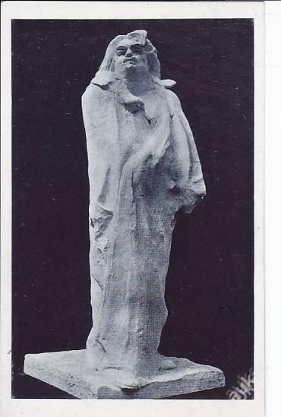

**Context**

1: Portrait of French novelist Honoré de Balzac. Commissioned by the Societé des Gens de Lettres to commemorate the writer.

2: Balzac was a famous French novelist in the 19th Century and had died in 1850.

3: Rodin commissioned in 1892. He spent five years working on the project.

4: Rodin initially focussed on the figure of Balzac. He created a series of nude standing figures which ranged from realistic to stylised.

5: Rodin travelled to Balzac’s hometown and made a series of studies of heads of men who were the same generation as Balzac. He did this in an attempt to capture a ‘likeness’ of Balzac.

6: Balzac is shown wearing a dressing gown. He was known to have worn this item of clothing when writing his novels. Rodin had a replica dressing gown made by Balzac’s tailor. He dipped this in plaster and draped it over a nude plaster model of Balzac.

7. A plaster copy was shown at the 1898 Salon, the work scandalised the public and critics. Rodin’s patrons rejected the work because of its lack of realism and the unflattering appearance of how they felt Balzac was represented. A bronze replica was not made until the 20th Century, by which time Rodin was dead.

**Visual Analysis**

1. This work makes Balzac appear informal and also suggests he is physically wrapped up in his own thoughts. The dressing gown is used to indicate Balzac’s working habits.

2. It challenges the conventions of memorial sculpture and portraiture. It is not an accurate likeness of the writer, instead it is Rodin’s interpretation of a great thinker or genius. **It is a creative response to a creative individual.**

3. The sculpture is nearly 3 meters tall, making it much larger than life-size. This gives the work a powerful, dominating appearance. It suggests that Balzac was an impressive individual and a renowned writer.

4: Balzac stands on a plinth, looking into the distance- this makes him appear deep in thought and possibly thinking about his writing.

5. Balzac is shown with hollow sockets where his eyes are. The lack of eyes suggest he doesn’t make eye contact with us meaning he is not intimidating or conscious of our presence. Instead he is deep in thought.

6: Balzac’s features appear deformed. Rodin has modelled the figure in an unrealistic and rough manner. This gives him an individualistic appearance, suggesting he was a unique character.

7: The face is stylised and simplified. Despite Rodin being able to create highly accurate likeness of an individual, he has simplified the forms of Balzac’s features to create an impression of the writer rather than a realistic portrait.

8: Balzac’s dressing gown is wrapped tightly around him, this might suggest he is wrapped up in his own thoughts and thinking about his writing.

9. Balzac stands in a upright, straight manner and this adds to the sense of importance and achievements of the writer.

**Working method**  
1. Rodin created a series of nude figures in clay, many of these were then cast in plaster or fired in a kiln. He **modelled** these figures and heads.

2. His intention was then to *dress* the nude figure he felt best characterised Balzac.

3. Likewise the various heads he created of Balzac were modelled in clay before firing.

4. He soaked a replica dressing gown in liquid plaster. This was then draped over the nude figure and the drapery/forms/folds arranged before the plaster had set.

5. This would then be shown to a patron and if satisfied a bronze replica would be cast.