**Godalming College**

Booklet Checked by: _____________

Grade: U/S 1 2 3

Comment: _______________________________________________________________________________________________________________________________________________________

**Sociology Department**

EXPLAING CLASS DIFFERENCES IN CRIME: MARXISM, NEO-MARXISM AND CRIMES OF THE POWERFUL

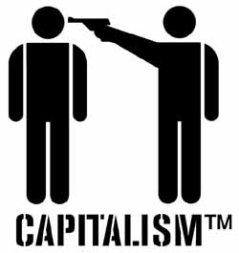

**WORKBOOK 4**

**Crime & Deviance**

|  |  |  |
| --- | --- | --- |
| **Name:** | **Set:** | **Group:** |

**After studying this Topic, you should:**

Understand differences in crime rates for different social classes and the methodological issues of studying this.

Understand why Marxists see crime as inevitable in capitalist society.

Understand Marxist and neo-Marxist approaches to crime and deviance, and the similarities and differences between them.

Be able to evaluate the strengths and limitations of Marxist and neo- Marxist approaches to crime and deviance.

Understand the nature and extent of white collar and corporate crime, and be able to evaluate sociological explanations of it.

**Social class and crime: Overview of the Statistics and Issues**

Newburn (2007) has noted that the sociology of crime and deviance has tended to focus on the crimes of the powerless rather than those of the powerful. This is largely because official statistics show that working-class people, particularly those with the least power for the lower class, are the main offenders.

The working class are also most likely to be the victims of crime:

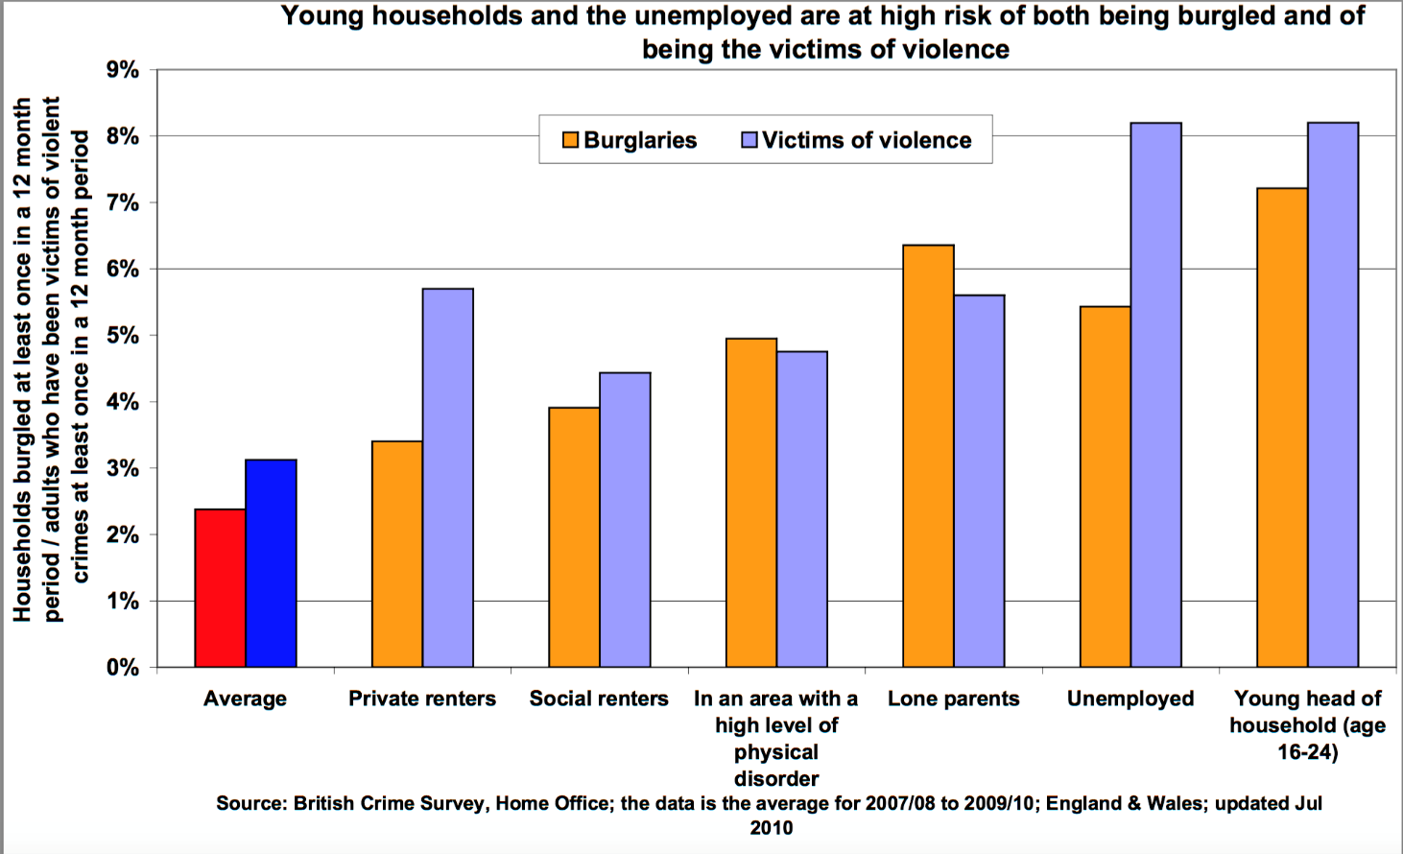

[www.poverty.org.uk](http://www.poverty.org.uk)

**What does this table show?**

There is a clear relationship between crime and class, insofar as the majority of convicted offenders are drawn from the working classes. As might also be expected, there is a clear correlation between type of crime and social class. For example:

Crimes involving violence, theft from property, etc. are mainly associated with the working class.

Fraud, embezzlement and so forth are mainly middle class crimes.

Corporate crime (involving such things as insider trading, environmental crimes, market- rigging and the like) is mainly an upper class phenomenon.

|  |  |
| --- | --- |
| Define | See p.91 of Webb- try to include some named sociologists |
| Corporate crime |  |
| Occupational crime |  |
| White collar crime |  |

This relationship is hardly surprising given the idea of different opportunity structures in our society (working class males and females, for example, are not, by definition, in positions of sufficient power to allow them to carry-out elaborate company frauds). However, simply because more members of the working class are convicted of crimes than the members of other social classes doesn't mean that we can automatically assume that the working classes are somehow "more criminal" than the middle / upper classes. In this respect, a number of ideas are significant:

*The type of crime committed is an important factor:*

The working class, for example, tend to be involved in crimes that are highly visible (crimes of violence, for example). In situations where there are clear victims and little attempt to hide criminal behaviour (for whatever reason), it follows that detection / arrest and conviction rates are likely to be higher.

Crimes such as fraud, insider dealing and so forth tend to be much less visible to the police, general public and so forth. Since the police do not routinely involve themselves in companies, offices and so forth, greater opportunity exists for this type of crime.

In this respect, the policing of these types of middle / upper class crimes is much more difficult - policing is reactive (that is, responding to a report of crime) rather than overly-active (policing an area where crime is likely to occur).

Finally, many forms of middle-class crime may not be defined as crimes at all. These include many forms of petty theft (making personal phone-calls at work, using the company's photocopier for personal work and so forth), as well as more-complex and serious forms of crime. Computer crime, for example, tends to be underestimated in crime statistics because, even when it is detected, a company may prefer to sack the employee rather than involve the police because the attendant publicity surrounding a major fraud may be considered more damaging to the company than the crime itself...

[www.sociology.org.uk](http://www.sociology.org.uk)

**Using the info above and your wider knowledge, outline the issues with trying to form a causal relationship between class and crime, rather than just a correlation.** [Correlation = connection between two or more things, causal relationship = one event causes the other]

**Explaining class differences in crime: Previous explanations**

Using the notes from the other theory booklets and p.87 of Webb provide a recap of how these theories would view differences in offending/victimisation based on class (try to include named sociologists):

|  |  |
| --- | --- |
| **Functionalism** | **Strain theory** |
|  |  |
| **Subcultural theory** | **Labelling theory** |
|  |  |

# Traditional Marxist Perspectives on Crime

How do Marxists agree with labelling theorists? (p.88 of Webb)

How do Marxists differ to labelling theorists (p.88 of Webb)

*The history of criminal legislation in England and in many countries shows that an excessive prominence was given by law to the protection of property.*

Herbert Manheim

*Property crime is better understood as a normal and conscious attempt to amass property than as the product of faulty socialisation or inaccurate and spurious labelling. Both working class and upper class crime…. Are real features of society involved in a struggle for property, wealth and self-aggrandisement…? A society which is predicated on unequal right to the accumulation of property gives rise to the legal and illegal desire to accumulate property as rapidly as possible.*

Taylor et al 1975

**A ROAD MAP FOR MARXISM**

Marxist approaches vary widely and can be divided broadly into the following four approaches

# 1. Traditional Marxism

With its emphasis upon the crimes of the powerful – especially white-collar and corporate crime compared with the crimes of the workers – crime and punishment here is selective - a tool of social control

# 2. Neo-Marxism/New criminology/Critical criminology

With its emphasis on blending interactionist and structuralist concerns and its sympathy (as other committed sociologies) with the underdog. Here the emphasis is on understanding the criminal.

[This booklet will deal with these first two]

# 3. Left Realism

As a reaction to New Criminology still with an emphasis on the underdog but this with the working class as the victims not perpetrators of crime

# 4. Marxist Subcultural theory

Emphasising the creation of class based subcultures as essentially oppositional, resisting the hegemony of the ruling class. **Moral panics** around youth subcultures, crime and ethnicity have also been the concern of Marxist analysts in particular

### Overview

##### MIDKARL1Labelling approaches opened up a concern with the process of criminalisation, but failed to explore this process in the context of the social, political and economic organisations of society. Nor did they ask why some acts were defined as deviant whereas others were not. This issue became a central theme of Marxist criminology.

Marx did not write at length about crime, but he did argue that the laws were generally the codified means by which one class, the rulers, kept another class, the rest of us in check.

Marxists recognise that for a society to function efficiently**, social order is necessary**. However, apart from communist societies, they consider that, in all societies, **one class – the ruling class** – **gains far more than other classes.** Marxists agree with functionalists that **socialisation** plays a **crucial role in promoting conformity and order**. However, unlike the latter, they are **highly critical of the ideas, values and norms of capitalist society,** which they term ‘capitalist ideology’. Modern Marxists point to **education and the media** as socialising agencies, which **delude or ‘mystify’ the working class** into conforming to a social order, which works against its real interests.

**Basic Beliefs:**

* Deviance is partly the product of **unequal power relations and inequality in general**. It is an understandable response to the situation of poverty.
* Marxists see power as largely **being held by those who own the factors of production**.
* Crime is often the **result of offering society-demeaning work with little sense of creativity**. The Marxist concept of alienation can be applied here.
* The **superstructure serves the ruling classes**.
* The state **passes laws, which support ruling class interests**. Maintain its power, coerce, and control the proletariat. They see individual property rights as much more securely established in law than the collective rights of, for instance, trade unions.
* Laws passed **reflect the wishes and ideologies of the ruling classes.**
* Moreover, people have unequal access to the law. Having money to hire a good lawyer can mean the difference between being found not guilty or guilty.

Thus for Marxists punishment for a crime may depend and vary according to the social class of the perpetrator.

The main issues for Marxist theories of Crime and Deviance are, therefore:

1. The manipulation of basic values and morality of society
2. The process of law creation.
3. The enforcement of law
4. Individual motivation.

## Who Makes the Laws

From a Marxist Viewpoint....

Laws are made by the state**,** BUT this represents the interests of the ruling class, not just “everyone” and certainly not equally.

This line of argument forms the basis of a theory of widespread crime and selective law enforcement; crime occurs right the way through society, but poor criminals receive harsher treatment than rich criminals. Marxists tend to emphasise ‘white collar, corporate crime’ and pay less attention to ‘blue collar’ variants. They note that the crimes of the upper class exert a greater economic toll on society than the crimes of the ‘ordinary people’

### Definitions of Business Crime from A Marxist Viewpoint

1. **Corporate or Business Crime**: This term is usually applied to business persons holding power who engage in fraudulent activity on behalf of their company to raise profits.
2. **White Collar Crime**: term that is more generic used for a range of crime in business.
3. **Organised Crime:** Best known examples include the ***mafia*** or ***cosa nostra***, where a complex web of politics, the law and big business can all be intertwined in a world of corruption and violence. Violence against members of the USA population by corporate gangsters in pursuit of profit far exceeds violence by ‘lower class street criminals’

#### MANNHEIM AND CHAMBLISS: Excessive Protection of Property

Many sociologists have noted the large number of laws dealing with property in capitalist society. For example, **Hermann Manheim** writes that....

*The history of criminal legislation in England and in many countries shows that an excessive prominence was given by law to the protection of property.*

According to **William Chambliss**, such laws were largely unnecessary in feudal society where land, unmoveable property, was the main source of wealth and landowners were the undisputed masters of the economic resources of the country.

However, with the increasing importance of trade and commerce, which involve movable property, and the eventual removal of feudalism by capitalism resulted in vast numbers of laws protecting the interests of the emerging class. Chambliss argues....

*The heart of the capitalist system is the protection of private property, which is, by definition, the cornerstone upon which capitalistic economies function. It is not surprising, then, to find that criminal laws reflect this basic concern.*

## SNIDER: Big Corporations Benefit from the Legal System

**Lauren Snider** notes that capitalistic state is often **reluctant to pass laws**, which **regulate big business** concerns, which **might threaten profitability**. She notes that capitalist states often use vast sums to attract investment from big corporations. They offer new investors...

* Tax concessions
* Cheap loans
* Grants

And will try to build infrastructures to help capitalism.

Snider suggests having offered this***the state is unwilling to enforce laws against pollution, workers health, and safety; or monopolies***

**Webb offers a useful summary of traditional Marxism. On pp.88-89**

Explain these points in your own words

1. Capitalism is criminogenic
2. David Gordon, rational response
3. The state and law making
4. Snider, prevention of laws by the powerful not in their interest
5. Selective enforcement
6. Ideological function of crime and law

**Activity**

**Quinney** considers the following components the key components within a Marxist analysis of crime. Complete the sentences with the word below to make sense of them.

1. America and by implication Britain is first and foremost an advanced ________________________ society.
2. Within capitalist societies, the state is organised to serve the interests of the capitalist ________________________________
3. Laws and conventions are created by the state and the capitalist class to preserve existing social relations of ___________________________
4. In order to maintain order in society, the control of crime (and deviance) is undertaken by state agencies, such as the _________________________
5. As a result of this, working class people remain oppressed, particularly through __________ means.
6. Crime and deviance can only be eradicated with the collapse of capitalism and the creation of a __________ society.

|  |  |  |
| --- | --- | --- |
| Police and Judiciary, | Inequality | Legal |
| Capitalist | Socialist | Class |

**EVALUATION OF TRADITIONAL MARXISM**

Look at the following are they strengths or weaknesses of Marxism?

|  |  |
| --- | --- |
| STATEMENT | STRENGTH/WEAKNESS? |
| 1. The Marxist solution is simple yet monumental: if capitalism creates crime, if capitalism is the problem, then the solution is clear, get rid of capitalism. |  |
| 1. Marxists tend to view the behaviour of individuals as largely governed by external forces. Thus their accounts are somewhat deterministic. Some theorists argue that individuals retain free will, which enables them to decide whether they want to commit crime. |  |
| 1. Marxists tend to represent working class crime as a creative response to oppression when reality is that much working class crime is directed at working class people. Moreover, they do not fully explain why all working class people do not commit crime. |  |
| 1. It seems to ignore the individual motivation. The stress is primarily on the nature of capitalism and how economic factors ‘force’ people to act in certain ways. |  |
| 1. It seems implausible to explain all laws in terms of the interests of the ruling elite; many laws appear to rest on general agreement. |  |
| 1. Socialist states also have high crime rates at least as great as our own. |  |

**NEO-MARXISM: CRITICAL CRIMINOLOGY**

Neo-Marxists are sociologists who have been influenced by many of the ideas put forward by Marxism, but they combine these with ideas from other approaches such as labelling theory.

The most important contribution has been made by Paul Taylor, Ian Walton and Jock Young "The New Criminology", 1973; "Critical Criminology", 1975 (editors).

Taylor et al:

* Attempted to combine various Marxist concepts (social structure, economic exploitation, alienation and so forth) with a number of Interactionist concepts (social reaction, primary and secondary deviation and so forth) in a "new" theory of crime and deviance. I
* In order to understand both criminal and non-criminal behaviour, critical criminologists argued that we have to understand the social framework within which laws are created and applied by and to various groups in society.
* "Laws" are not "neutral" expressions of social relationships; on the contrary, they are created and applied in capitalist societies for two main reasons:

a. To protect certain property rights (laws governing theft, contract rights, etc.).

b. To maintain a form of social order that is conducive to the continued economic exploitation of the working class by the ruling class (various "public order" offences - violence, picketing, political activity and so forth).

* Deviants are not seen to be "passive victims" of a labelling process, since it involves a level of choice on the part of the deviant (primary deviance). However, in terms of secondary deviation, the social reaction is conditioned by the ability of powerful groups to proscribe ("make unlawful") and prosecute various forms of deviance.

A "fully social" theory of deviance involves consideration of the following:

1. The wider origins of a deviant act (unequal distribution of wealth and power)
2. The immediate origins of a deviant act (the context in which the individual decides to commit the act)
3. The act itself (and its meaning for the actor- e.g. was it a form of rebellion against capitalism)
4. The immediate origins of a social reaction (the reactions of those around such as the police, family and community).
5. The wider origins of a deviant reaction (who has the power to define actors)
6. The effects of labelling (on the deviant’s future action. Does deviancy amplification occur?)
7. The nature of the deviant process as a whole (what is the impact more widely?)

Try applying this framework to the following case study.

Write your answers in the appropriate spaces

|  |  |
| --- | --- |
| **"Fully social" theory of deviance** | **Comment on Case Study** |
| 1. The wider origins of a deviant act. |  |
| 1. The immediate origins of a deviant act. |  |
| 1. The act itself. |  |
| 1. The immediate origins of a social reaction. |  |
| 1. The wider origins of a deviant reaction. |  |
| 1. The outcome of the social reaction to a deviant's further actions. |  |
| 1. The nature of the deviant process as a whole |  |

**CASE STUDY: 2011 England Riots**

**Understanding the 2011 Riots’, Cooper, Deacon and Newburn: READING ACTIVITY**

1. When did they happen?
2. What was the event that sparked them?
3. What happened during them?
4. What are the various reasons given for them according to: Bauman, Newburn, Communities and victims panel.
5. What conclusions are drawn by the writers of the article?

**ITEM 1** Wikipedia entry <https://en.wikipedia.org/wiki/2011_England_riots>

Between 6 and 11 August 2011, thousands of people rioted in several [London boroughs](https://en.wikipedia.org/wiki/London_borough) and in cities and towns across England. The resulting chaos generated [looting](https://en.wikipedia.org/wiki/Looting), arson, and mass deployment of police and resulted in the death of five people. Disturbances began on 6 August after a protest in [Tottenham](https://en.wikipedia.org/wiki/Tottenham), London, following the [death of Mark Duggan](https://en.wikipedia.org/wiki/Death_of_Mark_Duggan), a local man who was shot dead by police on 4 August.[12] Several violent clashes with police ensued, along with the destruction of police vehicles, a [double-decker bus](https://en.wikipedia.org/wiki/Double-decker_bus), and many homes and businesses, thus rapidly gaining attention from the media. Overnight, looting took place in [Tottenham Hale](https://en.wikipedia.org/wiki/Tottenham_Hale) retail park and nearby [Wood Green](https://en.wikipedia.org/wiki/Wood_Green). The following days saw similar scenes in other parts of London, with the most rioting taking place in [Hackney](https://en.wikipedia.org/wiki/London_Borough_of_Hackney), [Brixton](https://en.wikipedia.org/wiki/Brixton), [Walthamstow](https://en.wikipedia.org/wiki/Walthamstow), [Peckham](https://en.wikipedia.org/wiki/Peckham), [Enfield](https://en.wikipedia.org/wiki/London_Borough_of_Enfield), [Battersea](https://en.wikipedia.org/wiki/Battersea), [Croydon](https://en.wikipedia.org/wiki/Croydon), [Ealing](https://en.wikipedia.org/wiki/Ealing), [Barking](https://en.wikipedia.org/wiki/Barking), [Woolwich](https://en.wikipedia.org/wiki/Woolwich), [Lewisham](https://en.wikipedia.org/wiki/Lewisham) and [East Ham](https://en.wikipedia.org/wiki/East_Ham).

From 8 to 10 August, other towns and cities in England (including [Birmingham](https://en.wikipedia.org/wiki/Birmingham), [Coventry](https://en.wikipedia.org/wiki/Coventry), [Leicester](https://en.wikipedia.org/wiki/Leicester), [Derby](https://en.wikipedia.org/wiki/Derby), [Wolverhampton](https://en.wikipedia.org/wiki/Wolverhampton), [Nottingham](https://en.wikipedia.org/wiki/Nottingham), [West Bromwich](https://en.wikipedia.org/wiki/West_Bromwich), [Bristol](https://en.wikipedia.org/wiki/Bristol), [Liverpool](https://en.wikipedia.org/wiki/Liverpool,_England), [Manchester](https://en.wikipedia.org/wiki/Manchester), and [Salford](https://en.wikipedia.org/wiki/Salford,_Greater_Manchester)) saw what was described by the media as "[copycat](https://en.wikipedia.org/wiki/Copycat_crime) violence". [Social media](https://en.wikipedia.org/wiki/Social_media) sites including [Facebook](https://en.wikipedia.org/wiki/Facebook) also featured rumours of further disturbances or details surrounding known disturbances which were later proven to be inaccurate; for instance there were rumours of disturbances in the town of [Dudley](https://en.wikipedia.org/wiki/Dudley) and at the nearby [Merry Hill Shopping Centre](https://en.wikipedia.org/wiki/Merry_Hill_Shopping_Centre), but no incidents in these areas were detected by police. Rumours of a hospital being targeted by rioters in Birmingham were also proven to be wrong, as were rumours of disturbances in the [Heath Town](https://en.wikipedia.org/wiki/Heath_Town) district of Wolverhampton, which had witnessed a serious riot more than 20 years earlier.

By 15 August, more than 3,000 arrests had been made across England, with more than 1,000 people issued with criminal charges for various offences related to the riots.[13] Initially, courts sat for extended hours. There were a total 3,443 crimes across London linked to the disorder.[14] Along with the five deaths, at least 16 others were injured as a direct result of related violent acts. An estimated £200 million worth of property damage was incurred, and local economic activity was significantly compromised.

## The online video website [YouTube](https://en.wikipedia.org/wiki/YouTube) was soon host to much video footage of the riots,[15] which had been recorded by witnesses and participants. The riots have generated significant ongoing debate among political, social and academic figures about the causes and context in which they happened. Attributions for the rioters' behaviour include structural factors such as racism, classism, and economic decline, as well as cultural factors like criminality, hooliganism, breakdown of social morality, and gang culture.

**Item 2** ‘Young people have no right to riot but they have a right to be angry’ 18/8/11

I am a teacher in a sixth-form college in one of the most deprived boroughs in the country, Newham, and over the last year my colleagues and I have watched with growing despair as the last shreds of the rug are pulled out from under our kids' feet. EMA gone. Youth centres closed. Tuition fees trebled. University places cut. And now a thinktank has warned that students from low-income families are even less likely to be offered university places next year.

Do I think this gives young people the right to loot shops? No. Do I think this gives them the right to run riot through city centres and set upon ordinary working people? No, I do not. But ask me if I think young people have the right to be angry as all hell and I will give you an unequivocal yes. And what we saw last week was simply that: an outpouring of their blind rage against the system.

It's ugly, right? But we can't have it both ways. If rioting is unforgivable then equally indefensible is the lack of training and investment in the inner city. If looting is criminal then equally immoral is the abandonment of whole tranches of the urban landscape to decay and gang law. These young people are meant to be our future, but day after day I teach students who have to take three buses to college to avoid travelling through enemy territory. They arrive in class at nine, nerves rattling, exhausted already before the day has begun.

<https://www.theguardian.com/commentisfree/2011/aug/18/riot-young-people-a-level-school>

## ITEM 3 ‘Mark Duggan did not fire his weapon at police’

## POLICE fired two shots at Mark Duggan, with the first killing the man who sparked riots across Britain and the second passing through his body to hit an officer's radio, sources say.

## Duggan, 29, was armed when Metropolitan Police officers stopped him in a London cab on Friday but he did not fire the weapon, the sources added yesterday.

## The exact sequence of events leading to the fatal shooting remains unclear, but from informed sources and official statements a picture is emerging.

## The opening hearing of the inquest into Duggan's death heard that the father-of-four died of a single gunshot wound to the chest. The inquest at North London Coroner's Court in High Barnet was adjourned after a short hearing to December 12.

## More revelations were expected overnight with the release of results from ballistic tests.

## About 6pm last Thursday (3am Friday AEST), Semone Wilson, Duggan's fiance, received a text message from him. It said: "The feds are following me."

<http://www.theaustralian.com.au/news/world/mark-duggan-did-not-fire-his-weapon-at-police/story-e6frg6so-1226111938756>

**Item 4** ‘Police out in force after Tottenham riots’ 7/8/11

MP David Lammy made an emotional appeal for calm and restraint in a community left devastated by riots that broke out over the fatal police shooting of a man earlier in the week.

Mr Lammy said many of those who had committed the violent acts were from outside Tottenham, simply intent on causing violence.

Scotland Yard reported that 26 officers were injured during the unrest, while 42 people were arrested for offences including violent disorder, burglary and theft.

Mr Lammy said: "A community that is already hurting has now had the heart ripped out of it. The Post Office, Fitness shop, newsagents, mobile phone shops, council buildings that deal with customer complaints - smashed to pieces by mindless, mindless people last night."

He spoke as police patrolled the streets in Tottenham, north London, targeting "isolated pockets of criminality" as residents surveyed the damage left by [hundreds of rioters](http://www.channel4.com/news/police-cars-set-on-fire-in-north-london-street-clashes).

This is nothing like the sorts of scenes that we saw back 25 years ago, then there was a particular relationship with the police. This is an attack on Tottenham, on people, ordinary people.

Buildings and vehicles were set ablaze as rioters took to the streets demanding "justice" for the [death of Mark Duggan](http://www.channel4.com/news/youth-killed-policeman-injured-in-north-london-shooting), 29, who was shot dead by police on Thursday.

Mr Lammy said ordinary people had been left homeless by the violence, adding that the authorities did not know if there are fatalities to be found in some of the homes above the shops that had been destroyed.

The MP, who has lived in Tottenham all his life, rejected the idea that last night's troubles evoked memories of 1985, when a police officer, PC Keith Blakelock, was hacked to death following a riot in Broadwater Farm, where the marchers set off yesterday.

Mr Lammy said: "This is nothing like the sorts of scenes that we saw back 25 years ago, then there was a particular relationship with the police. This is an attack on Tottenham, on people, ordinary people, shopkeepers, women, children - who are now standing on the streets homeless as a consequence."

<http://www.channel4.com/news/police-patrol-tottenham-after-riots>

**Evaluation**

1. A major weakness in the critical criminology perspective appears to be that although they illustrate the way it is possible to arrive at a "social theory of deviance" no attempt was ever made to put this theory into practice.
2. Critical criminologists have been accused of "romanticising criminals" as being somehow in the revolutionary vanguard of the fight against Capitalism (mainly because criminals are seen to disrupt and threaten the accumulation of capital / profit). Traditional Marxism warns against this type of view (as does Functionalism for that matter), since there appears to be more evidence to support the view that criminals are simply involved in exploiting others through criminal means.
3. Critical criminology is a branch of Marxism that is termed "instrumental Marxism" because it focuses upon empirical demonstrations of the way in which a ruling class is held together by common class backgrounds, experiences and values.

# Neo Marxist Approaches to Youth Cultures

Another significant development within Neo Marxist approaches uses the concept of **hegemony** as a means of explaining the role played by youth sub-cultures in the lives of young people.

To remind you, a basic definition of hegemony is that it involves:

**"Political leadership based on the consent of the led - a consent that is secured by ensuring that the view of the world they hold is that which is generally favourable to the interests of the ruling class"**

In basic terms, what this means is that if you want people to behave in ways that are favourable to your interests, you have to convince them that these interests are really the interests of everyone

Youth sub-cultures, in this respect, are seen as an attempt by the exploited and the powerless to resist ruling class / bourgeois hegemony by adopting behaviour, forms of dress, etc., that appear to challenge the "consensus".

**Hall and Jefferson (eds), ("Resistance Through Rituals", 1976),**

This study characterized youth sub-cultures in this way - as symbolic or ritualistic attempts to resist the power of bourgeois hegemony by consciously adopting behaviour that appears threatening to the "establishment" - thereby giving the powerless a feeling of power.

**Hall, Critcher, Jefferson, Clarke and Roberts ("Policing the Crisis: Mugging, the State and Law and Order**", 1978) also attempted to do this - taking Interactionist insights and adding a Neo-Marxist conflict view.

**Hall et al's** basic argument is that the mass media's role in the creation /manufacture of youth sub-cultures / moral panics etc., can only be explained in terms of the media's structural relationship to other institutions and classes within contemporary capitalism.

In this way we can understand two things:

1. The actual processes involved in the development of youth cultures

2. Why regularities occur in this process - that is, why regular moral panics occur around the "problem" of young people.

In this respect, Hall et al argue that when crises occur within capitalism (widespread unemployment, for example), explanations are needed to account for why things are "going wrong". Since such explanations cannot involve questioning the capitalist system itself (for various economic, political and ideological reasons), "folk devils" are required to distract people's attention away from what Hall et al see as the real causes of the crisis (Capitalism).

In this way, "youth" can be targeted as a scapegoat for social problems - and **Hall et al** discuss the moral panic surrounding "black muggers" as an example of the way in which the powerless are used to "take the blame" for social problems.

**Criticisms:**

1. Feminists criticise malestream approach, although some aspects have been used to examine the culture of adolescent girls
2. The claim to a “correct” reading of the content of working class youth styles can be challenged (e.g., by Stanley Cohen from an interactionist standpoint)  
   Are offences by black youths “political acts” (Gilroy) or simply crimes directed at the acquisition of material goods for personal gain?
3. Does the sociologist always know best? Neo Marxists often discount youths own explanations and emphasise their own interpretation of underlying causes and meanings.

**Comparison of traditional Marxism and neo-marxism**

|  |  |  |
| --- | --- | --- |
| Issue | Traditional Marxism | Neo-Marxism |
| Key contributors | Mannheim and Chambliss: laws in the UK have protected the private property of landowners and businesses. This is the cornerstone to the functioning of capitalism.  Snider: capitalistic states are often reluctant to pass laws which regulate big business concerns, which might threaten profitability.  Gordon: crime is a rational response to capitalism. Crime is criminogenic.  Edwin Sutherland: challenged the idea that crime is purely a lower class phenomenon. Coined the term ‘white-collar crime’.  Tombs: corporations can influence the law so that their actions are not criminalised. Corporate crime is ‘widespread, routine, pervasive’. | Taylor, Walton and Young: combines Marxist concepts with interactionist concepts. Looks at social structural conditions, the meanings for the actors who commit deviant acts, the response to this by people with the power to label and the nature of the process on wider society.  Youth cultures: these are a way of young people resisting being exploited by adopting behaviour, forms of dress etc. that challenge the consensus.  Hall: resistance- looks at the creation of youth subcultures and the response by the media e.g. formation of moral panics.  Hebdige: exaggeration.  Clarke: exaggeration.  Brake: magical solutions |
| Key concepts | Criminogenic  Rational choice  White collar crime  Corporate crime  Occupational crime | Social reaction  Primary/secondary deviation. |
| Role of crime and law | Laws look like they benefit all e.g. health and safety when in fact laws benefit the ruling class disproportionality. | Laws are not neutral- they maintain the social order needed to exploit the working class and although deviants are not ‘passive victims’ (they make a choice) the role of the social reaction is important for secondary deviation. |
| View of the deviant | Passive victim. Does not look at individual motivation | Individual has choice- we need to look at the individual motivation of people who commit crime and the response to their actions. Why do the middle class get a lesser response? |
| Similarities | * Look at social structural conditions of capitalism that create the conditions for crime. * Believe the law is not neutral and benefits the ruling class who are less likely to be convicted of criminal offences. | |
| Differences | * Neo Marxists explore the individual motivation of people to commit crime, or not | |

**CRIMES OF THE POWERFUL**

Read pp.91-94 of Webb, mark on the activity below the statements that are true and those that are false. Correct the statements that are incorrect

|  |  |  |
| --- | --- | --- |
| **Crimes of the powerful** | | |
| 1. Marxists note that all classes commit crime, the law is selectively enforced so that higher class and corporate offenders are more likely to be prosecuted than working-class offenders. | T | F |
| 1. Reiman and Leighton’s (2012) book, *The Rich Get Richer, and the Poor Get Prison’,* shows that the more likely a crime is to be committed by working-class people, the less likely it is to be treated as an offence. There is a much higher rate of prosecution for ‘street’ crimes. | T | F |
| 1. Donald Sutherland aimed to challenge the idea that crime is purely a lower class phenomenon and coined the term ‘white-collar crime’. | T | F |
| 1. Sutherland’s definition of white collar crime fails to distinguish between two types of crime: occupational (crimes committed for personal gain against a company) and corporate (committed by employees for their organisation) | T | F |
| 1. Another big problem is that many of the harms caused by the powerful do not break criminal law. | T | F |
| 1. As a result Pearce and Tombs (2003) widen the definition of corporate crime as ‘any illegal act or omission that is the result of deliberate decisions or culpable negligence by a legitimate business organisation and that is intended to benefit the business’. | T | F |
| 1. Tombs (2013) argues big corporations can influence the law so that their actions are not criminalised. It is about who has the power to define an act as a crime rather than how harmful the act is. | T | F |
| 1. White collar crime does less harm than ‘street’ crimes. One estimate puts the cost of white collar crime in the USA at over ten times that of ordinary crimes. | T | F |
| 1. Tombs (2013) notes corporate crime has enormous costs: physical (deaths, injuries), environmental, and economic (to consumers, workers, taxpayers etc). | T | F |
| 1. Tombs (2013) concludes cooperate crime is not just the work of a few ‘bad pears’, but rather is ‘widespread, routine and pervasive’. | T | F |
| 1. Tombs (2013) calculates that up to 500 work-related deaths a year involve employers breaking the law. This is more than the annual number of homicides. | T | F |
| 1. Palmer (2008) estimates that occupational diseases cause 25,000 deaths a year in the UK. | T | F |
| 1. High-status professionals occupy positions of trust and respectability. As Carrabine et al (2014) note, we entrust them with a lot of personal information. However, their position and status give them the opportunity to abuse this trust. | T | F |
| 1. Sutherland argues white collar crime where trust is abused is of greater threat than working-class ‘street’ crime because it promotes cynicism and distrust of basic social institutions e.g. accountants, lawyers and doctors. | T | F |
| 1. Corporate crime is less visible because of: how the media sanitises it using technical language; lack of political will to tackle corporate crime with a rhetoric of being ‘tough on crime’ focused on street crime; the crimes are often too complex; de-labelling- where the crimes end up being seen as civil rather than criminal; under-reporting- people may be unaware that they are the victims of these corporations. | T | F |
| 1. However, since the financial crisis of 2008, the activities of a range of different people have made corporate crime more visible. | T | F |

|  |  |
| --- | --- |
| **1. White collar crime** | Committed by employees for their organisation in pursuit of its goals e.g. mis-selling products to increase profit. |
| **2. Occupational crime** | Refers to the harms committed when government institutions and businesses cooperate to pursue their goals. |
| **3. Corporate crime** | Could include false labelling or selling unfit goods e.g. presence of horse meat in food being sold as beef in the UK in 2013 |
| **4. Financial crime** | Where those in positions of power and status take advantage of this e.g. Harold Shipman, a Doctor who was convicted for the murder of 15 of his patients in 2000. |
| **5. Crimes against consumers** | Coined by Edwin Sutherland: ‘a crime committed by a person of respectability and high social status in the course of his occupation’ |
| **6. Crimes against employees** | Committed by employees simply for their own gain, often against the organisation they work for, e.g. stealing from the company |
| **7. Crimes against the environment** | When compared to street crime the crimes of the powerful are relatively invisible and even when visible they are often not seen as ‘real’ crime. |
| **8. State-corporate crime** | Including sexual and racial discrimination, violations in wage laws and health and safety laws. |
| 1. **The abuse of trust** | Such as tax evasion, bribery, money laundering and illegal accounting. |
| **10. Invisibility of corporate crime** | Include illegal pollution of air, water and land, also known as ‘green crimes’ |

**Sociologists have put forward a number of explanations for white collar and corporate crime. Make a summary of these from p.93-94 of the Webb textbook**

|  |  |
| --- | --- |
| **Strain theory** | **Differential association** |
|  |  |
| **Labelling theory** | **Marxism** |
|  |  |
| **Evaluation** | |

**Sources for corporate crime research:**

<https://revisesociology.com/2016/10/30/social-class-and-crime/>

<https://www.s-cool.co.uk/a-level/sociology/crime-and-the-effects-of-crime/revise-it/corporate-crime>

<http://revise-sociology-aqa.tumblr.com/post/100683859841/corporate-crime>

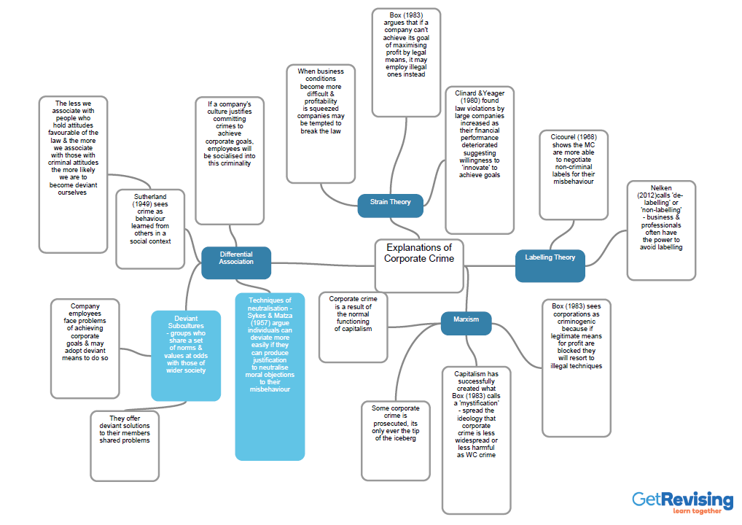

**Activity: Use this framework as a summary of the contribution made by Marxism and Neo Marxism - use this booklet, textbooks, class discussion and your notes. You are welcome to write this in another format if you wish e.g. mindmap, flashcards**

|  |  |
| --- | --- |
| **Issue** |  |
| **MARXISM** | |
| **How does MARXISM define deviance** |  |
| **Key views of Marxists** |  |
| **1.** |  |
| **2.** |  |
| **3.** |  |
| **What are the problems with this approach?** |  |
| **NEO MARXISM** | |
| **How does NEO MARXISM define deviance?** |  |

|  |  |
| --- | --- |
| **Key views of neo-Marxists** |  |
| **1.** |  |
| **2.** |  |
| **3.** |  |
| **What are the problems with this approach?** |  |
| **What are the main differences between Marxist and Neo-Marxist approaches?** |  |
| **General Evaluation Points of Marxist based explanations** | |
| 1 |  |
| 2 |  |
| 3 |  |
| 4 |  |

|  |  |
| --- | --- |
| **Key Concepts associated with Marxist based theories** |  |
| 1 |  |
| 2 |  |
| 3 |  |
| 4 |  |
| **Perspective Evaluation** |  |
| Functionalists |  |
| Feminism |  |
| New Right |  |
| Social Policy Implications |  |

SYNOPTIC LINKS WITH AREAS OF SOCIOLOGY YOU HAVE ALREADY STUDIED

|  |  |  |
| --- | --- | --- |
| **Issue** | **Links up to** | **Supporting study / Theory** |
| **Education** |  |  |
|  |  |  |
| **Family** |  |  |
|  |  |  |
| **Methods** |  |  |
|  |  |  |
| **Other** |  |  |
|  |  |  |

**50:50 Extension Tasks**

To help reinforce your learning and understanding in A-Level Sociology it is important to go beyond the set homework. Knowledge only stays in our heads if it is regularly reinforced and built upon. These tasks will help you do so. It is up to you what you do as people learn in different ways but it is important that you spend the same time on your work as you do in lessons, so 50:50

Tasks:

* Practice short questions from the end of the booklet and from throughout the textbooks.
* Plan and write an essay.
* Undertake additional reading to reinforce your understanding and develop your notes:

Browne, ‘Sociology for AQA Volume 2’, pp.456-458, 494-499 (corporate crime)

Haralambos and Holborn, ‘Sociology Themes and Perspectives’, 8th edition, pp.368-371

Webb, ‘AQA A Level Sociology, Book Two’, pp.87-94

* Create a quizlet or Kahoot for the different theories https://quizlet.com/en-gb <https://kahoot.com/>
* Write the key concepts (which can be found in the booklet) as flashcards or as a quizlet.

**Exam practice**

Outline two features of corporate crime [4 marks]

Outline three reasons why white collar crime may have low rates of prosecution [6 marks]

Item: Marxism sees capitalist society as divided along social class lines. The ruling class own the means of production and use their power to exploit the working class in pursuit of profits, often resulting in workers living in poverty. This relationship then determines the shape of the superstructure – that is, all the other institutions that make up society, including the state, the law and the criminal justice system. Capitalism is also intensely competitive, with companies and individuals motivated to seek profit.

Applying material from the Item, analyse two ways in which Marxists see class and crime as related [10 marks]

Item: Some sociologists focus on the ‘crimes of the powerful’. Crimes committed in the interests of businesses and other large institutions can be far more harmful and costly than street crimes that we tend to think of as ‘real crime’. Corporate crime can involve breaking criminal laws but may also include breaking other kinds of law. Some sociologists argue that corporate crime results from pressures to succeed, leading to employees pursuing business aims by illegitimate means. However, others claim that it is the product of capitalism.

Applying material from the Item and you knowledge, evaluate sociological explanations of corporate crime [30 marks]

Note: Begin with examining problems with defining corporate crime. Examine its scale in terms of harms caused. Consider reasons for its relative invisibility and under-reporting. Examine strain theory, labelling theory and Marxism as explanations of corporate crime, including how some of these have been combined. Evaluate by questioning how far these theories over-predict the amount of corporate crime.

Item: Some Marxist sociologists argue that capitalist society is criminogenic, that is, crime is an in-built and natural outgrowth of a capitalist society. Crime is a rational response to the competitiveness and inequality of life in capitalist society, and the law reflects ruling-class interests and ideology.

Applying material from the Item and your knowledge, evaluate the usefulness of Marxist approaches to understanding of the causes of crime [30 marks]

**Essay plan: Corporate crime**

Item: Some sociologists focus on the ‘crimes of the powerful’. Crimes committed in the interests of businesses and other large institutions can be far more harmful and costly than street crimes that we tend to think of as ‘real crime’. Corporate crime can involve breaking criminal laws but may also include breaking other kinds of law. Some sociologists argue that corporate crime results from pressures to succeed, leading to employees pursuing business aims by illegitimate means. However, others claim that it is the product of capitalism.

**Applying material from the Item and you knowledge, evaluate sociological explanations of corporate crime [30 marks]**



Paragraphs in 20 and 30 mark essays:

The Sociology sandwich is exactly the same as the burger idea we use for 10 marker, but it needs you to include more analysis/evaluation (using other studies, theories or methodology) to counter the point you are making. Each paragraph should have the elements of this ‘sandwich’ before you move onto your next point.



**Key areas of the question that you need to address:**

|  |  |
| --- | --- |
| What does the question want? | |
| **Introduction:** needs to address the debate and define key concepts in the question | |
| How could you use the **item** | |
| What key concepts will need to be included? | |
| **Explanation 1(including named sociologists, concepts and contemporary examples)** | **Comparison to other theories, problems with this explanation** |
| **Explanation 2** | **Comparison and evaluation** |
| **Explanation 3** | **Comparison and evaluation** |
| **Explanation 4** | **Comparison and evaluation** |
| Conclusion- weigh up the debate: is one of the explanations better than the others? Do we need to combine explanations? Is it that corporate crime is just problematic? | |