**WATER AID (2016) – Media Language Analysis**

*Consider the product’s codes and conventions, and how media language influences meaning in the advert:*

|  |  |  |
| --- | --- | --- |
| **Camera angles, framing & movement** | **Denotation**   * The close up on Claudia’s feet at the beginning of the advert * Contrast between establishing shot of a rainy day in England and the dry country side of Africa * Close ups on faces * Slow motion * Tracking camera shot   There’s a long shot  Close up on the people drinking from the tap  Arid landscape/setting  Tracking camera movement  Close up of walking feet with shoes | **Connotation & Roland Barthes’s Codes (semiotics)**   * This connotes that she struggles everyday with the long journey she has to take. * Connotes how little water Africa has and how much help they need. * Connotes how now having water people now have a face and personality, also representing to the audience what they are feeling * Connotes that nothing is being done fast enough and length in which she has to trek. * The camera mostly tracks the people to emphasise the fact that they have to walk extremely long distances for accessible water; water is something most of us take for granted and don’t understand the extent of effort some people have to go through to be able to access water * Connotes that we are walking with her on her daily trip to go and get water   This signifies how far her journey is to grab water  Connotes the positive effect the tap has on the people  Connotes her thirst/how dehydrated she would be without water  Following her on her journey, so we can sympathise with her.  Challenges generic convention of Water Aid adverts with bare feet which connotes poverty, the presence of the shoes symbolises a positive change that clean water has brought into their lives |
| **Mise-en-scene** | * The bright clothing they are wearing. * The lighting is high key and bright * Loads of clips of the bucket/Bucket on heads * Soft and naturalistic lighting | * This connotes that because of the help they have received they are now able to have a bright and happy future. * This connotes that there’s hope for a brighter future and more people can receive help. * The bucket connotes it is needed within their community to gain access to water.Generic iconography of the charity advert genre, connote ideas about the effort they have to make to get water and emphasises how they are less economically well off. * Connoting a welcoming atmosphere and a positive environment |
| **Editing** | * There are lots of short cuts * The shots cut from Claudia singing to the people around her using water in various different ways. | * This connotes the amount of people in need of clean water * Symbolises the various ways in which the community use the water funded by the people who donate therefore increasing the audiences understanding of the charity. |
| **Sound (diegetic & non-diegetic)** | * Claudia was singing in the ad. * The other children all sing together * Sound bridge from opening to Claudia’s life * The sound is parallel to the shots and scenes | * This connotes that she was happy and she can see herself having a brighter future ahead of her. * This gives a sense of togetherness and community, which signifies their happiness, it connotes a positive tone to the advert. * connotes the differences between developing world and UK lives * Connoting that the situation is very real and happening In the real world |
| **Written Codes** |  | This connotes that the problem is much wider than just in Claudia’s village, and that there are more people out there who need water.  Creates conceptual binary opposition between  Claudia’s positive story and that of other, less fortunate people.  Information given on how to donate. This is a generic convention of charity adverts.  Use of a personalised narrative  A direct appeal to the audience for money. All generic.  However, there is no non-diegetic voiceover or sad audio codes. It is in colour and high key lighting used. |
| **Generic conventions** | * A generic convention is to give the audience the name of the character we are following in the advert. * Statistics are used at the end | * This allows the reader to create an emotional attachment to the character, and therefore are more likely to donate. * There are lots of people that need help and assistance from others * The ad challenges and reinforces genre conventions. It challenges them, as it is a positive, upbeat representation of the charity, highlighting the work it has done, however it also reinforces them as the written codes at the end are shocking and upsetting, and plays to the generic conventions of a charity ad. * Generic low key lighting |
| **Applying Levi-Strauss** | Abundance vs. Scarcity  Clean vs. Dirty  Innocence vs. Responsibility  Binary opposites of music in parallel with images: ‘sunshine on a rainy day’ with children running, playing, laughing and positive connotations emphasised by high key lighting  Washed out colours at beginning becoming more vibrant at 01.02 in ad |  |

Now watch the following two charity adverts*;* [*Barnardos – Believe in Me*](https://www.youtube.com/watch?v=XnIcd4uJHao)  (2015) and [*Save the Children – Tomorrow*](https://www.youtube.com/watch?v=rL7gZ9alh4o) (2015).

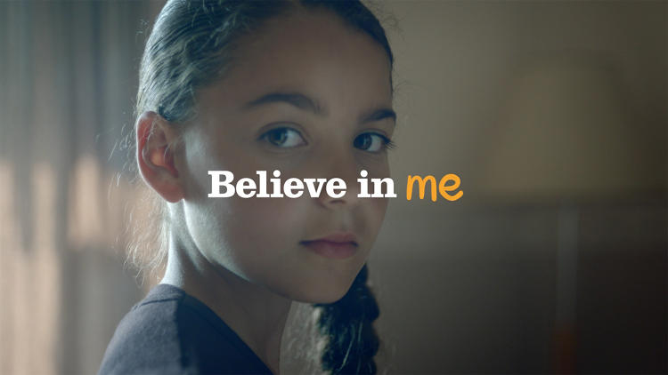 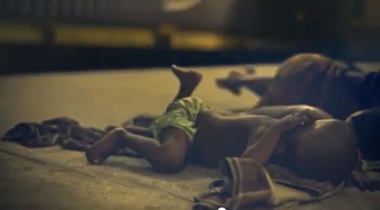

How does the advert use **media language**?

**Barnardos**

Lighting – At the beginning, there is de-saturated lighting which represents the children’s current state of mind and the lighting being dull and dim connotes a sense of depression. But as ad progresses the light shining from the windows connotes there is hope for the children (from outside – i.e. the public?)

Camera (angles and movement)

Editing

Written codes giving us an insight to the children’s lives and how they feel connoting that they aren’t just what they are being labelled as

Sound

Mise-en-scene

Broken mirror connotes a broken home and signifies that their family might be aggressive

The setting of all the different children featured are all very similar, they are small looking run down homes. This signifies realism and believability.

Written codes giving us an insight to the children’s lives and how they feel connoting that they aren’t just what they are being labelled as

**Save the Children**

Lighting:

Camera (angles and movement): At the beginning of the advert the camera close up is used of the children sleeping peacefully however then it changes to long shot of the conditions the children are sleeping in which connotes poverty and the difference lives they live and suffer through.

The lighting remains low-key throughout the advert to signify the setting of the advert being night time however it also further emphasises the serious tone/ message of the ad.

Editing: At the start of the advert it shows 3 second clips of children in bed but as the videos cut to people sleeping in bad conditions the video clips change to 5 seconds, this connotes the harsh reality of children that actually need help.

Sound: The music used throughout the whole advert is a soft piano version of ‘Tomorrow’ from the film Annie. The intertextuality helps people to understand that the children in need of help.

The piano in the background of the opening shots as they sleep from our perspective of a close up shot of their faces connotes that they are in a gentle sleep.

The music is contrapuntal to what is going on in the mise-en-scene, this music connotes joy and happiness while the advert shows images of children suffering in poverty. The music is from the film Annie, which is about a child that lived in poverty which is represented in the advert.

Mise-en-scene: The children are wearing limited clothing, as well as in dark colours such as greens and browns connotingpoverty and hardship. Most of the children are wearing dark coloured and dirty clothing, the objects around them are also in quite dark colours, this connotes that the children are suffering as they are sleeping outside and in bad conditions. It also implies that they are unable to afford to buy new items.

.

How is the ad similar to *Water Aid* in relation to their **generic conventions**? In what ways do they **subvert/challenge** the **generic expectations** of a charity ad?

**Barnardos:** Within both the Barnardos and Water Aid ad, the audience’s attention is continuously focused on the children as they are determined and passionate about the challenges they face whether it be dancing, drumming or collecting water, signifying that these individuals are portrayed as motivated within the adverts.

The ad is similar to Water Aid as there are bad living conditions. They subvert the generic expectations as the children have talents and are showing them off.

The use of personal pronouns, such as ‘I’. This individualises them.

Use of children in both ads.

Both use low key lighting which connotes the children’s isolation.

This ad uses them in a sad way, unlike Water Aid.

No use of facts or statistics.

Both use music.

Both empowering in their messages.

**Save The Children:**

It challenges generic expectations of charity ads because it doesn’t present a happier or different future if the audience donates which most charity ads show to persuade people to donate to try and make a clear difference

Both Water aid and Save the children, feature different children which connotes the amount of children affected by poverty and who need help. Save the children is much more of a traditional charity advert, compared to Water aid. Water aid tried to challenge the generic conventions by creating a more positive advert, however save the children is more depressing due to its dark lighting and emotional music.

Soundtrack is a reinforcement of the ‘sad’ charity ad, which pulls at the heart-strings.

Both use close-up shots to show the emotion on the children’s faces.

No use of direct mode of address.

Now apply **Bathes’** **semiotic** **codes**? How do the codes help **connote** the ideology of the cause/charity?

**Save the Children**

Sleeping on streets with ripped, dirty clothing signifying their human rights are not being met.

How does the advert use **binary codes (Levi-Strauss)** to create conflict within the text? Do these opposing **codes** help support a particular point of view (ideology)?

**Barnardos**

The children’s past vs. their future

The darkness on the inside vs. the bright light outside

**Save the Children**

Seeing children on the streets sleeping is the binary opposite of where they should be sleeping – safely in a bed