[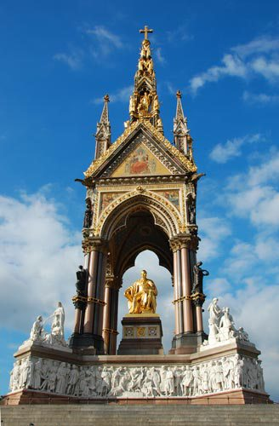](http://www.google.co.uk/url?sa=i&rct=j&q=&esrc=s&source=images&cd=&cad=rja&uact=8&ved=2ahUKEwiDq-jXvtPeAhXNy4UKHRMkCi4QjRx6BAgBEAU&url=http://www.travelsignposts.com/London/sightseeing/albert-memorial-london&psig=AOvVaw1VRTUM_IJ7ioVR7vXGa9_P&ust=1542271360665674)Sir George Gilbert Scott, *The Albert Memorial*, opened 1872,

54 metres high

Commemorative Sculpture (in Britain)

**Context:**

* Commissioned by Queen Victoria in 1862, in memory of her husband Prince Albert who had died the previous year
* Took over a decade to complete
* Architect George Gilbert Scott won the commission for the project
* A public subscription paid for the monument
* Gothic Revival (neo-Gothic) in style
* Located in Kensington, near the site of the Great Exhibition of 1851 which Prince Albert was instrumental in organising.
* Also near Exhibition Road which contains venues such as the V&A, Natural History Museum, Royal College of Art- all of which Albert encouraged the establishment of.

**Description:**

* Albert sits beneath a canopy, based on a ciborium. This is a structure often found in religious buildings and which is placed over an altar.
* Albert made from gilt bronze. Much larger than life, giving him a presence and dominance.
* Base of the structure is a white marble relief frieze of life-sized figures representing famous names from the Arts; eg Michelangelo, Beethoven, Shakespeare. This reminds us of Albert’s interest in the Arts.
* Albert shown wearing the costume of the Knight of the Garter- indicating his prominence
* He holds a catalogue for the Great Exhibition
* He looks in the direction of Exhibition Road- linking him to that area
* Allegorical figures in white marble appear below Albert. They represent industry; eg Commerce, Agriculture. This shows Albert’s interest in the domestic affairs of Britain.
* Bronze figures depicting Medicine and Astronomy- showing Albert’s interest in the Sciences
* The structure is elevated on a series of steps- lifting Albert physically and symbolically above the viewer
* The canopy interior is decorated with coloured glass mosaics of gold stars against a blue sky
* The exterior of the canopy also has mosaics, contained in the spandrels and tympana. These depict allegorical figures such as Poetry and Music.
* The canopy is elevated above Albert by clusters of Gothic columns in red and black marble and stone
* A central flèche and pinnacles on each corner are typically gothic and rise upwards. The flèche contains gilt depictions of religious allegorical characters- reminding us of Albert’s faith
* A giant jewelled crucifix tops the monument- reminding us of Albert’s death and suggesting he is memorialised in heaven as well as on earth.
* On the outer edges at ground level are white marble allegorical depictions of four continents- Europe, Africa, America, Asia- showing Albert’s interest in international politics and also the extent of the British Empire which his wife Queen Victoria rules.
* Albert’s Christian name inscribed at his feet. A longer inscription runs above the pointed arch of the canopy with references to Victoria, Albert and the public.  
    
  **Materials:**
* Brick used for the canopy.
* Red and black marble and stone columns support the canopy.
* White marble for allegorical figures in below Albert, in frieze, outer edges. Deep and shallow relief carving on the frieze give depth and realism. Life size scale of figures on frieze adds realism and contrasts with Albert’s larger form
* Gilt bronze for figure of Albert and also religious allegorical figures- making him appear divine.
* Bronze allows for great detail in the figures, their props, costumes- identifying what they represent.
* Coloured glass mosaic adds variety and makes the structure appear to be covered in jewels.
* Use of stone and bricks implies strength and endurance.
* Expensive materials such as bronze and gilding suggests opulence and wealth.

**Style:**

* Gothic Revival in style, shows the Victorians’ interest in Medieval and Gothic themes and art/architecture. Albert had a major interest in art from the Medieval and Gothic period.
* References to a ciborium were deliberate and inspired by Gothic examples found in Verona.
* The structure appears as a religious shrine or reliquary which preserves the figure of Albert.
* The references to various subjects within the work indicate Albert’s accomplishments and show his interest in the Arts, Sciences, politics, international affairs, commerce/business, religion.
* The imposing scale dominates the area and reinforces Albert’s authority and links to this area of London.

Consider the following when analysing this work: Subject. Patron. Location. Materials. Scale. Style. Allegorical figures. Symbolism.