[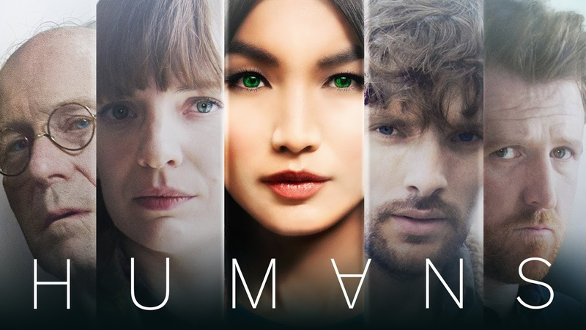](http://www.google.co.uk/url?sa=i&rct=j&q=&esrc=s&source=images&cd=&cad=rja&uact=8&ved=0ahUKEwjUs9zajuPUAhUBlxoKHRgOCXkQjRwIBw&url=http://tvode.com/what-do-you-think-of-humans/humans-sci-fi-tv-series-im109847/&psig=AFQjCNG6UYQ2kAmV9XhshX9b35xX-wdihw&ust=1498826029571284)

**EDUQAS AS MEDIA STUDIES**

**COMPONENT 2**

***HUMANS* (2015)**

**MEDIA LANGUAGE**

**INTRODUCTION**

**Directed by:** Sam Donovan

**Certificate:** 15

**Running time:** 42mins

**Synopsis:**

The sci-fi show based on the Swedish series *Real Humans* is focused on a universe where the latest gadget to have is a Synth, an android robot. Joe Hawkins (Tom Goodman-Hill) buys a Synth named Anita (Gemma Chan), hoping it will help his relationship with his wife Laura (Katherine Parkinson), who is sceptical.

**Background**

***Humans*** (stylised as HUM∀NS) is a science fiction television series that debuted on 14 June 2015 on Channel 4 and aMC. Written by the British team Sam Vincent and Jonathan Brackley, based on the award-winning Swedish science fiction drama *Real Humans*, the series explores the themes of artificial intelligence and robotics, focusing on the social, cultural, and psychological impact of the invention of anthropomorphic robots called "synths". The series is produced jointly by aMC in the United States, and Channel 4 and Kudos in Britain.

Eight episodes were produced for the first series, which concluded on 2 August 2015. The second eight-episode series premiered in the UK on 30 October 2016 and concluded on 18 December 2016. A third series was commissioned in March 2017 and premiered on 17 May 2018 and concluded 5 July 2018.

The first season of *Humans* received positive reviews from critics. The show is Channel 4's highest rated drama since the 1992’s *The Camomile Lawn*. It has been described as having "universal appeal" and as being "one of 2015's dramatic hits."

**CODES AND CONVENTIONS OF SCI FI**

For each genre category there are specific visual and narrative expectations called codes and conventions.

* **CODES:** (what you expect to see)
* **CONVENTIONS:** (what you expect to happen)

Complete the codes and conventions ‘table’ for Sci-Fi

|  |  |
| --- | --- |
| **Codes** | **Example** |
| Opening credits (typography, title language) |  |
| Setting |  |
| Lighting |  |
| Costume |  |
| Props |  |
| Iconography |  |

|  |  |
| --- | --- |
| **Conventions** | **Example** |
| Character types |  |
| Plot |  |
| Narrative |  |
| Resolution |  |
| Soundtrack |  |
| Messages and themes |  |

**CODES AND CONVENTIONS IN HUMANS**

Complete the codes and conventions ‘table’ for Humans, write notes where you have seen examples of Humans meeting codes and conventions of the sci-fi genre.

|  |  |
| --- | --- |
| **Codes** | **Humans** |
| Opening credits (typography, title language) |  |
| Setting |  |
| Lighting |  |
| Costume |  |
| Props |  |
| Iconography |  |

|  |  |
| --- | --- |
| **Conventions** | **Humans** |
| Character types |  |
| Plot |  |
| Narrative |  |
| Resolution |  |
| Soundtrack |  |
| Messages and themes |  |

**GENRE THEORY**

**Steve Neale**

* One of the pleasures of genre texts for the audience is the recognition of the familiar. Familiar conventions are drawn on and played out during the course of the text.
* Looking for the familiar is only part of the pleasure; **Steve Neale** suggests that audiences enjoy the repetition and the differences within a genre
* He suggested that genres change, develop, and vary, as they borrow from and overlap with one another

From your viewing complete the table to support Neale’s theory and identify conventions from *Humans* where there is evidence of repetition *and* variation

|  |  |
| --- | --- |
| **Repetition:** Write below the elements from Humans that you have seen elsewhere | |
| Humans (reference scene or element) | Where? What movie/TV? |
|  |  |
|  |  |
|  |  |
|  |  |
|  |  |
|  |  |
| **Variation:** Write below the elements from Humans you have not seen elsewhere | |
| Humans | |
|  | |
|  | |
|  | |
|  | |

**INTERTEXTUALITY**

*Definition: Where a media text makes references to another media text.*

* Could you identify any intertextual elements with Episode 1 of *Humans*?
* How did they work in terms of media language (creating meaning), genre and audiences?
* How do these bring ‘difference’ to the text (Neale)?

Now write a paragraph explaining to what extent *Humans* supports Neale’s theory of genre:

|  |
| --- |
|  |

Analyse the *Daily Telegraph* review by Michael Hogan, 30 October 2016 below.

What is “old” in terms of genre and what is new?

**Highlight the old genre terms in Blue**

**Highlight the new genre terms in Orange**

Last year’s launch of *Humans* – a stylish series about the rise of Artificial Intelligence as demonstrated by eerily anthropomorphic robots called “synths” – was a big hit for the broadcaster, netting its highest ratings for a drama since *The Camomile Lawn* way back in 1992. Now, for its second series, *Humans* has widened its scope with an admirably ambitious opening episode that hopped between the UK, the US, Germany and Bolivia, telling a panoramic story of man versus machine. One of the rogue synths released a secret software upgrade that gave their fellow machines human consciousness. Around the world, synthetic slaves began waking up and threw off their chains of bondage.

For a show about robots, Humans had perceptive things to say about humanity – as its title suggests. Feelings were described as “contradictory data – an excess of sensory feedback that makes no sense and serves no useful function.” “Emotions have functions, you’ll see,” said sage synth Max (Ivanno Jeremiah). Unusually for a dystopian drama, the script was stealthily funny. “I haven’t decided on my name yet,” deadpanned one newly liberated synth. “I’m oddly attracted to the word ‘radiator’, although I understand this is not considered a name.”

As with the debut series, it was the women who shone brightest, especially Emily Berrington and Gemma Chan as fugitive synths Niska and Mia. The willowy pair blended blank-faced impassivity with flickers of burgeoning humanity. Mia relished feeling the wind in her hair. Niska smiled at a headline reading: “Synth tram driver abandons passengers to look at the birds”. Josie Lawrence made a scene-stealing cameo as a robotic marriage counsellor, adopting a soft Edinburgh accent to put clients at ease. Meanwhile, *The Matrix*’s Carrie-Anne Moss also joined the cast, replacing William Hurt as the token Hollywood star. As a synth-sympathising US scientist, Moss was all furrowed brow and hard-bitten cynicism.

This second run will inevitably be compared to big-budget US import *Westworld*, which launched earlier this month on Sky Atlantic. Both shows explore the themes of artificial intelligence and malfunctioning technology. However, *Humans* is a different beast. It’s primarily a domestic drama, a story about families – be it the human Hawkins clan, whose lives were irrevocably changed by Mia, or the bond between sentient synths. This is sci-fi with heart and soul’

<http://www.telegraph.co.uk/tv/2016/10/30/for-a-show-about-robots-humans-has-a-lot-of-heart---channel-4-se/>

**NARRATIVE STRUCTURE**

Can you identify the various stages of the narrative in Episode 1 of *Humans*?

|  |  |
| --- | --- |
| STAGE | Episode 1 |
| EQUILIBRIUM |  |
| DISRUPTION |  |
| RECOGNITION |  |
| RESOLUTION |  |
| EQUILIBRIUM |  |

**Task: Does the episode fulfil the narrative (and genre) expectations of the audience? How?**

1. Are all these stages completely realised in Episode 1? Why?
2. The Todorovian narrative model is linear. Is this the case for Humans?

Re-watch parts of Episode 1 on e-stream to answer the narrative questions below

1. Can you identify all the flashback in Humans?
2. Can you identify the different narrative strands and character arcs at work in Humans?

**1.**

**2.**

**3.**

**4.**

**5.**

**6.**

**7.**

**8.**