**AS MEDIA STUDIES**

**COMPONENT 2: *HUMANS***

[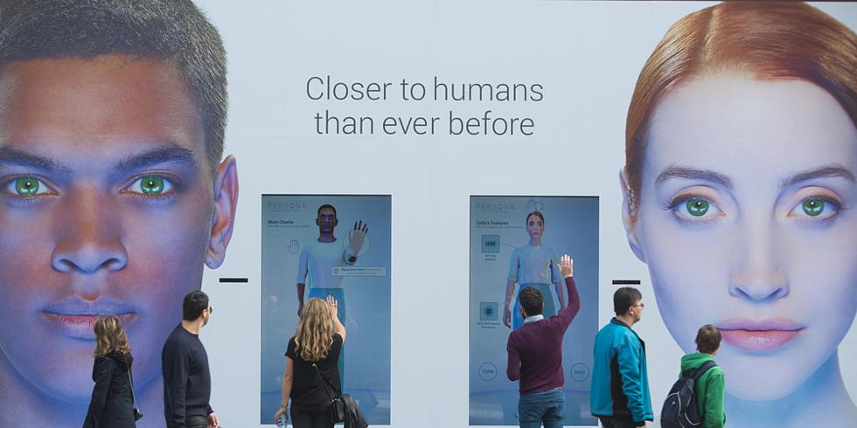](http://www.google.co.uk/url?sa=i&rct=j&q=&esrc=s&source=images&cd=&ved=2ahUKEwiIlsqD_JHcAhWCOhQKHZnjDR0QjRx6BAgBEAU&url=http://www.digitalspy.com/tv/humans/news/a647047/channel-4-explains-innovative-humans-marketing-campaign/&psig=AOvVaw14825UEVOtsholXN4-RJ2u&ust=1531221422945044)

**MEDIA INDUSTRY WORKBOOK**

**MEDIA INDUSTRIES**

**You will need to consider the following:**

* Processes of **production, distribution and circulation/consumption**
* Which **companies** contributed to Humans, how they are **owned** and **operated**
* The significance of economic factors, including commercial and **not-for-profit public funding**
* **International co-production** is growing and broadcasters such as **aMC** and HBO have achieved global success
* **Marketing** to a variety of audiences nationally and globally
* **Audiences’ consumption** habits (box-set, binge-watching, on-demand, catch-up, Netflix, Amazon etc.).
* **Portability** (tablet, mobile phone)
* The **regulatory** framework of contemporary media in the UK (**OFCOM**, BBFC classification, watershed)

**Humans Production:**

*Humans* was commissioned by aMC and C4 and made by Kudos Productions, a UK-based production company.

‘*We work with the best global talent to create, develop and produce popular, innovative, award winning drama and comedy series’.*

1. Look at the show-reel and website for Kudos. [http://www.kudos.co.uk](http://www.kudos.co.uk/). List five other programmes they have made.
2. What larger company are they part of (parent company)?
3. What can you find out about this parent company?
4. What other productions has the parent company made?
5. Who owns the parent company? What can you find out about them?

**CHANNEL 4**

* Channel 4 was started in 1982 when there were only three TV channels (BBCs 1 and 2, and ITV).
* Channel 4 is a publicly-owned, commercially-funded public service broadcaster
* Formed as a compromise between the demand for competitive expansion in broadcasting (with a new market for advertising) and the virtues of the BBC’s public service ethos.

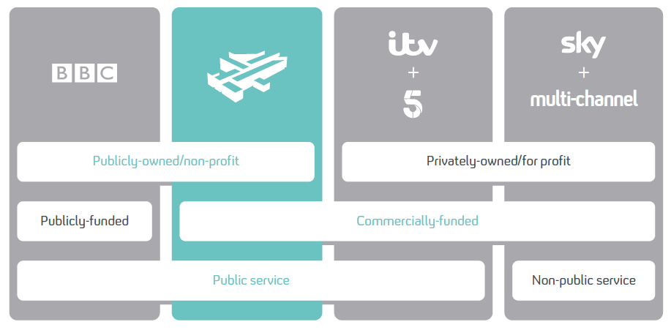

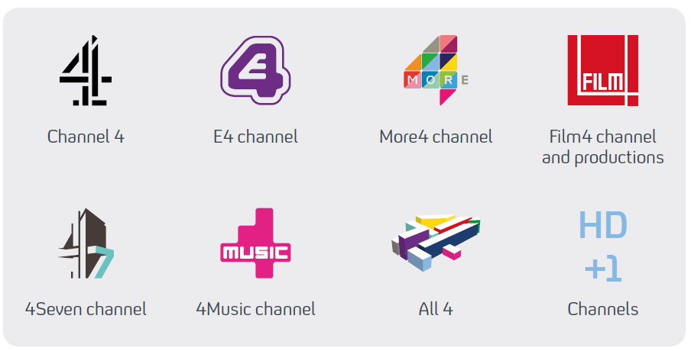

**AUDIENCE TARGETING/MARKETING/DISTRIBUTION**

In both the UK and US, *Humans* relied on publicity, media tie-ins and advertising campaigns mostly in the press (newspapers and magazines), online, plus outdoor campaigns and TV advertising and social media.

[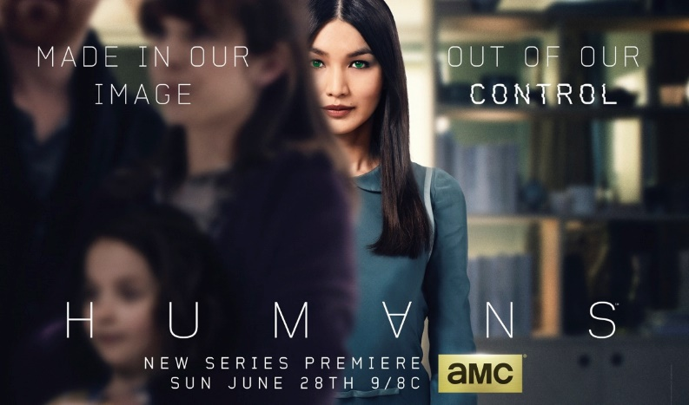](http://www.google.co.uk/url?sa=i&rct=j&q=&esrc=s&source=images&cd=&cad=rja&uact=8&ved=0ahUKEwiOttiimuPUAhWDtRoKHY1RD5kQjRwIBw&url=http://www.amc.com/shows/humans/talk/2015/05/poster-released-and-premiere-date-announced-for-humans&psig=AFQjCNF89ID4ob2yhLNWuVEw0MkkXdVkNg&ust=1498830865076738)[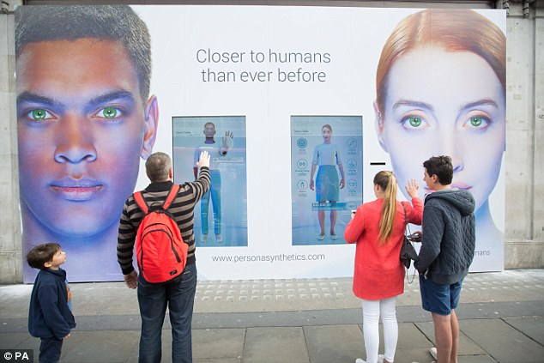](http://www.google.co.uk/url?sa=i&rct=j&q=&esrc=s&source=images&cd=&cad=rja&uact=8&ved=0ahUKEwik65eGmuPUAhWFuhQKHeyhBs0QjRwIBw&url=http://www.dailymail.co.uk/femail/article-3078322/Viewers-vent-Twitter-freaked-chilling-cyborg-housekeeper-advert-Channel-4.html&psig=AFQjCNFd1R1P486qRrZ9v1ZD3zLL7Fzj0Q&ust=1498830817177490)

*Campaign poster (interactive outdoor UK) US poster*

[](http://www.google.co.uk/url?sa=i&rct=j&q=&esrc=s&source=images&cd=&cad=rja&uact=8&ved=0ahUKEwjgi9rPmuPUAhVDuRQKHUneCJQQjRwIBw&url=http://www.denofgeek.com/tv/humans/35561/humans-channel-4-confirm-premiere-date-for-robot-drama&psig=AFQjCNHrE8-zp6bTmXtdGlrDMnczB3zX_w&ust=1498830954272367)

*UK poster*

**MARKETING**

1. On GOL look the ‘Marketing’ link for: the trailers for Persona synthetics – *Meet Sally* (1’30”) Series 1 <https://www.youtube.com/watch?v=_94sQiXlPtE> and *Persona Synthetics - Product Recall* (1’00) Series 2 <https://www.youtube.com/watch?v=wvnrD3MHz4s>

How is the programme being marketed? Consider genre/representations/media language.

1. Read the C4 article <http://www.channel4.com/info/press/news/persona-synthetics-initiate-product-recallfor-return-of-c4s-humans>

How is the programme being marketed?

1. How is social media used? Give examples.
2. What ‘conventional’ forms of marketing were used? TV/Radio interviews? Print? Look at all the clips on the resource. How were the audience targeted by these? Use of star power? Genre? Narrative? The institutions?

**TV**

**Radio**

**Print**

**C4 press packs and trailers for *humans***

Trailer C4 Series 1 <https://www.youtube.com/watch?v=HU4mwlTUXnc>

aMC press pack <https://www.amc.com/press-kits/humans-s1-press-kit/>

aMC marketing <https://www.amc.com/shows/humans/talk/category/synth-etiquette>

Trailer C4 series 2 <https://www.youtube.com/watch?v=DtfqtIzwnko>

1. Watch the UK trailer for *Humans*. How does it encourage you to watch the show?
2. One of the pleasures of genre texts for audiences is the recognition of the familiar. The trailer draws upon a number of sci-fi conventions, but also hints at new ones. Make a list of both familiar Artificial Intelligence conventions and fresh/different approaches.

|  |  |
| --- | --- |
| Familiar conventions | Variation |
|  |  |

1. Which aspects of the narrative are emphasised in the trailer?
2. How is the location/parallel reality represented in the trailer?
3. The role of a trailer is often to present narrative enigmas – what enigmas are offered by the trailer for *Humans*?
4. Which characters are introduced? What would you expect to see of the relationships between various characters?
5. Does the trailer introduce any of the text’s key themes?

Having looked at the range of techniques used, **how is *Humans* marketed to target audiences?** You need to make approx. 10 points here. Consider use of star power? Genre? Narrative? The institutions? Marketing events? Branding?